DELEGATED HOUSEHOLDER APPLICATION REPORT

Ward: Kentwood
App Ref: 220070/HOU
Address: 94a Oak Tree Road, Tilehurst, Reading, RG31 6JY
Proposals: The construction of a single storey timber clad garden building.
Case Officer: Chukwudi Onwudinanti
Applicant: Mr Bhrat Jyoti
Date received (valid from): 18 January 2022
Target Decision date: 15 March 2022

1. INTRODUCTION
The proposal site is a detached dwelling on the western side of Oak road, among dwellings of varied styles and sizes. The dwelling has a large garden to the rear, where the outbuilding is proposed.

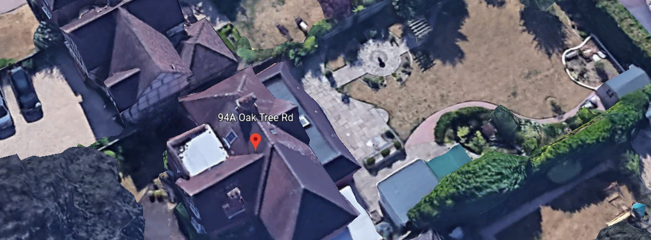

2. PROPOSAL AND SUPPORTING INFORMATION

The construction of a single storey timber clad garden building, measuring 7.2m by 4.2m and set back 0.5m from the rear boundary and 0.9m to the side boundaries.

Plans considered (Received 19th January 2022):
TQRQM22014115338793 : Location Plan
TQRQM22014121626970 : Block Plan
210901071TGO1 : Floor Plans/Elevations

- RELEVANT PLANNING HISTORY

None

4. CONSULTATIONS

4.1 The following addresses were consulted by letter.

36 Brooksby Road, Tilehurst, Reading, RG31 6LY
38 Brooksby Road, Reading, RG3 6LY
98 Oak Tree Road, Tilehurst, Reading, RG31 6JY
96a Oak Tree Road, Tilehurst, Reading, RG31 6JY

Natural Environment have been consulted and they responded:
No vegetation of concern there, so no objections.

4.2 No letters of representation have been received.

Equality Act 2010:
In determining this application the Council is required to have regard to its obligations under the Equality Act 2010. However, there is no indication or evidence (including from consultation on the application) that the protected groups identified by the Act have or will have different needs, experiences, issues and priorities in relation to this particular planning application. Therefore in terms of the key equalities protected characteristics it is considered there would be no significant adverse impacts as a result of the development.

- LEGAL AND PLANNING POLICY CONTEXT

Section 38(6) of the Planning and Compulsory Purchase Act 2004 requires that proposals be determined in accordance with the development plan unless material considerations indicate otherwise. Material considerations include relevant policies in the National Planning Policy framework (NPPF) - among them the 'presumption in favour of sustainable development'. The following local and national planning policy and guidance is relevant to this application:

National Policy
National Planning Policy Framework
National Planning Practice Guidance

Reading Borough Local Plan (2019)
CC7 (Design and the Public Realm)
CC8 (Safeguarding Amenity)
H9 (House Extensions and Ancillary Accommodation)

SPG/SPD
- A Design Guide to House Extensions SPG

6. APPRAISAL

H9 states: An extension to a house will be acceptable where it:

- Respects the character of the house in terms of scale, location, materials and design;

To assess this, the following has been considered – would the proposal:
- detract from the appearance of the original building through the use of ill-matching materials and by not fitting in with the design, scale and proportions of the original building; NO, the proposal is for an outbuilding to the rear of the property.
- reduce the amount of usable amenity space for the property to an unacceptable degree; NO, there is no significant impact on the usable amenity space.
- require the loss of trees in the garden or put significant trees at risk; NO, the applicant has demonstrated, with photos, that there will not be any trees affected by the proposed outbuilding.NE has also confirmed that there is no vegetation or trees of concern.

- Respects the character and pattern of neighbouring properties and the street as a whole in terms of scale, location, materials and design, and any important existing building line; Respects neighbour’s amenities and does not present a large blank façade to public areas.

To assess this, the following has been considered – would the proposal:
- significantly reduce the amount of daylight and sunlight enjoyed by neighbouring properties; NO
- invade the privacy of neighbouring properties through overlooking from windows or balconies; NO
- detract from the character of neighbouring properties through siting, excessive bulk, ill-matching materials or inconsistent design; NO
- detract from the appearance of the street or area by using ill-matched materials, glazing and detailing; NO

CC8: Safeguarding Amenity states an extension to a house will be acceptable where it will not cause a significant detrimental impact to the living environment of existing or new residential properties.

To assess this, the following has been considered – would the proposal cause a significant detrimental impact to the living environment of existing or new residential properties in terms of:

- Privacy and overlooking;
- Access to sunlight and daylight;
- Visual dominance and overbearing effects of a development;
- Noise and disturbance;
- Artificial lighting;
- Vibration;
- Dust and fumes;
- Smell;
- Crime and safety.

- CONCLUSION
The proposed development has been assessed and the proposed works are considered to be in accordance with the above relevant policies and planning permission can be granted.

8. RECOMMENDATION
Grant

