Our Ref: 21004 QVS2-RP-01

Mr Giorgio Villa,
Falconer Chrester Hall Architects

8th of August 2022

Dear Mr Villa,

QVS 2 – Structural Strategy for Retention of Structural Beams within the Bugle Public House

Following our recent conversations, you have asked that we formally write to you regarding the proposed strategy for retaining the existing structural beams within the Bugle Public House within the proposed hotel development.

The existing structure consists of timber beams with a suspended timber floor joists, these are supported off a traditional solid masonry walls located around the perimeter of the building. The roof consists of a tiled roof supported by cut timber roof rafters and existing timber beams spanning between the existing perimeter masonry walls.

The proposal for maintaining the existing timber beams will involve installing a steel picture frame along the existing party wall of the Bugle Public House and No. 144 Friar Street. This steel picture frame will be installed directly below the existing timber beams which are bed into the existing masonry party wall. This will avoid damaging the existing historic fabric of these beams.

During the building works, the Main Contractor will need to install a row of Mabey System 160 props with a new strip foundation to temporarily support the beams while the new steel picture frame installed. This Mabey System 160 should be adequately braced to provide stability to the building structure as a whole. The proposed line of these Mabey System 160 temporary works is indicated on the structural sketches.

The sequence of works for the installation of the picture frame will be:
- Installation of Mabey System 160 Temporary Works Solution.
- Demolish existing masonry party wall to expose the ends of the historic timbers
- Form new foundation for steel picture frame.
- Install new steel picture frame to the underside of the existing retained timber beams.
- Remove the temporary works and make good any existing connections.

Given that the existing façade to the Bugle Public House is being retained, then maintaining the installation of the existing suspended timber floor and timber beams will negate the need for a complex façade retention system. The existing floor structure will provide diaphragm action to stabilise the building while the works are being undertaken.

I trust this letter clarifies the proposed construction, but should you have any further questions please feel free to contact me.

Yours sincerely
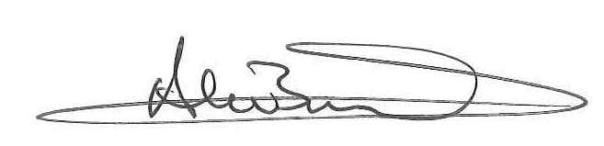

Alan Bowling - Project Director
BEng (Hons) C Eng M.I.Struct.E
Axiom Structures Limited

