DELEGATED HOUSEHOLDER APPLICATION REPORT

Ward: Caversham
App Ref: 211847/HOU
Address: 87a Henley Road, Caversham, Reading, RG4 6DS
Proposals: Single storey rear conservatory extension and formation of a balcony roof terrace over existing flat roof extension
Case Officer: Chukwudi Onwudinanti
Applicant: David Thomas
Date received (valid from): 12 November 2021
Target Decision date: 3 February 2022

1. INTRODUCTION
The proposal site is a detached building on the southern side of Hanley road. It sits within a predominantly residential area, among dwellings of varied styles and sizes.

2. PROPOSAL AND SUPPORTING INFORMATION

The proposal is for a single storey rear conservatory extension and formation of a balcony roof terrace over existing flat roof extension. The extension measures 3m in depth and 4.15m in width, covering the area currently occupied by the conservatory. The proposed terrace is sited on the present flat roof covering parts of the ground floor and will not extend beyond the existing lines of the first floor.

Plans considered (Received 15th November 2021)
Site Location Plan
Drawing NO - 01 : Existing Floor Plans
Drawing NO - 02: Existing/Proposed Elevations
Drawing NO - 03 : Existing/Proposed Elevations
Drawing NO - 04 : Proposed Ground Floor Plans
Drawing NO - 05 : Proposed First Floor Plans
Drawing NO - 06 : Proposed Sections
Drawing NO - 07 : Proposed Block Plan

3. RELEVANT PLANNING HISTORY

None

4. CONSULTATIONS

4.1 The following addresses were consulted by letter.

2 Queen Annes Gate, Caversham, Reading, RG4 5DU
Flat 3, 87 Henley Road, Caversham, Reading, RG4 6DS
Flat 2, 87 Henley Road, Caversham, Reading, RG4 6DS
Flat 1, 87 Henley Road, Caversham, Reading, RG4 6DS
Flat 4, 87 Henley Road, Caversham, Reading, RG4 6DS
87b Henley Road, Caversham, Reading, RG4 6DS
3 Queen Annes Gate, Caversham, Reading, RG4 5DU
1 Queen Annes Gate, Caversham, Reading, RG4 5DU

4.2 No letters of representation have been received.

Equality Act 2010:
In determining this application the Council is required to have regard to its obligations under the Equality Act 2010. However, there is no indication or evidence (including from consultation on the application) that the protected groups identified by the Act have or will have different needs, experiences, issues and priorities in relation to this particular planning application. Therefore in terms of the key equalities protected characteristics it is considered there would be no significant adverse impacts as a result of the development.

- LEGAL AND PLANNING POLICY CONTEXT

Section 38(6) of the Planning and Compulsory Purchase Act 2004 requires that proposals be determined in accordance with the development plan unless material considerations indicate otherwise. Material considerations include relevant policies in the National Planning Policy framework (NPPF) - among them the 'presumption in favour of sustainable development'. The following local and national planning policy and guidance is relevant to this application:

National Policy
National Planning Policy Framework
National Planning Practice Guidance

Reading Borough Local Plan (2019)
CC7 (Design and the Public Realm)
CC8 (Safeguarding Amenity)
H9 (House Extensions and Ancillary Accommodation)

SPG/SPD
- A Design Guide to House Extensions SPG

6. APPRAISAL

H9 states: An extension to a house will be acceptable where it:

- Respects the character of the house in terms of scale, location, materials and design;

To assess this, the following has been considered – would the proposal:
- detract from the appearance of the original building through the use of ill-matching materials and by not fitting in with the design, scale and proportions of the original building; NO, all aspects of the proposed development are to the rear, with minimal changes to the internal spaces.
- reduce the amount of usable amenity space for the property to an unacceptable degree; NO
- require the loss of trees in the garden or put significant trees at risk; NO

- Respects the character and pattern of neighbouring properties and the street as a whole in terms of scale, location, materials and design, and any important existing building line; Respects neighbour’s amenities and does not present a large blank façade to public areas.

To assess this, the following has been considered – would the proposal:
- significantly reduce the amount of daylight and sunlight enjoyed by neighbouring properties; NO
- invade the privacy of neighbouring properties through overlooking from windows or balconies; NO, there is no additional impact of overlooking on the properties to the rear of the proposed site as there are existing windows on the same side as the proposed balcony. The balcony does not extend beyond the line of the existing dwelling, and is away from the site boundaries so will not present overlooking impacts on the buildings to the sides of the dwelling.
- detract from the character of neighbouring properties through siting, excessive bulk, ill-matching materials or inconsistent design; NO
- detract from the appearance of the street or area by using ill-matched materials, glazing and detailing; NO

CC8: Safeguarding Amenity states an extension to a house will be acceptable where it will not cause a significant detrimental impact to the living environment of existing or new residential properties.

To assess this, the following has been considered – would the proposal cause a significant detrimental impact to the living environment of existing or new residential properties in terms of:

- Privacy and overlooking;
- Access to sunlight and daylight;
- Visual dominance and overbearing effects of a development;
- Noise and disturbance;
- Artificial lighting;
- Vibration;
- Dust and fumes;
- Smell;
- Crime and safety.

- CONCLUSION
The proposed development has been assessed and the proposed works are considered to be in accordance with the above relevant policies and planning permission can be granted.

8. RECOMMENDATION
Grant
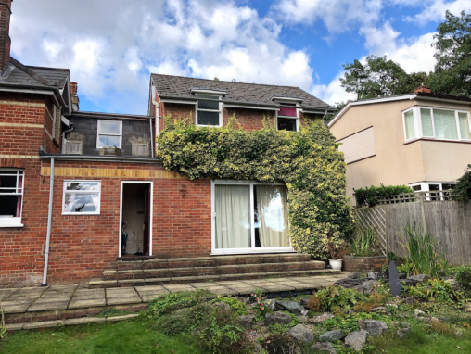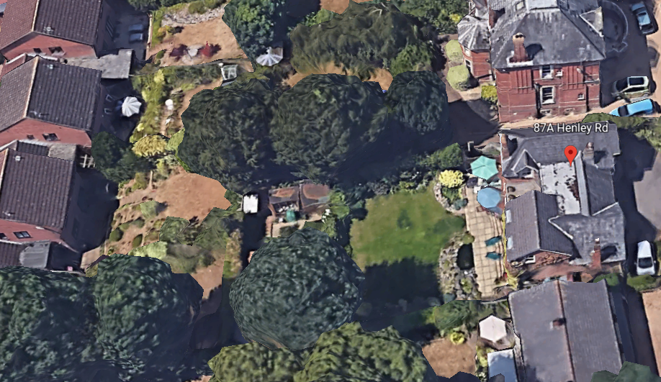

Site Photos from Applicant and Google Earth.

