MATERIAL SCHEDULE FOR POST-FOUNDATION LEVEL
CONDITION 3

DEVELOPMENT AT

Land Adjacent to
114 – 116 School Road
Tilehurst
Reading
RG31 5AX

DEVELOPER

Chesters Place Limited

PREPARED BY

C Thorpe

DATE

22nd July 2022

V3

Facing brickwork

Ibstock 65mm Laybrook Multi Orange Stock

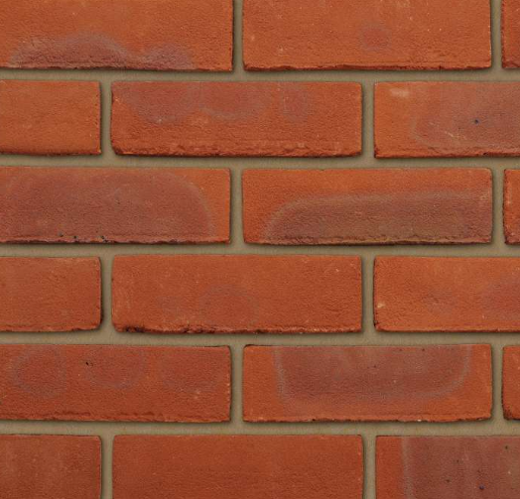

Contrasting yellow brick detailing

Wienerberger Smeed Dean
Weathered Yellow Stock Facing

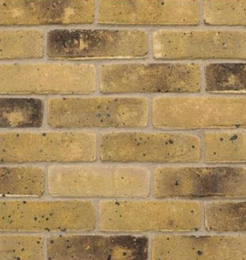

Roof Tiles

Marley Modern – Smooth Grey

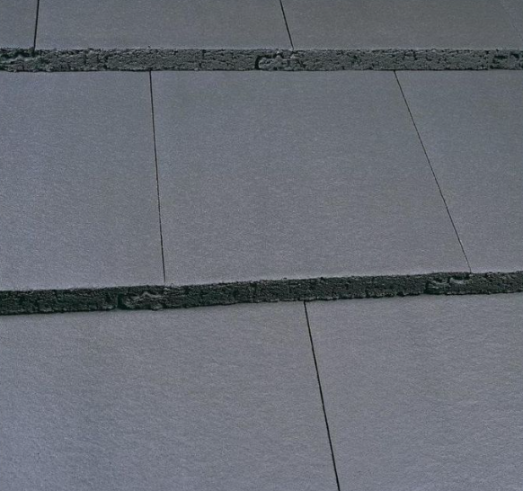

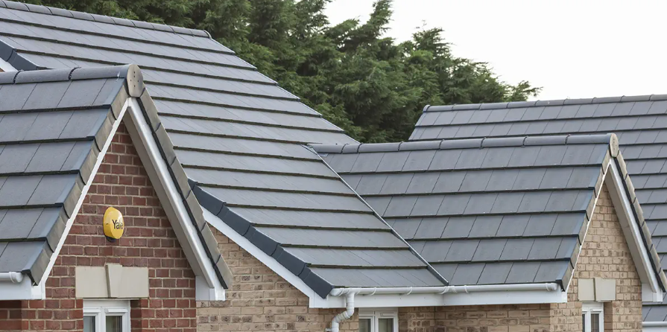

Shop Front Stall Risers

Timber with a simple panel detailing
To a height of 600mm & finished in grey

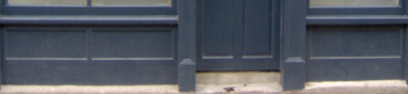

Stone detailing

Colour - Cotswold



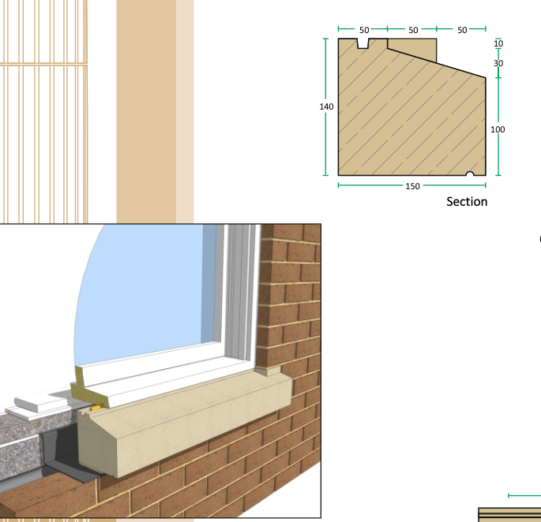

WINDOWS

White UPVC plastic
50 / 50 tilt & turn design



Facia & Guttering

Black half-round guttering and white square edge facia
both in plastic

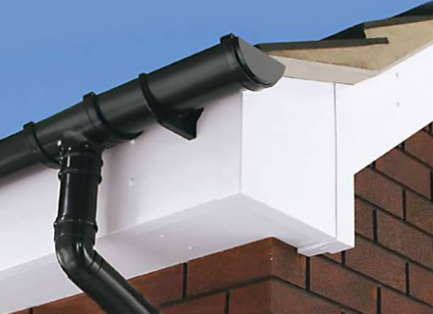

The front door to apartments

Finished in white

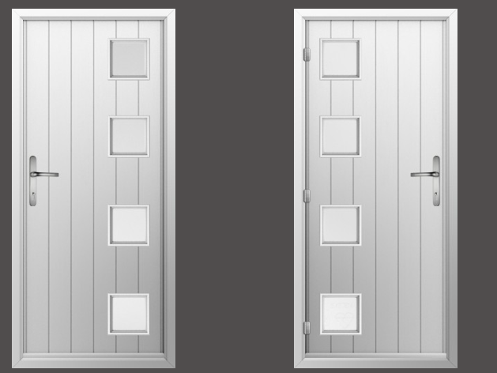

Door to bin and communal outside area

Finished in white



Door & side windows to shop unit
Double glazed windows to front and side of the shop unit

Aluminium and finished in a grey powder-coated aluminium

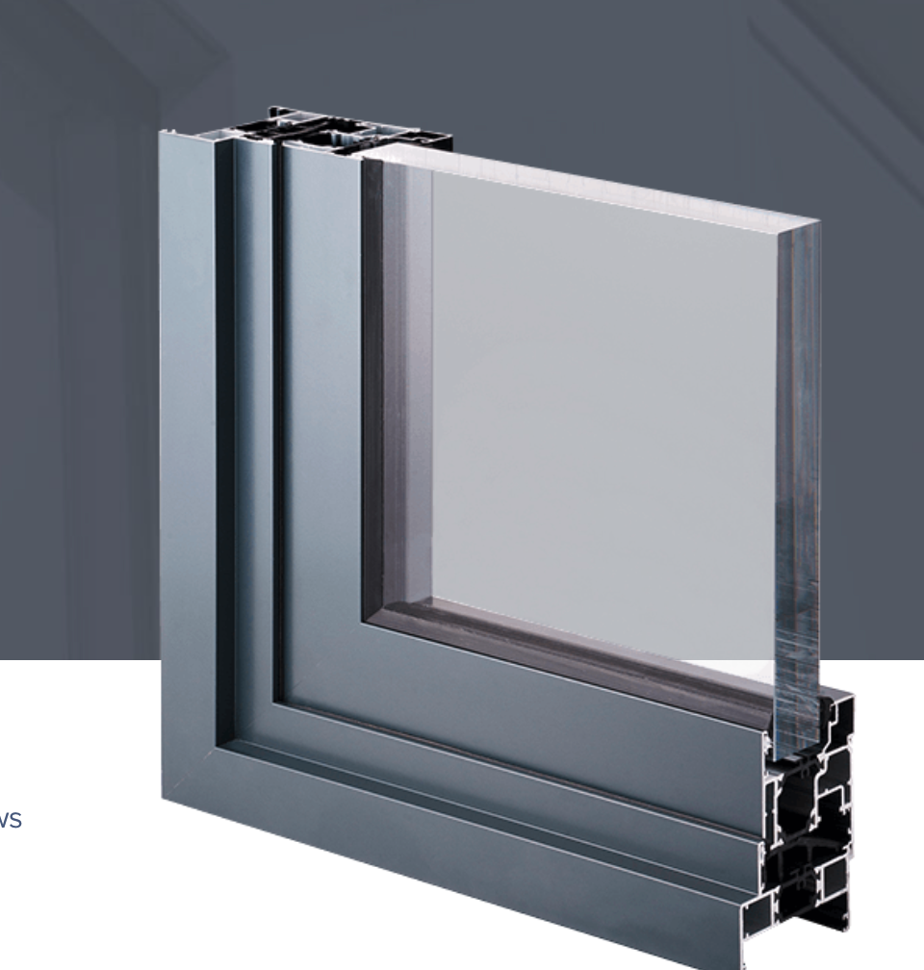

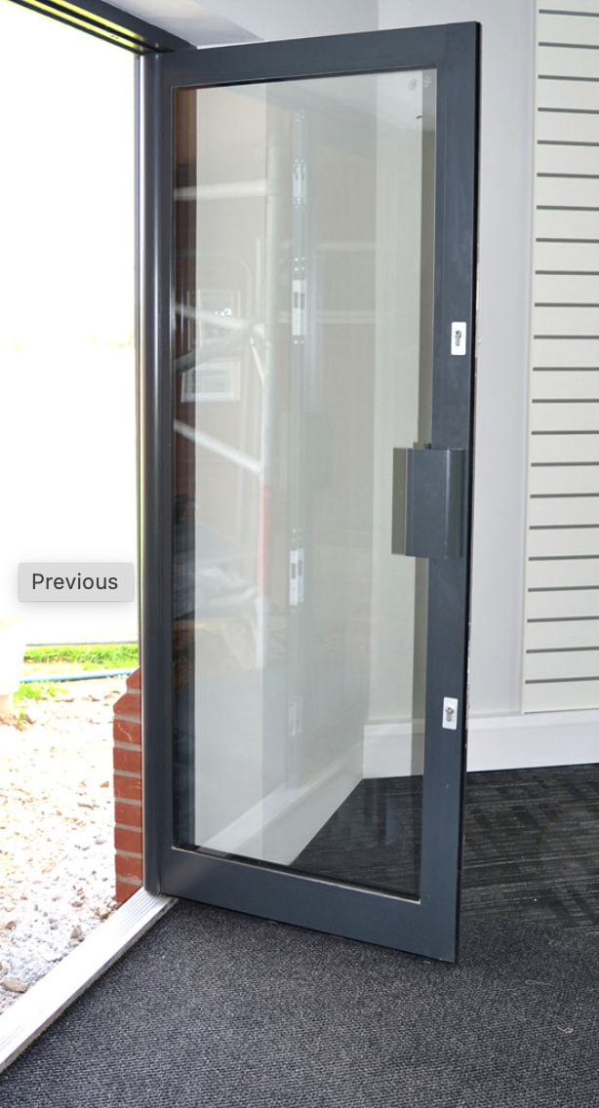

All shop unit windows and door layouts are as per the approved drawings

