

DELEGATED PLANNING APPLICATION REPORT
Ward: Battle
App Ref: 220792/FUL
Address: 387 Oxford Road, Reading
Proposals: Retention of existing store and cold room extension.
Case Officer: Chukwudi Onwudinanti
Date received (valid from): 9 August 2022
Target Decision date: 9 November 2022 (EXT)

1. SITE DESCRIPTION
The proposal site is a mixed use terrace building on the southern side of Oxford Road, west of the intersection with Albany Road which is a One-way street that only exits from Oxford Road in one direction. It is among buildings of similar mixed uses, mostly less than 50m from the Abu Bakr Muslim Centre on Oxford Road.

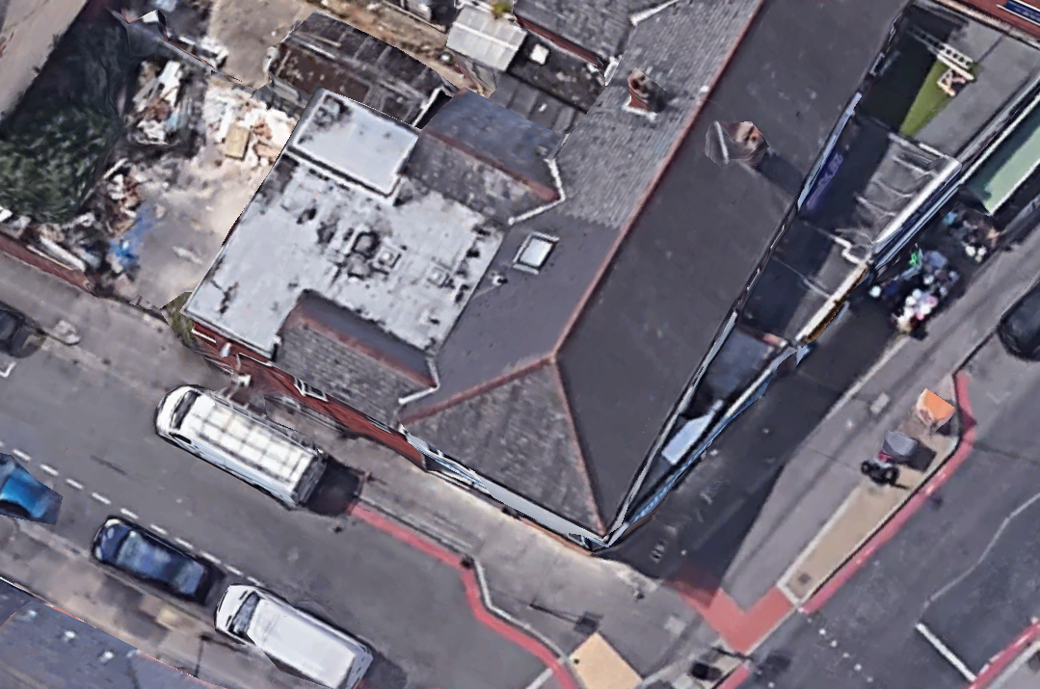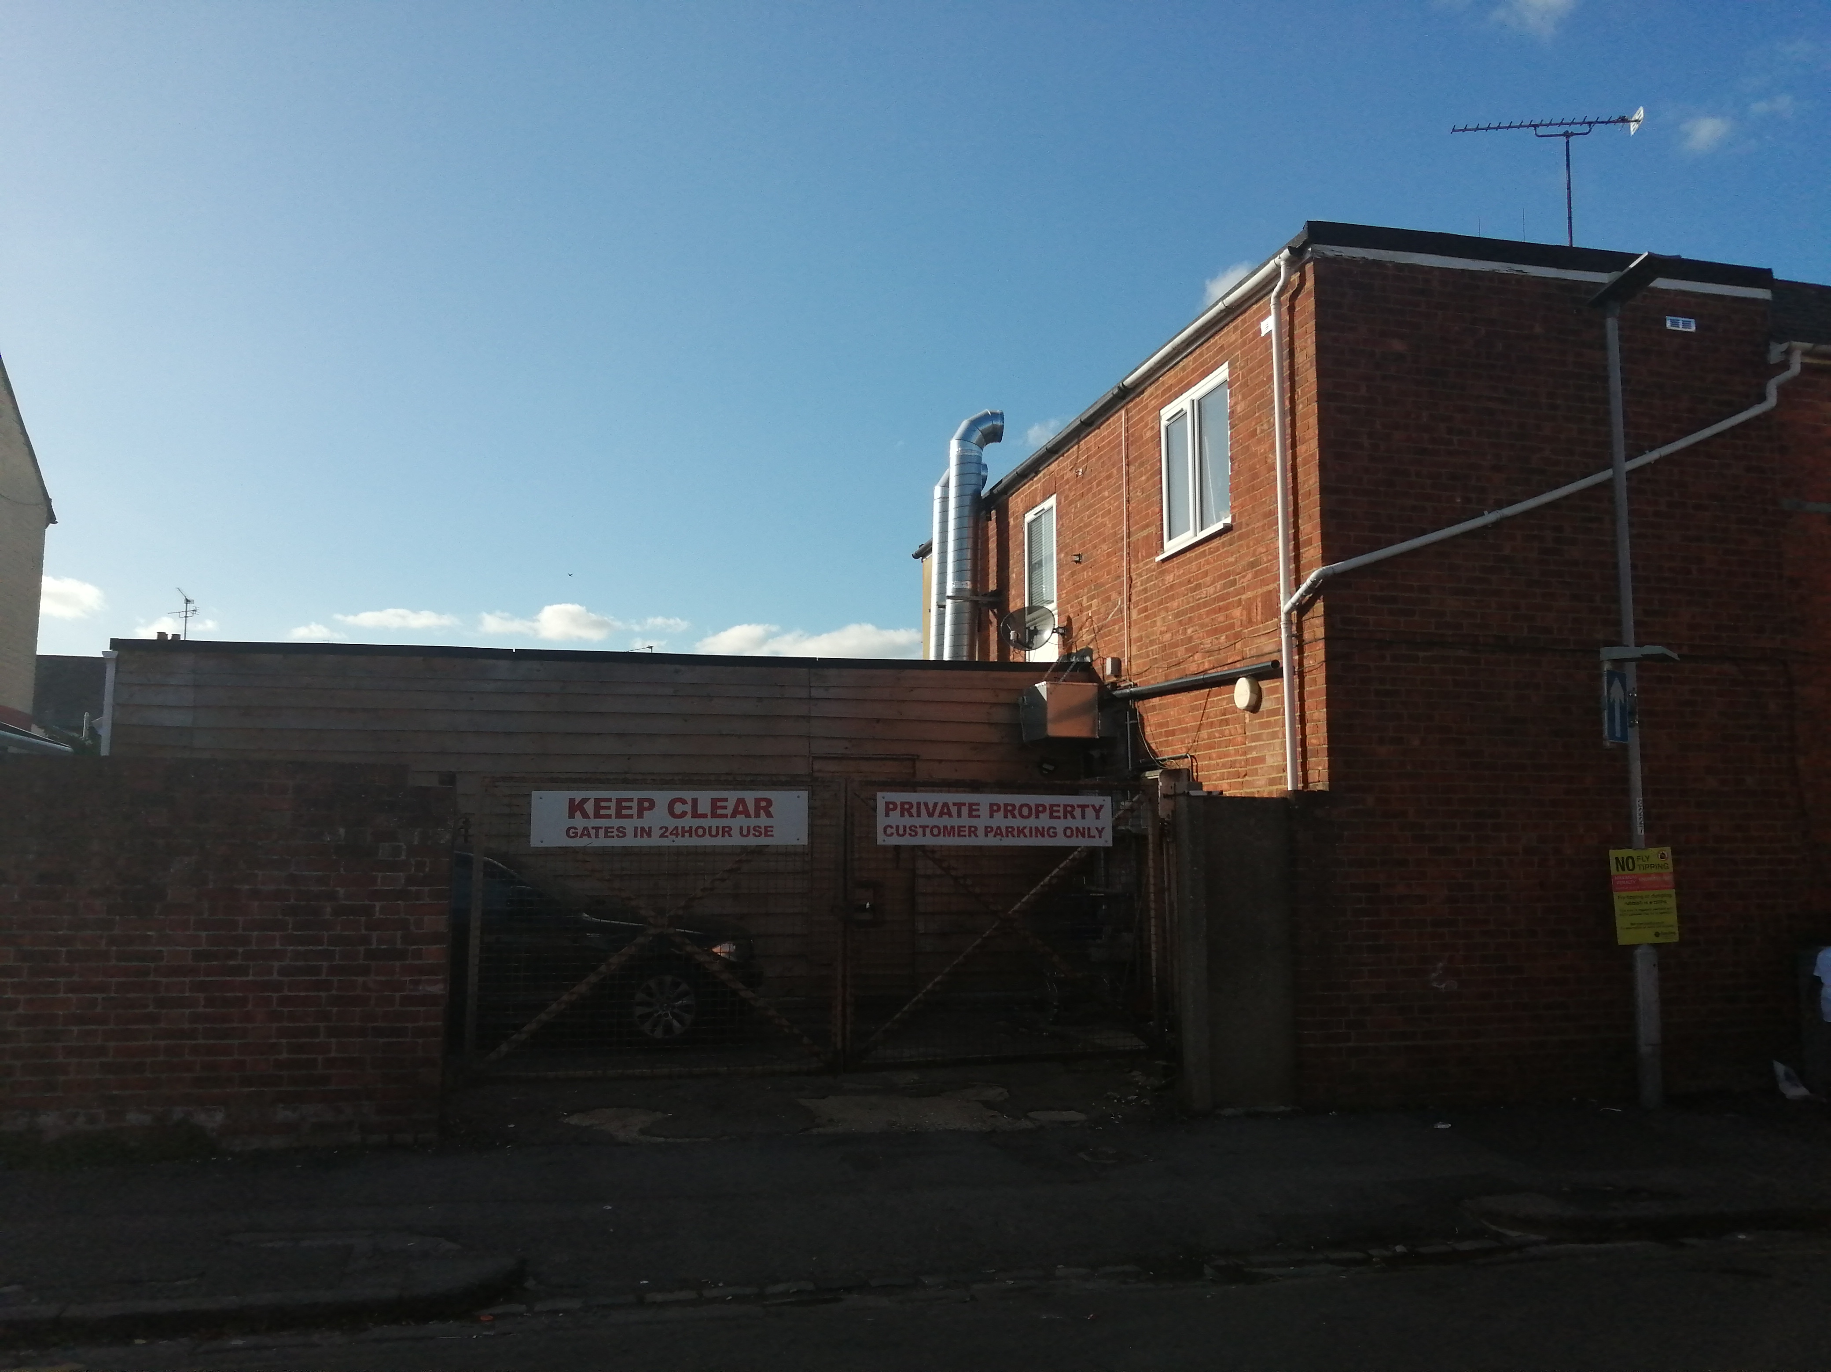

2. PROPOSAL AND SUPPORTING INFORMATION
The proposal is for retrospective approval for extension to an existing store, measuring approximately 7.7m deep and 5.5m wide, using timber cladding for the exterior walls.

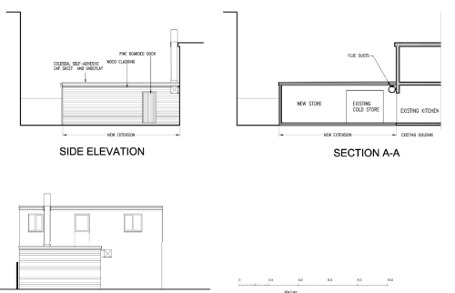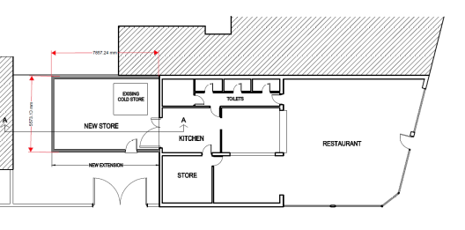

Elevations As Is Floor Plan As Is

Plans considered received 27th May 2022
Drawing No: 20071-1: Location Plan
Drawing No: 20071-2: Block Plan
Drawing No: 20071-4A: Elevations/Sections received 1st November 2022
Drawing No: 20071-3: Site Plan & Floor Plan

- RELEVANT PLANNING HISTORY

Application Ref: 190405
Description: Enforcement Expediency

Application Ref: 191413
Description: Retention of canopy, extraction flue, cold room and storage units to
Rear
Decision: Refused
Date of Decision: 20/10/2019

4. CONSULTATIONS

No letters of representation have been received.

Equality Act 2010:
In determining this application the Council is required to have regard to its obligations under the Equality Act 2010. However, there is no indication or evidence (including from consultation on the application) that the protected groups identified by the Act have or will have different needs, experiences, issues and priorities in relation to this particular planning application. Therefore in terms of the key equalities protected characteristics it is considered there would be no significant adverse impacts as a result of the development.

- LEGAL AND PLANNING POLICY CONTEXT

Section 38(6) of the Planning and Compulsory Purchase Act 2004 requires that proposals be determined in accordance with the development plan unless material considerations indicate otherwise. Material considerations include relevant policies in the National Planning Policy framework (NPPF) - among them the 'presumption in favour of sustainable development'.

National Policy and Guidance
National Planning Policy Framework
National Planning Practice Guidance

Reading Borough Local Plan (2019)
CC7: DESIGN AND THE PUBLIC REALM
CC8: SAFEGUARDING AMENITY
H9: HOUSE EXTENSIONS AND ANCILLARY ACCOMMODATION

Equality Act 2010:
In determining this application the Council is required to have regard to its obligations under the Equality Act 2010. However, there is no indication or evidence (including from consultation on the application) that the protected groups identified by the Act have or will have different needs, experiences, issues and priorities in relation to this particular planning application. Therefore, in terms of the key equalities protected characteristics it is considered there would be no significant adverse impacts as a result of the development.

APPRAISAL
The proposal has no significant material difference from the previous application refused, as highlighted above in this report. However, the concerns around cluster and appearance have been addressed by the applicant, in de-cluttering the site and confirming that the timber cladding will be stained dark to mitigate any amenity and public realm issues in terms of appearance.

It has also been considered by the LPA, that notwithstanding the peculiarity of this extension, all aspects of it is to the rear and facing a one-way street, minimising the impact of any appearance not wholly suited to the neighbouring environment.

RECOMMENDATION
Approve

Subject to the following conditions:
AP1: Approved Plans
M3: Materials as Specified

