

DELEGATED HOUSEHOLDER APPLICATION REPORT

Ward: Caversham Heights
App Ref: 221199/HOU
Address: 54 Buxton Avenue, Caversham, Reading, RG4 7BU
Proposals: Proposed two storey rear extension
Case Officer: Chukwudi Onwudinanti
Applicant: Dr. and Mr. Jill and KA Flint-Taylor and von Glehn
Date received (valid from): 12 August 2022
Target Decision date: 4 October 2022 (EXT)

1. SITE DESCRIPTION

The site is a semi-detached dwelling on the western side of Buxton Avenue, among dwellings of similar style and size, in a predominantly residential area. There is a current single storey rear extension comprising part glazed and part brick built elements. There are a number of trees and hedging to the boundaries.

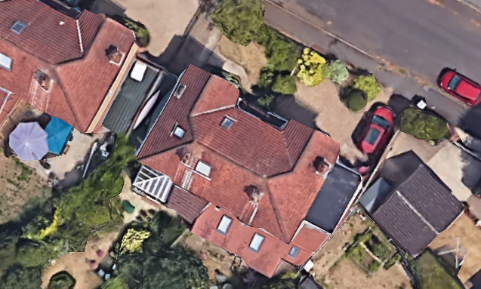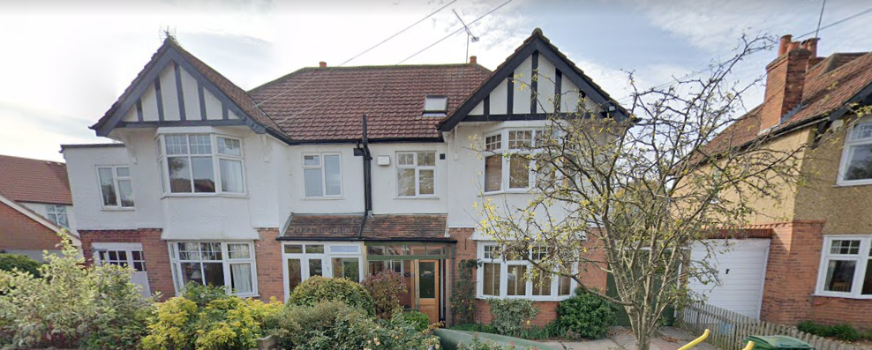

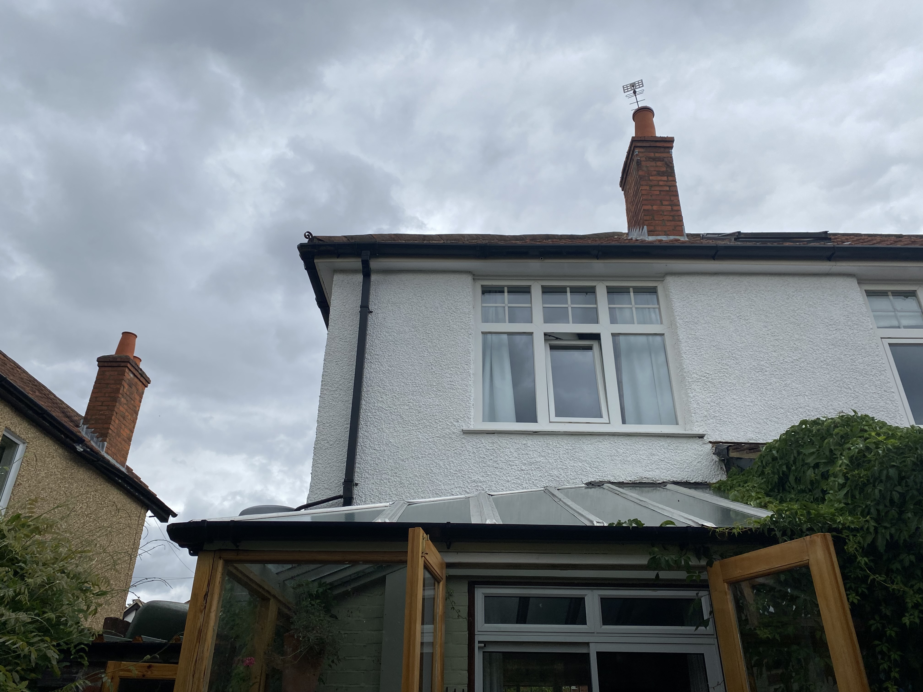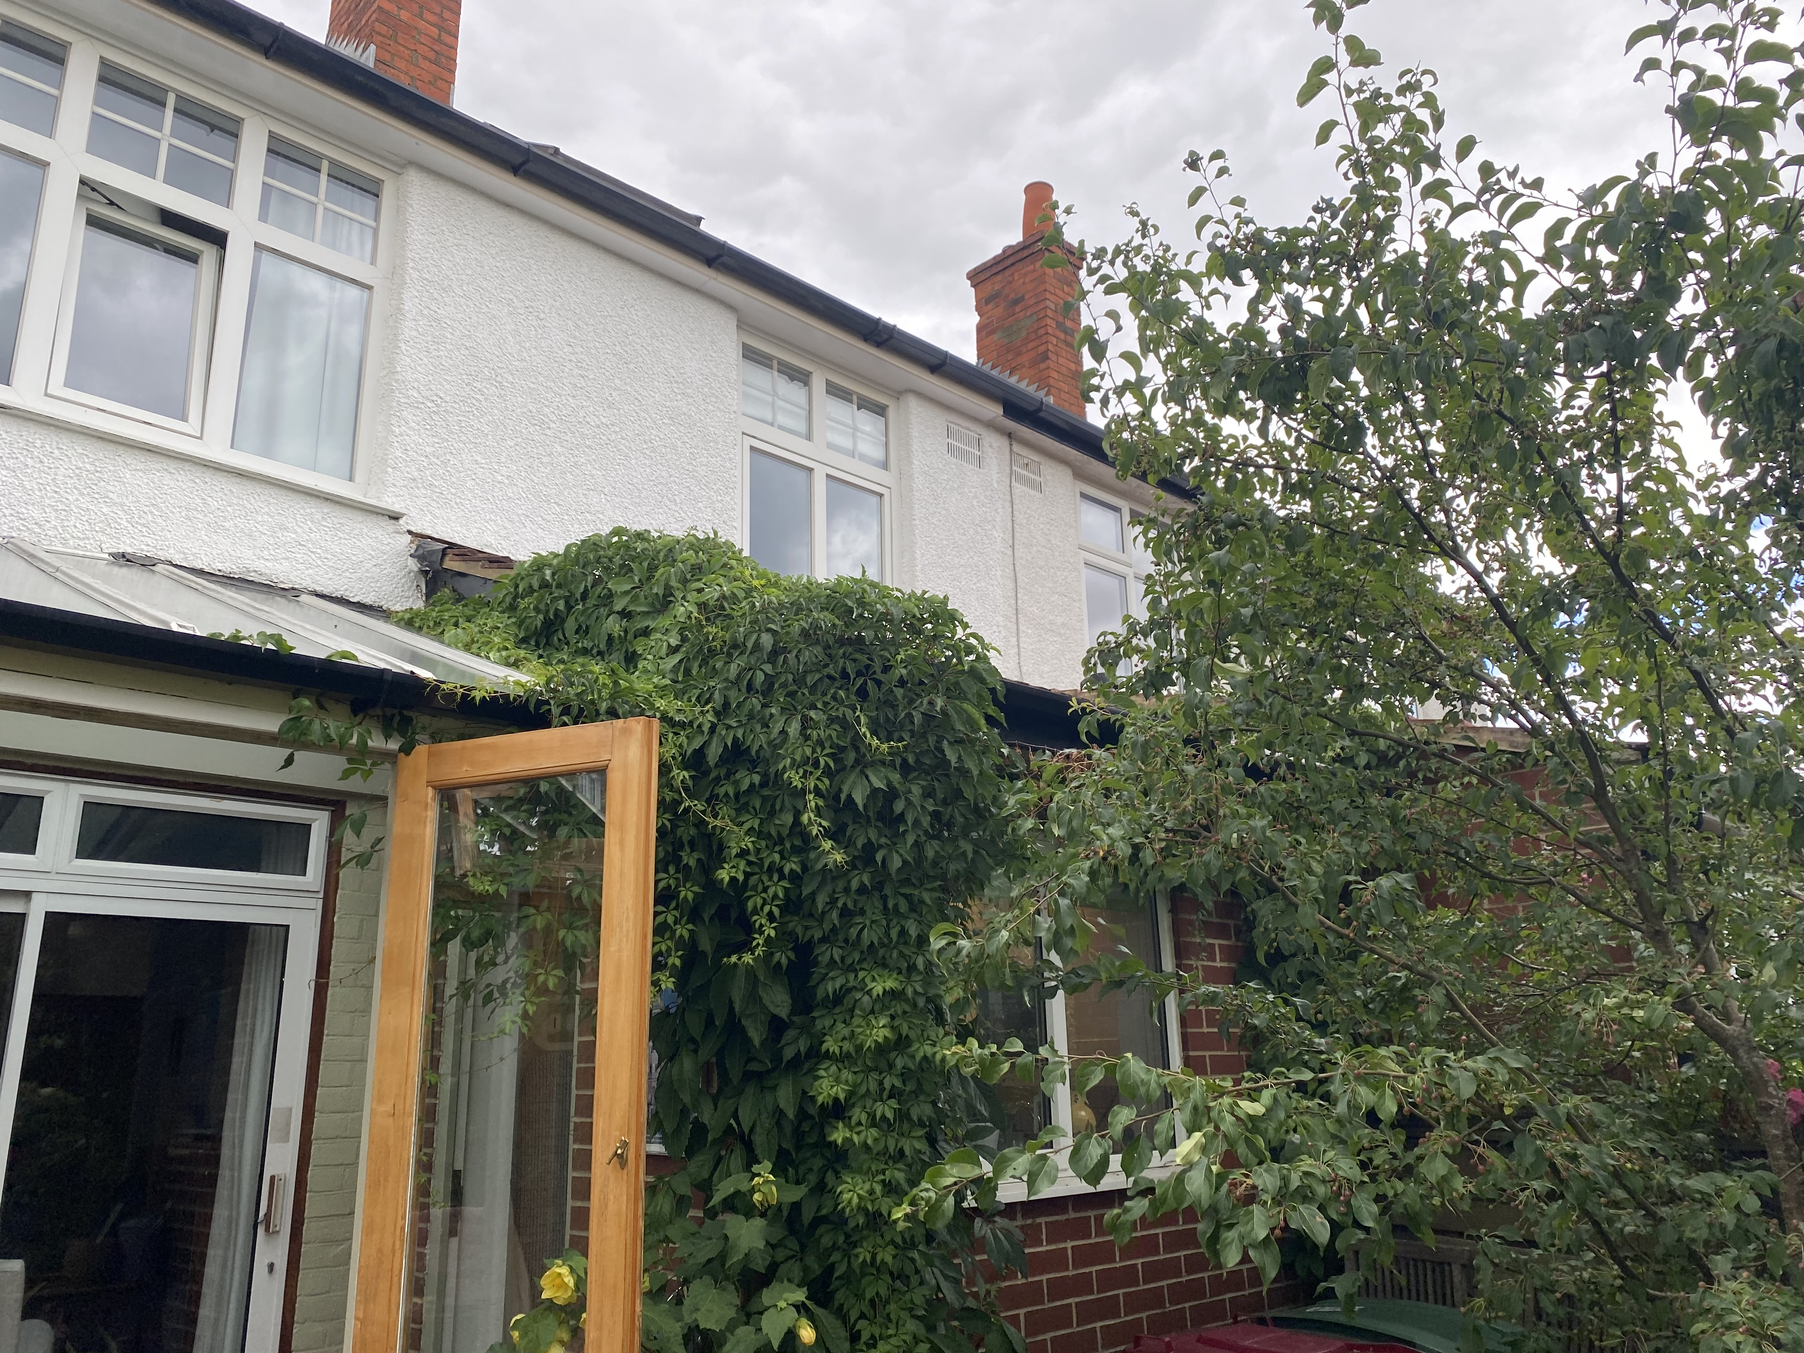

2. PROPOSAL AND SUPPORTING INFORMATION
Proposed is a two storey rear extension measuring approximately 2m deep and 3.3m wide to replace the existing garden roof, integrating the roof over the extension with the existing roof of the brick built part of the extension, at the same eaves height.

Plans considered received 15th August 2022
Drawing No: P861-01-01-Location Plan
Drawing No: P861-01-02- Existing Block Plan
Drawing No: P861-01-03- Existing Roof Plan
Drawing No: P861-01-04-Existing Floor Plans
Drawing No: P861-01-05-Existing Elevations
Drawing No: P861-01-06- Proposed Block Plan
Drawing No: P861-01-07- Proposed Roof Plan
Drawing No: P861-01-09A-Proposed Elevations (Vaulted Roof)
Drawing No: P861-01-10-Proposed Elevations (Parapet Roof)
Drawing No: P861-01-08B-Proposed Floor Plans, received 2nd November 2022
Drawing No: P861-01-08A-Proposed Floor Plans with 45 Degree Assessment received 1st November 2022
Drawing No: P861-01-09A-Proposed Elevations (Vaulted Roof), received 2nd November 2022

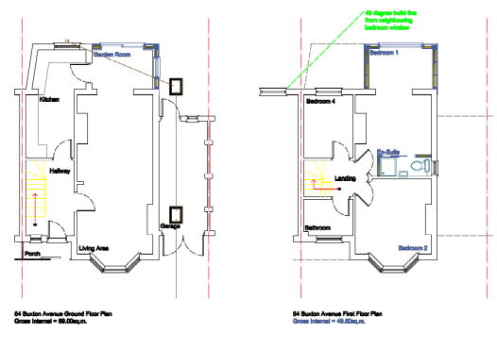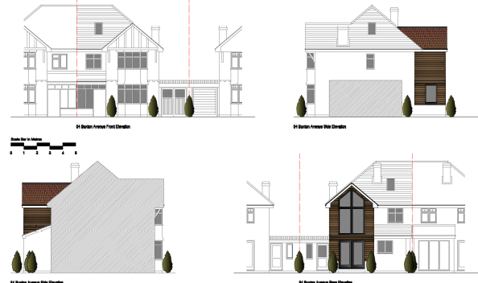

Proposed Floor Plans Proposed Elevations

- RELEVANT PLANNING HISTORY

None

4. CONSULTATIONS

The following addresses were consulted by letter.

42a Highmoor Road, Caversham, Reading
56 Buxton Avenue, Caversham, Reading, RG4 7BU
52 Buxton Avenue, Caversham, Reading, RG4 7BU
42 Highmoor Road, Caversham, Reading, RG4 7BH

No letters of representation have been received.

Equality Act 2010:
In determining this application the Council is required to have regard to its obligations under the Equality Act 2010. However, there is no indication or evidence (including from consultation on the application) that the protected groups identified by the Act have or will have different needs, experiences, issues and priorities in relation to this particular planning application. Therefore in terms of the key equalities protected characteristics it is considered there would be no significant adverse impacts as a result of the development.

- LEGAL AND PLANNING POLICY CONTEXT
Section 38(6) of the Planning and Compulsory Purchase Act 2004 requires that proposals be determined in accordance with the development plan unless material considerations indicate otherwise. Material considerations include relevant policies in the National Planning Policy framework (NPPF) - among them the 'presumption in favour of sustainable development'.

National Policy
National Planning Policy Framework
National Planning Practice Guidance

Reading Borough Local Plan (2019)
CC7 (Design and the Public Realm)
CC8 (Safeguarding Amenity)
H9 (House Extensions and Ancillary Accommodation)

SPD
Design Guide to House Extensions (2021)

6. APPRAISAL
Character and Appearance

Policy H9 states that an extension to a house will be acceptable where it respects the character of the house in terms of scale, location, materials and design and respects the character and pattern of neighbouring properties and the street as a whole in terms of scale, location, materials and design, and any important existing building line. Policy CC7 also sets out relevant considerations for design.

The proposal is to the rear of the existing dwelling and is of a proportionate scale, extending less than 4m to the rear and spanning just half the width of the existing building. The materials are to match existing and the design is sympathetic to the existing character of the building, including symmetrical roof and even eave lines.

It is therefore considered that the proposal will not detract from the character of the existing dwelling and the neighbouring properties for the reasons stated above.

Residential Amenity

Policy H9 states that an extension will be acceptable where it does not result in an overbearing impact on neighbours. Policy H10 seeks to ensure that the amenity of gardens and other outdoor areas are not compromised. Policy CC8 states an extension to a house will be acceptable where it will not cause a significant detrimental impact to the living environment of existing or new residential properties.

- Privacy and overlooking: The original design had side-facing windows which would have presented privacy and overlooking issues. However, these windows have been removed in the revised drawings on the advice of the LPA.
- Overbearing effects: While the extension is on two storey levels, the depth and scale of the extension are proportionate and sympathetic, such that any overbearing effects are mitigated.
- Sunlight and daylight: The 45 degree assessment has been done and presented, showing that the sunlight and daylight available to adjoining properties are not impeded.
- Amenity Space: There would be no impact on the available amenity space

- CONCLUSION
The proposed development has been assessed as set out above and is considered to be acceptable on that basis, subject to the following conditions.

- RECOMMENDATION : Grant
Recommended Conditions:
TL1: Time Limit
AP1: Approved Plans
M1: Materials to Match Existing
PD2: No New Openings

