DELEGATED HOUSEHOLDER APPLICATION REPORT

Ward: Peppard
App Ref: 220077/HOU
Address: 342 Peppard Road, Emmer Green, Reading, RG4 8UY
Proposals: Proposed side, front and roof extensions with new and enlarged dormer windows to front and back. Conversion of existing garages to create new habitable areas and new external material finishes to external elevations.
Case Officer: Chukwudi Onwudinanti
Applicant: Mrs White
Date received (valid from): 20 January 2022
Target Decision date: 30 April 2022

- INTRODUCTION
The site is a chalet bungalow on the eastern side of Peppard road. The dwelling is a counterpoint on the street as it is the only bungalow among rows of two storey similarly styled and sized buildings, in an exclusively residential area.
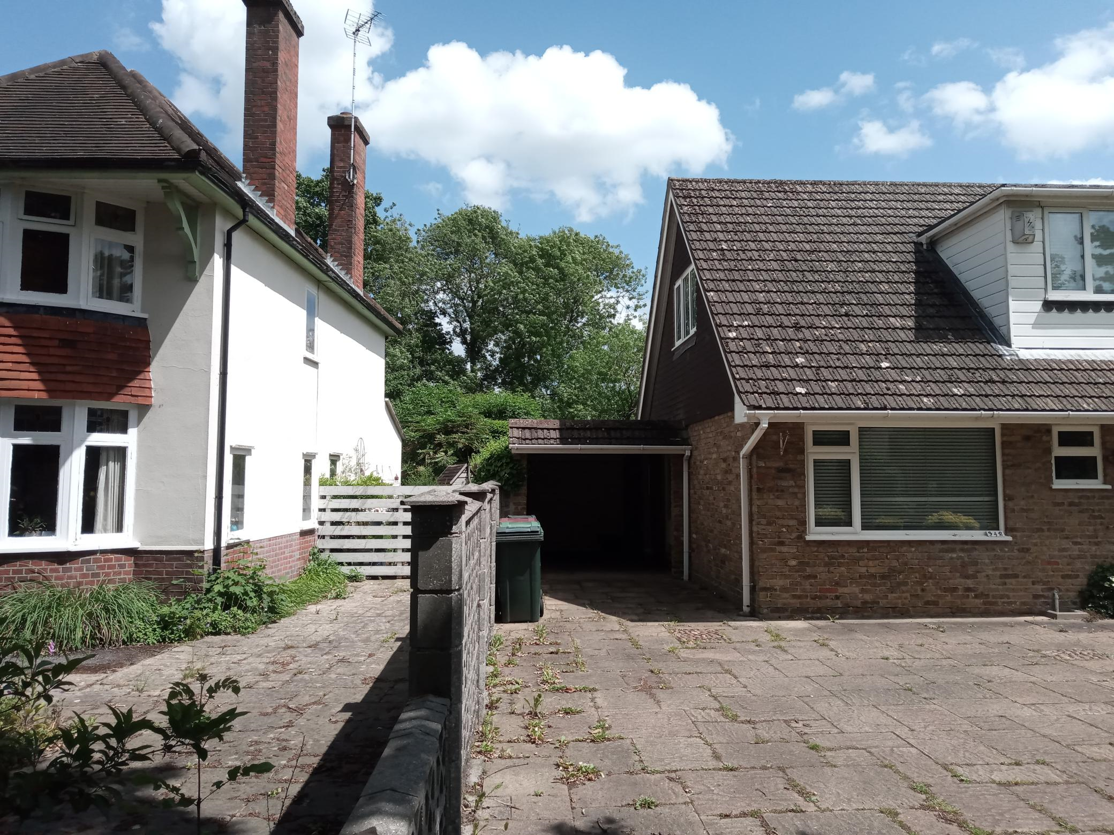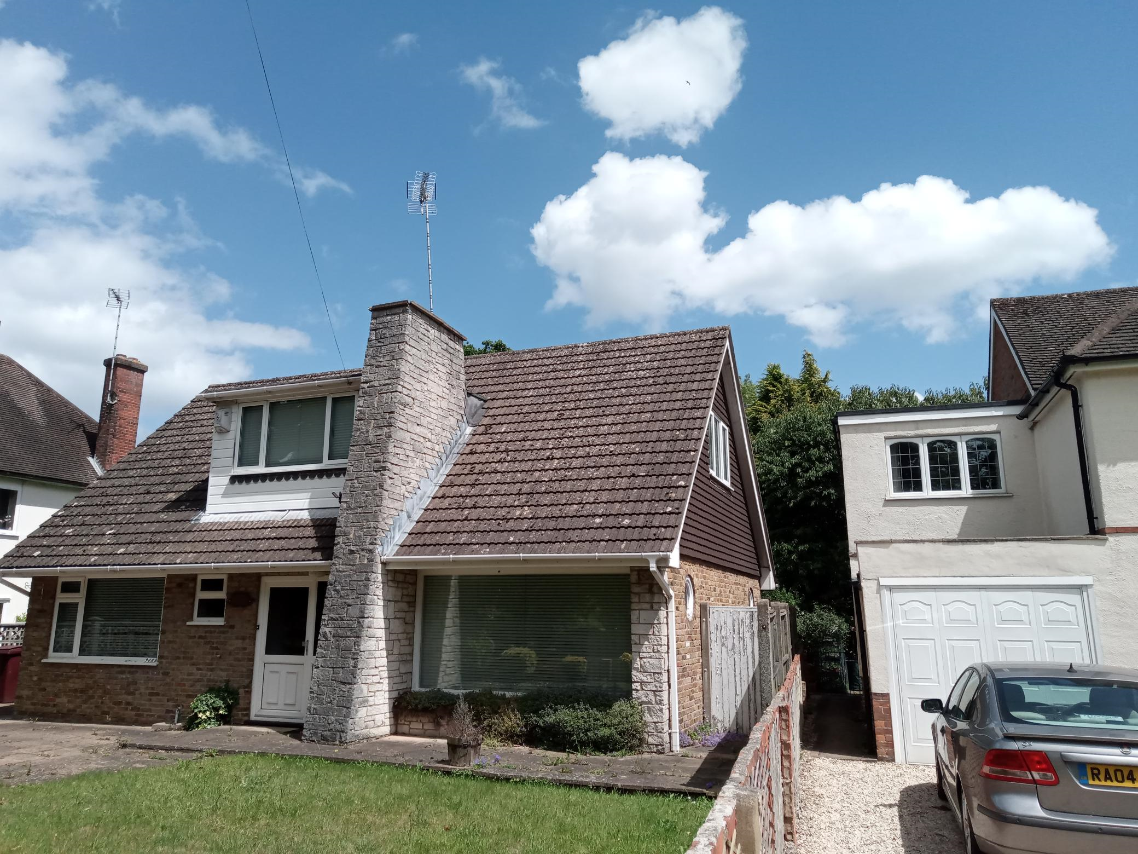

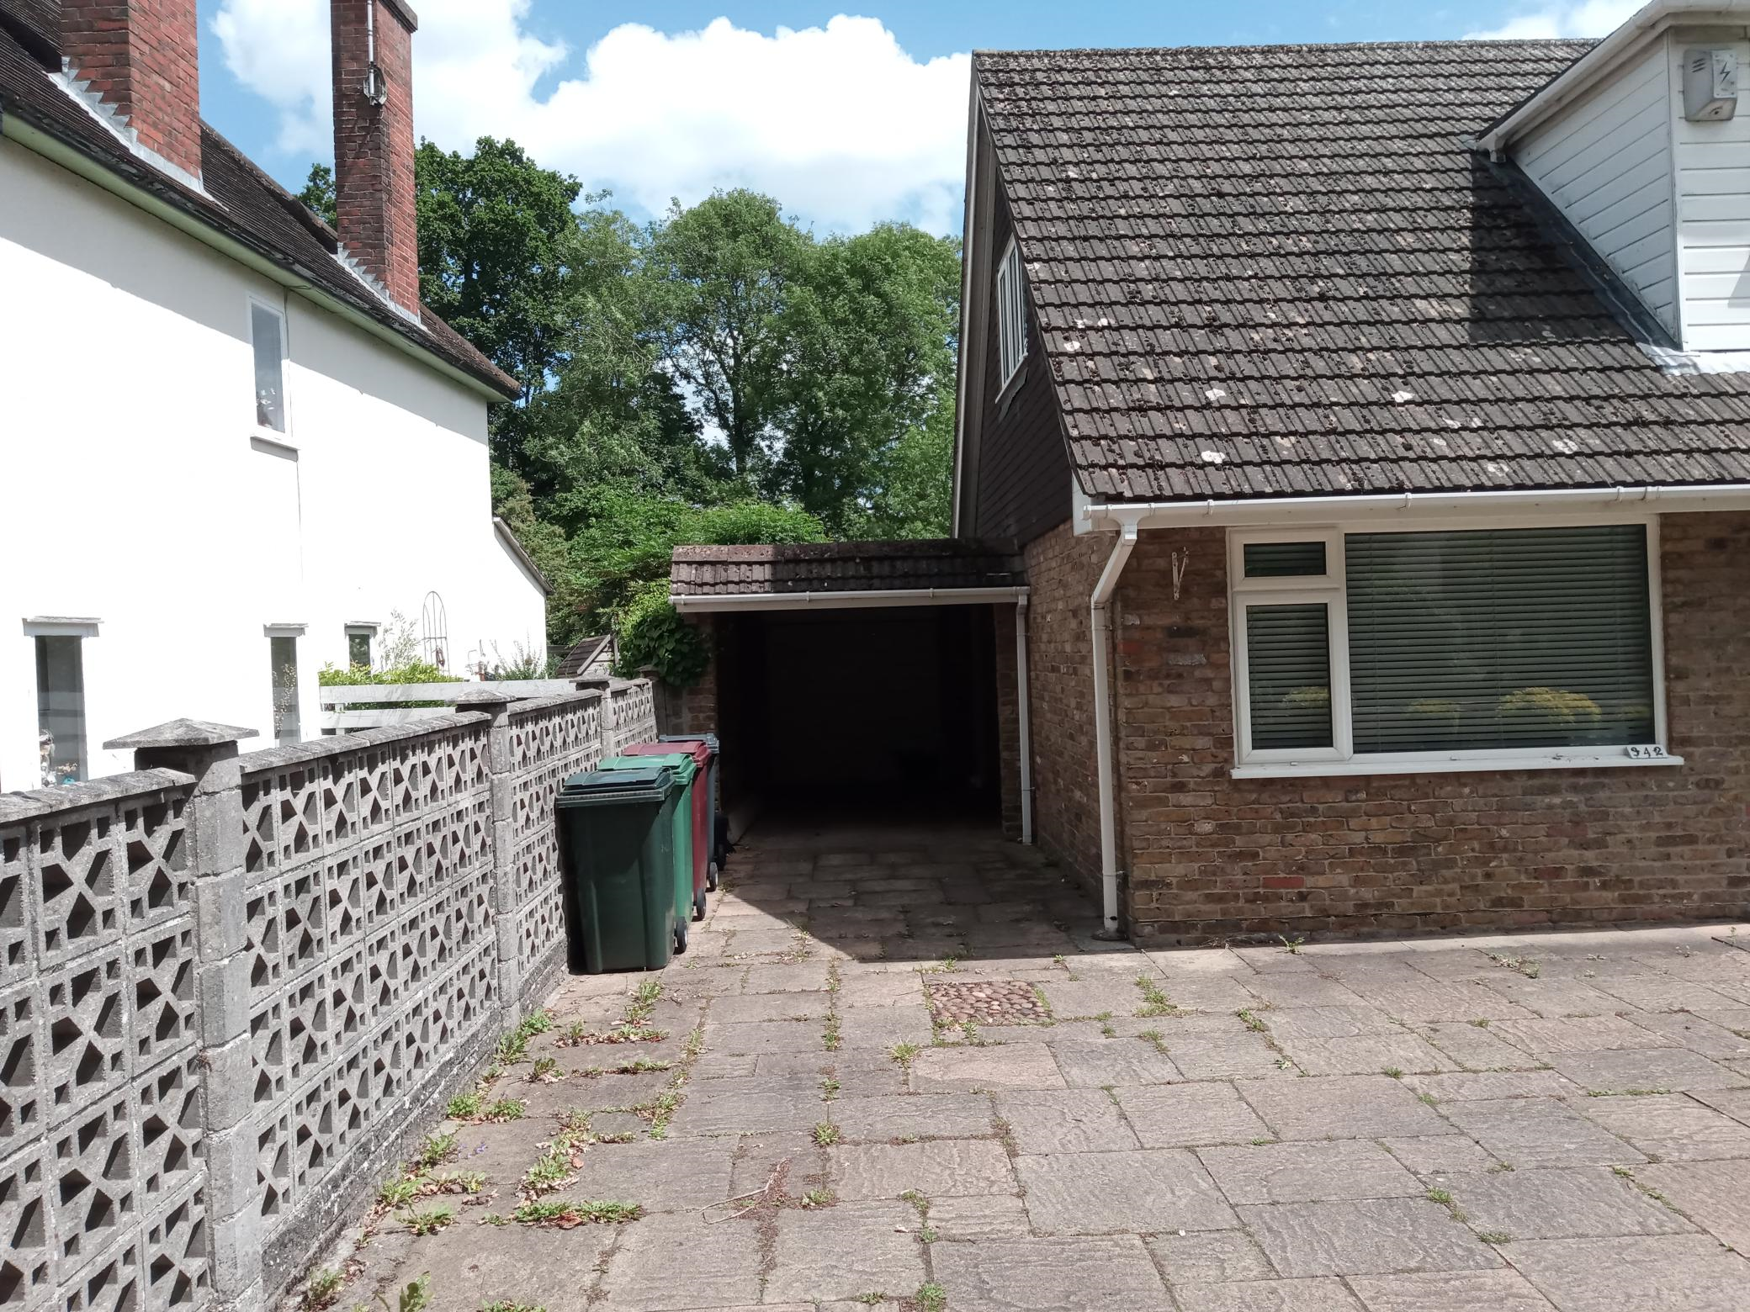
Site Photos taken 10/06/2022

2. PROPOSAL AND SUPPORTING INFORMATION

Proposed side, front and roof extensions with new and enlarged dormer windows to front and back. Conversion of existing garages to create new habitable areas and new external material finishes to external elevations.

Plans and Drawings considered (Received 20th January 2022)
21-342PR-P-01.1 Existing GA Floor Plans
21-342PR-P-01.2 Proposed GA Floor Plans
21-342PR-P-01.3 Existing & Proposed Roof Plans
21-342PR-P-02.1 Existing External Elevations
21-342PR-P-02.2 Proposed External Elevations
21-342PR-P-02.3 Existing External Elevations
21-342PR-P-02.4 Proposed External Elevations
21-342PR-P-03.1 Principle Elevation Aerial Massing Illustration
21-342PR-P-03.2 Rear Elevation Aerial Massing Illustration
21-342PR-P-03.3 Principle Perspective Visualisation
21-342PR-P-03.4 Precedent images

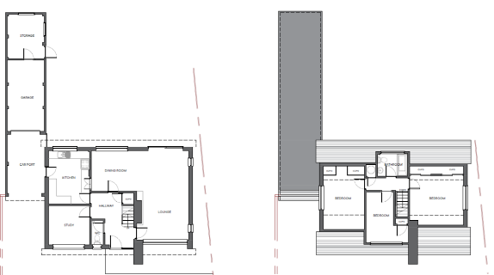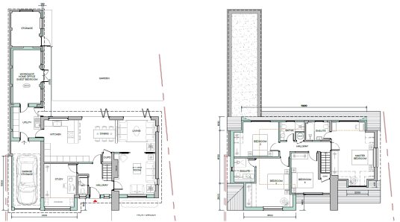
Existing Floor Plans Proposed Floor Plans

- RELEVANT PLANNING HISTORY

None

4. CONSULTATIONS

4.1 The following addresses were consulted by letter.

340a Peppard Road, Emmer Green, Reading, RG4 8UY
340 Peppard Road, Emmer Green, Reading, RG4 8UY
8 Jefferson Close, Emmer Green, Reading, RG4 8US

Internal Consultees
Natural Environment – Trees: Advised Conditions I15 and I24
Natural Environment – Ecology: Bat survey requested, submitted and confirmed satisfactory.
Transport Development: No objections

4.2 No letters of representation have been received from neighbours consulted.

Equality Act 2010:
In determining this application the Council is required to have regard to its obligations under the Equality Act 2010. However, there is no indication or evidence (including from consultation on the application) that the protected groups identified by the Act have or will have different needs, experiences, issues and priorities in relation to this particular planning application. Therefore in terms of the key equalities protected characteristics it is considered there would be no significant adverse impacts as a result of the development.

- LEGAL AND PLANNING POLICY CONTEXT

Section 38(6) of the Planning and Compulsory Purchase Act 2004 requires that proposals be determined in accordance with the development plan unless material considerations indicate otherwise. Material considerations include relevant policies in the National Planning Policy framework (NPPF) - among them the 'presumption in favour of sustainable development'. The following local and national planning policy and guidance is relevant to this application:

National Policy
National Planning Policy Framework
National Planning Practice Guidance

Reading Borough Local Plan (2019)
CC7 (Design and the Public Realm)
CC8 (Safeguarding Amenity)
H9 (House Extensions and Ancillary Accommodation)

SPD
- Design Guide to House Extensions (2021)

6. APPRAISAL

H9 states: An extension to a house will be acceptable where it:

- Respects the character of the house in terms of scale, location, materials and design;

To assess this, the following has been considered – would the proposal:
- detract from the appearance of the original building through the use of ill-matching materials and by not fitting in with the design, scale and proportions of the original building; NO, while the alterations and materials to be used in this proposal are extensive and will greatly alter the appearance of the existing dwelling, it is considered that that the proposed changes would not have a detrimental effect on the overall appearance of the building.
- reduce the amount of usable amenity space for the property to an unacceptable degree; NO, the footprint of the existing building is not proposed to increase significantly.
- require the loss of trees in the garden or put significant trees at risk; NO

- Respects the character and pattern of neighbouring properties and the street as a whole in terms of scale, location, materials and design, and any important existing building line; Respects neighbour’s amenities and does not present a large blank façade to public areas.

To assess this, the following has been considered – would the proposal:
- significantly reduce the amount of daylight and sunlight enjoyed by neighbouring properties; NO, all aspects of the development that would be within the boundaries of adjoining buildings will be at one storey level and will have no impact on the buildings adjacent to the site on both sides.
- invade the privacy of neighbouring properties through overlooking from windows or balconies; NO, there are no additional buildings on the sides of the proposed development that will be at more than one storey level.
- detract from the character of neighbouring properties through siting, excessive bulk, ill-matching materials or inconsistent design; NO, the original dwelling is already a counterpoint on the street scene and this proposal will only enhance that existing character.
- detract from the appearance of the street or area by using ill-matched materials, glazing and detailing; NO

CC8: Safeguarding Amenity states an extension to a house will be acceptable where it will not cause a significant detrimental impact to the living environment of existing or new residential properties.

To assess this, the following has been considered – would the proposal cause a significant detrimental impact to the living environment of existing or new residential properties in terms of:

- Privacy and overlooking;
- Access to sunlight and daylight;
- Visual dominance and overbearing effects of a development;
- Noise and disturbance;
- Artificial lighting;
- Vibration;
- Dust and fumes;
- Smell;
- Crime and safety.

- CONCLUSION
The proposed development has been assessed and the proposed works are considered to be in accordance with the above relevant policies and planning permission can be granted.

8. RECOMMENDATION
Grant

