DELEGATED HOUSEHOLDER APPLICATION REPORT

Ward: Redlands
App Ref: 212071/FUL
Address: 14 Denmark Road, Reading
Proposals: Replacement windows, ground floor front bay window
Case Officer: Chukwudi Onwudinanti
Applicant: Cheniston Investments Ltd
Date received (valid from): 22 December 2021
Target Decision date: 28 April 2022

1. INTRODUCTION
The site is a multi-storey dwelling, housing residential flats, on the western side of Denmark Road, among buildings of similar styles and sizes, in a predominantly residential area. It is in the Alexandra Conservation Area (Appraisal March 2005) which also encompasses parts of Erleigh Road and Alexandra Road. The property is not listed.

2. PROPOSAL AND SUPPORTING INFORMATION

“The proposal is to replace the ground floor windows with new fixed and openable windows, in the same pattern as the existing, with thermally efficient modern metal frames and double glazing. Smart Systems Alitherm Heritage 47 frames are proposed as having minimal frame size and face width. The existing frames and glass will be removed complete, with minimal interference with the stone mullions, and new frames inserted within the existing stone structural opening. The frames will be located in the same general plane as the existing, to maintain the stone mullion appearance”.

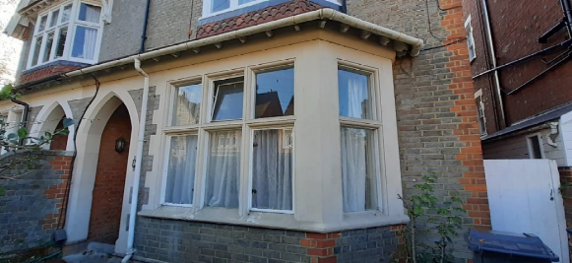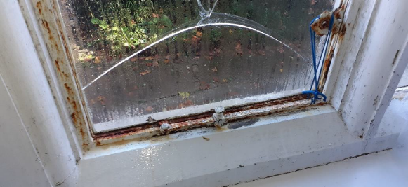

Plans considered
21-2072/100 A : Plans as Existing
21-2072/000 A : Site Location Plans
21-2072/099 A : Site Plans
21-2072/101 A : Plans as Proposed
Alitherm Heritage Window : Detail 1A

- RELEVANT PLANNING HISTORY

210867/PREAPP – Replacement of window (front) ground floor level only at 14 Denmark Road, Reading, RG1
Planning Officer : David Brett
Observation : “The principle of changing the glazing in order to improve the thermal dynamics of the flat is considered acceptable and an inherent benefit of the development”
“there are no objections and are essentially like for like replacement of Metal framed widows for Metal framed windows. Only exception is they are installing double frame glazing which is more sustainable. Visually, the difference will be minimal”.
“it is considered unlikely that the replacement windows would harm the character and appearance of the existing building or surrounding area based on the like-for-like materials selected”.

The above observation was given by the PO in consultation with the Conservation and Urban Design Officer,
4. CONSULTATIONS

4.1 The following addresses were consulted by letter.

12 Denmark Road, Reading, Berkshire, RG1 5PA
18 Denmark Road, Reading, RG1 5PA
Flat 2, 14 Denmark Road, Reading, RG1 5PA
16 Denmark Road, Reading, RG1 5PA
10 Denmark Road, Reading, RG1 5PA
Flat 3, 14 Denmark Road, Reading, RG1 5PA

4.2 No letters of representation have been received.
The planning officer has relied on the observation previously given by the PLA in Application No 210867/PREAPP, in satisfying the requirements for consultation with the Conservation Officer.

Equality Act 2010:
In determining this application the Council is required to have regard to its obligations under the Equality Act 2010. However, there is no indication or evidence (including from consultation on the application) that the protected groups identified by the Act have or will have different needs, experiences, issues and priorities in relation to this particular planning application. Therefore in terms of the key equalities protected characteristics it is considered there would be no significant adverse impacts as a result of the development.

- LEGAL AND PLANNING POLICY CONTEXT

Section 38(6) of the Planning and Compulsory Purchase Act 2004 requires that proposals be determined in accordance with the development plan unless material considerations indicate otherwise. Material considerations include relevant policies in the National Planning Policy framework (NPPF) - among them the 'presumption in favour of sustainable development'. The following local and national planning policy and guidance is relevant to this application:

National Policy
National Planning Policy Framework
National Planning Practice Guidance

Reading Borough Local Plan (2019)
CC7 (Design and the Public Realm)
CC8 (Safeguarding Amenity)
H9 (House Extensions and Ancillary Accommodation)
EN1 (Protection and Enhancement of the Historic Environment)
EN3 (Enhancement of Conservation Areas)

SPG/SPD
- A Design Guide to House Extensions SPG

6. APPRAISAL

H9 states: An extension to a house will be acceptable where it:

- Respects the character of the house in terms of scale, location, materials and design;

To assess this, the following has been considered – would the proposal:
- detract from the appearance of the original building through the use of ill-matching materials and by not fitting in with the design, scale and proportions of the original building; There is a change of materials for the replacement windows from steel to coated aluminium, however this will not impact on the appearance of the building but will give the building better thermal efficiency.
- reduce the amount of usable amenity space for the property to an unacceptable degree; NO
- require the loss of trees in the garden or put significant trees at risk; NO

- Respects the character and pattern of neighbouring properties and the street as a whole in terms of scale, location, materials and design, and any important existing building line; Respects neighbour’s amenities and does not present a large blank façade to public areas.

To assess this, the following has been considered – would the proposal:
- significantly reduce the amount of daylight and sunlight enjoyed by neighbouring properties; NO
- invade the privacy of neighbouring properties through overlooking from windows or balconies; NO
- detract from the character of neighbouring properties through siting, excessive bulk, ill-matching materials or inconsistent design; NO
- detract from the appearance of the street or area by using ill-matched materials, glazing and detailing; NO

CC8: Safeguarding Amenity states an extension to a house will be acceptable where it will not cause a significant detrimental impact to the living environment of existing or new residential properties.

To assess this, the following has been considered – would the proposal cause a significant detrimental impact to the living environment of existing or new residential properties in terms of:

- Privacy and overlooking;
- Access to sunlight and daylight;
- Visual dominance and overbearing effects of a development;
- Noise and disturbance;
- Artificial lighting;
- Vibration;
- Dust and fumes;
- Smell;
- Crime and safety.

- CONCLUSION
The proposed development has been assessed and the proposed works are considered to be in accordance with the above relevant policies and planning permission can be granted.

8. RECOMMENDATION
Grant

