DELEGATED HOUSEHOLDER APPLICATION REPORT

Ward: Kentwood
App Ref: 220206/HOU
Address: 7 Edenhall Close, Reading, RG31 6RR
Proposals: Conversion of the garage into a habitable room and first floor side extension over the existing footprint of the garage to provide two extra bedrooms and an ensuite.
Case Officer: Chukwudi Onwudinanti
Applicant: Mr Richard Bown
Date received (valid from): 15 February 2022
Target Decision date: 12 April 2022

1. INTRODUCTION
The site is a detached dwelling unit on the Northern side of Edenhall close, among buildings of varied sizes and styles. The surrounding area is predominantly residential and on the western side of the building is Elsie Road.

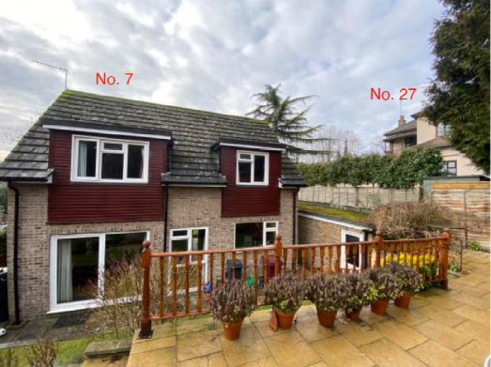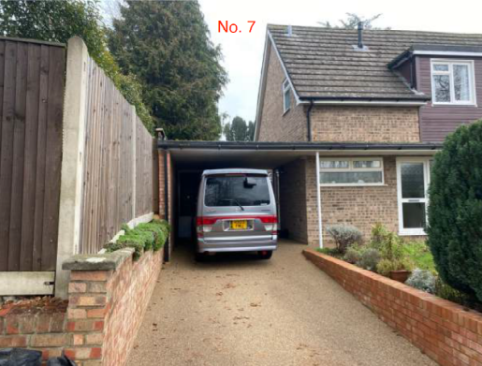

2. PROPOSAL AND SUPPORTING INFORMATION

Conversion of the garage into a habitable room and first floor side extension over the existing footprint of the garage to provide two extra bedrooms and an ensuite. The first floor extension will have an external staircase leading up to it at the rear of the property, from the raised part of the rear garden.

Plans considered (Received 16th February 2022)
001_A : Location + Block Plan Existing
050_A : Location + Block Plan Proposed
005_A : Existing Site Plan
052_A : Proposed Site Plan
004_A : Existing GA Plans
051_A : Proposed GA Plans
008_A : Existing 3D Views
055_A : Proposed 3D Views
007_A : Existing Elevations
054_A : Proposed Elevations
006_A : Existing Elevations
053_A : Proposed Elevations

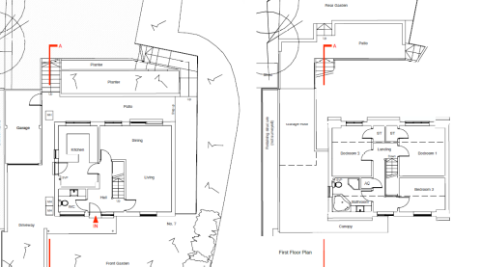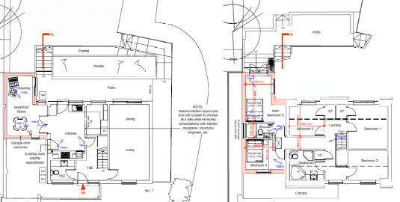

- RELEVANT PLANNING HISTORY

None

4. CONSULTATIONS

4.1 The following addresses were consulted by letter.

27 Elsley Road, Tilehurst, Reading, RG31 6RP
23 Elsley Road, Tilehurst, Reading, RG31 6RP
14 Edenhall Close, Tilehurst, Reading, RG31 6RR
25 Elsley Road, Tilehurst, Reading, RG31 6RP

4.2 No letters of representation have been received.

Equality Act 2010:
In determining this application the Council is required to have regard to its obligations under the Equality Act 2010. However, there is no indication or evidence (including from consultation on the application) that the protected groups identified by the Act have or will have different needs, experiences, issues and priorities in relation to this particular planning application. Therefore in terms of the key equalities protected characteristics it is considered there would be no significant adverse impacts as a result of the development.

- LEGAL AND PLANNING POLICY CONTEXT

Section 38(6) of the Planning and Compulsory Purchase Act 2004 requires that proposals be determined in accordance with the development plan unless material considerations indicate otherwise. Material considerations include relevant policies in the National Planning Policy framework (NPPF) - among them the 'presumption in favour of sustainable development'. The following local and national planning policy and guidance is relevant to this application:

National Policy
National Planning Policy Framework
National Planning Practice Guidance

Reading Borough Local Plan (2019)
CC7 (Design and the Public Realm)
CC8 (Safeguarding Amenity)
H9 (House Extensions and Ancillary Accommodation)

SPG/SPD
- A Design Guide to House Extensions SPG

6. APPRAISAL

H9 states: An extension to a house will be acceptable where it:

- Respects the character of the house in terms of scale, location, materials and design;

To assess this, the following has been considered – would the proposal:
- detract from the appearance of the original building through the use of ill-matching materials and by not fitting in with the design, scale and proportions of the original building; NO
- reduce the amount of usable amenity space for the property to an unacceptable degree; NO
- require the loss of trees in the garden or put significant trees at risk; NO

- Respects the character and pattern of neighbouring properties and the street as a whole in terms of scale, location, materials and design, and any important existing building line; Respects neighbour’s amenities and does not present a large blank façade to public areas.

To assess this, the following has been considered – would the proposal:
- significantly reduce the amount of daylight and sunlight enjoyed by neighbouring properties; NO
- invade the privacy of neighbouring properties through overlooking from windows or balconies; NO
- detract from the character of neighbouring properties through siting, excessive bulk, ill-matching materials or inconsistent design; NO
- detract from the appearance of the street or area by using ill-matched materials, glazing and detailing; NO

CC8: Safeguarding Amenity states an extension to a house will be acceptable where it will not cause a significant detrimental impact to the living environment of existing or new residential properties.

To assess this, the following has been considered – would the proposal cause a significant detrimental impact to the living environment of existing or new residential properties in terms of:

- Privacy and overlooking;
- Access to sunlight and daylight;
- Visual dominance and overbearing effects of a development;
- Noise and disturbance;
- Artificial lighting;
- Vibration;
- Dust and fumes;
- Smell;
- Crime and safety.

- CONCLUSION
The proposed development has been assessed and the proposed works are considered to be in accordance with the above relevant policies and planning permission can be granted.

8. RECOMMENDATION
Grant

