DELEGATED HOUSEHOLDER APPLICATION REPORT

Ward: Minster
App Ref: 220220/HOU
Address: 37 Boston Avenue, Reading, RG1 6JU
Proposals: Proposed first floor side and rear extension with pitch tiled roof
Case Officer: Chukwudi Onwudinanti
Applicant: Mr Z Wahid
Date received (valid from): 17 February 2022
Target Decision date: 6 May 2022

1. INTRODUCTION
The proposal site is on the Northern side of Boston Avenue, among buildings of similar style and sizes. It is in a largely residential area, charectrised by similar semi-detached buildings with hip roofs, on both sides of Boston Avenue. The other end of the semi-detached unit had been similarly extended but the hip roof element maintianed, while a similar extension, with a gable end roof stands opposite the site.

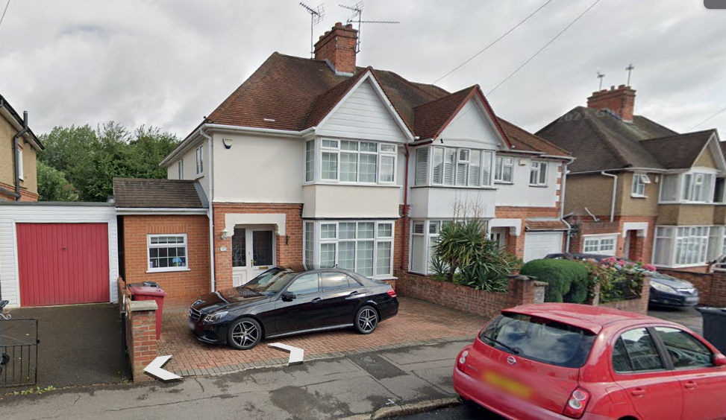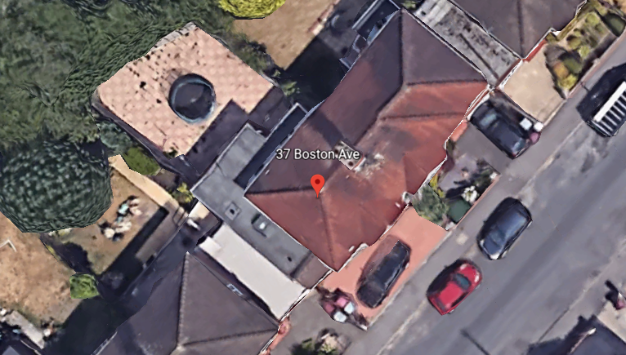

2. PROPOSAL AND SUPPORTING INFORMATION

Proposed first floor side and rear extension with pitch tiled roof

Plans considered (Received 10th February 2022)
Site Location Plan
Drawing NO: NM37BA01 – Existing Floor Layout Plans
Drawing NO: NM37BA02 – Existing Elevations
Drawing NO: NM37BA03 – Proposed Floor Layout Plans
Drawing NO: NM37BA04 – Proposed Elevations
Drawing NO: 002 Block Plan
Drawing NO: NM37BA03 – Amended Proposed Layout Plans (Received 28th February 2022)

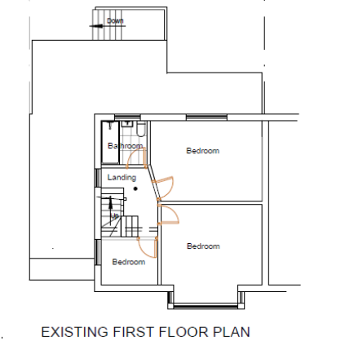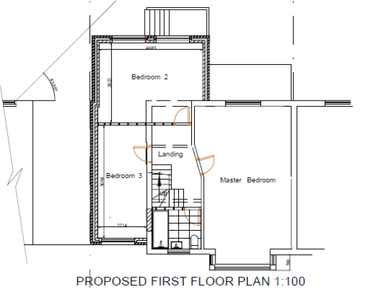

- RELEVANT PLANNING HISTORY

Application NO: 200983
Description: Proposed loft conversion with dormer
Decision: Approved
Decision Date: 9th September 2020

4. CONSULTATIONS

4.1 The following addresses were consulted by letter.

31 Berkeley Avenue, Reading, RG1 6JS
33 Berkeley Avenue, Reading, RG1 6JS
39 Boston Avenue, Reading, RG1 6JU
35 Boston Avenue, Reading, RG1 6JU

4.2 No letters of representation have been received.

Equality Act 2010:
In determining this application the Council is required to have regard to its obligations under the Equality Act 2010. However, there is no indication or evidence (including from consultation on the application) that the protected groups identified by the Act have or will have different needs, experiences, issues and priorities in relation to this particular planning application. Therefore in terms of the key equalities protected characteristics it is considered there would be no significant adverse impacts as a result of the development.

- LEGAL AND PLANNING POLICY CONTEXT

Section 38(6) of the Planning and Compulsory Purchase Act 2004 requires that proposals be determined in accordance with the development plan unless material considerations indicate otherwise. Material considerations include relevant policies in the National Planning Policy framework (NPPF) - among them the 'presumption in favour of sustainable development'. The following local and national planning policy and guidance is relevant to this application:

National Policy
National Planning Policy Framework
National Planning Practice Guidance

Reading Borough Local Plan (2019)
CC7 (Design and the Public Realm)
CC8 (Safeguarding Amenity)
H9 (House Extensions and Ancillary Accommodation)

SPG/SPD
- A Design Guide to House Extensions SPG

6. APPRAISAL

H9 states: An extension to a house will be acceptable where it:

- Respects the character of the house in terms of scale, location, materials and design;

To assess this, the following has been considered – would the proposal:
- detract from the appearance of the original building through the use of ill-matching materials and by not fitting in with the design, scale and proportions of the original building; NO, as much as the roof design will be different from the original hip style in the original dwelling, the new pitch will be in keeping with the style of roof as approved in the relevant application stated above.
- reduce the amount of usable amenity space for the property to an unacceptable degree; NO, the extent of the extension is only a vertical addition to the existing ground floor store.
- require the loss of trees in the garden or put significant trees at risk; NO

- Respects the character and pattern of neighbouring properties and the street as a whole in terms of scale, location, materials and design, and any important existing building line; Respects neighbour’s amenities and does not present a large blank façade to public areas.

To assess this, the following has been considered – would the proposal:
- significantly reduce the amount of daylight and sunlight enjoyed by neighbouring properties; NO, the 45 degree line has been drawn by the agent to demonstrate that the new extension does not impact on the sunlight enjoyed by NO.35.
- invade the privacy of neighbouring properties through overlooking from windows or balconies; NO, there are no windows on the side of the extension overlooking the adjoining neighbours.
- detract from the character of neighbouring properties through siting, excessive bulk, ill-matching materials or inconsistent design; NO, the extension complements a previous extension on the other side of the semi-detached unit.
- detract from the appearance of the street or area by using ill-matched materials, glazing and detailing; NO

CC8: Safeguarding Amenity states an extension to a house will be acceptable where it will not cause a significant detrimental impact to the living environment of existing or new residential properties.

To assess this, the following has been considered – would the proposal cause a significant detrimental impact to the living environment of existing or new residential properties in terms of:

- Privacy and overlooking;
- Access to sunlight and daylight;
- Visual dominance and overbearing effects of a development;
- Noise and disturbance;
- Artificial lighting;
- Vibration;
- Dust and fumes;
- Smell;
- Crime and safety.

- CONCLUSION
The proposed development has been assessed and the proposed works are considered to be in accordance with the above relevant policies and planning permission can be granted.

8. RECOMMENDATION
Grant

