

DELEGATED HOUSEHOLDER APPLICATION REPORT

Ward: Coley
App Ref: 221236/HOU
Address: 238 Wensley Road, Reading, RG1 6DP
Proposals: Proposed single storey rear extension with front porch extension
Case Officer: Chukwudi Onwudinanti
Applicant: Mrs Baddra Ali
Date received (valid from): 18 August 2022
Target Decision date: 4 October 2022 (EXT)

1. SITE DESCRIPTION
The application site is a semi-detached dwelling house on the western side of Wensley Road, among dwellings of similar style and size lined up on same side of the road, while buildings of varied styles stand on the opposite side. It has the National Rail lines running at the back of this line of properties.
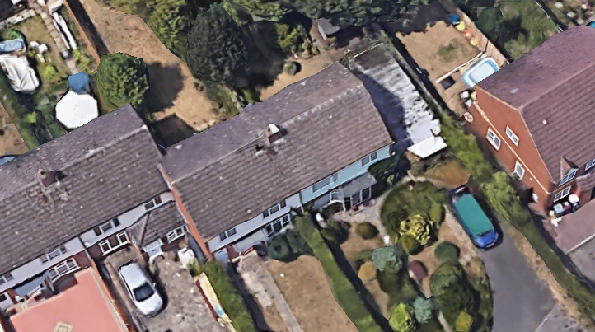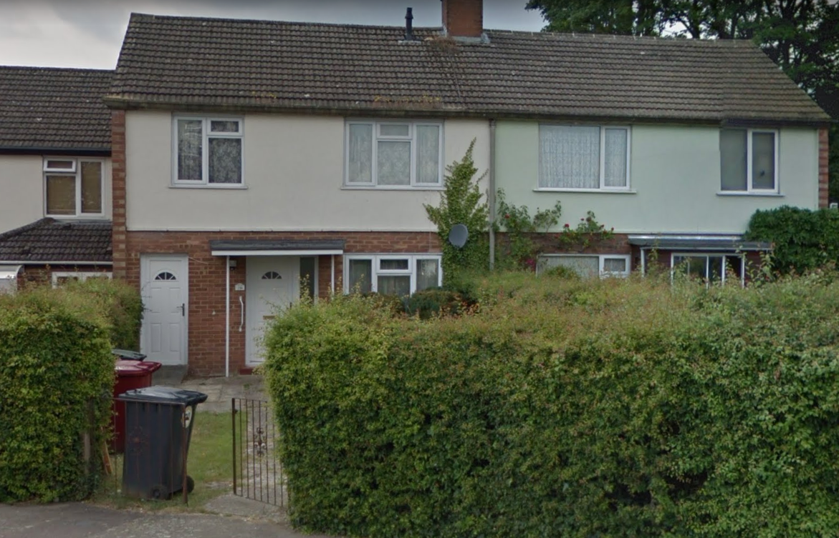

2. PROPOSAL AND SUPPORTING INFORMATION
The proposal includes a rear extension measuring approximately 4.5m deep and 6.6m wide (the full width of the existing dwelling, at a single storey level with an overall ground to eve height of 2.2m. The proposal also includes a front porch extension of approximately 4m by 1.6m, creating a front porch and a cloak room.

Plans considered received 19th August 2022
WR238:001: Location and Block Plan
CW238:002: Existing and Proposed Ground Floor Plans received 21st October 2022
CW238:003: Existing Elevations
CW238:004: Proposed Elevations

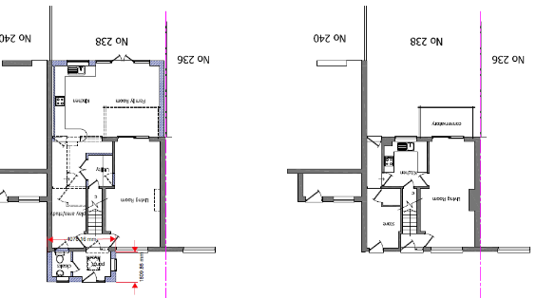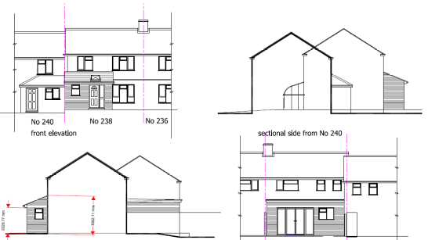

Existing and Proposed Ground Floor Plans Proposed Elevations

- RELEVANT PLANNING HISTORY
None

4. CONSULTATIONS

The following addresses were consulted by letter.

240 Wensley Road, Reading, RG1 6DP
236 Wensley Road, Reading, RG1 6DP

No letters of representation have been received as follows:

Transport Comments:

There are no transport objections to the proposed single storey rear extension and front porch extension as this will not impact on the parking provision for the site. The submitted Location/Block Plan WR238:001 illustrates 2 parking spaces which complies with the requirement as set out in the Councils current Parking Standards and Design SPD. However, the enlarged parking area will need to be constructed in permeable materials so not to increase the surface water run-off from the site.

Therefore, there are no transport objections subject to the conditions and informatives below;
DC1 VEHICLE PARKING (AS SPECIFIED)

Equality Act 2010:
In determining this application the Council is required to have regard to its obligations under the Equality Act 2010. However, there is no indication or evidence (including from consultation on the application) that the protected groups identified by the Act have or will have different needs, experiences, issues and priorities in relation to this particular planning application. Therefore in terms of the key equalities protected characteristics it is considered there would be no significant adverse impacts as a result of the development.

- LEGAL AND PLANNING POLICY CONTEXT
Section 38(6) of the Planning and Compulsory Purchase Act 2004 requires that proposals be determined in accordance with the development plan unless material considerations indicate otherwise. Material considerations include relevant policies in the National Planning Policy framework (NPPF) - among them the 'presumption in favour of sustainable development'. The following local and national planning policy and guidance is relevant to this application:

National Policy
National Planning Policy Framework
National Planning Practice Guidance

Reading Borough Local Plan (2019)
CC7 (Design and the Public Realm)
CC8 (Safeguarding Amenity)
H9 (House Extensions and Ancillary Accommodation)
TR5 (Car and Cycle Parking)

SPD
Design Guide to House Extensions (2021)
Revised Parking Standards and Design SPD 2011

6. APPRAISAL
Character and Appearance

Policy H9 states that an extension to a house will be acceptable where it respects the character of the house in terms of scale, location, materials and design and respects the character and pattern of neighbouring properties and the street as a whole in terms of scale, location, materials and design, and any important existing building line. Policy CC7 also sets out relevant considerations for design.

The rear extension measures the entire width of the existing dwelling and is 4.5m in depth at a height of 3.1m, with a flat roof. Although this is slightly greater in depth than the SPD guidance of 4m, it is considered that overall it is proportionate to the size of the existing structure.

The extension to the front to create a porch extends about 1.6m beyond the front line of the principal elevation, however, the property is already staggered forward of the building line of no. 240 and there are other similar examples within the immediate area.

It is therefore considered that the changes proposed in this application will not negatively impact on the character of the existing building and the neighbouring properties.

Residential Amenity

Policy H9 states that an extension will be acceptable where it does not result in an overbearing impact on neighbours. Policy H10 seeks to ensure that the amenity of gardens and other outdoor areas are not compromised. Policy CC8 states an extension to a house will be acceptable where it will not cause a significant detrimental impact to the living environment of existing or new residential properties.

- Privacy and overlooking: As have been stated above in this report, the proposal does not present any changes above the single storey level, above 3m from the ground. Therefore it is considered that there are no aspects of the application that will imping on the privacy of the neighbouring properties.
- Overbearing effects: All aspects of the proposal are within the scale of the existing property and are not of heights that will be overbearing to any neighbouring properties as no extensive blank wall is presented to the sides of the dwelling.
- Sunlight and daylight: The property is single storey and although slightly deeper than the SPD guidance and the neighbour would notice the additional depth and height of the extension it is not considered that there would be any significant impact on daylight/sunlight to the habitable room windows at no 236.

Sufficient amenity space would remain.

- CONCLUSION
The proposed development has been assessed as set out above and is considered to be acceptable on that basis, subject to the following conditions.

- RECOMMENDATION: Grant
Recommended Conditions:
AP1: Approved Plans
M1: Materials to match Existing
TL1 : Time limit standards
DC1: Vehicle Parking (As Specified)

