DELEGATED HOUSEHOLDER APPLICATION REPORT

Ward: Abbey
App Ref: 220289/FUL
Address: 21 Duke Street, Reading, RG1 4SA
Proposals: Repositioning of doorway on front elevation
Case Officer: Chukwudi Onwudinanti
Applicant: Lipman Properties
Date received (valid from): 16 May 2022
Target Decision date: 5 August 2022 (Ext)

- INTRODUCTION
The site is comprised of residential buildings and commercial buildings known together as Dukesbridge Court within the Market Place/ London Street Conservation Area. The site is bounded on the south side by the River Kenneth and on the other sides by a mix of residential and office buildings.
.
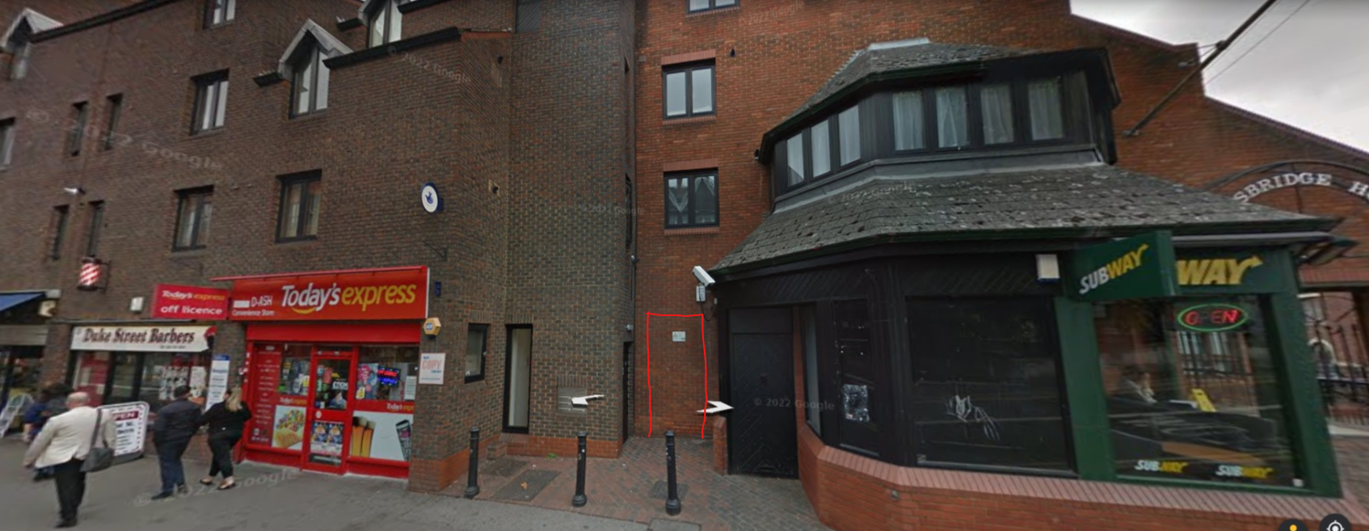

2. PROPOSAL AND SUPPORTING INFORMATION
The proposal seeks to reposition the doorway on the front elevation, installed between parts of the complex that houses Subway and Today’s Express, by the side of the existing entrance door. This entrance will be covered by a mono-pitch roof mimicking the roof of the subway in terms of style and pattern.

Plans considered received 1st March 2022
5016 PA 17 : Block Plan
5016 PA 18 : Site Plan
5016 PA 19 : Existing Plan and Elevation
5016 PA 20 : Proposed Plan and Elevation

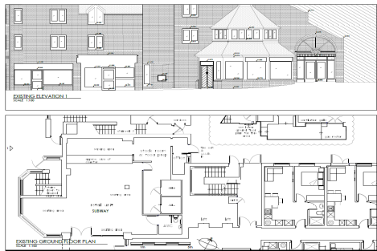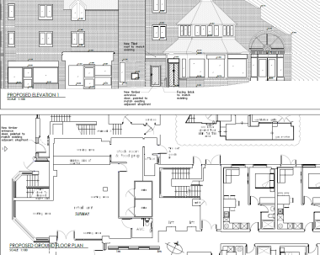
Existing Plans/Elevations Proposed Plans/Elevations

- RELEVANT PLANNING HISTORY

Application Ref : 041410
Description : New shop front, change of entrance doors and change existing smoked glass to clear glass in windows
Decision: Permitted
Date of Decision: 3 February 2005

4. CONSULTATIONS

4.1 The following addresses were consulted by letter.

17 Duke Street, Reading, RG1 8NN
19 Duke Street, Reading, RG1 4SA
23 Duke Street, Reading, RG1 4SA

Internal Consultees
CAAC

No comments received

Heritage

No comments received

4.2 No letters of representation have been received.

Equality Act 2010:
In determining this application the Council is required to have regard to its obligations under the Equality Act 2010. However, there is no indication or evidence (including from consultation on the application) that the protected groups identified by the Act have or will have different needs, experiences, issues and priorities in relation to this particular planning application. Therefore in terms of the key equalities protected characteristics it is considered there would be no significant adverse impacts as a result of the development.

- LEGAL AND PLANNING POLICY CONTEXT

Section 38(6) of the Planning and Compulsory Purchase Act 2004 requires that proposals be determined in accordance with the development plan unless material considerations indicate otherwise. Material considerations include relevant policies in the National Planning Policy framework (NPPF) - among them the 'presumption in favour of sustainable development'. The following local and national planning policy and guidance is relevant to this application:

National Policy
National Planning Policy Framework
National Planning Practice Guidance

Reading Borough Local Plan (2019)
CC7 (Design and the Public Realm)
EN1 (Protection and Enhancement of the Historic Environment)

- APPRAISAL

CC7 Design and the Public Realm

All development must be of high design quality that maintains and enhances the character and appearance of the area of Reading in which it is located

Developments will also be assessed to ensure that they: -
- Respond positively to their local context and create or reinforce local character and distinctiveness, including protecting and enhancing the historic environment of the Borough and providing value to the public realm;

Whilst this proposal is to install an additional door to the front of a building in a conservation area, it is considered that previous developments of shop fronts and advertisement installations on the same building has made this addition of a door less impactful on the general appearance of the building. It is also judged that the proposal does not detract from the appearance of the street or area as the material to be used for the door and the covering roof is to match the existing materials used for the door and the roof of the surrounding existing elements of the building.

b) EN1 Protection and Enhancement of the Historic Environment

Historic features, areas of historic importance and other elements of the historic environment, including their settings will be protected and where possible enhanced.
- All proposals will be expected to protect and where possible enhance the significance of heritage assets and their settings, the historic character and local distinctiveness of the area in which they are located.

The proposal seeks to add a door to the building which neither restores the original building features nor removes inappropriate additions or alterations. However, it is considered that the overall impact of this addition is mitigated by the shop fronts and doors and glazing already installed historically in the front facing part of the building, reducing the additional effect of the door to be added.

- CONCLUSION
The proposed development has been assessed and the proposed works are considered to be in accordance with the above relevant policies and planning permission can be granted.

8. RECOMMENDATION
Grant

