DELEGATED HOUSEHOLDER APPLICATION REPORT

Ward: Caversham
App Ref: 221024/VAR
Address: 6 Grosvenor Road, Caversham, Reading, RG4 5EJ
Proposals: Application for removal or variation of a conditions 2 and 3 following grant of planning permission. (211365)
Case Officer: Chukwudi Onwudinanti
Applicant: Mr Chris Vaughan
Date received (valid from): 12 July 2022
Target Decision date: 16 September 2022 (EXT)

INTRODUCTION
The application site relates to No.6 Grosvenor Road, a detached property located on the north side of Grosvenor Road, a private road, close to the junction with Peppard Road to the west. The immediate surrounding area is predominantly residential, largely featuring expansive detached houses set in generous plots along the north and west side of Grosvenor Road and more densely located terraces to the south east of Grosvenor Road.
The property is not a listed building or located within a conservation area.
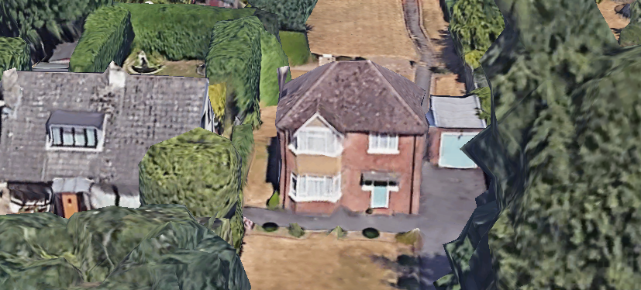

PROPOSAL AND SUPPORTING INFORMATION

- Application for removal or variation of a condition following grant of planning permission 211365
- Changes to materials and
- Changes to the Plans

Plans considered received 14th July 2022
Drawing No: VC-0722-01: Proposed Ground Floor Plan
Drawing No: VC-0722-02: Proposed First Floor Plan
Drawing No: VC-0722-03: Proposed Elevations
Drawing No: VC-0722-04: Existing Plans and Elevations
Drawing No: VC-0722-05: Location Plan
Drawing No: VC-0722-06: Block Plan

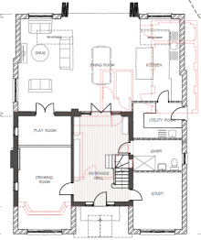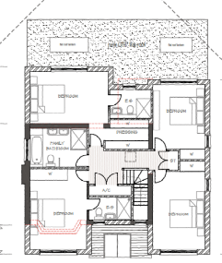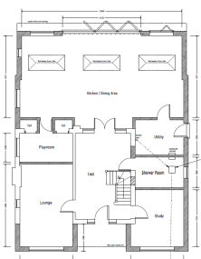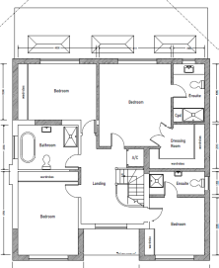
Permitted Plans (Recessed at rear) VAR Plans (showing area of infill)

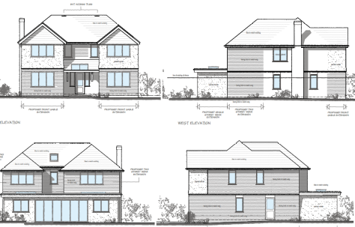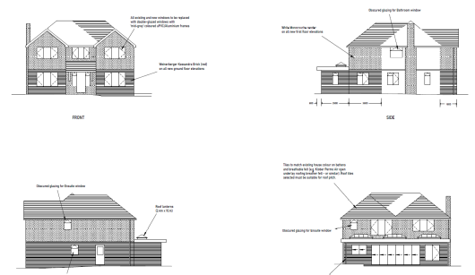
Previously Permitted Elevations VAR Elevations

RELEVANT PLANNING HISTORY
Application Ref: 211365
Description: Single storey side and rear extensions. Two storey side and rear extensions. Front gable extensions. Demolition of garage.
Decision: Permitted
Decision Date: 7th March 2022

CONDITIONS TO VARY

2. The development hereby permitted shall ONLY be carried out in accordance with the following approved plans:
Drawing No: Existing Site Plan and Garage Elevations 3694/103 Received 18th August 2021
Drawing No: Block and Location Plan 3694/100 Rev F
Drawing No: Ground Floor Layout 3694/210 Rev G
Drawing No: First Floor Layout 3694/211 Rev G
Drawing No: Roof Plan 3694/212 Rev F
Drawing No: Proposed Elevations 3694/213 Rev G
Received 22nd February 2022
REASON: For the avoidance of doubt and to ensure that the development is carried out and adhered to in accordance with the application form and associated details hereby approved.

REVISED CONDITION
2. The development hereby permitted shall ONLY be carried out in accordance with the following approved plans received 14th July 2022:
Drawing No: VC-0722-01: Proposed Ground Floor Plan
Drawing No: VC-0722-02: Proposed First Floor Plan
Drawing No: VC-0722-03: Proposed Elevations
Drawing No: VC-0722-06: Block Plan
REASON: For the avoidance of doubt and to ensure that the development is carried out and adhered to in accordance with the application form and associated details hereby approved.

3
3. The materials to be used in the construction of the external surfaces of this development shall be as specified on the plans and application form unless otherwise agreed in writing with the Local Planning Authority.
REASON: In the interests of visual amenity and ensuring the new development responds positively to the local context and character in accordance with Policies CC7 and H9 of the Reading Borough Local Plan 2019.

REVISED CONDITION
3. The materials to be used in the construction of the external surfaces of this development shall be as specified on the plans and application form unless otherwise agreed in writing with the Local Planning Authority.
REASON: In the interests of visual amenity and ensuring the new development responds positively to the local context and character in accordance with Policies CC7 and H9 of the Reading Borough Local Plan 2019.
4
REVISED MATERIALS NOTES

All the first floor elevations and the existing chimney will have a white Monocouche rendered finish.
All the proposed ground floor elevations will have a brickwork finish.
All existing and proposed windows will be replaced with double glazed windows with 'mid-grey' coloured uPVC/aluminium frames.
Additional roof lanterns and windows on the ground floor rear extension to allow more light to the Kitchen and Dining Area.

REVISED STRUCTURAL NOTES
Whilst remaining outside of the 45 degree lines, the new first floor rear wall to be straightened across the full width of the back of the house to create an improved first floor room layout.

Equality Act 2010:
In determining this application the Council is required to have regard to its obligations under the Equality Act 2010. However, there is no indication or evidence (including from consultation on the application) that the protected groups identified by the Act have or will have different needs, experiences, issues and priorities in relation to this particular planning application. Therefore in terms of the key equalities protected characteristics it is considered there would be no significant adverse impacts as a result of the development.

LEGAL AND PLANNING POLICY CONTEXT

Section 38(6) of the Planning and Compulsory Purchase Act 2004 requires that proposals be determined in accordance with the development plan unless material considerations indicate otherwise. Material considerations include relevant policies in the National Planning Policy framework (NPPF) - among them the 'presumption in favour of sustainable development'. The following local and national planning policy and guidance is relevant to this application:

National Policy
National Planning Policy Framework 2021
National Planning Practice Guidance 2014
Reading Borough Local Plan (2019)
CC7: Design and the Public Realm
CC8: Safeguarding Amenity
H9: House Extensions and Ancillary Accommodation

Supplementary Planning Guidance
Design Guide to House Extensions SPD (2021)

Neighbour letters were sent to adjoining properties at No’s 4, 8 and 8a Grosvenor Road, 25, 23 and 25 Cedarwood Crescent and 20a, 20b, 22a and 22 Peppard Road.

No letters of objection were received.

APPRAISAL

In line with NPPG, this proposal has been considered to be ‘minor material amendments’, as both individually and collectively (by virtue of scale and/or nature considerations) they are considered to result in a development which is not substantially different from the one which was originally approved. The current modifications to design and materials are not in contradiction to the request for and subsequent amendments secured in the previous application 211365. While the materials proposed in this application would NOT match the existing building, it is still considered that the design and proportions of the extension ensure that the development does not detract from the character of the existing property such that they will warrant a refusal to this application.
Previous Consultation Response from 211365 made relevant in current application:
Ecology: No objection subject to condition in respect of a Bat Licences from Natural England.

CONCLUSION
The proposed development has been assessed and the proposed works are considered to be in accordance with the above relevant policies and planning permission can be granted.

RECOMMENDATION
GRANT subject to conditions and informative

