DELEGATED HOUSEHOLDER APPLICATION REPORT

Ward: Kentwood
App Ref: 220329/HOU
Address: 45 Kentwood Close, Reading, RG30 6DH
Proposals: Demolition of existing garage, proposed two and single storey rear extension, two and single storey side extension and two storey front extension.
Case Officer: Chukwudi Onwudinanti
Applicant: Mr & Mrs Witney
Date received (valid from): 9 March 2022
Target Decision date: 5 August 2022 (Ext)

1. INTRODUCTION
The site is a semi-detached dwelling on the northern side of Kentwood Close. It is one of similarly styled and sized buildings on both sides of the cul-de-sac that is Kentwood Close and is in an area of predominantly residential dwellings. There are existing single storey extensions of approximately 6m depth on both sides of the boundary fence between the proposal site and No 43.

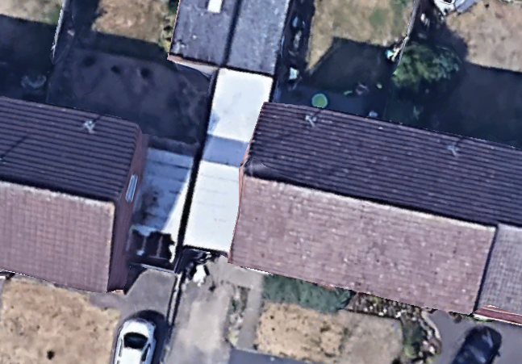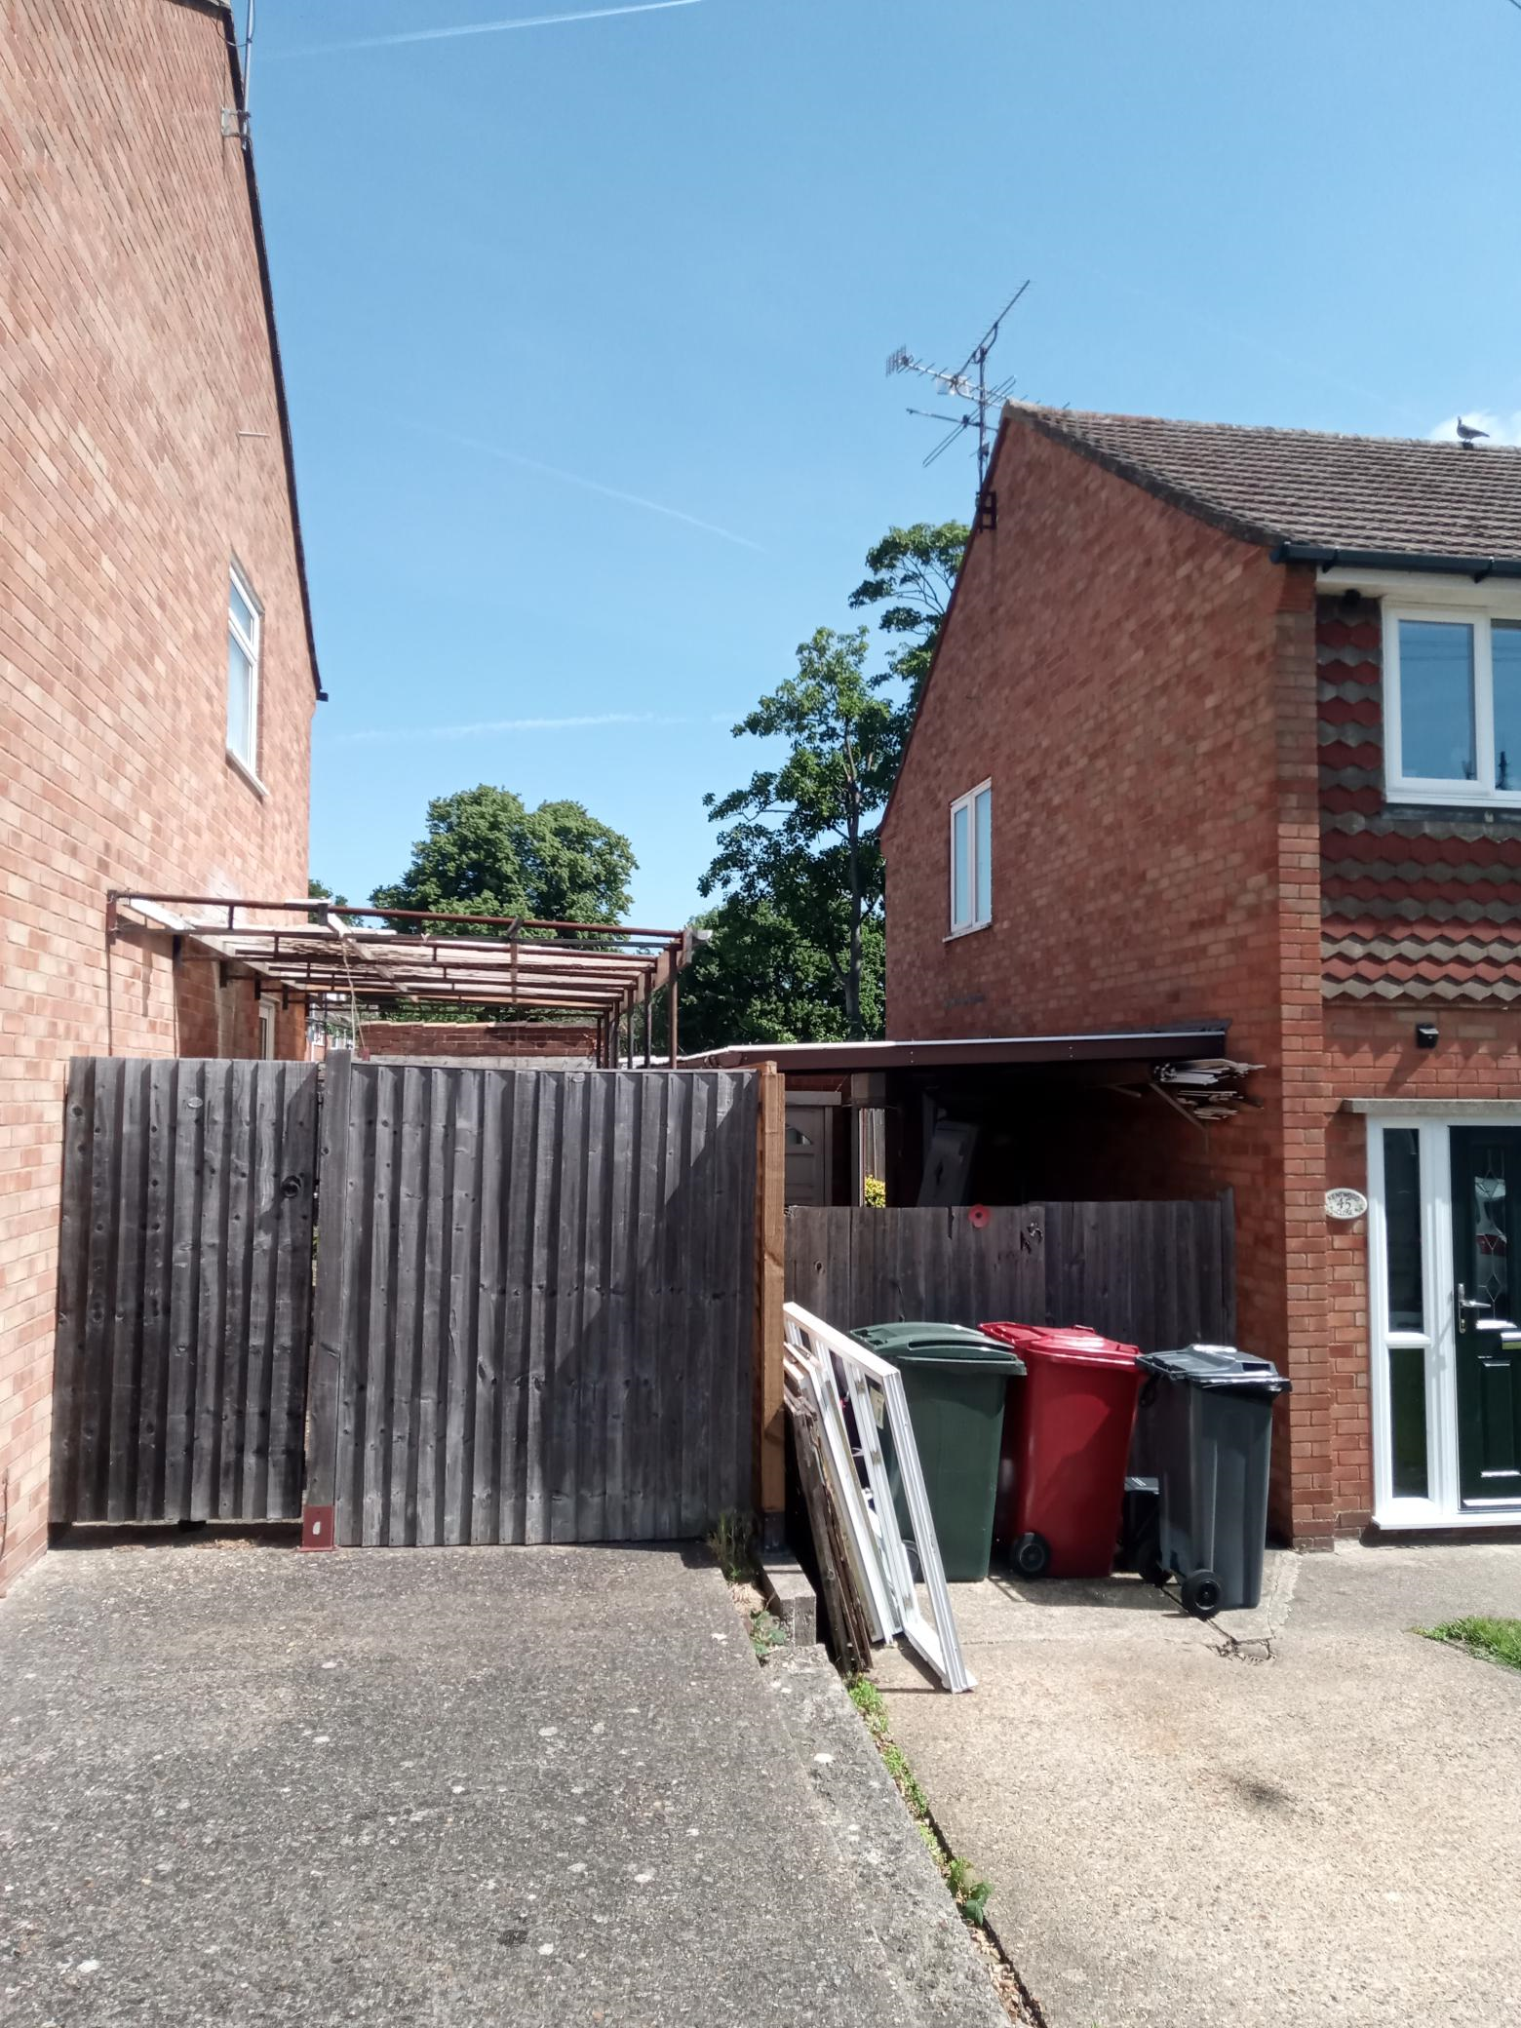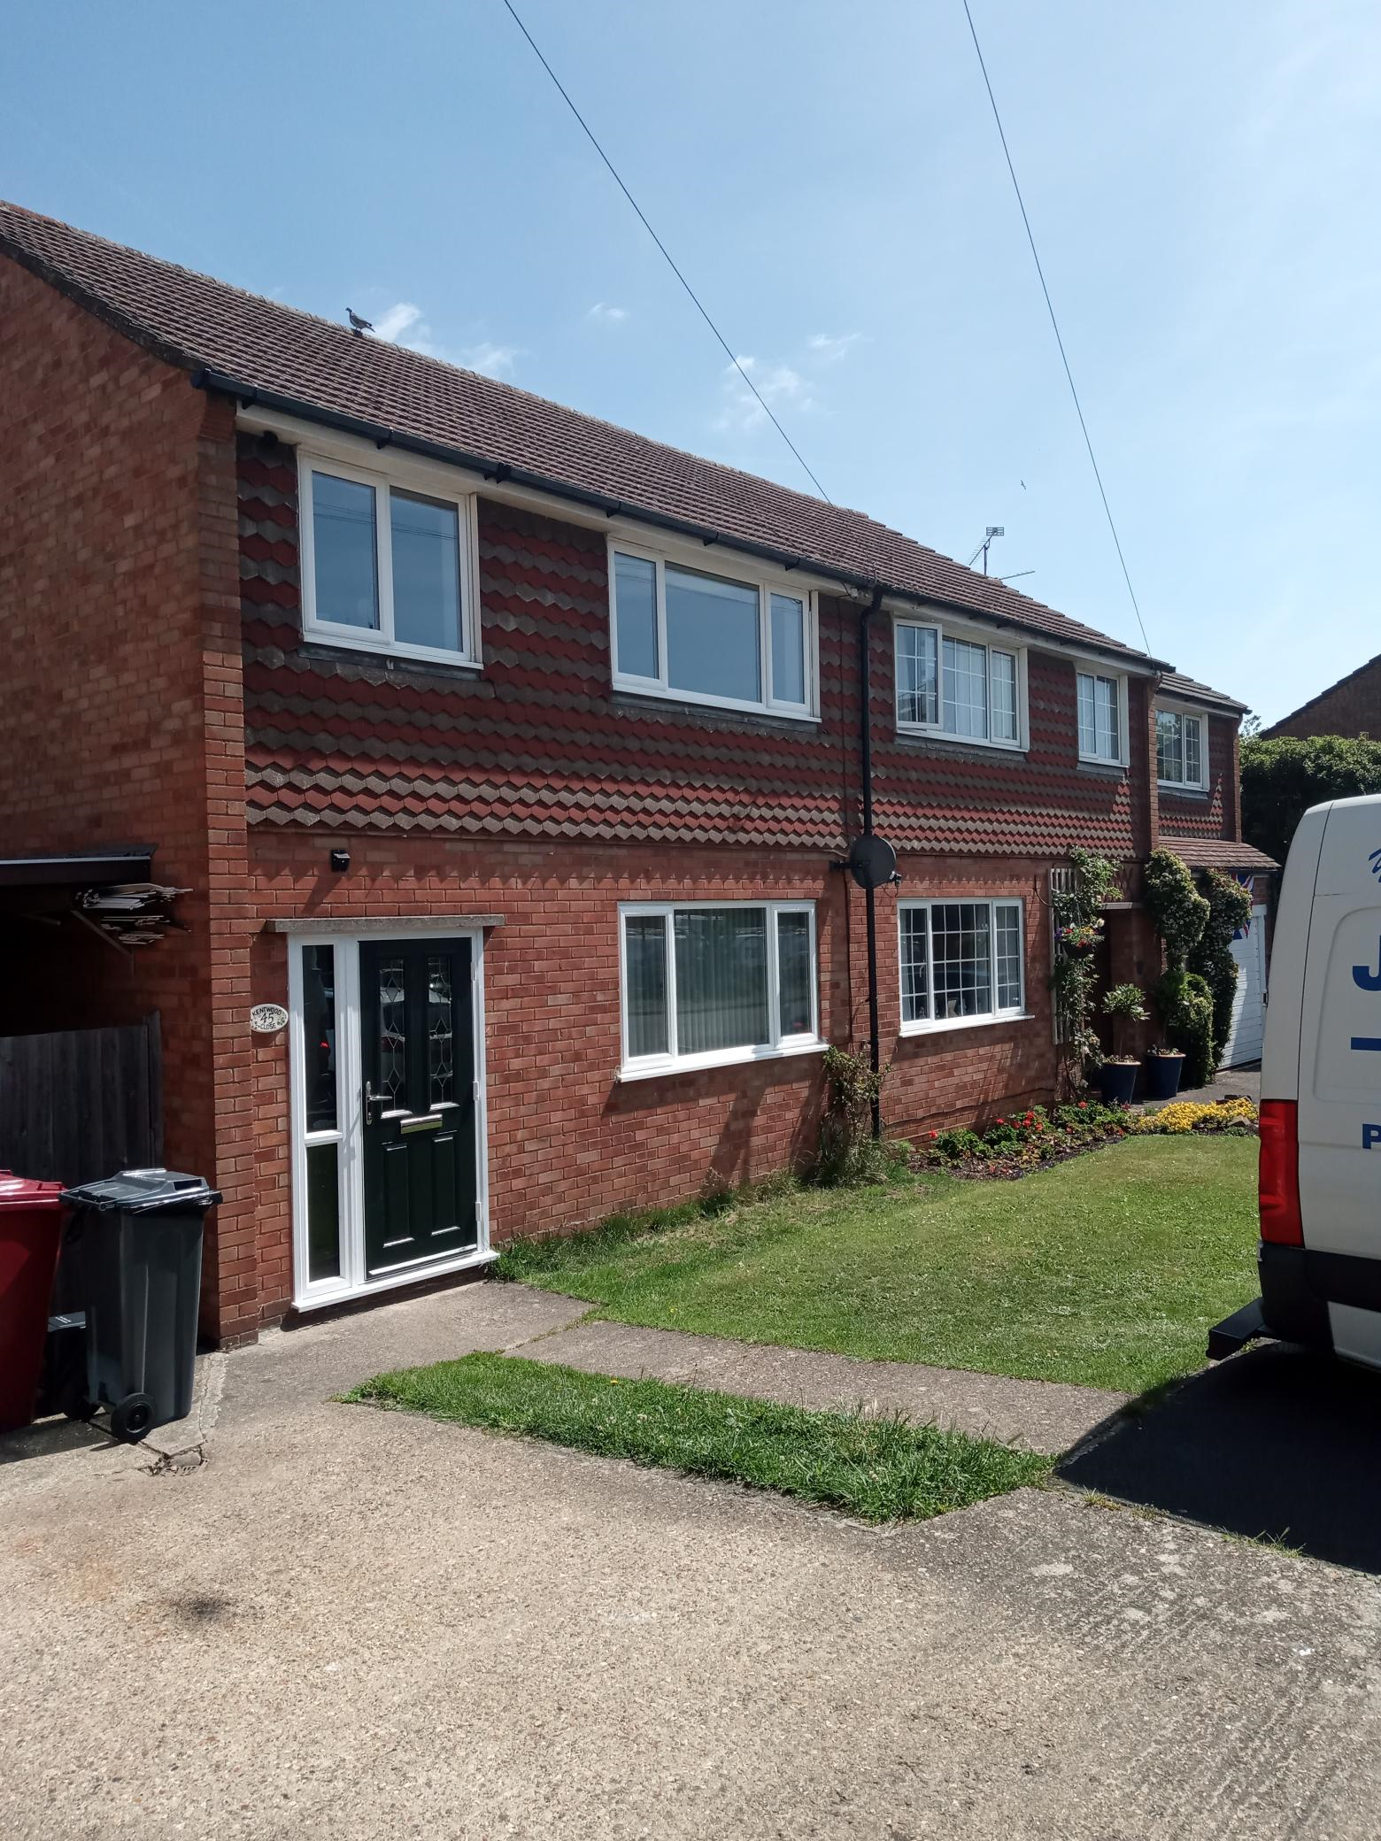

2. PROPOSAL AND SUPPORTING INFORMATION

The proposal is for the demolition of the existing garage, development of a two storey side extension measuring approximately 2.2m at the front and 1m at the rear on the ground floor level and 2m at the first floor level. The proposal also includes a part single storey and part two storey rear extension measuring approximately 3m deep and 5m wide across the rear façade of the original dwelling. All external finish and roof materials are to match existing.

Plans considered received 15 July 2022
22/869 -01: Existing Plans and Elevations
22/869 -02 Rev C: Proposed Plans
22/869 -03 Rev C: Proposed Elevations
22/869 -04 Rev B: Site & Location Plan

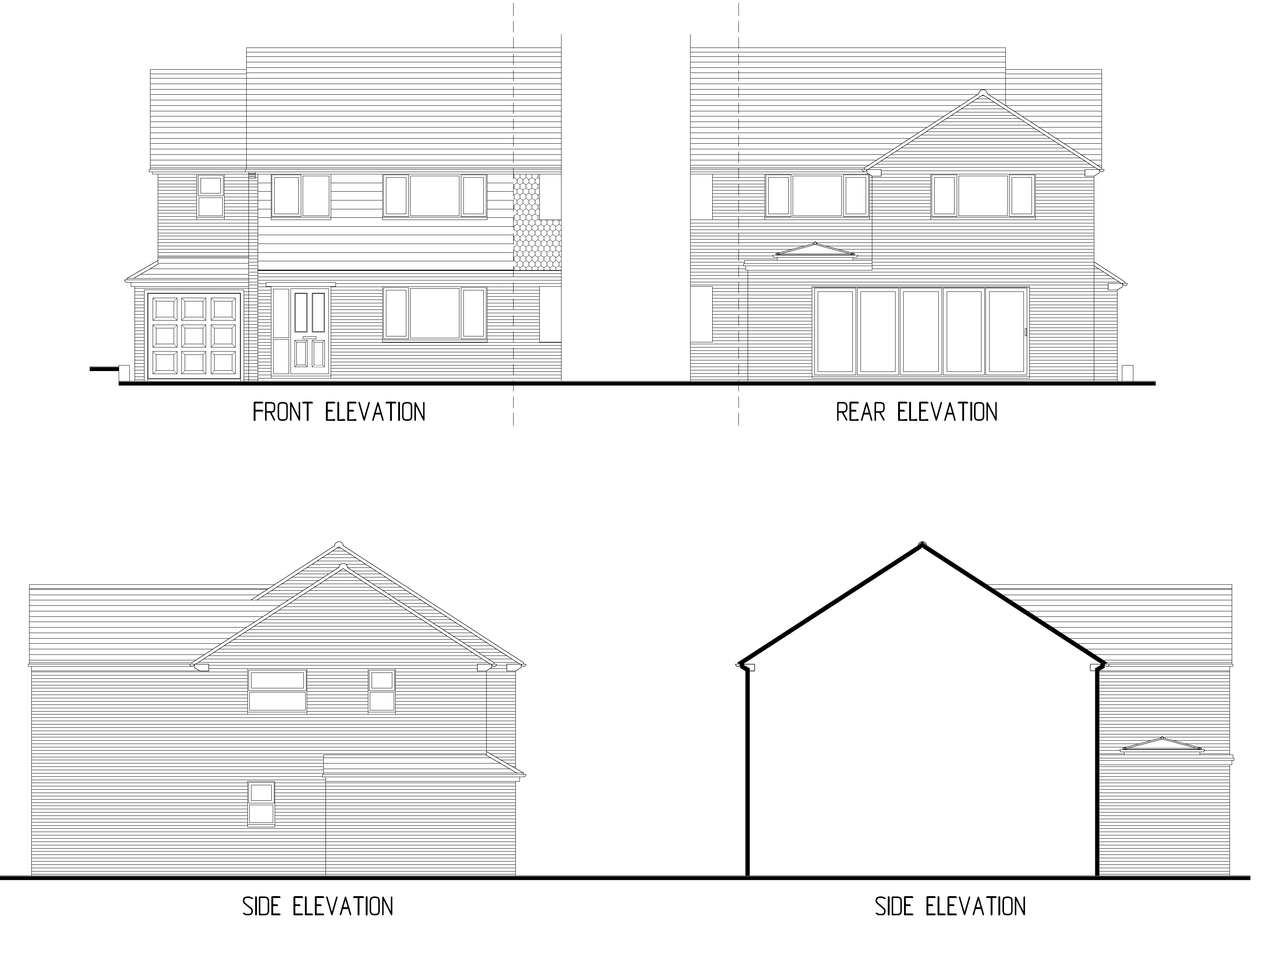

- RELEVANT PLANNING HISTORY

None

4. CONSULTATIONS

4.1 The following addresses were consulted by letter.

43 Kentwood Close, Tilehurst, Reading, Berkshire, RG30 6DH
37 Kentwood Close, Tilehurst, Reading, RG30 6DH
47 Kentwood Close, Tilehurst, Reading, RG30 6DH

4.2 A letter of objection has been received from No 47, stating thus:

“Regarding the proposed extension at No 45 Kentwood Close.
We have a extreme concern the extension at the rear of the property will restrict the light into our rear lounge & kitchen windows & garden.”

In regards to above, the Planning Officer is satisfied that the proposal, stepped away from the boundary as it is on the first floor mitigates this concern.

Transport was consulted regarding the loss of garage caused by this proposal. They requested a site plan illustrating the provision of a car space for parking, away from the street. This was provided and confirmed by transport to be adequate.

Discussion with the agent
The initial proposal as submitted was deemed by the Officer to be overbearing and not in scale with the original dwelling. The agent has worked with the Officer to get the design to the level where it has been deemed to be subservient to the original dwelling. The 45 degree assessment submitted by the agent on the advice of the PO also shows that the neighbour on No 43 are not adversely impacted by this proposal.

Equality Act 2010:
In determining this application the Council is required to have regard to its obligations under the Equality Act 2010. However, there is no indication or evidence (including from consultation on the application) that the protected groups identified by the Act have or will have different needs, experiences, issues and priorities in relation to this particular planning application. Therefore in terms of the key equalities protected characteristics it is considered there would be no significant adverse impacts as a result of the development.

- LEGAL AND PLANNING POLICY CONTEXT

Section 38(6) of the Planning and Compulsory Purchase Act 2004 requires that proposals be determined in accordance with the development plan unless material considerations indicate otherwise. Material considerations include relevant policies in the National Planning Policy framework (NPPF) - among them the 'presumption in favour of sustainable development'. The following local and national planning policy and guidance is relevant to this application:

National Policy
National Planning Policy Framework
National Planning Practice Guidance

Reading Borough Local Plan (2019)
CC7 (Design and the Public Realm)
CC8 (Safeguarding Amenity)
H9 (House Extensions and Ancillary Accommodation)

SPD
- Design Guide to House Extensions (2021)

6. APPRAISAL

H9 states: An extension to a house will be acceptable where it:

- Respects the character of the house in terms of scale, location, materials and design;

To assess this, the following has been considered – would the proposal:
- detract from the appearance of the original building through the use of ill-matching materials and by not fitting in with the design, scale and proportions of the original building; NO, while the original proposal submitted was not fitting to the scale and design of the original dwelling, the design has been revised to produce an acceptable version of the proposal. The front aspect of the original proposal has been stepped back from the original dwelling and the roof style has been redesigned to mirror the original roof.
- reduce the amount of usable amenity space for the property to an unacceptable degree; NO, the original dwelling has not been increased in size such that the remaining amenity space would remain at an acceptable level. The rear extension only goes into the existing rear usable amenity space by 3m, leaving more than the size of the new resultant building as the rear garden.
- require the loss of trees in the garden or put significant trees at risk; NO

- Respects the character and pattern of neighbouring properties and the street as a whole in terms of scale, location, materials and design, and any important existing building line; Respects neighbour’s amenities and does not present a large blank façade to public areas.

To assess this, the following has been considered – would the proposal:
- significantly reduce the amount of daylight and sunlight enjoyed by neighbouring properties; NO, the proposal site is set away from No 43 at an angle that the 45 degree line would not be breached. The proposal is stepped away on the first floor from the boundary with No 47, such that the ground floor aspect does not significantly reduce the amount of daylight and sunlight received by No 47.
- invade the privacy of neighbouring properties through overlooking from windows or balconies; NO, the windows to the side of this proposal are bathroom windows which are obscured and this is recommended to be conditioned.
- detract from the character of neighbouring properties through siting, excessive bulk, ill-matching materials or inconsistent design; NO, while the proposal presents an independently roofed porch which is a departure from the original design, it is considered to enhance the front façade of the building and matches the style that has been used at the other end of the semi-detached building in a previous extension.
- detract from the appearance of the street or area by using ill-matched materials, glazing and detailing; NO

CC8: Safeguarding Amenity states an extension to a house will be acceptable where it will not cause a significant detrimental impact to the living environment of existing or new residential properties.

To assess this, the following has been considered – would the proposal cause a significant detrimental impact to the living environment of existing or new residential properties in terms of:

- Privacy and overlooking;
- Access to sunlight and daylight;
- Visual dominance and overbearing effects of a development;
The proposal presents new features to the existing dwelling and the terrace and also increases the size of the original dwelling. However, the agent has been able to provide revisions that mitigate the issues listed above and the overlooking and loss of privacy to Nos 47 and 43 have been minimised. Access to sunlight as well as visual dominance have also been resolved by the revised drawings.

- CONCLUSION
The proposed development has been assessed and the proposed works are considered to be in accordance with the above relevant policies and planning permission can be granted.

8. RECOMMENDATION
Grant

