Delegated Application Report

Target Date: 04/05/2022 Extended Target Date: 10/08/2022
Address: The Moorings, Mill Green, Caversham, Reading
Application No: 220591/CLE
Proposal: Certificate of Lawfulness for Existing use as commercial boatyard
Case Officer: Claire Ringwood

Site Description
The site is located to the north of the River Thames. There is a pedestrian footpath to the north of the site and then residential properties to the north of the footpath. To the east is a commercial boatyard, and to the west is what appears to be gardens of the houses on the north side of the footpath which extend across the footpath and abut the River Thames. The site has biodiversity/green link and Major Landscape Feature designations in the Reading Borough Local Plan.

The site is accessed via a pedestrian gate from the footpath to the north and the applicant claims there has been a vehicular access from the end of Mill Green which extends eastwards along the pedestrian footpath to a set of double gates to the site. A planning application for a vehicular access has recently been refused planning permission and is pending an appeal decision (application ref: 210544).

A site visit was undertaken by Planning Officers on 28th July 2022. Photographs show that works have been undertaken on site and the main building refurbished and is now capable of being used as an independent residential unit as it has all the necessary facilities. There are two external toilets and mains water. The slipway and original winch have been retained. Other external works have been undertaken such as some new paving, new mooring posts, new wooden shed, trellis on top of the fence.

Description of Use or Development
Certificate of Lawfulness for Existing use as commercial boatyard.

The application form states the Use Class as B2 ‘general industrial’ and the description states ‘the maintenance and repair of boats’. The Planning Statement refers to the ‘continued use of site as commercial boatyard’.

The applicant’s agent was asked to provide a more precise description and suggested Class E (g) (iii) light industrial use) however Officers are not satisfied that the evidence provided as part of the certificate demonstrates either a B2 or Class E (g) (iii) use.

Officers consider a commercial boatyard to include activities such as the construction, storage, maintenance, repair, or refurbishing of vessels, such as the boatyard to the east of The Moorings but, based on the evidence submitted it is not clear exactly what the use of the site is or has been.

Relevant Planning History
10/00275/PREAPP (alternative/later reference 100544) - Pre-application advice for proposed demolition of existing shed and erection of log cabin. Erection of new boathouse. Replacement of existing fence with new 1.8m high fence. Observations sent 06/08/2010. This letter indicates that the Officer at the time considered the site was being used as a leisure plot, but the lawful use was unclear.

171996/OUT - Outline application for the demolition of existing storage building, wet dock and slipway and erection of two detached dwellings. Withdrawn 05/01/2018. The submitted application form refers to the existing use as ‘mooring and commercial premises including storage building, wet dock and slipway’ but again this was not investigated by Officers at the time.

Photos showing the storage shed (as it existed prior to the most recent works undertaken by the applicant as observed at the site visit July 2022) submitted in the Planning Statement with this Outline application:

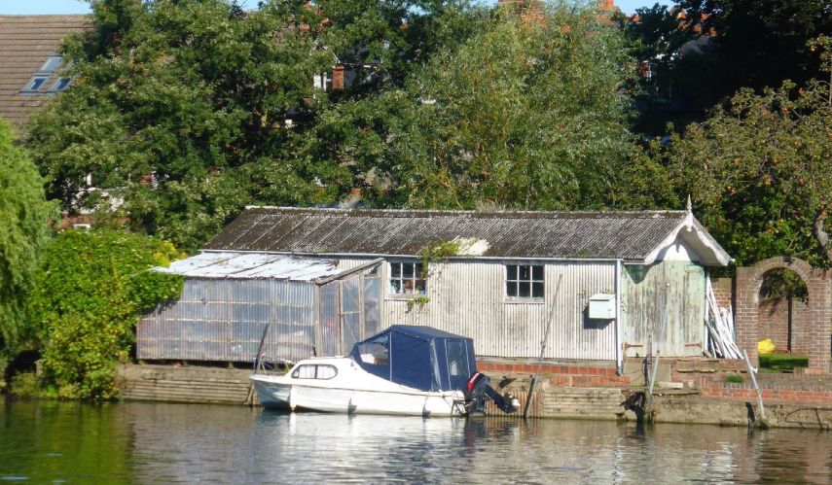

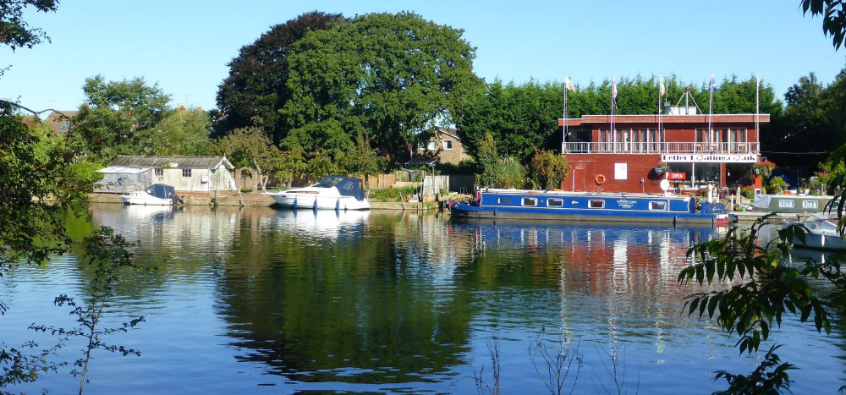

210544/FUL - Vehicular access with permeable surface on land south of Mill Green to provide access to The Moorings. Refused 07/02/2022. Appeal dismissed 15/11/2022 (Inspectorate Ref: APP/E0345/W/22/3298362).

Relevant Planning Policy and Guidance
Section 10 of the Planning and Compensation Act 1991 established a procedure that enables anyone who wishes to do so, to apply to the local planning authority to determine whether a proposed use or operation, or an existing operational development or an existing use of land, or any other matter constituting a failure to comply with any condition or limitation subject to which planning permission has been granted, is lawful, and is so, be granted a certificate to that effect.

A Lawful Development Certificate is a legal document stating the lawfulness of past, present or future development. If granted by the local planning authority, the certificate means that enforcement action cannot be carried out to the development referred to in the certificate. However, the certificate will not protect from enforcement action by the planning authority if the specified use or development is then changed ‘materially’ without a planning application for it.

The certificate is not planning permission. The planning merits of use, operation or activity in the application are not relevant. The issue of a certificate depends entirely on factual evidence about the history and planning status of the building or other land and the interpretation of any relevant planning law or judicial authority. The responsibility is on the applicant to provide evidence to support the application.

The NPPG states that ‘The applicant is responsible for providing sufficient information to support an application. In the case of applications for existing use (section 191 of the Town and Country Planning Act 1990), if a local planning authority has no evidence itself, nor any from others, to contradict or otherwise make the applicants version of events less than probable, there is no good reason to refuse the application, provided the applicants evidence alone is sufficiently precise and unambiguous to justify the grant of a certificate on the balance of probability’.

Consultations
- Legal Services – the certificate should be refused because the evidence of the use of the site as a commercial boatyard has not been established.
- Planning Enforcement – there are a number of records for this site dating from 2003 to the present time.
- Environmental Protection – no records.
- Business Rates – records show the site has been entered into the Business Rates since at least 01.04.1995 and in occupation by the owners since 04.11.2020. The description for this assessment is mooring and premises.
- Electoral Services – no records.
- Although neighbour consultations are not normally carried out for lawful development certificates, due to local interest during the course of the previous full application, neighbour consultations were considered appropriate in this instance. 30 representations have been received. The planning-related representations that are considered material to this lawful development submission are summarised below:

- Local residents have neither seen nor heard anything to indicate the site was being used as a commercial boatyard, some residents have lived locally for many years;
- Local residents have never known it to be a boatyard;
- The occasional boat has been seen moored there and a few people enjoying the sunshine on the land which looked recreational in nature;
- The site has always been marketed as a leisure plot and not as a commercial site;
- It was previously known as The Orchard because of the apple trees that grew in it;
- Concern over the future use of the site if a lawful development certificate is granted – Officer Note – future activities on the site are not within the remit of this lawful development certificate;
- Other works ongoing within the site - Officer Note: Planning Enforcement are investigating;
- One local resident knew the upholsterer who lived there on a boat and she undertook upholstery work but her activities were not those of a boatyard;
- There has never been any signage indicating there was a business operation;
- Can company records showing the operation be submitted?;
- If The Moorings ever operated on a commercial footing those businesses must have ceased operating a long time ago;
- The evidence submitted does not prove the site’s continuous use as a commercial boatyard;
- The Moorings was sold at Auction in October 2020 and was described as a leisure plot, mooring for leisure craft and a storage shed with no reference to commercial use;
- Notification of the application was not received and the application should be delayed – Officer Note: the Council do not have to consult local residents on lawful development certificates however as there has been local interest in this site following a previous application notifications were undertaken and included those previously notified and any additional objectors;
- Concern over the conversion to a commercial boatyard – Officer Note: a lawful development certificate is not a planning application. It is a procedure that allows anyone to submit a lawful development certificate for an existing or proposed use. It is a legal document stating the lawfulness of past, present or future development. Further clarification is detailed in the ‘Relevant Planning Policy and Guidance’ above;
- The evidence states the site had no mains water or electricity, therefore, how could it be used as a commercial boatyard?;
- The evidence states the land was covered in silt and overgrown, again proof that it had not been used for any significant commercial purposes for any length of time;
- The evidence states there was no vehicular access so how could a commercial boatyard operate?;
- The evidence suggests the site was used to fit out a private boat and states ‘we didn’t undertake anything commercial by nature’;
- The uses evidenced i.e. boat upholstery and boat hood supplier are not commercial boatyard activities;
- Only very occasionally have boats been moored there;
- There is no crane or other heavy lifting equipment on the site which is essential for a working commercial boatyard;
- There is a lack of evidence/record of any boatyard/commercial business activity for at least 30-50 years;
- In 2006 there were 5 dumped/derelict boats leaking diesel and motor oil into the river and one other boat, 3 of these were removed from the river and 2 were craned out and cut up for scrap in the boatyard next door;
- The evidence provided by previous tenants is unreliable;
- The supposed workshop is referred to as a summerhouse;
- One tenant answered an advert for a ‘mooring to let’;
- One tenant stated he didn’t undertake anything ‘commercial by nature’;
- It is more likely the site was used as a private moorings with a wet dock used to overwinter a private launch plus an outbuilding; many private dwellings with a river frontage will have a covered wet dock;
- Why hasn’t the Statutory Declaration and the 2006 aerial photograph been submitted;
- The slipway isn’t what you’d expect in a commercial boatyard, it ends abruptly and has no way to get anything but small boats out of the water other than lift by hand and the winch shown in photos clearly hasn’t been used in a long time.

Submitted Evidence
The agent submitted the following information, received on 21st April 2022:
Location Plan
Drawing No: SJG3510

The agent submitted the following information, received on 11th May 2022:
Planning Statement including evidence and Counsel’s opinion

Statutory Declaration, received 12th October 2022

Analysis of Evidence
The applicant has submitted a lawful development certificate to establish the use of The Moorings, Mill Green as a commercial boatyard has been ongoing for more than 10 years.

The relevant time period is 21st April 2012 to 21st April 2022.

As noted above, a site visit was undertaken by Planning Officers on 28th July 2022. Photographs show that works have been undertaken on site and the main building refurbished which now contains a lounge area, fitted kitchen, bedroom, en-suite shower and toilet with patio doors to one end. There are two external toilets and mains water has been installed. The slipway and original winch have been retained. Other external works have been undertaken such as some new paving, new mooring posts, new wooden shed, trellis on top of the fence. Some of these works are being considered by Planning Enforcement as they may have required planning permission. It was clear from this site visit that there is no current commercial boatyard activities although the submitted Planning Statement claims ‘The Moorings continue to have a commercial boatyard use, there having been no evidence of its abandonment.’

The applicant has submitted various forms of evidence, including a Planning Statement, OS Maps dating from 1898, 1912 and 1938, emails from two previous tenants, one from 1993 to 1995 and the second from 1996 to 2010 and the Opinion of a QC. The details within the Planning Statement make reference to a Statutory Declaration by the wife of a previous owner, however, this document has not been submitted with the lawful development certificate. Officers have, however, seen a copy of this Statutory Declaration, as it was submitted with refused application 210544/FUL, but there is no mention within that document as to the use of the site.

The Planning Statement refers to The Moorings as comprising riverside moorings, a workshop, wet dock and slipway with an access with double gates to the eastern boundary and a separate pedestrian access to the west. As detailed above in ‘Property History’ a recent application has been refused for a vehicular access to the site and an appeal dismissed by the Planning Inspectorate. Any reference to an existing vehicular access is not accepted by Officers and the referenced workshop is now living accommodation.

The agent states that the OS Maps within the Planning Statement show a covered wet dock and slipway in 1898 and the existing workshop in 1912 and 1938 however Officers do not consider this is conclusive evidence that there was a commercial boatyard use at these times and no invoices, company records, accounts etc have been provided to show any commercial boat activity.

The Planning Statement contends the slipway, winch and dilapidated diesel tanks/pumps, which have recently been removed, are also evidence of a commercial boatyard use. Officers consider that any private dwellings with a river frontage will have a covered wet dock to overwinter a private boat and the fact that these are on site are again not conclusive evidence that there was a commercial boatyard use.

The evidence provided from previous tenants of the site do not indicate in any way a commercial boatyard use and at best could be considered as private moorings with some maintenance and repair. The evidence from the earliest tenant is that he licensed the land and moorings for a two year period in 1993 after it was advertised in a magazine as a ‘mooring plot’. This is contradictory to the site being claimed to be a commercial boatyard. This tenant had a small Dutch oil tanker which he needed to convert. He states the land and mooring was totally overgrown and covered in silt. This is contradictory to the site being in continuous use as a commercial boatyard. He installed an electricity supply to the ‘summerhouse’ (there is no mention of a workshop). This tenant states he did not undertake anything commercial by nature which is again contradictory to the commercial boatyard use being claimed.

The second tenant rented the land after the tenant above, but cannot remember the owner of the site or the exact dates he was there. He refers to the dates ‘from about 1996 until 2010’ where he moored his barge the Apolonia. Local residents recall this boat, but the owner of the boatyard next door contends that on his arrival in February 2006 this tenant and his boat the Apolonia were not at The Moorings and that the boat was sold in 2005.

The partner of this second tenant ran a marine upholstery manufacturing business from the workshop but she also had a mobile workshop in a Bedford horse transporter. A local resident recalls a young girl in 1996 using ‘the small boathouse as a sewing room for boat accessories, but since then, and for many years, the site seemed little used’. The second tenant has stated he worked as a boat repairer from The Moorings, but no further evidence has been provided to show what this involved. He states the site was once an orchard but has no photographs of the site being used for business, no publicity or advertisements as he said all works were found by recommendation.

The opinion of the KC (previously QC prior to the change of monarch) refers in length to the matter of the access which is not relevant to the lawful development certificate and has been addressed in the recently refused planning application 210544/FUL. The KC goes into detail about ‘abandonment’ and states that ‘unless contradicted by the evidence of others, the evidence in appendices 5, 6 & 8 demonstrates The Moorings have been used or occupied successively by the owners or tenants as a commercial boatyard since 1978 and 10 at least 2010’.

Officer’s do not consider there is evidence one way or the other to determine whether the suggestion that a historic commercial boatyard use has not been lost via abandonment or a change to another use i.e. as a leisure plot with moorings. The intention of the current and past owners for the site is not known and the evidence provided for the period 1993-2010 is incomplete and contradictory. As noted above, statements by the previous tenants confirm there was no commercial use and the repeated references to the site as a leisure plot as shown in the auction details. It is possible that the use of the site had changed to that of a leisure plot with a mooring by around 2010 and continued up to 2020, this would be consistent with the indications that the boats had been removed and the slipway and machinery allowed to fall into disrepair but again, there is no evidence to determine this point. As such, there is insufficient evidence to demonstrate whether or not there was a historic boatyard use that has not been lost by a change of use to a leisure plot with mooring use and the certificate cannot therefore be granted.

The Council, through evidence of its own and the representations provided by local residents, are not satisfied that the evidence submitted by the applicant demonstrates the site has been used as a commercial boatyard for more than 10 years. The aerial photograph in 2006, it is claimed by the KC, corroborates the use as a commercial boatyard. However, information provided by the owner of the neighbouring boatyard confirms there were 6 boats at The Moorings in 2006 but 5 of these were ‘dumped/derelict’ and causing a pollution hazard. He states that with the help of the Environment Agency 3 of these boats were removed from the river and 2 were craned out and cut up for scrap in his boatyard next door. These seem to be the same boats referred to, and shown, in the aerial photograph provided in the Planning Statement. The owner of the boatyard next door also states that up until the applicant’s arrival at the site, the only boats to have used The Moorings were a small day boat owned by the previous owner and a pleasure cruiser owned by a tenant of the boatyard.

The KC continues ‘the wet dock, slipway and workshop are all in good condition’ however, as Officers have highlighted, there have been lots of work recently undertaken on the site and there is no longer a workshop but accommodation for the applicant. Interestingly, the KC states ‘On the basis of the above, I have seen no evidence that there has been no new planning unit formed and no evidence that there has been subsequent change of the boatyard use.’

There has been a lot of local interest in this site and through the consultation process a large amount of evidence has been provided by local residents, some of whom have lived locally for many years. The site was sold at auction in 2013 and 2020 and both times was described as a ‘leisure plot’. Another local resident claims the previous owner was elderly and used to allow local residents to collect fruit from his trees on the site (the site used to be known as The Orchard) and he had 2 medium sized boats and one small boat on the site ‘the entire time we lived there’ and ‘the larger one belonged to [the tenant] who worked in the boatyard next door.’

Another local resident states the slipway is not a slipway you would expect in a commercial boatyard, it ends abruptly and has no way to get anything but small boats out of the water. The winch was completely seized up when they were given a tour of the site by the previous owner, and they have ‘historical evidence this area was used as a ferry crossing so it’s possible that the winch was used for that for some reason.’

Another resident has lived in Mill Green since 1996 and states the previous owner at the time used the site for his own boat where he moored it and maintained it.

The Council’s Business Rates section has confirmed the boatyard to the east of the application site, which Officers consider is a commercial boatyard, is described as ‘workshop and premises’ unlike The Moorings which has the classification of ‘moorings and premises’. Officers consider that had The Moorings been a commercial boatyard then the descriptions for both sites would be the same.

Notwithstanding the above, the suggestion by the KC that the historic use of the site as a commercial boatyard has not been lost via abandonment by a change to another use (such as a leisure plot with mooring use) can also not be determined due to the lack of, incomplete and contradictory evidence submitted.

The law on applications for existing use certificates is clear and in relation to the submitted application it is incumbent on the applicant to prove, on the balance of probabilities, that the site had an existing lawful use as a commercial boatyard for the relevant time as noted above. The applicant’s evidence alone is not sufficiently precise and unambiguous to justify the grant of a certificate on the balance of probability and consequently the application will be refused for the reason set out below.

Recommendation
Refuse Certificate

Reason for refusal:

The applicant has not provided sufficient evidence or other information that satisfies the Local Planning Authority that the use of the site as a commercial boatyard has been ongoing for more than ten years or that the historic use of the site was as a commercial boatyard and that the use has not been abandoned. It follows that there is no justification to grant the certificate of lawfulness applied for by the applicant.

