DELEGATED HOUSEHOLDER APPLICATION REPORT

Ward: Mapledurham
App Ref: 220207/CLP
Address: 1 Mapledene, Reading, RG4 7DQ
Proposals: Proposed single storey rear extension and roof lights
Case Officer: Chukwudi Onwudinanti
Applicant: Mr Kulkarni
Date received (valid from): 15 February 2022
Target Decision date: 24th June 2022 (Ext)

INTRODUCTION
The proposed site is located on the northern side of the cul-de-sac that is Mapledene. It is a detached residential dwelling, one of five of similarly styled and sized buildings that make up the Mapledene.

The application site is not a listed building or located in a conservation area. It is not in an area subject to any Article 4 restrictions.

PROPOSAL AND SUPPORTING INFORMATION
This proposal is for a Certificate of Lawfulness for a rear extension, 2.996 metres in depth and 2.6 metres in height. In addition the submitted proposed plans also show the following changes:
- Enlargement of two existing rear facing roof lights (and removal of one existing roof light)

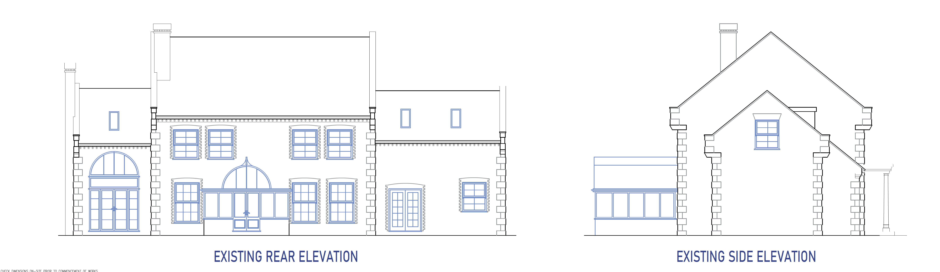
Existing rear and side elevations

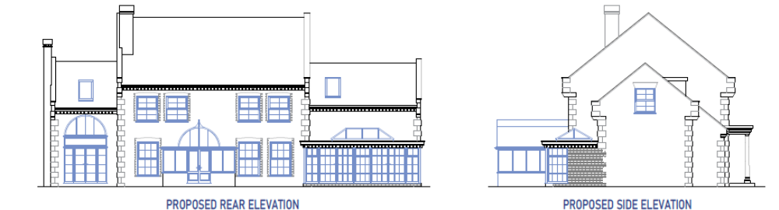
Proposed rear and side elevations

Plans and Documents Considered (Received 16th February 2022)
21005.S.PP-30 Existing Ground Floor Plan
21005.S.PP-31 Existing Elevations
21005.S.PP-32 Proposed Ground Floor Plan
21005.S.PP-34 Location Plans
21005.S.PP-35 Block Plan
21005.S.PP-33 Rev A Proposed Elevations (Received 22/06/2022)

Email from agent dated 17th May confirming matching materials.
Email from agent dated 22nd June confirming new Velux windows to project 0.075m

RELEVANT PLANNING HISTORY
None

CONSULTATIONS
No consultations were undertaken as it is not required for an application of this type.
Agent has sent in revised drawings to match description of proposal.

Equality Act 2010:
In determining this application the Council is required to have regard to its obligations under the Equality Act 2010. However, there is no indication or evidence (including from consultation on the application) that the protected groups identified by the Act have or will have different needs, experiences, issues and priorities in relation to this particular planning application. Therefore in terms of the key equalities protected characteristics it is considered there would be no significant adverse impacts as a result of the development.

RELEVANT PLANNING POLICY & GUIDANCE
National Planning Practice Guidance
The Town and Country Planning (General Permitted Development) (England) Order 2015 (GPDO)
Permitted development rights for householders – Technical Guidance September 2019

ASSESSMENT (Class A)
A Certificate of Lawfulness for a Proposed Development has been submitted as the applicant considers the proposal falls within the permitted development rights of the property.

The proposal must be assessed to ensure that it complies with the conditions Class A, Part 1, Schedule 2 of the Town and Country Planning (General Permitted Development) (England) Order 2015 (as amended), which relates to ‘The enlargement, improvement or other alteration of a dwellinghouse’.

A.1 Development is not permitted by Class A if:

A.1 (a) permission to use the dwellinghouse as a dwellinghouse has been granted only by virtue of Class M, N, P or Q of Part 3 of this Schedule (changes of use) Complies
A.1 (b) as a result of the works, the total area of ground covered by buildings within the curtilage of the dwellinghouse (other than the original dwellinghouse) would exceed 50% of the total area of the curtilage (excluding the ground area of the original dwellinghouse) Complies
A.1 (c) the height of the part of the dwellinghouse enlarged, improved or altered would exceed the height of the highest part of the roof of the existing dwellinghouse N/A
A.1 (d) the height of the eaves of the part of the dwellinghouse enlarged, improved or altered would exceed the height of the eaves of the existing dwellinghouse N/A
A.1 (e) the enlarged part of the dwellinghouse would extend beyond a wall which (i) forms the principal elevation of the original dwellinghouse; or (ii) fronts a highway and forms a side elevation of the original dwellinghouse Complies
A.1 (f) subject to paragraph (g), the enlarged part of the dwellinghouse would have a single storey and – (i) extend beyond the rear wall of the original dwellinghouse by more than 4 metres in the case of a detached dwellinghouse, or 3 metres in the case of any other dwellinghouse, (ii) exceed 4 metres in height Complies
A.1 (g) for a dwellinghouse not on article 2(3) land nor on a site of special scientific interest, the enlarged part of the dwellinghouse would have a single storey and – (i) extend beyond the rear wall of the original dwellinghouse by more than 8 metres in the case of a detached dwellinghouse, or 6 metres in the case of any other dwellinghouse, or (ii) exceed 4 metres in height Complies
A.1 (h) the enlarged part of the dwellinghouse would have more than a single storey and – (i) extend beyond the rear wall of the original dwellinghouse by more than 3 metres, or (ii) be within 7 metres of any boundary of the curtilage of the dwellinghouse opposite the rear wall of the dwellinghouse N/A
A.1 (i) the enlarged part of the dwellinghouse would be within 2 metres of the boundary of the curtilage of the dwellinghouse, and the height of the eaves of the enlarged part would exceed 3 metres Complies
A.1 (j) the enlarged part of the dwellinghouse would extend beyond a wall forming a side elevation of the original dwellinghouse, and would – (i) exceed 4 metres in height, (ii) have more than a single storey, or (iii) have a width greater than half the width of the original dwellinghouse N/A
A.1 (k) it would consist of or include – (i) the construction or provision of a verandah, balcony or raised platform (ii) the installation, alteration or replacement of a microwave antenna, (iii) the installation, alteration or replacement of a chimney, flue or soil and vent pipe, or (iv) an alteration to any part of the roof of the dwellinghouse N/A
A.2 In the case of a dwellinghouse on article 2(3) land, development is not permitted by Class A if: N/A

CONDITIONS
Development is permitted by Class A subject to the following conditions:

A.3 (a) the materials used in any exterior work (other than materials used in the construction of a conservatory) must be of a similar appearance to those used in the construction of the exterior of the dwellinghouse Complies as per email sent by agent 17th May 2022
A.3 (b) any upper-floor window located in a wall or roof slope forming a side elevation of the dwellinghouse must be (i) obscure-glazed, and (ii) non-opening unless the parts of the window which can be opened are more than 1.7 metres above the floor of the room in which the window is installed N/A

A.3 (c) where the enlarged part of the dwellinghouse has more than a single storey, or forms an upper storey on an existing enlargement of the original dwellinghouse, the roof pitch of the enlarged part must, so far as practicable, be the same as the roof pitch of the original dwellinghouse N/A

CONCLUSION
Sufficient evidence has been provided to demonstrate that a Certificate of Lawfulness should be granted for the proposal to build an extension, 2.996 metres to the rear and 2.6 metres in height.

The proposal has been assessed against the Town and Country Planning Act 1990 (as amended) and Class A, Part 1, Schedule 2 of the Town and Country Planning (General Permitted Development) (England) Order 2015 (as amended) and it has been confirmed that the proposal would be lawful for planning purposes on the basis of the following drawings and information:
Drawing No 21005.S.PP-32 Proposed Ground Floor Plan received 16th February 2022
Drawing No 21005.S.PP-33 Proposed Elevations received 16th February 2022
Drawing No 21005.S.PP-35 Block Plan received 16th February 2022
and emails received from Agent 17th May 2022 and 22nd June 2022

Informatives
Building Regulations
Construction and Demolition
Encroachment and Party Wall Act

RECOMMENDATION: GRANT CERTIFICATE

