DELEGATED HOUSEHOLDER APPLICATION REPORT

Ward: Norcot
App Ref: 211873/HOU
Address: 50 Amblecote Road, Tilehurst, Reading, RG30 4BP
Proposals: Proposed erection of part single part two storey side and rear extension to dwelling.
Case Officer: Chukwudi Onwudinanti
Applicant: Mr J Fijalkowski
Date received (valid from): 18 November 2021
Target Decision date: 29 April 2022

1. INTRODUCTION
The site is a two storey semi-detached dwelling on the Southern side of Amblecote road, in a predominantly residential area. It is among buildings of similar style and size on the same side of the street and bungalows on the other side of the street.
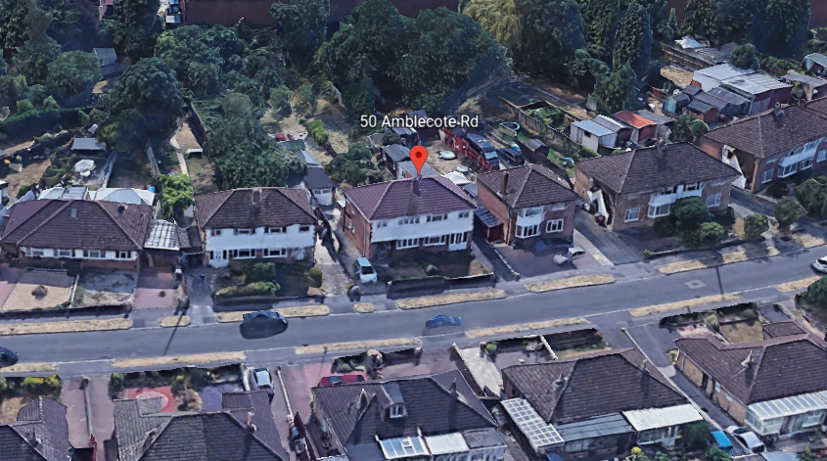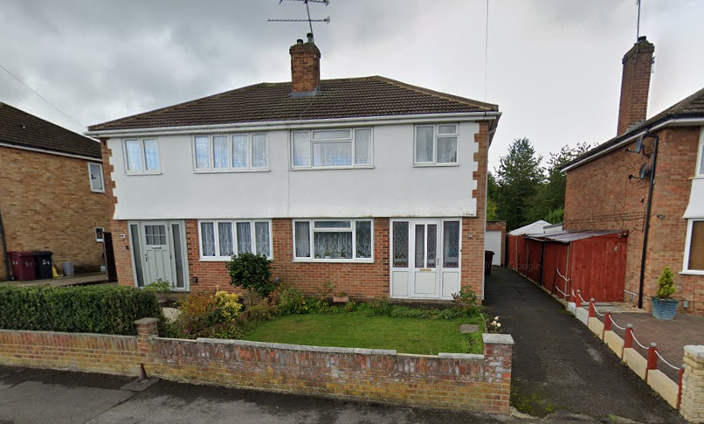

2. PROPOSAL AND SUPPORTING INFORMATION

The proposal is to erect a part single, part two storey side and rear extension to the original dwelling. This proposal will increase the dwelling by approximately 1.2m to the side and 1.1m to the rear.

Plans considered (Received 18th December 2021)
Drawing NO 05: Existing Block plan
Drawing NO 16: Proposed Block plan
Drawing NO 01: Existing Ground & First Floor plans
Drawing NO 11: Proposed Ground & First Floor plans
Drawing NO 02: Existing Roof plan
Drawing NO 12: Proposed Roof plan
Drawing NO 03: Existing Elevations
Drawing NO 13: Proposed Elevations
Drawing NO 20 : Loss of Light Assessment
Drawing NO 20 REV A : Loss of Light Assessment

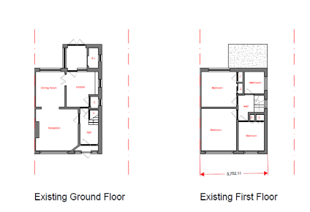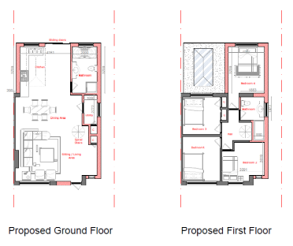

- RELEVANT PLANNING HISTORY

None

4. CONSULTATIONS

4.1 The following addresses were consulted by letter.

46 Amblecote Road, Tilehurst, Reading, RG30 4BP
48 Amblecote Road, Tilehurst, Reading, RG30 4BP
52 Amblecote Road, Tilehurst, Reading, RG30 4BP
Unit 5, Marcus Close, Tilehurst, Reading, RG30 4EA

4.2 No letters of representation have been received objecting to the proposal, however there has been a representation form the neighbour, requesting that a party wall be erected by the applicant as agreed between them. This request has been passed on to the applicant.

In their correspondence with the agent, the PO advised the agent to submit a loss of light assessment drawing to better determine the impact of the proposed extension on the neighbouring properties on both sides. These have subsequently been provided.

Equality Act 2010:
In determining this application the Council is required to have regard to its obligations under the Equality Act 2010. However, there is no indication or evidence (including from consultation on the application) that the protected groups identified by the Act have or will have different needs, experiences, issues and priorities in relation to this particular planning application. Therefore in terms of the key equalities protected characteristics it is considered there would be no significant adverse impacts as a result of the development.

- LEGAL AND PLANNING POLICY CONTEXT

Section 38(6) of the Planning and Compulsory Purchase Act 2004 requires that proposals be determined in accordance with the development plan unless material considerations indicate otherwise. Material considerations include relevant policies in the National Planning Policy framework (NPPF) - among them the 'presumption in favour of sustainable development'. The following local and national planning policy and guidance is relevant to this application:

National Policy
National Planning Policy Framework
National Planning Practice Guidance

Reading Borough Local Plan (2019)
CC7 (Design and the Public Realm)
CC8 (Safeguarding Amenity)
H9 (House Extensions and Ancillary Accommodation)

SPG/SPD
- A Design Guide to House Extensions SPG

6. APPRAISAL

H9 states: An extension to a house will be acceptable where it:

- Respects the character of the house in terms of scale, location, materials and design;

To assess this, the following has been considered – would the proposal:
- detract from the appearance of the original building through the use of ill-matching materials and by not fitting in with the design, scale and proportions of the original building; NO, the size and footprint of the original dwelling is increased but the size of the extension has been considered by the PO to still be subservient to the original dwelling.
- reduce the amount of usable amenity space for the property to an unacceptable degree; NO
- require the loss of trees in the garden or put significant trees at risk; NO

- Respects the character and pattern of neighbouring properties and the street as a whole in terms of scale, location, materials and design, and any important existing building line; Respects neighbour’s amenities and does not present a large blank façade to public areas.

To assess this, the following has been considered – would the proposal:
- significantly reduce the amount of daylight and sunlight enjoyed by neighbouring properties; NO, the 45 degree rule has been used by the applicant to show that there is no loss of light on both sides of the proposal, caused by the extension as proposed.
- invade the privacy of neighbouring properties through overlooking from windows or balconies; NO, there are no windows to the sides of the extension.
- detract from the character of neighbouring properties through siting, excessive bulk, ill-matching materials or inconsistent design; NO
- detract from the appearance of the street or area by using ill-matched materials, glazing and detailing; NO

CC8: Safeguarding Amenity states an extension to a house will be acceptable where it will not cause a significant detrimental impact to the living environment of existing or new residential properties.

To assess this, the following has been considered – would the proposal cause a significant detrimental impact to the living environment of existing or new residential properties in terms of:

- Privacy and overlooking;
- Access to sunlight and daylight;
- Visual dominance and overbearing effects of a development;
- Noise and disturbance;
- Artificial lighting;
- Vibration;
- Dust and fumes;
- Smell;
- Crime and safety.

- CONCLUSION
The proposed development has been assessed and the proposed works are considered to be in accordance with the above relevant policies and planning permission can be granted.

8.0 RECOMMENDATION
Grant

