DELEGATED APPLICATION REPORT Target Date: 19/03/21
Application No: 201107/FUL
Address: 267-271 Oxford Road
Proposal: Change of use from motorcycle sales and workshop (Sui Generis) to retail shop (Class E), with alterations to shop front (retrospective)
Case Officer: Tom Hughes
Site Description and Surrounding Area
The application site comprises a triple-unit single storey mid-terraced premises, located to the east of Reading West railway station. The site is within Castle Hill/Russell Street/Oxford Road Conservation Area, Oxford Road District Centre and a Reading High Streets Heritage Action Zone. The pre-existing use of 267-271 Oxford Road was a premises for motorcycle sales, repair and serving. At the time of the application, the frontage comprised a large, central, glazed opening, with vertical fenestration to each side and an over-size fascia board above. A small forecourt area was previously used for the display of motorcycles. During the course of the application, the proposals applied for have been partially implemented and the use commenced. Development not included within the proposal has also been undertaken.
Proposal
The proposal is for the change of use of the premises from a motorcycle sales and workshop (Sui Generis) to a retail shop (Class E), with various alterations to the shop front (retrospective). The shop front alterations include the installation of new fenestration and entrance doors, installation of stall risers and painting, and the provision of retractable awnings.
Plans Considered
The agent supplied the following, received 04/08/20:
Drawing No: 936/02 – Site Location and Block Plan
Drawing No: 936/01 – Existing and Proposed Floor Plans and Elevations
On 23/09/20 the agent was requested to clarify to the type of use proposed and the intentions for the forecourt area. Attention was also drawn to the site location within a Reading High Street Heritage Action Zone, Conservation Area and District Centre. Additional information, and improvements to the shopfront, were requested.
Subsequently the agent supplied the following, received 25/09/20:
Heritage details, maps and records
Subsequently the agent supplied the following, received 19/10/20:
Drawing No: 936/01 Rev. A – Existing and Proposed Floor Plans and Elevations
Subsequently the agent supplied the following, received 10/03/21:
Drawing No: 936/01 Rev. B – Existing and Proposed Floor Plans and Elevations
On 17/03/21 the agent was advised of further issues with the proposed shop front alterations.
Subsequently the agent supplied the following, received 17/03/21:
Drawing No: 936/01 Rev. C – Existing and Proposed Floor Plans and Elevations
Relevant Planning History
None.
Consultation Responses
Neighbouring owners and occupiers at 178-190 (evens) and 265-273 (odds) Oxford Road and 8-12 (evens) Ormsby Street were consulted by letter. A site notices was displayed. No letters of representation were received.
Reading Borough Transport Development Control
The site is located in Zone 2, Primary Core Area, of the Revised Parking Standards and Design SPD. Red Route operates along the Oxford Road preventing on street parking. This zone directly surrounds the Central Core Area and extends to walking distances of 2km from the centre of Reading. Typically this zone is well served by public transport, with buses continuing either into or out of the Central Core Area via this zone.
There are currently two dropped kerbs outside the site. Given the change of use will not require dropped kerbs to service the proposed unit as there are delivery bays further along the road, the existing dropped kerbs will require reinstating in line with the footway, and a license will be required from the Highways Department to undertake works on any part of the Highway. It should be noted that parking is not permitted on any part of the public footway.
It is considered that in this location the proposed change of use will have a negligible impact in terms of Transport and therefore there are no Transport objections to the proposed development.
Reading Borough Conservation and Urban Design Officer
There is an extant 19th century villa in the middle of the original lot, which is set back about 25m from Oxford Road. About 1905, the forecourt of the villa was filled in with the current commercial building. The site is located on the edge of a conservation area, slightly east of West Reading Railway Station. The premises has recently changed its use from motorcycle sales to a supermarket.

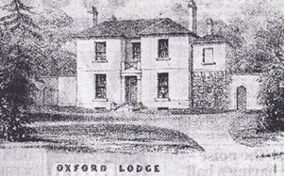 | 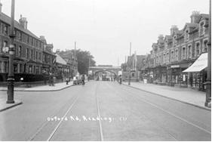
Fig 1. Original Oxford Lodge, mid-19th century. | Fig.2. Historic Photo, circa 1910.

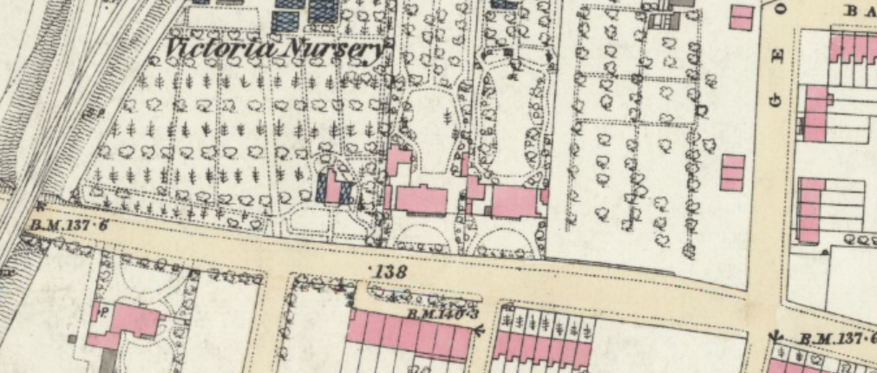
Map.1. Original 19th century Villa, now sited behind shops, circled in red.
Source: Ordnance Survey. Berkshire XXXVII.3 (Reading)
Surveyed: 1875, Published: 1879. (National Library of Scotland).

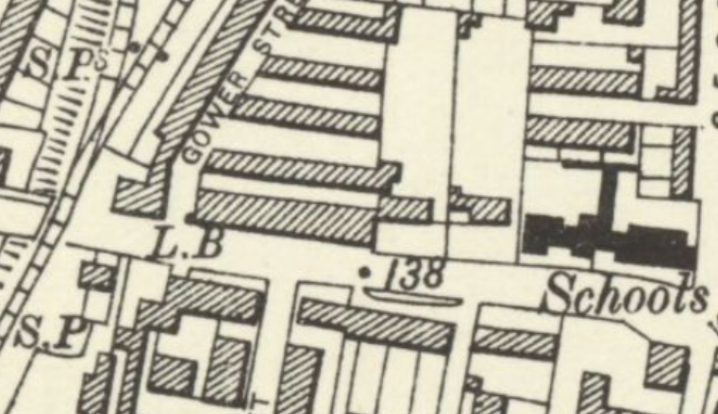
Map 1: Ordnance Survey; Berkshire XXXVII.NE (includes: Earley; Reading.)
Revised: 1898, Published: 1900

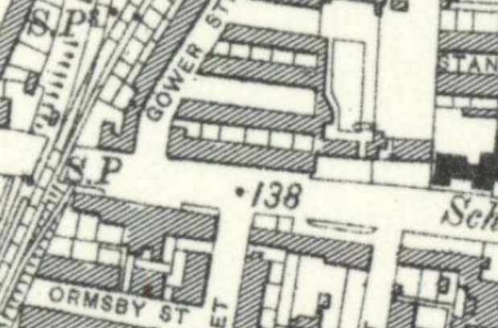
Map 2: Ordnance Survey; Berkshire XXXVII.NE (includes: Earley; Reading.)
Revised: 1909 to 1910, Published: 1913

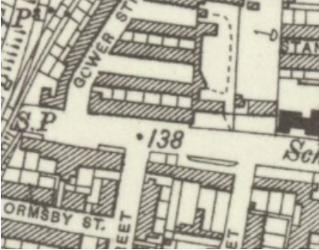
Map 3. OS: Berkshire XXXVII.NE (includes: Earley; Reading.)
Revised: 1931 to 1933, Published: ca. 1936

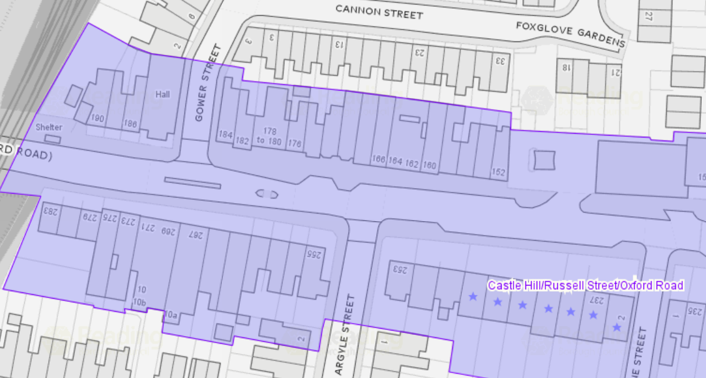
Map. 4. OS: 267-271 Oxford Street

The site was visited by the CUDO, Bruce Edgar on Wednesday 27.01.2021 and up to date photos were taken then.
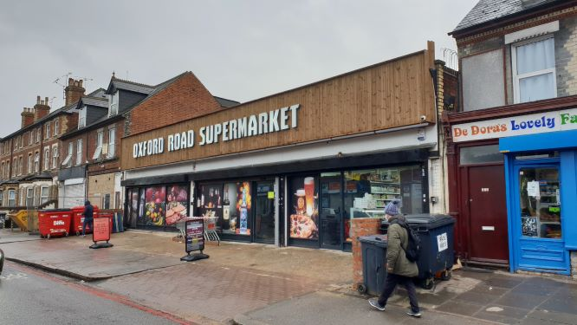
Fig 1. Current photo taken on 27.01.2021. The shop front has been installed before approval.

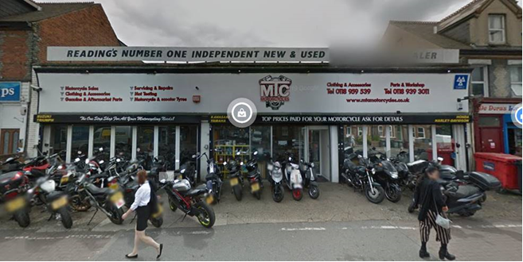
Fig 2. Photo of previous motorbike shop. 2020.

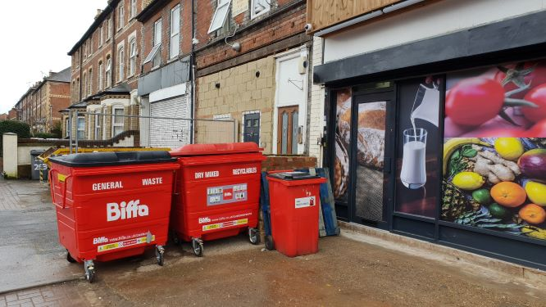 | 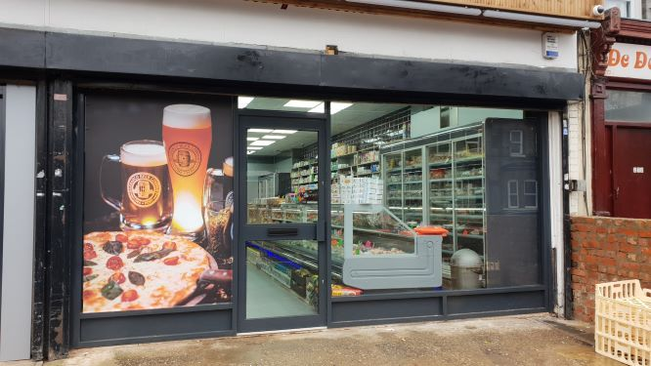
Fig 3. | Fig 4.

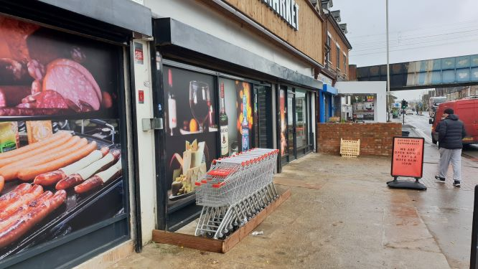 | 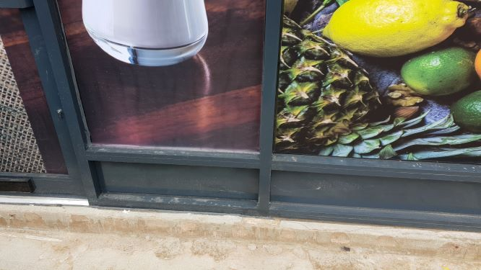
Fig 5. | Fig 6.

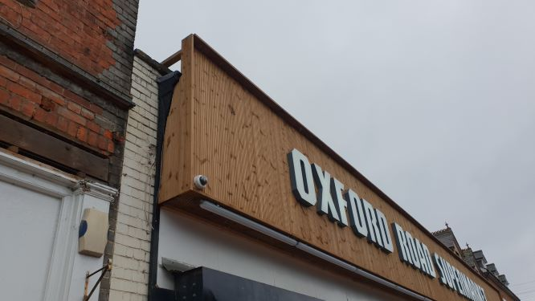 | 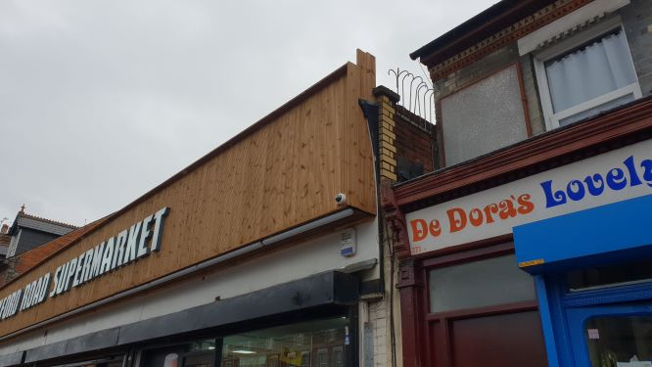
Fig 7. | Fig 8.

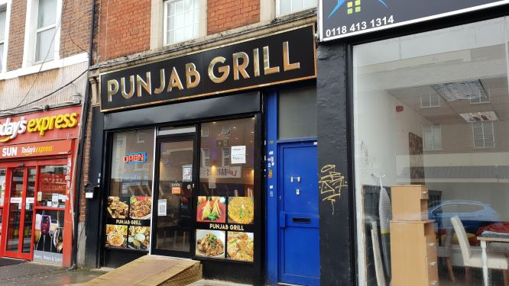 | 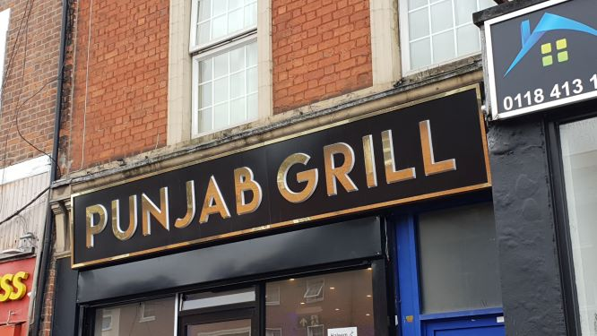
Fig 9. | Fig 10.

The shop is within a Conservation Area, and part of a Heritage Action Zone project to upgrade Oxford Road. Further to internal Council officer meeting (PO, CUDO & HAZ) about the application, we request the agent address the following information and take on board our design comments. The NPPF, gives guidance that proposed works in areas like this should be an enhancement to the character and significance of the property.
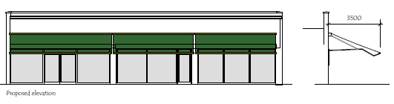
Fig 11. As part of the application the agent was asked to make the new shop fronts
in timber and have a stall riser component.

1. As part of the shopfront application negotiations the agent was asked to make the new shop fronts in timber and have a stall riser component. Although the application has not been officially approved, the owner has done what was asked and would be approved. (See Figs 4 & 6).
2. Other outstanding issues in regard to the shopfront application:
a. The owner has placed a number of trolleys outside the shop on the pavement area, within a small hob on the pavement.
Action required: The trolleys should be kept within the shop and details of this should be submitted for approval with shop-front application. Also the outside hob should be removed.
b. A screened area should be made adjacent the eastern boundary, to hide the waste disposal bins.
Action required: Details should be submitted for this item as part of the shop front approval.
c. Photographic images have been placed on the outside of new shopfront glazing.
Action required: The images should ideally be placed behind the glazing.
d. The final finish of the columns faces between the three shopfronts and finish of the base concrete plinth of left-hand shopfront needs to be submitted resolved.
Action required: Material details need to be submitted for approval.
3. No application submitted, but signage has been installed on site.
See figs 1, 7 & 8.
4. There are concerns about the existing unapproved signage and it needs to be modified and a new application submitted.
a. The newly installed signage backing board is too large and the wrong material.
Its height should be reduced back to below the original cornice detail and reinstate the original shop brick parapet and coping.
b. A new smaller weatherproof painted board, should be installed for the signage panel. The cost of the new signage lettering is noted, and it could be remounted on a new backing board. Details of this should be submitted for approval.
c. It is proposed that the unapproved sign could remain in-situ temporarily, while the new signage is being approved, but it this is only for a limited time.
These notes should be forwarded to the agent and owner for their action and submission of details for the shopfront application pavement works as well as a new signage application.
Equality Act 2010
In determining this application, the Council is required to have regard to its obligations under the Equality Act 2010. However, there is no indication or evidence (including from consultation on the application) that the protected groups identified by the Act have or will have different needs, experiences, issues and priorities in relation to this particular planning application. Therefore in terms of the key equalities protected characteristics it is considered there would be no significant adverse impacts as a result of the development.
Relevant Planning Policy and Guidance
The following local and national planning policy and guidance is relevant to this application:
National Planning Policy Framework
Planning (Listed Buildings and Conservation Areas) Act 1990
Reading Borough Local Plan (2019)
Policy CC1 – Presumption in Favour of Sustainable Development
Policy CC2 – Sustainable Design and Construction
Policy CC3 – Adaption to Climate Change
Policy CC5 – Waste Minimisation and Storage
Policy CC6 – Accessibility and the Intensity of Development
Policy CC7 – Design and the Public Realm
Policy CC8 – Safeguarding Amenity
Policy EN1 – Protection and Enhancement of the Historic Environment
Policy EN3 – Enhancement of Conservation Areas
Policy EN6 – New Development in a Historic Context
Policy EN12 – Biodiversity and the Green Network
Policy EN18 – Flooding and Drainage
Policy EM1 – Provision of Employment
Policy EM4 – Maintaining a Variety of Premises
Policy TR3 – Access, Traffic and Highway-Related Matters
Policy TR5 – Car and Cycle Parking and Electric Vehicle Charging
Policy RL1 – Network and Hierarchy of Centres
Policy RL3 – Vitality and Viability of Smaller Centres
Policy OU4 – Advertisements
Policy OU5 – Shopfronts and Cash Machines
Reading Borough Revised Parking Standards and Design SPD (2011)
Reading Borough Sustainable Design and Construction SPD (2019)
Castle Hill/Russell Street/Oxford Road Conservation Area Appraisal (2020)
Appraisal
Principle of development
On 21st July 2020 the Government published The Town and Country Planning (Use Classes) (Amendment) (England) Regulations 2020, which came into force on 1st September 2020. Amongst other changes, the former Part A use classes were revoked and a new Class E (Commercial, Business and Service) was introduced. Class E covers the former use classes of A1 (shops), A2 (financial and professional services), A3 (restaurants and cafes) and parts of D1 (non-residential institutions) and D2 (assembly and leisure). Retail shops now fall within Class E. Accordingly, the proposals are for a change of use from a Sui Generis use to Class E.
The site is located within Oxford Road West District Centre. Policies RL1 and RL3 seek to ensure that the vitality and viability of centres is maintained and enhanced. The policies set out to retain a strong element of retail in the core of each centre, since retail is the primary contributor to vitality and viability. Due to the amendment of the Regulations, the LPA’s control on retaining a significant retail element has been weakened. Nonetheless, ensuring that the vitality and viability of centres remains is still of primary importance. By introducing a new retail use to the District Centre, the proposals are in accordance with these policies. On this basis, the principle of the change of use is acceptable.
The Castle Hill/Russell Street/Oxford Road Conservation Area Appraisal notes the site as one which presents opportunities for enhancement. This is consolidated by the location within a Reading High Street Heritage Action Zone. While the specific alterations to the shop front will be addressed below, the principle of making improvements to the pre-existing frontage is acceptable.
Design and impact on the character of the surrounding area
The Conservation Area Appraisal notes 267-271 Oxford Road as concealing the historic villa, Oxford Lodge, directly behind it, though its roof can be seen from Gower Street opposite the site. The pre-existing façade, scale, appearance and set back of the premises are noted as being discordant with the remainder of the area. The Conservation Area Appraisal notes several negative features of the Conservation Area including modern shop fronts which have destroyed the original 19th century retail frontages; garish, irregularly sized retail signage that destroys a sense of harmony along the retail corridor; and poorly kept retail frontages extending to the pavement and detracting from the traditional street line, causing issue with pedestrian flow. 267-271 Oxford Road is noted as a site which presents opportunities for enhancement.
During the course of the application, the development proposed has been partially implemented. Further physical alterations to the frontage, not included within the proposed development have also been installed.

It is considered that the large size of the fascia, the modern form, appearance and visual prominence as well as the use of unsympathetic materials comprising the shopfront are harmful to the appearance of the host building and the character and appearance of the wider conservation area.

RECOMMENDATION
REFUSE

