DELEGATED HOUSEHOLDER APPLICATION REPORT

Ward: Mapledurham
App Ref: 212048/HOU
Address: Donaldswood, Upper Warren Avenue, Caversham, Reading, RG4 7EJ
Proposals: First floor rear extension.
Case Officer: Chukwudi Onwudinanti
Applicant: Mr J Cassidy
Date received (valid from): 19 December 2021
Target Decision date: 28 April 2022

1. INTRODUCTION
This site is located North of the intersection of Graveney Drive and Upper Warren Avenue. It is a detached two storey dwelling siting on a plot of approximately 1600sqm, with neighbouring properties to the two sides and none near to the rear. The view to the rear is shielded by large mature trees, with thick leafy covers.
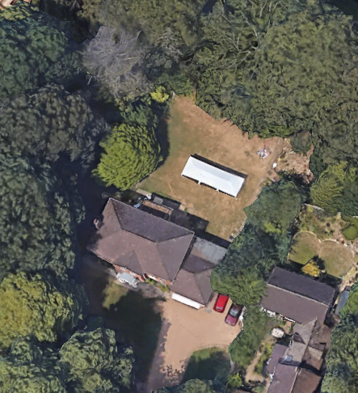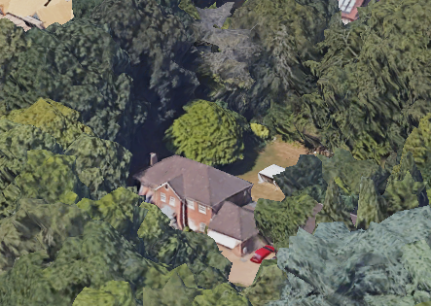

2. PROPOSAL AND SUPPORTING INFORMATION

The proposal is for a first floor rear extension, measuring approximately 4.1 wide and 2.4m deep, extending upwards from the existing ground floor family room to create an extended Bedroom and Bathroom upstairs.

Plans considered (Received 20th December 2021)
Drawing NO. 01 A : Existing Plans & Elevations
Drawing NO. 02 A : Proposed plans & Elevations

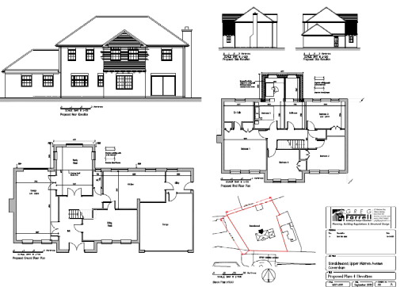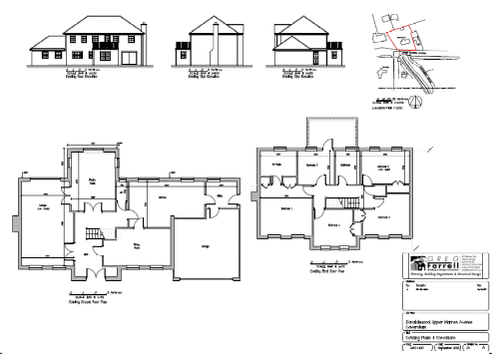

- RELEVANT PLANNING HISTORY

None

4. CONSULTATIONS

4.1 The following addresses were consulted by letter.

5 Mapledene, Caversham, Reading, Berkshire, RG4 7DQ
4 Mapledene, Caversham, Reading, RG4 7DQ
Quarry House, 3 Mapledene, Caversham, Reading, RG4 7DQ
5 Graveney Drive, Caversham, RG4 7EG
10a Upper Warren Avenue, Caversham, Reading
8A Upper Warren Avenue, Caversham, Reading

4.2 RBC ecology were consulted and a BAT Report was advised. The agent subsequently submitted a BAT Report which RBC Ecology confirmed to be acceptable and confirmed that no Bat habitats were present and no danger to bats were presented by the application.

Natural Environment were consulted and their advice included the following:
Please also attach Informatives I15 (amended) and I24 to clearly indicate the importance of trees:
I15 Advice about TPO.d trees
You are advised that no tree works are approved by virtue of this consent. Any works to trees subject to a Tree Preservation Order will require submission of a tree works application.
I24 Do not damage the verge
You are advised to avoid the use of the grass verges for development related activity, e.g. storage of materials, due to the resulting potential harm to important street trees.

Equality Act 2010:
In determining this application the Council is required to have regard to its obligations under the Equality Act 2010. However, there is no indication or evidence (including from consultation on the application) that the protected groups identified by the Act have or will have different needs, experiences, issues and priorities in relation to this particular planning application. Therefore in terms of the key equalities protected characteristics it is considered there would be no significant adverse impacts as a result of the development.

- LEGAL AND PLANNING POLICY CONTEXT

Section 38(6) of the Planning and Compulsory Purchase Act 2004 requires that proposals be determined in accordance with the development plan unless material considerations indicate otherwise. Material considerations include relevant policies in the National Planning Policy framework (NPPF) - among them the 'presumption in favour of sustainable development'. The following local and national planning policy and guidance is relevant to this application:

National Policy
National Planning Policy Framework
National Planning Practice Guidance

Reading Borough Local Plan (2019)
CC7 (Design and the Public Realm)
CC8 (Safeguarding Amenity)
H9 (House Extensions and Ancillary Accommodation)

SPG/SPD
- A Design Guide to House Extensions SPG

6. APPRAISAL

H9 states: An extension to a house will be acceptable where it:

- Respects the character of the house in terms of scale, location, materials and design;

To assess this, the following has been considered – would the proposal:
- detract from the appearance of the original building through the use of ill-matching materials and by not fitting in with the design, scale and proportions of the original building; NO, the extension is to the rear and is only an upward extension on the existing ground floor space.
- reduce the amount of usable amenity space for the property to an unacceptable degree; NO
- require the loss of trees in the garden or put significant trees at risk; NO, there are no loss of trees to be caused by the proposal and adequate informative have been provided by the PO, on the advice of the Natural Environment Consultants, to protect the trees during works.

- Respects the character and pattern of neighbouring properties and the street as a whole in terms of scale, location, materials and design, and any important existing building line; Respects neighbour’s amenities and does not present a large blank façade to public areas.

To assess this, the following has been considered – would the proposal:
- significantly reduce the amount of daylight and sunlight enjoyed by neighbouring properties; NO, the extension is not close to any boundaries.
- invade the privacy of neighbouring properties through overlooking from windows or balconies; NO, the line of sight to any properties from the proposed windows are adequately shielded by mature trees all around the property.
- detract from the character of neighbouring properties through siting, excessive bulk, ill-matching materials or inconsistent design; NO
- detract from the appearance of the street or area by using ill-matched materials, glazing and detailing; NO

CC8: Safeguarding Amenity states an extension to a house will be acceptable where it will not cause a significant detrimental impact to the living environment of existing or new residential properties.

To assess this, the following has been considered – would the proposal cause a significant detrimental impact to the living environment of existing or new residential properties in terms of:

- Privacy and overlooking;
- Access to sunlight and daylight;
- Visual dominance and overbearing effects of a development;
- Noise and disturbance;
- Artificial lighting;
- Vibration;
- Dust and fumes;
- Smell;
- Crime and safety.

- CONCLUSION
The proposed development has been assessed and the proposed works are considered to be in accordance with the above relevant policies and planning permission can be granted.

8. RECOMMENDATION
Grant

