DELEGATED HOUSEHOLDER APPLICATION REPORT

Ward: Caversham
App Ref: 220307/HOU
Address: 28 Marsack Street, Caversham, Reading, RG4 5AP
Proposals: Removal of existing conservatory and erection of new single storey rear
Case Officer: Chukwudi Onwudinanti
Applicant: Beard
Date received (valid from): 3 March 2022
Target Decision date: 5 August 2022 (Ext)

1. INTRODUCTION
The proposal site is a semi-detached dwelling on the southern side of Marsack Street in Caversham. It is surrounded by buildings of similar style and size on the same side of Marsack street but buildings of varied styles on the opposite side of the street. The street is a mix of residential buildings on one side and office/commercial buildings on the other. There are external garages which link most of the buildings on the residential side of the street. To the rear is an exsiting conservatory of ca 3m in depth, adjacent to the neighbour’s single storey rear extension of a similar size. The proposal is neither in a conservation area or an article 4 direction site.

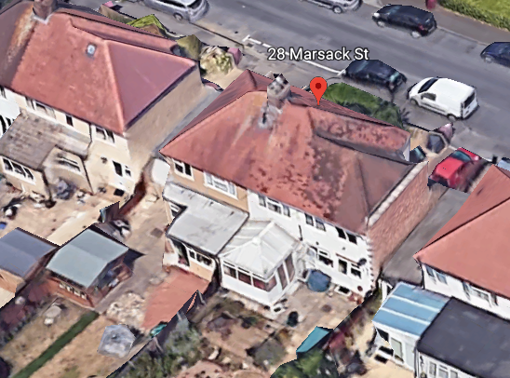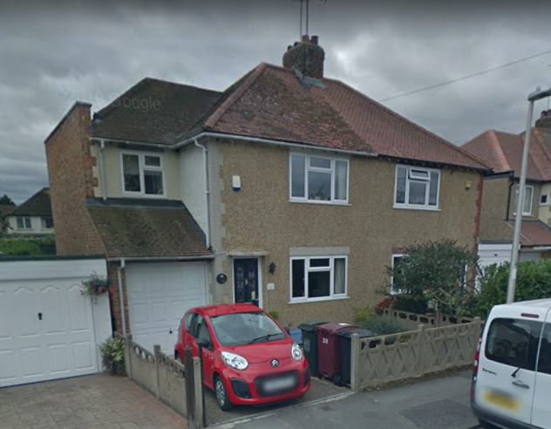

2. PROPOSAL AND SUPPORTING INFORMATION
The proposal is to remove the existing conservatory and erect a new single storey rear extension, measuring approximately 4.5m deep with a further ca 0.5 m deep roof overhang, and running the width of the existing building.
Plans considered received 3 March 2022
001 00 : Location Plan
002 00 : Block Plan
005 01 : Existing Plans and Elevations
010 02 : Proposed Plans and Elevations

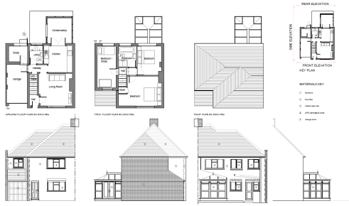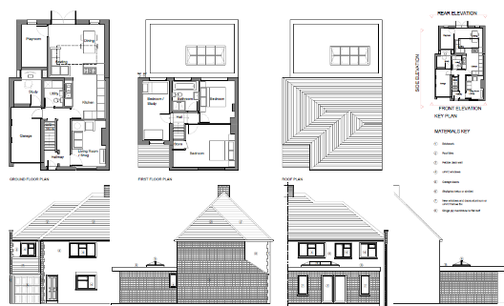

Existing Plans and Elevations Proposed Plans and Elevations

- RELEVANT PLANNING HISTORY
Application Ref : 021329
Description : Two storey side extension to dwelling
Decision : Permitted
Decision Date : 10 March 2003

4. CONSULTATIONS

4.1 The following addresses were consulted by letter.

26 Marsack Street, Caversham, Reading, Berkshire, RG4 5AP
23 Nelson Road, Caversham, Reading, RG4 5AT
30 Marsack Street, Caversham, Reading, RG4 5AP

4.2 No letters of representation have been received.

Equality Act 2010:
In determining this application the Council is required to have regard to its obligations under the Equality Act 2010. However, there is no indication or evidence (including from consultation on the application) that the protected groups identified by the Act have or will have different needs, experiences, issues and priorities in relation to this particular planning application. Therefore in terms of the key equalities protected characteristics it is considered there would be no significant adverse impacts as a result of the development.

- LEGAL AND PLANNING POLICY CONTEXT

Section 38(6) of the Planning and Compulsory Purchase Act 2004 requires that proposals be determined in accordance with the development plan unless material considerations indicate otherwise. Material considerations include relevant policies in the National Planning Policy framework (NPPF) - among them the 'presumption in favour of sustainable development'. The following local and national planning policy and guidance is relevant to this application:

National Policy
National Planning Policy Framework
National Planning Practice Guidance

Reading Borough Local Plan (2019)
CC7 (Design and the Public Realm)
CC8 (Safeguarding Amenity)
H9 (House Extensions and Ancillary Accommodation)

SPD
- Design Guide to House Extensions (2021)

6. APPRAISAL

H9 states: An extension to a house will be acceptable where it:

- Respects the character of the house in terms of scale, location, materials and design;

To assess this, the following has been considered – would the proposal:
- detract from the appearance of the original building through the use of ill-matching materials and by not fitting in with the design, scale and proportions of the original building; NO, while the proposal will increase the footprint of the original dwelling, the increase in the overall size is still deemed to fit with the scale, design and proportions of the original building.
- reduce the amount of usable amenity space for the property to an unacceptable degree; NO, part of the proposal is taking up the area of the demolished conservatory, so the additional amount of usable amenity space taken up by the rest of the proposal is not significant.
- require the loss of trees in the garden or put significant trees at risk; NO

- Respects the character and pattern of neighbouring properties and the street as a whole in terms of scale, location, materials and design, and any important existing building line; Respects neighbour’s amenities and does not present a large blank façade to public areas.

To assess this, the following has been considered – would the proposal:
- significantly reduce the amount of daylight and sunlight enjoyed by neighbouring properties; NO, all the aspects of the proposal are single storey , so while the extension goes about 1.5m deeper than the line of the neighbouring property, the flat roof of the proposal and the height raise no significant impact on the amount of daylight and sunlight enjoyed by the properties on Nos 26 and 30.
- invade the privacy of neighbouring properties through overlooking from windows or balconies; NO, there are no balconies proposed.
- detract from the character of neighbouring properties through siting, excessive bulk, ill-matching materials or inconsistent design; NO
- detract from the appearance of the street or area by using ill-matched materials, glazing and detailing; NO

CC8: Safeguarding Amenity states an extension to a house will be acceptable where it will not cause a significant detrimental impact to the living environment of existing or new residential properties.

To assess this, the following has been considered – would the proposal cause a significant detrimental impact to the living environment of existing or new residential properties in terms of:

- Privacy and overlooking;
- Access to sunlight and daylight;
- Visual dominance and overbearing effects of a development;

As stated in the appraisal above, the proposal is single storey and is not deemed to present privacy and overlooking issues on the neighbouring properties on Nos 26 and 30. The proposal is also deemed NOT to have any detrimental effects on these neighbours in terms of their access to sunlight and daylight. The proposal is not visually dominant nor overbearing.

- CONCLUSION
The proposed development has been assessed and the proposed works are considered to be in accordance with the above relevant policies and planning permission can be granted.

8. RECOMMENDATION
Grant

