Del report 220498 44 Pottery Rd
Single storey front porch extension and changes to fenestration.
Policy: DM9, CS7, design guide to house extensions
Consutations: neighbour letters sent to Nos. 42 and 46 and 21 Denby Way, no objections received.
Site notice issued to be displayed, assumer displayed for relevant period although no confirmed. Neighbour letters considered suitable in any event.
Relevant Planning History: no relevant/recent site history.
ASSESSMENT:
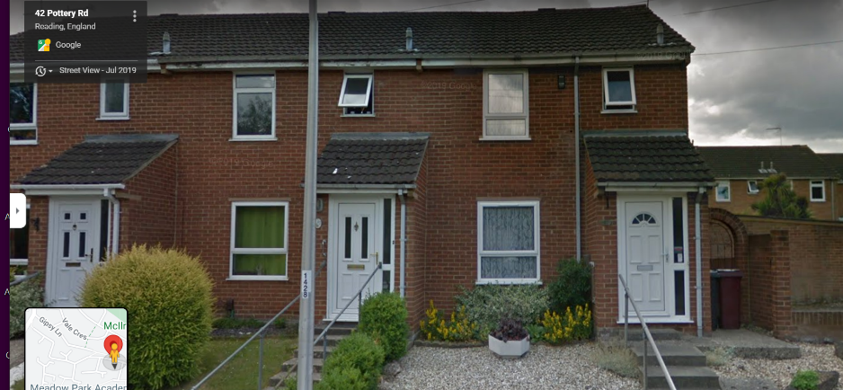
Modern end-of terrace property, set back and up from the road, the right-hand one below:

Proposal is a front extension, essentially extending across from the existing (original) porch across towards the neighbouring property boundary, an additional 1.7m. Gf window to lounge would be nudged further left, same current projection as porch (1.5m). Light to this room would be reduced, now being sited between its own porch and the neighbouring one, but open-plan living area has patio doors to rear (south). Very minor proposal. No additional impact on neighbour amenity, very limited streetscene impact, may even be permitted development, but this application has been assessed on its merits. Materials are proposed to match existing. Complies with above policies.
Equalities Act – no conflicts with the defined characteristics.
Recommendation: GRANT planning permission subject to below conditions and informatives:
Tl1 3 yrs
Ap1 plans
22.44PR.SITE Location and Block Plan
22.44PR.P02 Proposed ground floor plan and elevations
M1 Materials to match
Std informatives

