DELEGATED HOUSEHOLDER APPLICATION REPORT

Ward: Southcote
App Ref: 220115/HOU
Address: 41 Silchester Road, Reading, RG30 3EJ
Proposals: Two storey side extension
Case Officer: Chukwudi Onwudinanti
Applicant: Mrs J Spence
Date received (valid from): 8 March 2022
Target Decision date: 12 August 2022 (Ext)

1. INTRODUCTION
The site is an end of terrace dwelling on the Northern side of Silchester Road, close to the junction with Faircross Road, among other buildings of similar style and sizes. The area is predominantly residential. On the opposite side of the road is Southcote Primary school, stretching the length of Silchester Road.

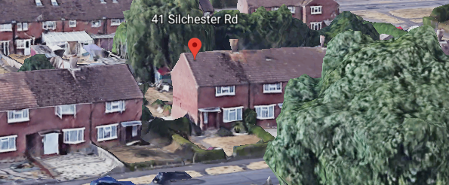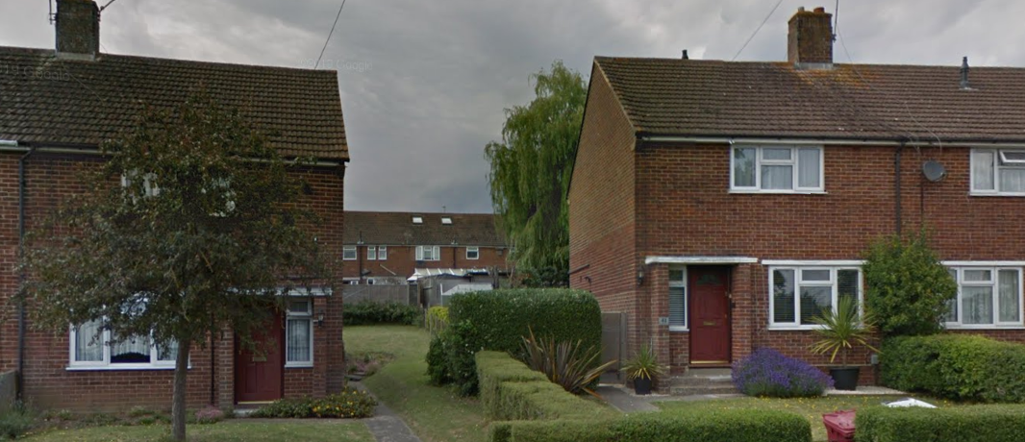

2. PROPOSAL AND SUPPORTING INFORMATION

The proposal is for a two storey side extension, stepped back from the principal elevation frontline, measuring approximately 5 metres to the side and … metres to the rear.

Plans considered
Received 25th January 2022
Location Plan
1221/1 Existing Ground Floor Plan
1221/4 Existing Elevations
1221/4B: Existing Elevations
Received 1st August 2022
1221/5A: Block Plan
1221/2B: Proposed Ground Floor Plan
1221/3B: Proposed First Floor Plan
1221/4B: Proposed Elevations

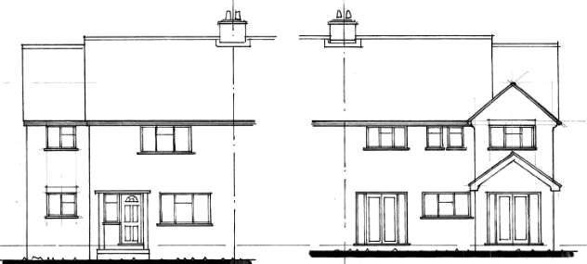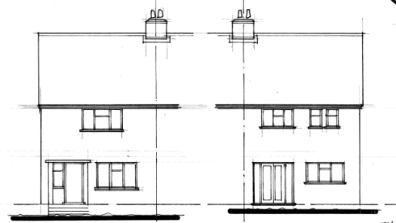
Proposed Elevations Existing Elevations

- RELEVANT PLANNING HISTORY

Application Ref: 201400
Description: Single storey side extension
Decision: Permitted

4. CONSULTATIONS

4.1 The following addresses were consulted by letter.

39 Silchester Road, Reading, Berkshire, RG30 3EJ
115 Southcote Lane, Reading, RG30 3AJ
113 Southcote Lane, Reading, RG30 3AJ
43 Silchester Road, Reading, RG30 3EJ

4.2 Natural Environment was consulted regarding the suspected willow tree at the rear of the property.

Natural Environments Comments:
“From the above photo, the tree is far enough away for us not to be worried about the extension impacting it (I note the location of the extension of the proposed Block Plan and measuring on iShare it seems roughly 15m from the trunk, if in the north corner of the garden, and the rear elevation of the extension). Willows have vigorous root systems so even if there was a minor impingement, it would cope, especially as the gardens surrounding it provide a favourable rooting environment.”

Equality Act 2010:
In determining this application the Council is required to have regard to its obligations under the Equality Act 2010. However, there is no indication or evidence (including from consultation on the application) that the protected groups identified by the Act have or will have different needs, experiences, issues and priorities in relation to this particular planning application. Therefore in terms of the key equalities protected characteristics it is considered there would be no significant adverse impacts as a result of the development.

- LEGAL AND PLANNING POLICY CONTEXT

Section 38(6) of the Planning and Compulsory Purchase Act 2004 requires that proposals be determined in accordance with the development plan unless material considerations indicate otherwise. Material considerations include relevant policies in the National Planning Policy framework (NPPF) - among them the 'presumption in favour of sustainable development'. The following local and national planning policy and guidance is relevant to this application:

National Policy
National Planning Policy Framework
National Planning Practice Guidance

Reading Borough Local Plan (2019)
CC7 (Design and the Public Realm)
CC8 (Safeguarding Amenity)
H9 (House Extensions and Ancillary Accommodation)

SPG/SPD
- Design Guide to House Extensions (2021)

6. APPRAISAL

H9 states: An extension to a house will be acceptable where it:

- Respects the character of the house in terms of scale, location, materials and design;

To assess this, the following has been considered – would the proposal:
- detract from the appearance of the original building through the use of ill-matching materials and by not fitting in with the design, scale and proportions of the original building; NO, while the side and rear extensions add 2.6m and 4.4m approximately to the side and rear of the original dwelling respectively, the proposal is considered not detract from the appearance of the original building in such a way as to be unacceptable. The materials to be used will match the existing external finishes, the frontline of the extension has been stepped back from the principal elevation and the ridgeline of the extended part has been stepped down for the original ridgeline, making the extension subservient to the original dwelling.
- reduce the amount of usable amenity space for the property to an unacceptable degree; NO, the PO has worked with the agent for this application to revise the original design for this proposal. The initial proposal was considered by the PO to be massive. The proposal has been subsequently reduced in size to an acceptable level.
- require the loss of trees in the garden or put significant trees at risk; NO, there are no trees in close proximity with the proposal or deemed to be at risk of damage as a result of carrying out the development.

- Respects the character and pattern of neighbouring properties and the street as a whole in terms of scale, location, materials and design, and any important existing building line; Respects neighbour’s amenities and does not present a large blank façade to public areas.

To assess this, the following has been considered – would the proposal:
- significantly reduce the amount of daylight and sunlight enjoyed by neighbouring properties;

NO, this application has been subjected to the 45 degree sunlight test and is not considered to be of any significant impact to the sunlight enjoyed by the neighbours on both sides, as a result of this development.

- invade the privacy of neighbouring properties through overlooking from windows or balconies;

NO, the only window to be installed at the side of the proposal overlooking the neighbours is annotated on the drawing to be obscured. It is however considered by the PO that it will be prudent to attach a PD2 condition of no new openings.

- detract from the character of neighbouring properties through siting, excessive bulk, ill-matching materials or inconsistent design;

NO, as discussed above, the initial drawings submitted for this proposal has been revised to mitigate the risk of excessive bulk and the design has been revised to better reflect the design of the original dwelling.

- detract from the appearance of the street or area by using ill-matched materials, glazing and detailing; NO

CC8: Safeguarding Amenity states an extension to a house will be acceptable where it will not cause a significant detrimental impact to the living environment of existing or new residential properties.

To assess this, the following has been considered – would the proposal cause a significant detrimental impact to the living environment of existing or new residential properties in terms of:

- Privacy and overlooking;
- Access to sunlight and daylight;
- Visual dominance and overbearing effects of a development;

As stated above in this report, the initial designs submitted with this application has been revised to become more acceptable in terms of its impact on the adjoining neighbours and the character of the street scene. Access to sunlight and daylight, as well as the effects of visual dominance have been tempered with the revisions made to ensure that the overall extension does safeguard the amenity within its location on Silchester Road.

- CONCLUSION
The proposed development has been assessed and the proposed works are considered to be in accordance with the above relevant policies and planning permission can be granted.

8.0 RECOMMENDATION
Grant

