DELEGATED HOUSEHOLDER APPLICATION REPORT

Ward: Park
App Ref: 212015/HOU
Address: 139 Wykeham Road, Reading, RG6 1PW
Proposals: New bay window to front. New cycle store to front garden. Construction of a single storey side extension.
Case Officer: Chukwudi Onwudinanti
Applicant: Mr & Mrs Florides
Date received (valid from): 14 December 2021
Target Decision date: 29th April 2022

1. INTRODUCTION
The proposal site is a mid-terrace dwelling standing on the eastern side of Wykeham Road, among rows of terraced buildings.

2. PROPOSAL AND SUPPORTING INFORMATION

The proposal is to introduce a new bay window to front, measuring 2.4m by 0.6m and a cycle store to front garden. It includes also construction of a single storey side extension measuring 6.4m by 1.4m, which seeks to close the existing gap between this terrace building and the one beside it. A metal cycle shed is also to be placed in the front garden of the dwelling.
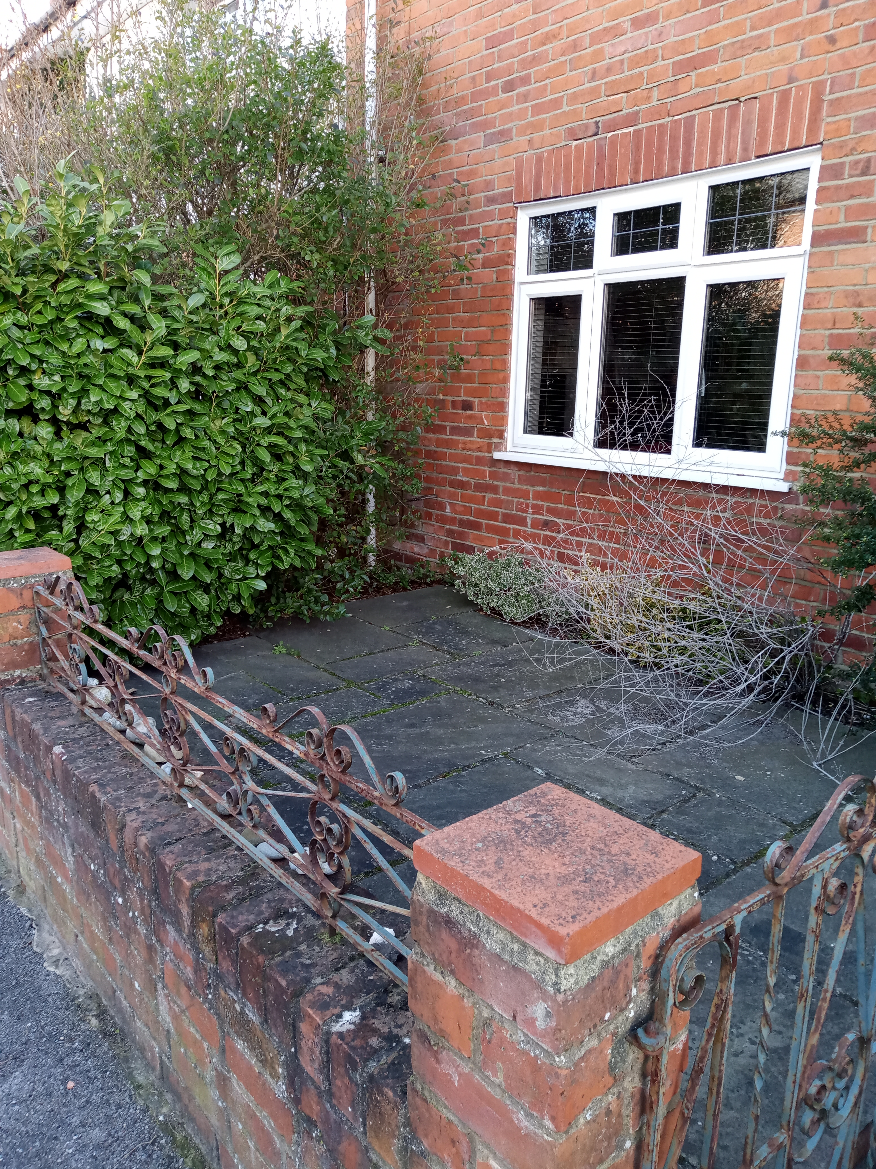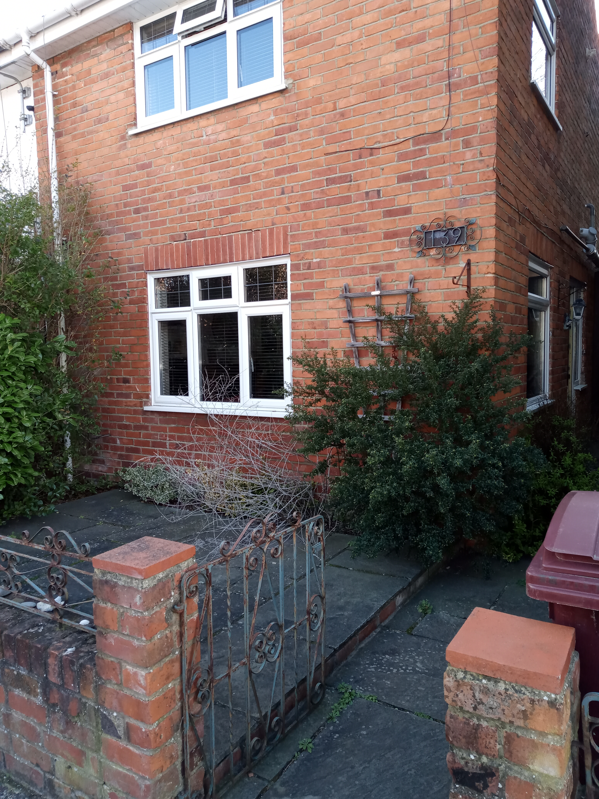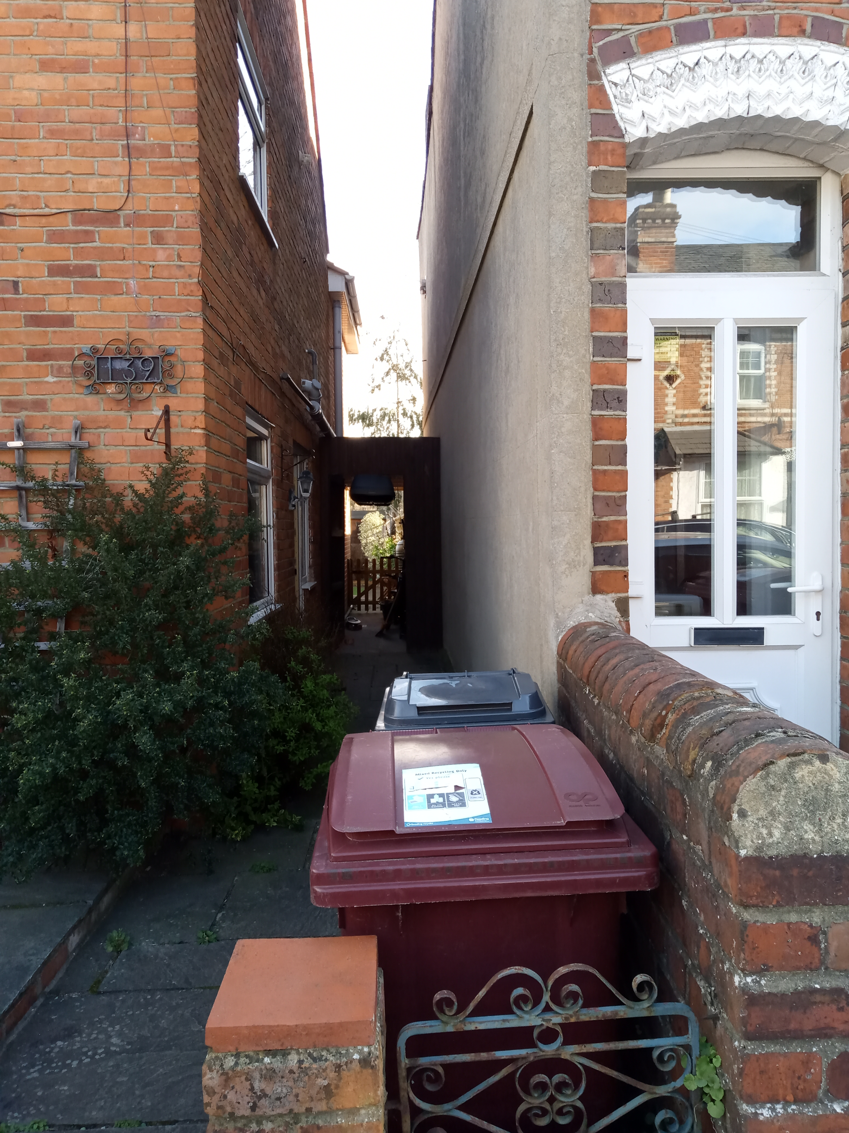
Site photos taken on 9th March 2022

Plans considered (Received 15th December 2021)
Site Location Plan
Block/Site Plan
Existing and Proposed Ground Floor and Elevations.
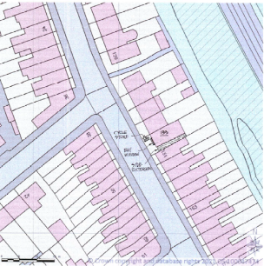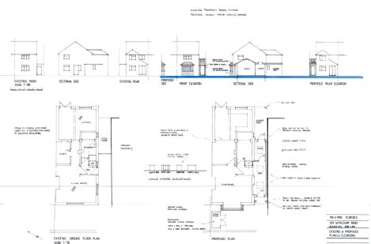

- RELEVANT PLANNING HISTORY

None

4. CONSULTATIONS

4.1 The following addresses were consulted by letter.

137 Wykeham Road, Reading, RG6 1PW
151 Wykeham Road, Reading, RG6 1PW

4.2 No letters of representation stating any objections have been received, however a letter of support have been received from the adjoining NO 151 Wykeham Road, as posted below :

Comment Type: Support
Comment: I confirm in writing I have no objection to this planning proposal Dec 2021

Equality Act 2010:
In determining this application the Council is required to have regard to its obligations under the Equality Act 2010. However, there is no indication or evidence (including from consultation on the application) that the protected groups identified by the Act have or will have different needs, experiences, issues and priorities in relation to this particular planning application. Therefore in terms of the key equalities protected characteristics it is considered there would be no significant adverse impacts as a result of the development.

- LEGAL AND PLANNING POLICY CONTEXT
Section 38(6) of the Planning and Compulsory Purchase Act 2004 requires that proposals be determined in accordance with the development plan unless material considerations indicate otherwise. Material considerations include relevant policies in the National Planning Policy framework (NPPF) - among them the 'presumption in favour of sustainable development'. The following local and national planning policy and guidance is relevant to this application:

National Policy
National Planning Policy Framework
National Planning Practice Guidance

Reading Borough Local Plan (2019)
CC7 (Design and the Public Realm)
CC8 (Safeguarding Amenity)
H9 (House Extensions and Ancillary Accommodation)

SPG/SPD
- A Design Guide to House Extensions SPG

6. APPRAISAL

H9 states: An extension to a house will be acceptable where it:

- Respects the character of the house in terms of scale, location, materials and design;

To assess this, the following has been considered – would the proposal:
- detract from the appearance of the original building through the use of ill-matching materials and by not fitting in with the design, scale and proportions of the original building; NO
- reduce the amount of usable amenity space for the property to an unacceptable degree; NO, the space between the proposal site and the next terrace is already a private access to the front door of the proposal site and is already in use for storage by the applicants.
- require the loss of trees in the garden or put significant trees at risk; NO

- Respects the character and pattern of neighbouring properties and the street as a whole in terms of scale, location, materials and design, and any important existing building line; Respects neighbour’s amenities and does not present a large blank façade to public areas.

To assess this, the following has been considered – would the proposal:
- significantly reduce the amount of daylight and sunlight enjoyed by neighbouring properties; NO
- invade the privacy of neighbouring properties through overlooking from windows or balconies; NO
- detract from the character of neighbouring properties through siting, excessive bulk, ill-matching materials or inconsistent design; NO
- detract from the appearance of the street or area by using ill-matched materials, glazing and detailing; NO

CC8: Safeguarding Amenity states an extension to a house will be acceptable where it will not cause a significant detrimental impact to the living environment of existing or new residential properties.

To assess this, the following has been considered – would the proposal cause a significant detrimental impact to the living environment of existing or new residential properties in terms of:

- Privacy and overlooking;
- Access to sunlight and daylight;
- Visual dominance and overbearing effects of a development;
- Noise and disturbance;
- Artificial lighting;
- Vibration;
- Dust and fumes;
- Smell;
- Crime and safety.

- CONCLUSION
The proposed development has been assessed and the proposed works are considered to be in accordance with the above relevant policies and planning permission can be granted.

8. RECOMMENDATION
Grant

