DELEGATED HOUSEHOLDER APPLICATION REPORT

Ward: Thames
App Ref: 220499/HOU
Address: 33 Gravel Hill, Reading, RG4 8QN
Proposals: Proposed rear extension, loft conversion with dormer windows and changes to existing fenestration
Case Officer: Chukwudi Onwudinanti
Applicant: Evie Baldwin
Date received (valid from): 1 April 2022
Target Decision date: 05 August 2022 (Ext)

1. INTRODUCTION
The propos site is a chalet bungalow, with an existing loft space with half-hips, on the northern side of Gravel Hill, sitting among other buildings of varying styles and sizes, in a predominantly residential area, near to the edge of the Borough and open countryside. The street scene is not dominated by any particular consistent character.
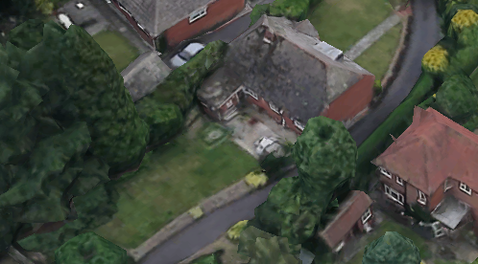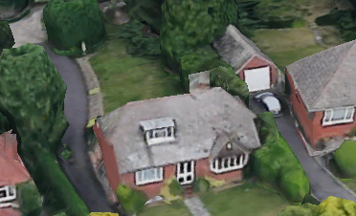

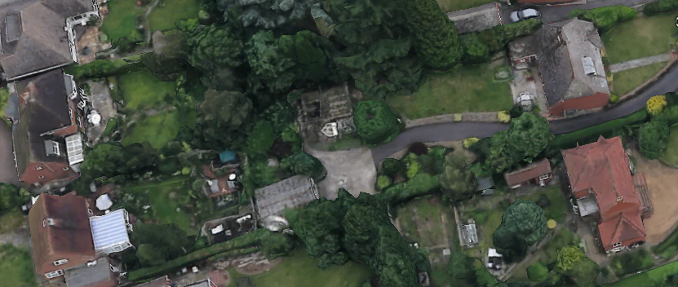
2. PROPOSAL AND SUPPORTING INFORMATION

Proposed rear extension, loft conversion with dormer windows and changes to existing fenestration

Plans considered received 1st Apr1l 2022
Location Plan
GHEG22.11 – Existing Plans
GHEG22.12 – Existing Elevations
GHEG22.13 – Proposed Plans
GHEG22.14 – Proposed Block Plan & Roof Plan
GHEG22.15 – Proposed Elevations

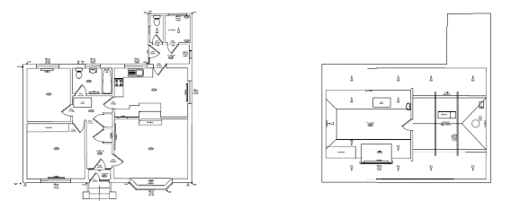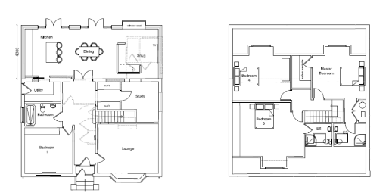
Existing Floor Plans Proposed Floor Plans

- RELEVANT PLANNING HISTORY

None

4. CONSULTATIONS

4.1 The following addresses were consulted by letter.

24 Highdown Avenue, Emmer Green, Reading, RG4 8QS
26 Highdown Avenue, Emmer Green, Reading, RG4 8QS
35 Gravel Hill, Emmer Green, Reading, RG4 8QN
31 Gravel Hill, Emmer Green, Reading, RG4 8QN

4.2 Trees
Natural Environment was consulted. They requested a Tree survey and Arboricultural Statement which was submitted by the agent and subsequently confirmed as adequate by NE, subject to condition L7A.

Equality Act 2010:
In determining this application the Council is required to have regard to its obligations under the Equality Act 2010. However, there is no indication or evidence (including from consultation on the application) that the protected groups identified by the Act have or will have different needs, experiences, issues and priorities in relation to this particular planning application. Therefore in terms of the key equalities protected characteristics it is considered there would be no significant adverse impacts as a result of the development.

- LEGAL AND PLANNING POLICY CONTEXT

Section 38(6) of the Planning and Compulsory Purchase Act 2004 requires that proposals be determined in accordance with the development plan unless material considerations indicate otherwise. Material considerations include relevant policies in the National Planning Policy framework (NPPF) - among them the 'presumption in favour of sustainable development'. The following local and national planning policy and guidance is relevant to this application:

National Policy
National Planning Policy Framework
National Planning Practice Guidance

Reading Borough Local Plan (2019)
CC7 (Design and the Public Realm)
CC8 (Safeguarding Amenity)
EN14 (Trees, Hedges and Woodland)
H9 (House Extensions and Ancillary Accommodation)

SPD
- Design Guide to House Extensions (2021)

6. APPRAISAL

H9 states: An extension to a house will be acceptable where it:

- Respects the character of the house in terms of scale, location, materials and design;

To assess this, the following has been considered – would the proposal:
- detract from the appearance of the original building through the use of ill-matching materials and by not fitting in with the design, scale and proportions of the original building; NO, while the footprint of the dwelling will be increased by approximately 4.5m to the rear and the dormer will also increase, the overall increase in size of the original dwelling will not be of unacceptable scale or proportions. The use of flat roof is not in fitting with the design of the original dwelling and while not deemed as a very good design in terms of the character of the dwelling and by extension the effect on the street scene, this effect is not significant in this case as the site of the proposal is on a relatively raised level with the street level, so not seen from the normal eye levels and perspectives.
- reduce the amount of usable amenity space for the property to an unacceptable degree; NO, the usable amenity will not be significantly impacted.
- require the loss of trees in the garden or put significant trees at risk; NO, the aboricultural statement has shown that there will not be trees put at significant risk and the Natural Environment consultees agree with this view.

- Respects the character and pattern of neighbouring properties and the street as a whole in terms of scale, location, materials and design, and any important existing building line; Respects neighbour’s amenities and does not present a large blank façade to public areas.

To assess this, the following has been considered – would the proposal:
- significantly reduce the amount of daylight and sunlight enjoyed by neighbouring properties; NO, the proposal does not present any aspects that will reduce the amount of daylight and sunlight enjoyed by NO 31.
- invade the privacy of neighbouring properties through overlooking from windows or balconies; NO, while there are new dormer windows presented by this proposal on the Northern Elevation, the distance to the next property is well above 30m to the back garden and 50m to the next dwelling on that line of sight. However, the PO has deemed it fit to put a condition to obscure these windows to mitigate the sideways views that are possible from the height of the windows.
- detract from the character of neighbouring properties through siting, excessive bulk, ill-matching materials or inconsistent design; NO
- detract from the appearance of the street or area by using ill-matched materials, glazing and detailing; NO

CC8: Safeguarding Amenity states an extension to a house will be acceptable where it will not cause a significant detrimental impact to the living environment of existing or new residential properties.

To assess this, the following has been considered – would the proposal cause a significant detrimental impact to the living environment of existing or new residential properties in terms of:

- Privacy and overlooking;
- Access to sunlight and daylight;
- Visual dominance and overbearing effects of a development;

The proposal does not present any aspects that will significantly cause loss of privacy or overlooking on the neighbours as the plot to the rear boundary of the property is more than 50 metres away. However, a condition to obscure the windows to mitigate the overlooking to the sides has been inserted in the decision. There are no impacts on sunlight and daylight as well as all the aspects of the extension are at the one storey level. The overall proposal blends well into the character of the buildings around the site, so no overbearing effects or visual dominance are presented.
- CONCLUSION
The proposed development has been assessed and the proposed works are considered to be in accordance with the above relevant policies and planning permission can be granted.

8. RECOMMENDATION
Grant

