

DELEGATED APPLICATION REPORT
Ward: Emmer Green
App Ref: 220820/FUL & 220821/LBC
Address: Old Grove House, St Barnabas Road, Emmer Green, Reading, RG4 8RA
Proposals: Remove internal concrete floor. Salvage and retain historic fabric (where appropriate). Lay insulated Limecrete floor and re-lay salvaged materials and new stone tiles. Install external air dam. Re- open doorway between technical room and living room
Case Officer: Chukwudi Onwudinanti
Applicant: Mr Alex Mitchie
Date received (valid from): 9 August 2022
Target Decision date: 23 January 2023(EXT)

1. SITE DESCRIPTION
The proposal site is a detached Grade II listed dwelling located on St Barnabas Road, Emmer Green. The listing was formerly listed as Old Grove House and Barn. The building is a two storey red brick construction with a slate roof and end chimney.

Old Grove house is set further back from the highway than other dwellings on this road, and presents two principal elevations on St Barnabas Road and Old Barn Close.
Include listing description
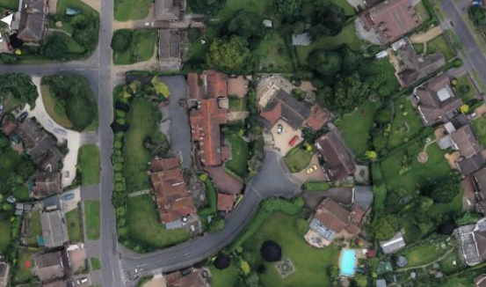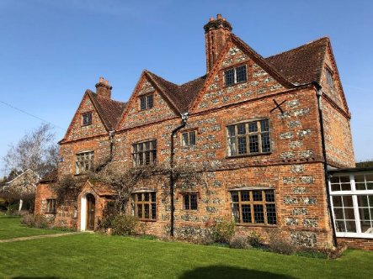

Site visit photos ( Taken 16th December 2022):
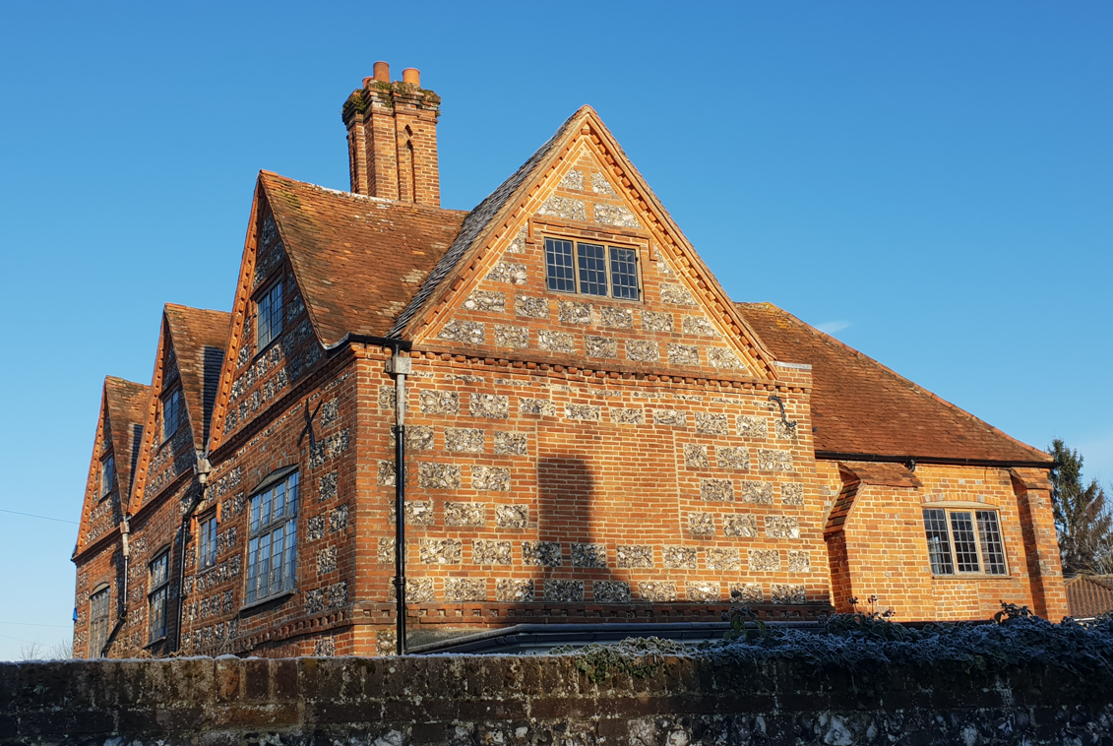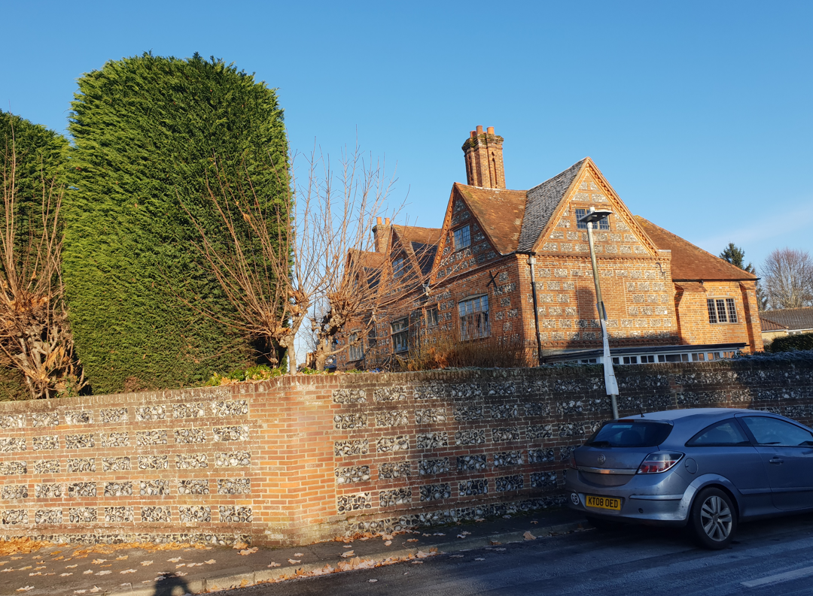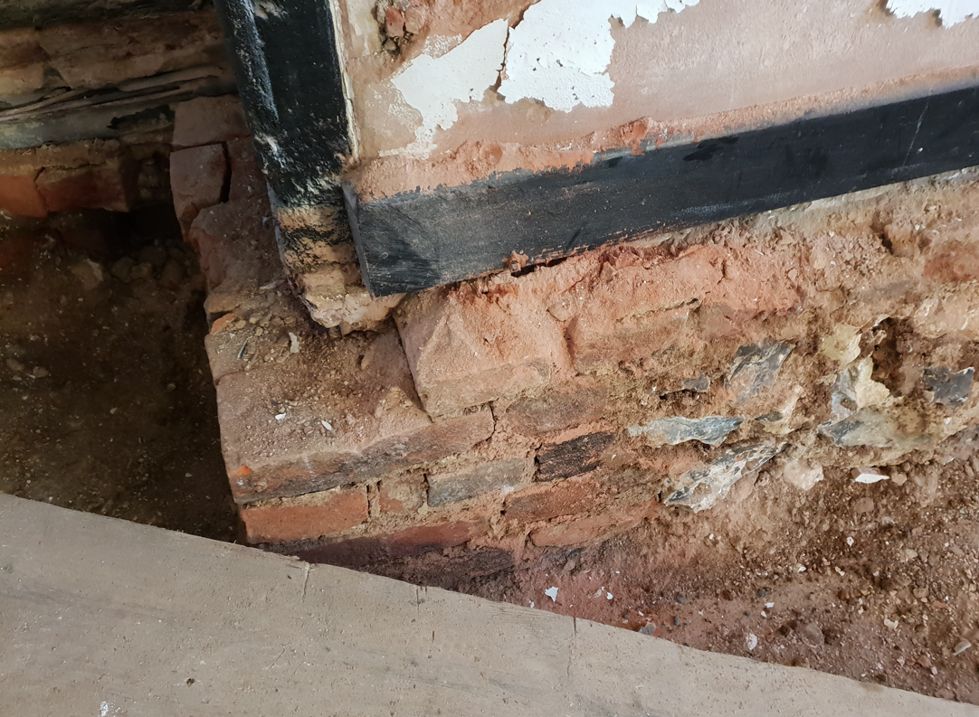

2. PROPOSAL AND SUPPORTING INFORMATION
The proposal is to remove internal concrete floor while salvaging and retaining historic
Fabric (where appropriate), lay insulated limecrete floor and re-lay salvaged materials and new stone tiles. It also seeks to install external air dam and re- open a doorway between technical room and living room

Plans considered (dated May 2022 and received 6 June 2022)
Drawing: A01 - Site Plan
Drawing: A02 - Site Location Plan
Drawing: A03 - Ground Floor Plan - Existing/Enabling
Drawing: A10 - Ground Floor Plan – Proposed
Drawing: A17 - Proposed Limecrete Floor Detail
Heritage Statements

The proposal presents internal as well as external works (Air dam drainage on the external perimeter), hence LBC is sought alongside Full Approval for the external works.

- RELEVANT PLANNING HISTORY
None

4. CONSULTATIONS

The following addresses were consulted by letter.

28 St Barnabas Road, Emmer Green, Reading, RG4 8RA
Manor Barn, St Barnabas Road, Emmer Green, Reading, RG4 8RA
5 St Barnabas Road, Emmer Green, Reading, RG4 8RA
No letters of representation have been

Heritage Advice

A site visit was conducted on 16th December 2022 by the Planning Officer and the Heritage consultant. The Heritage Consultant recommended approval, subject to the works being carried out as documented and specified by the conservation architects.

Equality Act 2010:
In determining this application the Council is required to have regard to its obligations under the Equality Act 2010. However, there is no indication or evidence (including from consultation on the application) that the protected groups identified by the Act have or will have different needs, experiences, issues and priorities in relation to this particular planning application. Therefore in terms of the key equalities protected characteristics it is considered there would be no significant adverse impacts as a result of the development.

- LEGAL AND PLANNING POLICY CONTEXT
Section 38(6) of the Planning and Compulsory Purchase Act 2004 requires that proposals be determined in accordance with the development plan unless material considerations indicate otherwise. Material considerations include relevant policies in the National Planning Policy framework (NPPF) - among them the 'presumption in favour of sustainable development'. The following local and national planning policy and guidance is relevant to this application:

Section 16(2) of the Planning (Listed Buildings and Conservation Areas) Act 1990 requires the local planning authority to have special regard to the desirability of preserving a listed building or its setting or any features of special interest which it possesses.

Section 72 (1) of the Planning (Listed Buildings and Conservation Areas) Act 1990 requires the local planning authority in the exercise of its functions to pay special attention to the desirability of preserving or enhancing the character or appearance of a conservation area.

National Policy
National Planning Policy Framework
Section 16: Conserving and enhancing the historic environment
National Planning Practice Guidance
Reading Borough Local Plan (2019)
CC7: Design and the Public Realm)
EN1: Protection and Enhancement of the Historic Environment
Other Documents
Historic England, Managing Significance in Decision-Taking in the Historic Environment, Historic Environment Good Practice Advice in Planning 2 (GPA2) 2015

6. APPRAISAL

a) Principle of Development
The principle of improvements and repairs to a listed building are acceptable in principle in accordance with Policy EN1 and Section 16 of the NPPF, subject to the works protecting and where possible enhancing the significance of the Listed Building including its setting, the historic character and local distinctiveness of the area in which it is located and will not have an adverse impact on those elements which contribute to their special architectural or historic interest.

b) Effect on Heritage Asset
The Listing for this property does not contain any specific reference to internal features of the building. Internal works to this property is limited to removal of the original existing floor finish, salvaging and using same to apply as final finish to the floors. It has been demonstrated in the Heritage statement submitted with this application and in the conditions report that this work is sought to preserve the walls and original timber footings from the effect of rising damp.

With regard to the floor related works these would include:

• Kitchen- Carefully lift existing clay tiles for insertion of insulated limecrete floor. Re-lay a natural stone tile

• Living Room- Carefully number and lift existing clay tiles for insertion of insulated limecrete floor. Re-lay salvaged clay tiles

• Dining Room & Living Room- Carefully number and lift existing floorboards for insertion of insulated limecrete floor. Re-lay salvaged floor boards

• Living Room and Bar Area- Carefully lift existing clay tiles for insertion of insulated limecrete floor. Re-lay a natural stone tile

• Wine Cellar- Carefully number and lift existing clay tiles for insertion of insulated limecrete floor. Re-lay salvaged clay tiles.

• Hall- Carefully lift existing clay tiles for insertion of insulated limecrete floor. Re-lay a natural stone tile

The proposal also includes re-opening an original doorway, which was closed up during previous internal works. Reintroducing this doorway would bring back the historical form and layout within this part of the house and would, therefore, create an enhancement to the Listed Building.

The above listed works are not considered to cause significant impacts on the different areas of the listed building as stated above in this report as the works seek to salvage and replace existing features where possible. The Heritage Consultant also considers that the works to be carried out would conserve the architectural significance of this heritage asset and that the details submitted demonstrate adequate and appropriate safeguards.

Therefore, it is considered that these works, if carried out as sympathetically as proposed, would not be of significant impact to the features of this listed building.

c) Drainage
The application proposes excavation and the installation of air dam drainages around the sides

The installation of the external air dam is not considered to be of significant impact on the setting of the Listed Building, nor on the character of the existing dwelling. The justification for this work is to protect and preserve the timber foundations and the walls of the listed building and the LPA accepts these justifications.

Subject to appropriate conditions for Listed Building Consent and Full Approval, the scheme would accord with relevant Policy EN1 and the NPPF.

- CONCLUSION
The proposed development has been assessed as set out above and is considered to be acceptable on that basis, subject to the following conditions.

8. RECOMMENDATION : Give Consent and Permission
Recommended Conditions for Consent:
AP1: Approved Drawings
TL1: Time Limit Standard
Add as required and put recommendations separately for LB and FUL

