DELEGATED HOUSEHOLDER APPLICATION REPORT

Ward: Tilehurst
App Ref: 221179/HOU
Address: 114 Teviot Road, Tilehurst, Reading, RG30 4SS
Proposals: Single storey rear extension and re-cladding
Case Officer: Chukwudi Onwudinanti
Applicant: Mr & Mrs P Fletcher
Date received (valid from): 9 August 2022
Target Decision date: 11 November 2022 (EXT)

- SITE DESCRIPTION
The proposal site is an end of terrace dwelling on the western side of Teviot Road, among other dwellings in Terrace styles of four to five dwellings in each terrace group. It is a predominantly residential area characterised by terraces on both sides of the road, which starts and ends on two intersections with Corwen Road.

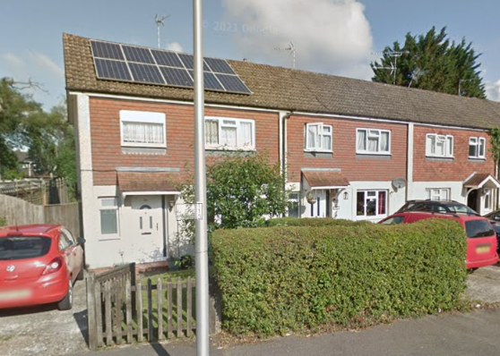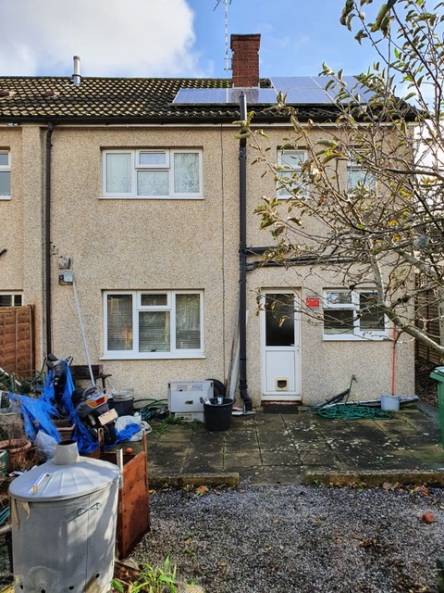

2. PROPOSAL AND SUPPORTING INFORMATION
This application is for a single storey rear extension measuring 3.5m deep and 6.4m wide (the whole width of the existing dwelling). It also includes a change of the external finish from pebble dash to facing bricks to the side.

Plans considered received 10th August 2022
Location Plan
Drawing No: 1052/01- Existing
Drawing No: 1052/03- Proposed for Planning
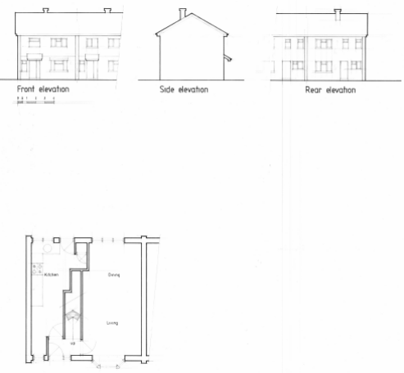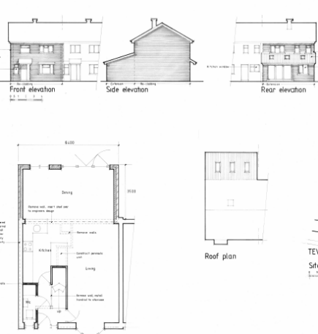

Existing Proposed for Planning

- RELEVANT PLANNING HISTORY
None

4. CONSULTATIONS

The following addresses were consulted by letter.

30 Ogmore Close, Tilehurst, Reading, RG3 4SX
112 Teviot Road, Tilehurst, Reading, RG30 4SS
116 Teviot Road, Tilehurst, RG30 4SS

No letters of representation have been received.

Equality Act 2010:
In determining this application the Council is required to have regard to its obligations under the Equality Act 2010. However, there is no indication or evidence (including from consultation on the application) that the protected groups identified by the Act have or will have different needs, experiences, issues and priorities in relation to this particular planning application. Therefore in terms of the key equalities protected characteristics it is considered there would be no significant adverse impacts as a result of the development.

- LEGAL AND PLANNING POLICY CONTEXT

Section 38(6) of the Planning and Compulsory Purchase Act 2004 requires that proposals be determined in accordance with the development plan unless material considerations indicate otherwise. Material considerations include relevant policies in the National Planning Policy framework (NPPF) - among them the 'presumption in favour of sustainable development.

National Policy
National Planning Policy Framework
National Planning Practice Guidance

Reading Borough Local Plan (2019)
CC7 (Design and the Public Realm)
CC8 (Safeguarding Amenity)
H9 (House Extensions and Ancillary Accommodation)

SPD
Design Guide to House Extensions (2021)

6. APPRAISAL
Character and Appearance

Policy H9 states that an extension to a house will be acceptable where it respects the character of the house in terms of scale, location, materials and design and respects the character and pattern of neighbouring properties and the street as a whole in terms of scale, location, materials and design, and any important existing building line. Policy CC7 also sets out relevant considerations for design.

The extension is to the rear of the building and is only 3.4m deep and less than 4m high. The change of the exterior materials will be to face bricks. Although the existing materials are tile hung and pebble dash to the front and pebbledash to the rear there are other properties in close proximity which have brick exteriors.

Therefore, it is considered that the scale and style of this proposal will not have a detrimental impact on the character of the area and the existing dwelling to an unacceptable degree.

Residential Amenity

Policy H9 states that an extension will be acceptable where it does not result in an overbearing impact on neighbours. Policy H10 seeks to ensure that the amenity of gardens and other outdoor areas are not compromised. Policy CC8 states an extension to a house will be acceptable where it will not cause a significant detrimental impact to the living environment of existing or new residential properties.

The proposal is not deemed to have any overbearing or overlooking impact as the extension is limited to a single storey level and does not present any heights which could provide vantage points for overlooking. The depth of 3.4m is not considered enough to have any negative impact on the sunlight and daylight available to adjoining properties and will not present any significant overbearing issues on the properties on both sides of the existing dwelling.

- CONCLUSION
The proposed development has been assessed as set out above and is considered to be acceptable on that basis, subject to the following conditions.

8. RECOMMENDATION: Grant

Recommended Conditions:
API: Approved Plans
M2: Materials as specified
TL1: Time limit standards

