DELEGATED HOUSEHOLDER APPLICATION REPORT

Ward: Thames
App Ref: 220661/FUL
Address: 65 Caversham Road, Reading, RG1 8AD
Proposals: Infill of Loading bay screen to rear facade and installation of new Entrance screen and doors, canopy over
Case Officer: Chukwudi Onwudinanti
Applicant: Stevco
Date received (valid from): 5 May 2022
Target Decision date: 5 August 2022 (Ext)

1. Site description and Surrounding Area

The proposal site is a commercial building on the eastern side of Caversham Road, the former ‘Dawsons’ music shop, adjacent to the fire station with the car park to the rear accessed from Northfield Road to the north.
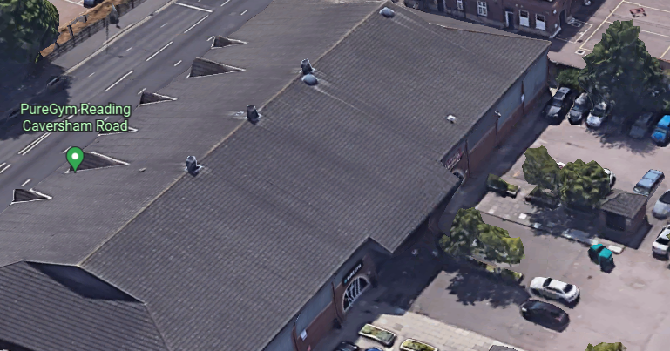

2. PROPOSAL AND SUPPORTING INFORMATION
The proposal seeks to infill of Loading bay screen to rear façade with matching red bricks and installation of new Entrance screen and door with a canopy over.

Plans considered (Received 6 May 2022)
Location Plan
Proposed Mezzanine Plan
Existing Elevations
Proposed Elevations

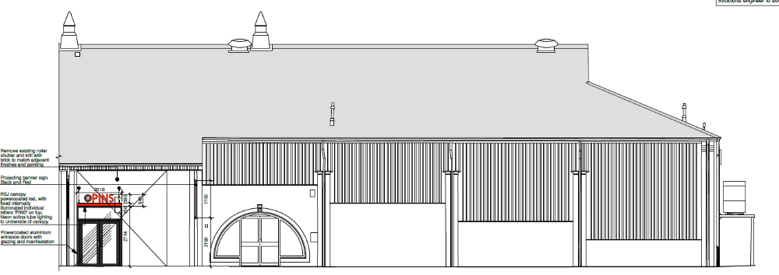

- RELEVANT PLANNING HISTORY
Application Ref :220376
Description: : External Canopies to front and rear Facades with internally lit Individual letters. High level banner signs. Fascia Signage Internally Illuminated.
Decision : Not yet Determined

4. CONSULTATIONS

4.1 Transport and Environment were consulted.

Transport Comments.

“The proposal does not change the exiting parking arrangements; The site is located on the ground floor and has access to a large, shared car park accessed via the rear from Northfield Rd. There are no Transport objections to this application as deliveries can still be made via the existing car park.”

Environment had no comments.

Equality Act 2010:
In determining this application the Council is required to have regard to its obligations under the Equality Act 2010. However, there is no indication or evidence (including from consultation on the application) that the protected groups identified by the Act have or will have different needs, experiences, issues and priorities in relation to this particular planning application. Therefore in terms of the key equalities protected characteristics it is considered there would be no significant adverse impacts as a result of the development.

- LEGAL AND PLANNING POLICY CONTEXT

Section 38(6) of the Planning and Compulsory Purchase Act 2004 requires that proposals be determined in accordance with the development plan unless material considerations indicate otherwise. Material considerations include relevant policies in the National Planning Policy framework (NPPF) - among them the 'presumption in favour of sustainable development'. The following local and national planning policy and guidance is relevant to this application:

National Policy
National Planning Policy Framework
National Planning Practice Guidance

Reading Borough Local Plan (2019)
CC7 (Design and the Public Realm)
CC8 (Safeguarding Amenity)
RL6: (Protection of Leisure Facilities and Public Houses)

- APPRAISAL

CC7 : Design and the Public Realm

All development must be of high design quality that maintains and enhances the character and appearance of the area of Reading in which it is located.

The works in this proposal are not introducing elements which are not already in use in the existing building and the infill seeks to use the existing materials of the external walls. This will ensure that the character of the building and indeed the area is sufficiently maintained by this proposal. The proposal therefore “responds positively to their local context and create or reinforce the distinctiveness” of the area. It also does not detract from the visual attractiveness of the building.

CC8: Safeguarding Amenity states an extension to a house will be acceptable where it will not cause a significant detrimental impact to the living environment of existing or new residential properties.

All works on this proposal are to be carried out at the rear of the property and will not have any significant effect on the amenity of the environment and the existing developments around the site. Also, it is not deemed that there will be any impact on the amenity of the living environment of the residential buildings that are near the proposed site.

RL6: Protection of Leisure Facilities and Public Houses states that Existing leisure facilities or public houses will generally be retained, and there is a strong
presumption in favour of retaining leisure facilities or public houses where they are the
only facility of their type in a district, major local or local centre.

This proposal does not cause the loss of any leisure facility.

- CONCLUSION
The proposed development has been assessed and the proposed works are considered to be in accordance with the above relevant policies and planning permission can be granted.

8. RECOMMENDATION
Grant

