

DELEGATED HOUSEHOLDER APPLICATION REPORT

Ward: Thames
App Ref: 220597/HOU
Address: 2 Champion Road, Caversham, Reading, RG4 8EL
Proposals: Renovation, internal remodelling and side extension. Replacement garden store with existing hard standing of the parking space retained.
Case Officer: Chukwudi Onwudinanti
Applicant: Shane and Francoise Miller
Date received (valid from): 23 April 2022
Target Decision date: 11 November 2022 (EXT)

1. SITE DESCRIPTION
The proposal is a detached dwelling unit on the southern side of Champion Road, on the junction with Piggotts Road, among buildings of varying styles and sizes. It sits in an area that is predominantly residential.

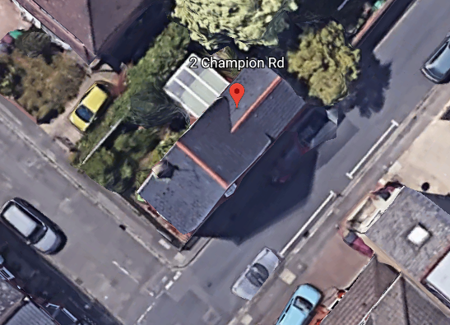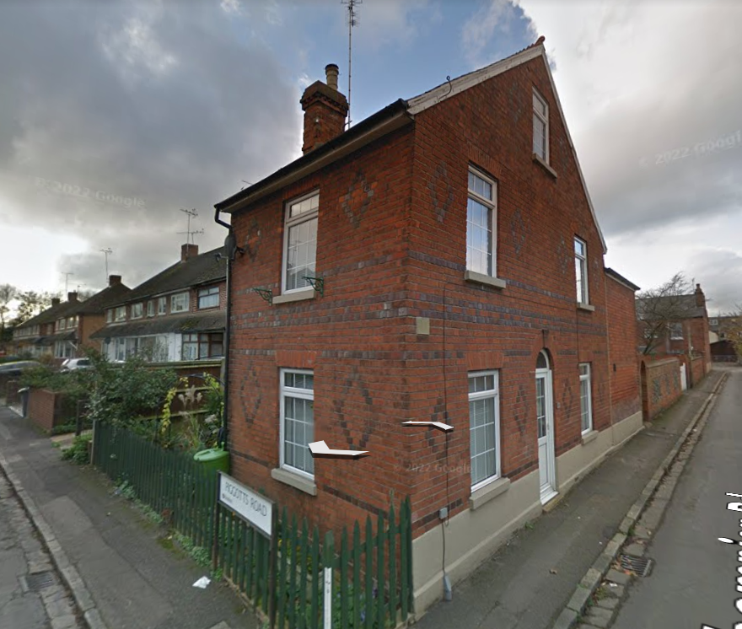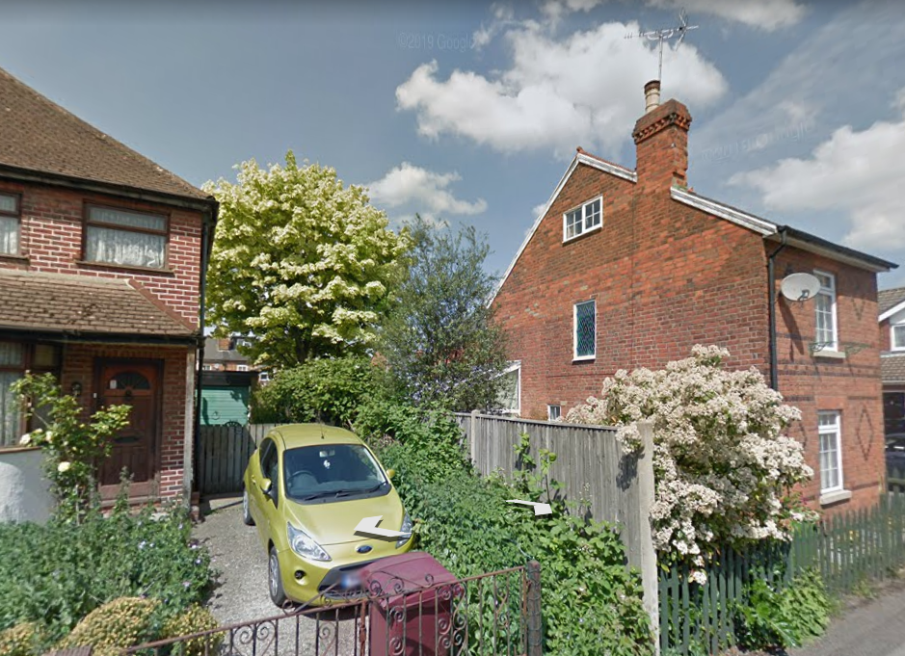

2. PROPOSAL AND SUPPORTING INFORMATION
The proposal is for renovation, internal remodelling and two storey side extension measuring approximately 3m by 9.6m, stepped back 1.5m from the principal elevation line. It also proposes the replacement of the garden store with existing hard standing of the parking space retained.

Plans considered received 25th April 2022
Drawing No: 0101 – Site Location Plan
Drawing No: 0100 - Existing Plans and Elevations
Drawing No: 0105 Rev A – Coloured Site Plan received 20th October 2022
Drawing No: 0001 Rev B - Block Plan and Proposed Site Plan received 20th October 2022
Drawing No: 0109 Rev B – Proposed Floor Plans and Elevations received 20th October 2022
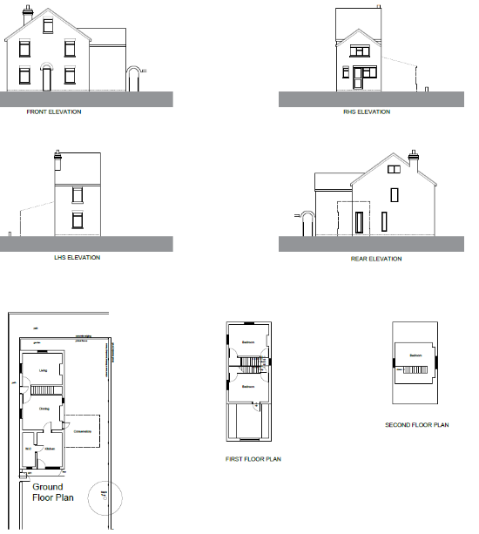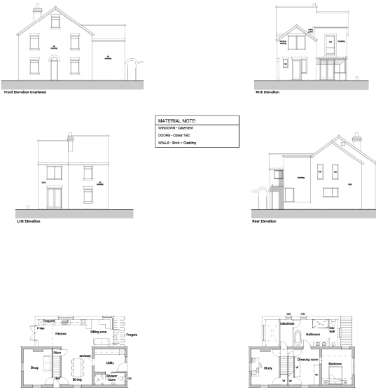

Existing Floor Plans and Elevations Proposed Floor Plans and Elevations

- RELEVANT PLANNING HISTORY
None

4. CONSULTATIONS

The following addresses were consulted by letter.

10 Mill Road, Caversham, Reading, Berkshire, RG4 8DP
1 Piggotts Road, Caversham, Reading, RG4 8EN
8 Mill Road, Caversham, Reading, RG4 8DP
12 Mill Road, Caversham, Reading, RG4 8DP

No letters of representation have been.

Transport Comments:

The property currently has a dropped kerb from Champion Rd, serving a gated access to an existing area of hard standing which Google images confirm has been used for off road parking.

The property is located in an area where the Councils Residential Parking Permit Scheme operates and our records indicate that the property has been allocated. Given the extensive restrictions in place controlling parking in the area and the retention of the existing parking arrangements, Transport do not have any objections to this application.

The appropriate licence will need to be applied for should any works impact the public highway/footway.

Equality Act 2010:
In determining this application the Council is required to have regard to its obligations under the Equality Act 2010. However, there is no indication or evidence (including from consultation on the application) that the protected groups identified by the Act have or will have different needs, experiences, issues and priorities in relation to this particular planning application. Therefore in terms of the key equalities protected characteristics it is considered there would be no significant adverse impacts as a result of the development.

- LEGAL AND PLANNING POLICY CONTEXT

Section 38(6) of the Planning and Compulsory Purchase Act 2004 requires that proposals be determined in accordance with the development plan unless material considerations indicate otherwise. Material considerations include relevant policies in the National Planning Policy framework (NPPF) - among them the 'presumption in favour of sustainable development'. The following local and national planning policy and guidance is relevant to this application:

National Policy
National Planning Policy Framework
National Planning Practice Guidance

Reading Borough Local Plan (2019)
CC7 (Design and the Public Realm)
CC8 (Safeguarding Amenity)
H9 (House Extensions and Ancillary Accommodation)
TR3 (Access Traffic and Highway-related Matters)
EN14 (Trees, Hedges and Woodlands)

SPD
Design Guide to House Extensions (2021)

6. APPRAISAL
Character and Appearance

Policy H9 states that an extension to a house will be acceptable where it respects the character of the house in terms of scale, location, materials and design and respects the character and pattern of neighbouring properties and the street as a whole in terms of scale, location, materials and design, and any important existing building line. Policy CC7 also sets out relevant considerations for design.

The LPA has worked proactively with the agent to revise the original drawings submitted with this application. The previous design was considered to be out of scale and character from the existing dwelling which has the characteristic of presenting two principal elevations as a result of its location on a corner plot. The concerns were with the roof over the extension and the materials proposed which were considered by the LPA as not being integrated with the existing dwelling.

Consequently, the agent has revised the designs, making the roof as integrated as it can be with the existing and the exterior materials variation being limited to the rear of the property that is not visible from the street scene. The timber cladding to be used for some aspect of the development has been secured by condition to be of a natural, neutral finish as agreed with the agent. There still remains an aspect of the roof which is still flat but this has also been limited to the rear of the property. The revisions have been considered to bring the proposal into conformity with the character, scale and design of the existing building and the neighbouring properties.

Residential Amenity

Policy H9 states that an extension will be acceptable where it does not result in an overbearing impact on neighbours. Policy H10 seeks to ensure that the amenity of gardens and other outdoor areas are not compromised. Policy CC8 states an extension to a house will be acceptable where it will not cause a significant detrimental impact to the living environment of existing or new residential properties.

- Privacy and overlooking: The aspect of the proposal that presented a balcony was considered to present overlooking and privacy issues. This aspect has been removed in the revisions, thereby resolving this concern.
- Overbearing effects: The scale of the proposal has been toned down and the roof integrated as closely as possible to the existing roof, mitigating any overbearing issues that the original proposal presented.
- Sunlight and daylight: No aspect of the proposal is close enough to the adjoining properties to affect the sunlight and daylight accessible to the adjoining properties.
- Amenity Space : sufficient would remain

Trees
No trees will be affected by the changes to the shed in the garden.

- CONCLUSION
The proposed development has been assessed as set out above and is considered to be acceptable on that basis, subject to the following conditions.

8. RECOMMENDATION: Grant
Recommended Conditions:
AP1: Approved Plans
M3: Materials as Specified
TL1: Time Limit Standards
No windows on side elevation

