DELEGATED HOUSEHOLDER APPLICATION REPORT

Ward: Tilehurst
App Ref: 212078/HOU
Address: 87 Armour Road, Tilehurst, Reading, RG31 6HB
Proposals: Two storey rear extension
Case Officer: Chukwudi Onwudinanti
Applicant: Ms Taylor
Date received (valid from): 23 December 2021
Target Decision date: 17 February 2022

1. INTRODUCTION
The site is a semi-detached dwelling unit on the southern side of Armour Road, in a predominantly residential area with a mix of dwelling styles.

2. PROPOSAL AND SUPPORTING INFORMATION
The proposal is a part two storey rear extension, with a small increase in the width of the first floor of the outrigger and widened ground floor mono-pitch rear extension below. There is also a proposed obscure glazed side facing window to serve a proposed bathroom.

Plans considered
Drawing No 01: Existing Plans and Elevations Plus Location Plan
Drawing No 02: Proposed Plans and Elevations Plus Block Plan

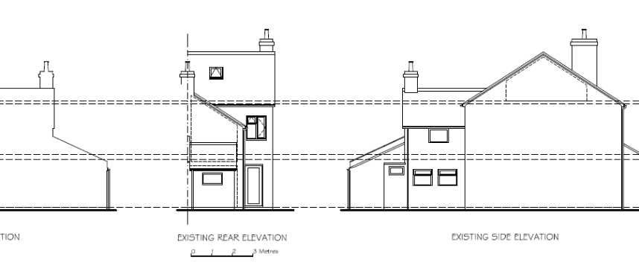

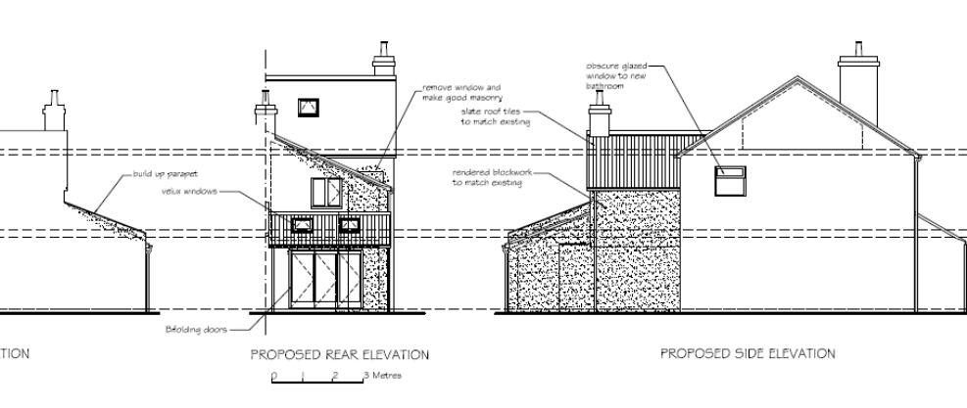

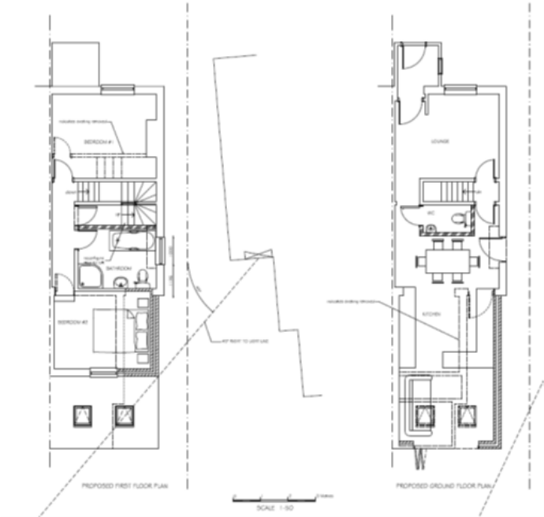

- RELEVANT PLANNING HISTORY

None

4. CONSULTATIONS

4.1 The following addresses were consulted by letter.

85 Armour Road, Tilehurst, Reading, RG31 6HB
89 Armour Road, Tilehurst, Reading, RG31 6HB
44 Crescent Road, Reading, RG1 5SP
42 Crescent Road, Reading, RG1 5SP

4.2 No letters of representation have been received.

Equality Act 2010:
In determining this application the Council is required to have regard to its obligations under the Equality Act 2010. However, there is no indication or evidence (including from consultation on the application) that the protected groups identified by the Act have or will have different needs, experiences, issues and priorities in relation to this particular planning application. Therefore in terms of the key equalities protected characteristics it is considered there would be no significant adverse impacts as a result of the development.

- LEGAL AND PLANNING POLICY CONTEXT
Section 38(6) of the Planning and Compulsory Purchase Act 2004 requires that proposals be determined in accordance with the development plan unless material considerations indicate otherwise. Material considerations include relevant policies in the National Planning Policy framework (NPPF) - among them the 'presumption in favour of sustainable development'. The following local and national planning policy and guidance is relevant to this application:

National Policy
National Planning Policy Framework
National Planning Practice Guidance

Reading Borough Local Plan (2019)
CC7 (Design and the Public Realm)
CC8 (Safeguarding Amenity)
H9 (House Extensions and Ancillary Accommodation)

SPD
- Design Guide to House Extensions 2021

6. APPRAISAL

H9 states: An extension to a house will be acceptable where it:

- Respects the character of the house in terms of scale, location, materials and design;

To assess this, the following has been considered – would the proposal:
- detract from the appearance of the original building through the use of ill-matching materials and by not fitting in with the design, scale and proportions of the original building; NO, the overall scale of the proposal is considered to be subservient to the original dwelling and within the scale advised within the SPD, with a design which respects the host dwelling. It would be matching materials. Reduce the amount of usable amenity space for the property to an unacceptable degree; NO, the proposal does not significantly increase the footprint of the existing dwelling, and therefore, sufficient amenity space would be retained
- require the loss of trees in the garden or put significant trees at risk; NO

- Respects the character and pattern of neighbouring properties and the street as a whole in terms of scale, location, materials and design, and any important existing building line; Respects neighbour’s amenities and does not present a large blank façade to public areas.

To assess this, the following has been considered – would the proposal:
- significantly reduce the amount of daylight and sunlight enjoyed by neighbouring properties; NO, the increase in width at first floor would not impinge on the 45 degree line and therefore, would not have a significant detrimental effect, with respect to daylight and sunlight, on no. 85.
- invade the privacy of neighbouring properties through overlooking from windows or balconies; NO, there is a proposed first floor side facing window within the original dwelling, which would serve a bathroom. It is proposed to be obscure glazed and this will be secured through condition..
- detract from the character of neighbouring properties through siting, excessive bulk, ill-matching materials or inconsistent design; NO
- detract from the appearance of the street or area by using ill-matched materials, glazing and detailing; NO

CC8: Safeguarding Amenity states an extension to a house will be acceptable where it will not cause a significant detrimental impact to the living environment of existing or new residential properties.

To assess this, the following has been considered – would the proposal cause a significant detrimental impact to the living environment of existing or new residential properties in terms of: No

- Privacy and overlooking;
- Access to sunlight and daylight;
- Visual dominance and overbearing effects of a development;
- Noise and disturbance;
- Artificial lighting;
- Vibration;
- Dust and fumes;
- Smell;
- Crime and safety.

- CONCLUSION
The proposed development has been assessed and the proposed works are considered to be in accordance with the above relevant policies and planning permission can be granted.

8. RECOMMENDATION
Grant

