DELEGATED HOUSEHOLDER APPLICATION REPORT

Ward: Kentwood
App Ref: 220862/HOU
Address: 827 Oxford Road, Tilehurst, Reading, RG30 6TU
Proposals: Proposed part double storey side extension plus internal alteration
Case Officer: Chukwudi Onwudinanti
Applicant: Mr Edd Albores
Date received (valid from): 13 June 2022
Target Decision date: 28 September 2022 (EXT)

1. SITE DESCRIPTION
The proposal site is a 1980s style semi-detached two storey building on the eastern side of the intersection of Oxford Road with Selborne Gardens. This site therefore has two sides facing two street scenes, the front elevation facing Oxford Road and Selborne Gardens and the right side elevation being seen prominently from Oxford Road.

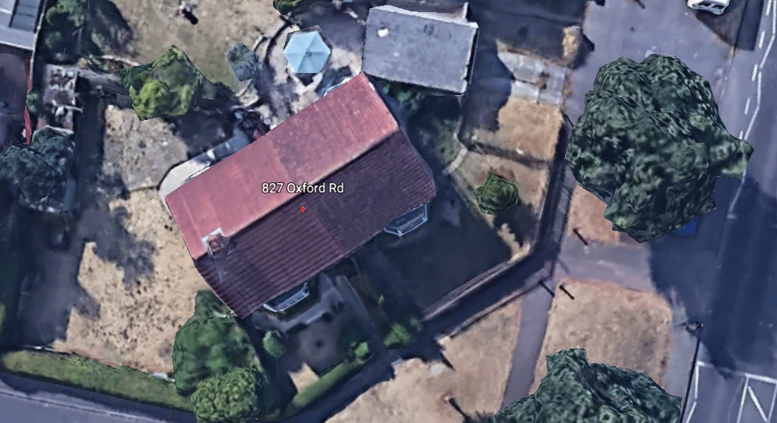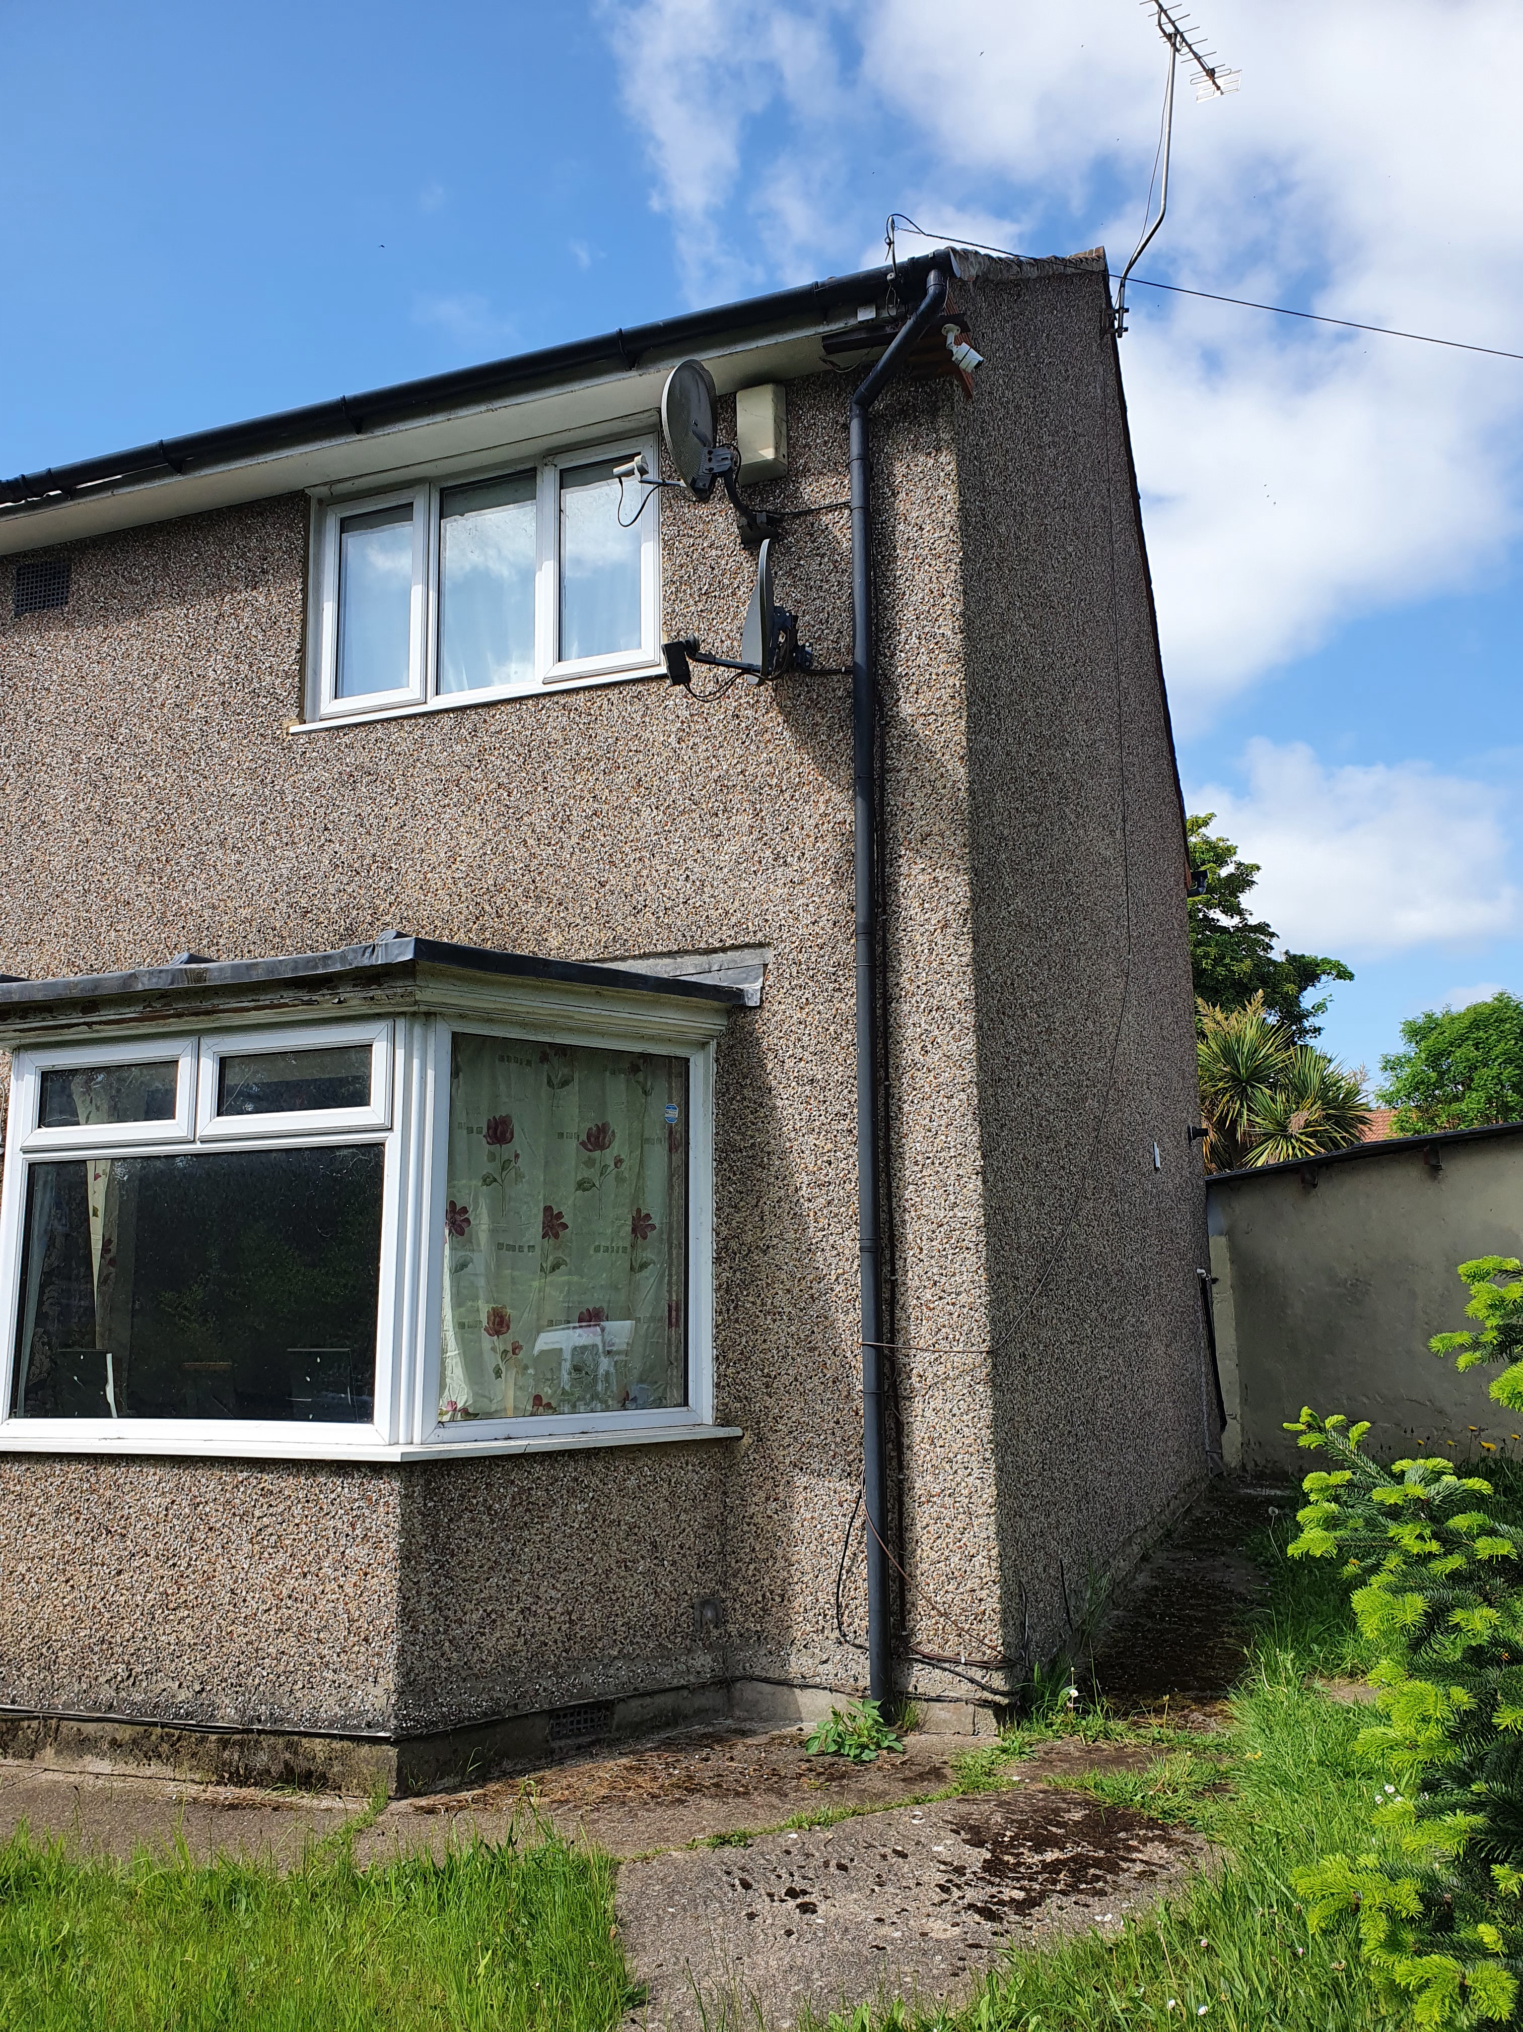

2. PROPOSAL AND SUPPORTING INFORMATION
The proposal presents a two storey side extension, measuring approximately 3.8m to the side and 6.8m deep, stepped back from the line of the principal elevation by approximately 1m. New roof ridge over extension is stepped back approximately .4m from the ridge of the existing roof.

Discussions with Agent.
The initial design submitted with this proposal was considered too massive and out of keeping with the scale and original design of the existing building. The PLA has worked with the agent to reduce the size of the extension by removing the front projection and stepping it back from the principal elevation while stepping the roofline down from the original roof ridgeline. This has produced a more subservient design.
Plans considered received 28th September 2022
Drawing No: 01/7 Site Location Plan Rev D
Drawing No: 02/7 Proposed Block Plan Rev D
Drawing No: 03/7 Existing and Proposed Ground Floor Plans Rev D
Drawing No: 04/7 Existing and Proposed First Floor Plans Rev D
Drawing No: 05/7 Existing and Proposed Roof Plans Rev D
Drawing No: 06/7 Existing and Proposed Front and Rear Elevations Rev D
Drawing No: 07/7 Existing and Proposed East and West Elevations Rev D

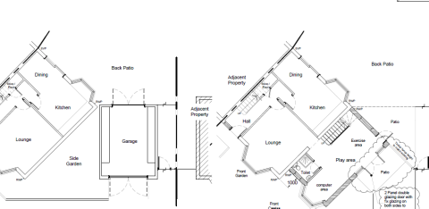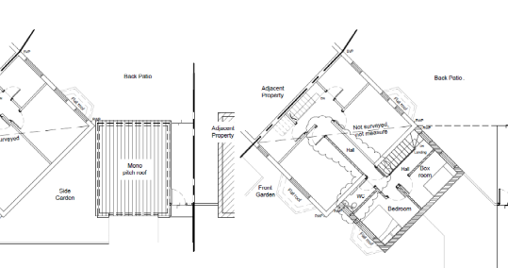

Existing and Proposed Ground Floor Plans Existing and Proposed First Floor Plans

- RELEVANT PLANNING HISTORY
None

4. CONSULTATIONS
The following addresses were consulted by letter.

825 Oxford Road, Tilehurst, Reading, RG30 6TU
829 Oxford Road, Tilehurst, Reading, RG30 6TU
18 Selborne Gardens, Tilehurst, Reading, RG30 6TT

No letters of representation have been received as follows:

Equality Act 2010:
In determining this application the Council is required to have regard to its obligations under the Equality Act 2010. However, there is no indication or evidence (including from consultation on the application) that the protected groups identified by the Act have or will have different needs, experiences, issues and priorities in relation to this particular planning application. Therefore in terms of the key equalities protected characteristics it is considered there would be no significant adverse impacts as a result of the development.

- LEGAL AND PLANNING POLICY CONTEXT

Section 38(6) of the Planning and Compulsory Purchase Act 2004 requires that proposals be determined in accordance with the development plan unless material considerations indicate otherwise. Material considerations include relevant policies in the National Planning Policy framework (NPPF) - among them the 'presumption in favour of sustainable development'. The following local and national planning policy and guidance is relevant to this application:

National Policy
National Planning Policy Framework
National Planning Practice Guidance

Reading Borough Local Plan (2019)
CC7 (Design and the Public Realm)
CC8 (Safeguarding Amenity)
H9 (House Extensions and Ancillary Accommodation)

SPD
Design Guide to House Extensions 2021
Revised Parking Standards and Design SPD 2011

6. APPRAISAL
Character and Appearance
Policy H9 states that an extension to a house will be acceptable where it respects the character of the house in terms of scale, location, materials and design and respects the character and pattern of neighbouring properties and the street as a whole in terms of scale, location, materials and design, and any important existing building line. Policy CC7 also sets out relevant considerations for design.

The original design submitted has been modified on advice, such that the scale of the extension has been reduced, the front stepped back and the ridgeline stepped down from the line of the existing roof. The orientation of the extension has also been modified from the original, to continue on same axis as the existing while mimicking the same style and fenestration. These amendments have made the overall extension subservient enough to the original dwelling so that the character of the house and the street scene are preserved.

Residential Amenity
Policy H9 states that an extension will be acceptable where it does not result in an overbearing impact on neighbours. Policy H10 seeks to ensure that the amenity of gardens and other outdoor areas are not compromised. Policy CC8 states an extension to a house will be acceptable where it will not cause a significant detrimental impact to the living environment of existing or new residential properties.

In assessing these, the proposal has been appraised on the following:
- Privacy and overlooking; The extension, as stated above in this report, has been scaled down from the original submissions, bringing the extension closer to the existing and away from the boundaries. There are also no side windows presented as a result of this proposal, therefore it is considered not to cause any harmful impacts on the adjoining property.
- Overbearing effects; the scale of the development is proportionate and sympathetic to its immediate surroundings and adjoining properties, so does not present any overbearing effects. The ridgeline has been stepped down, and the frontline stepped back, thereby reducing the mass of new development presented to the sightlines from the street and adjoining neighbours.
- Sunlight and daylight;
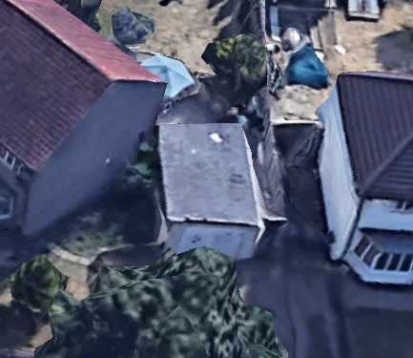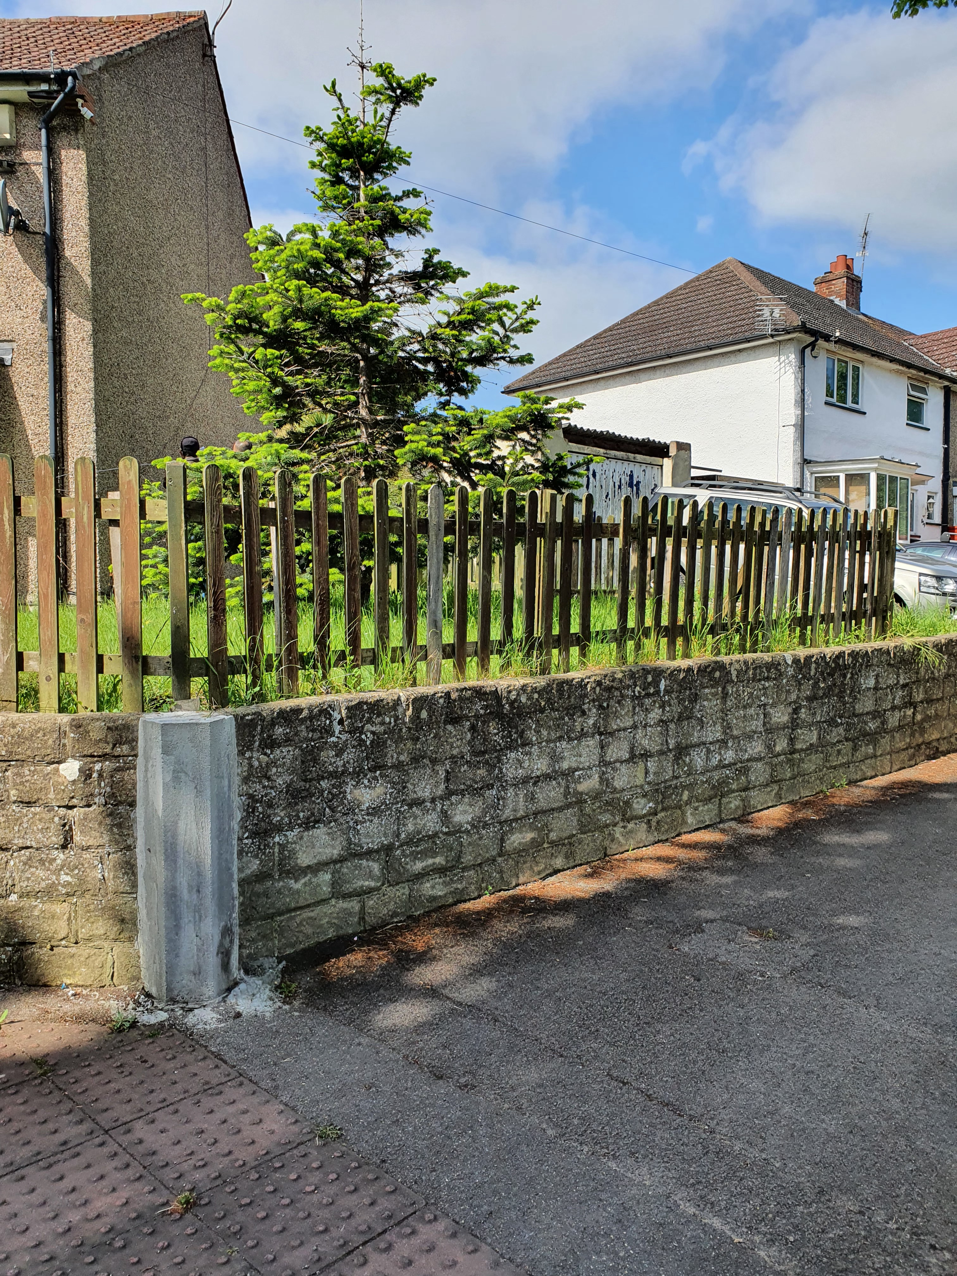
Owing to the angle of the existing building and the proposed extension (which follows the orientation of the existing), the gap between the extension and the adjoining neighbours, and the absence of side windows on the adjoining building, it is considered that there will not be any loss of sunlight and daylight to any habitable rooms in the adjoining building.

- CONCLUSION
The proposed development has been assessed as set out above and is considered to be acceptable on that basis, subject to the following conditions.

8. RECOMMENDATION
Application Permitted

Recommended Conditions:
AP1 Approved Plans
T1 Time Limits
M1 Materials as Existing
PD6 Ancilliary Domestic Use

