

DELEGATED HOUSEHOLDER APPLICATION REPORT

Ward: Caversham
App Ref: 230575/HOU
Address: 1 Short Street, Caversham, Reading, RG4 8JJ
Proposals: First floor side and rear extension
Case Officer: Chukwudi Onwudinanti
Applicant: Mr & Mrs Clark
Date received (valid from): 27 April 2023
Target Decision date: 1st August 2023 (EXT)

1. SITE DESCRIPTION
The site comprises a two-storey building with dual pitched single storey ancillary structure attached to the two-storey building taking up the remainder of the plot. The site is rectangular in shape with the long side fronting onto Short Street. The surrounding area is made up of residential properties and garages.

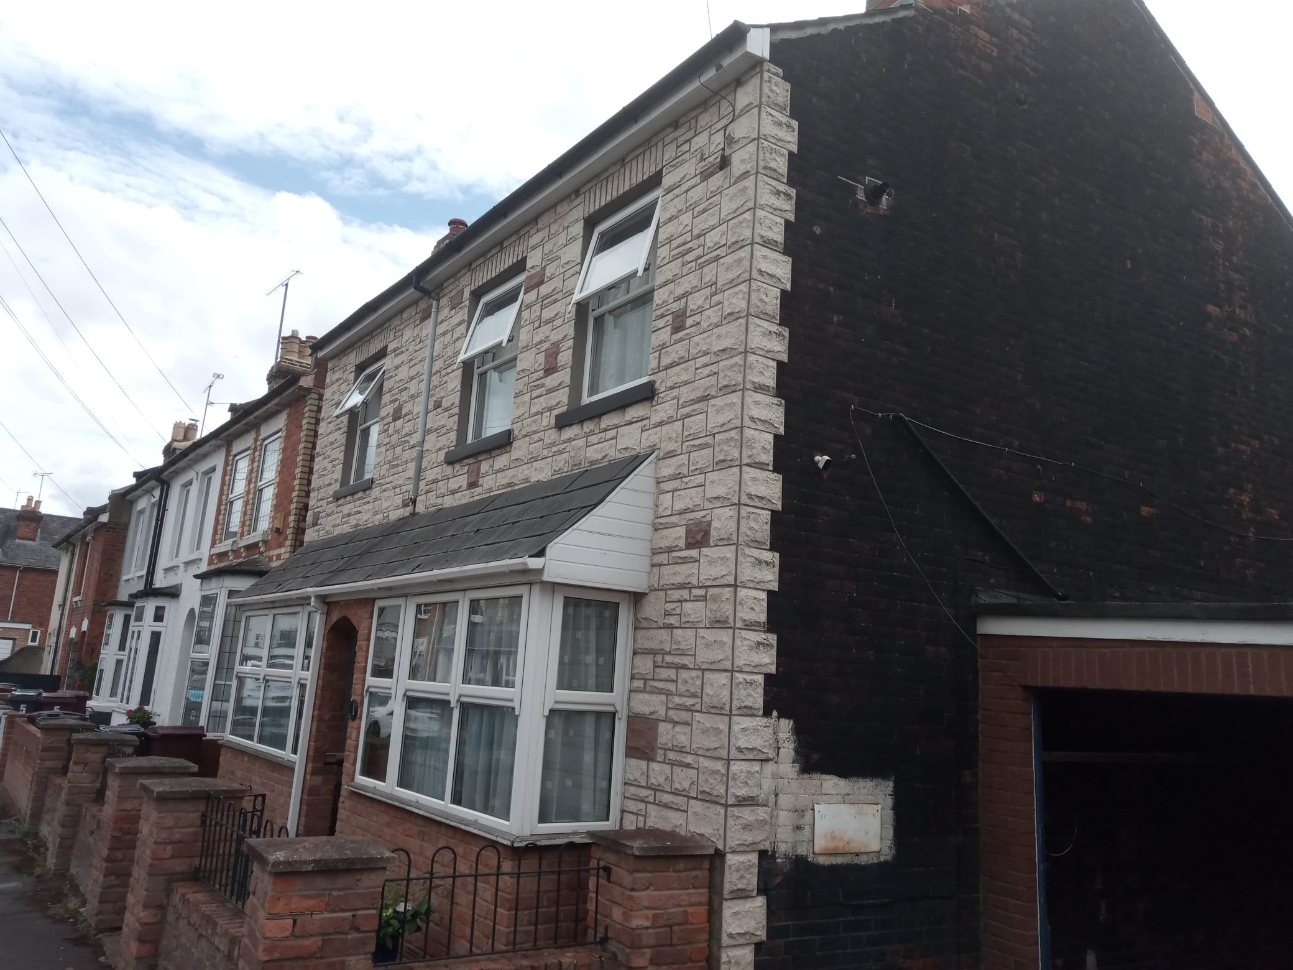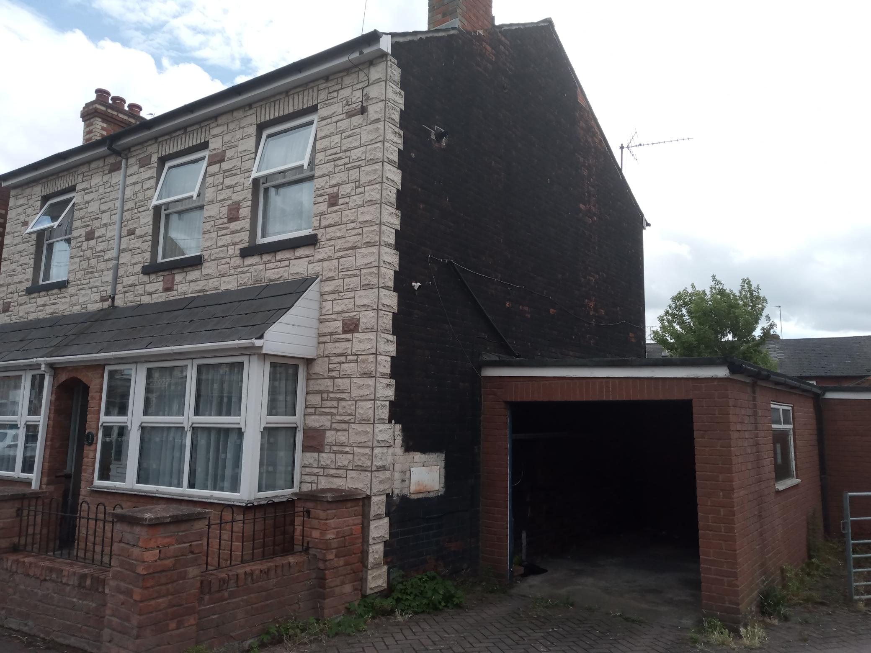

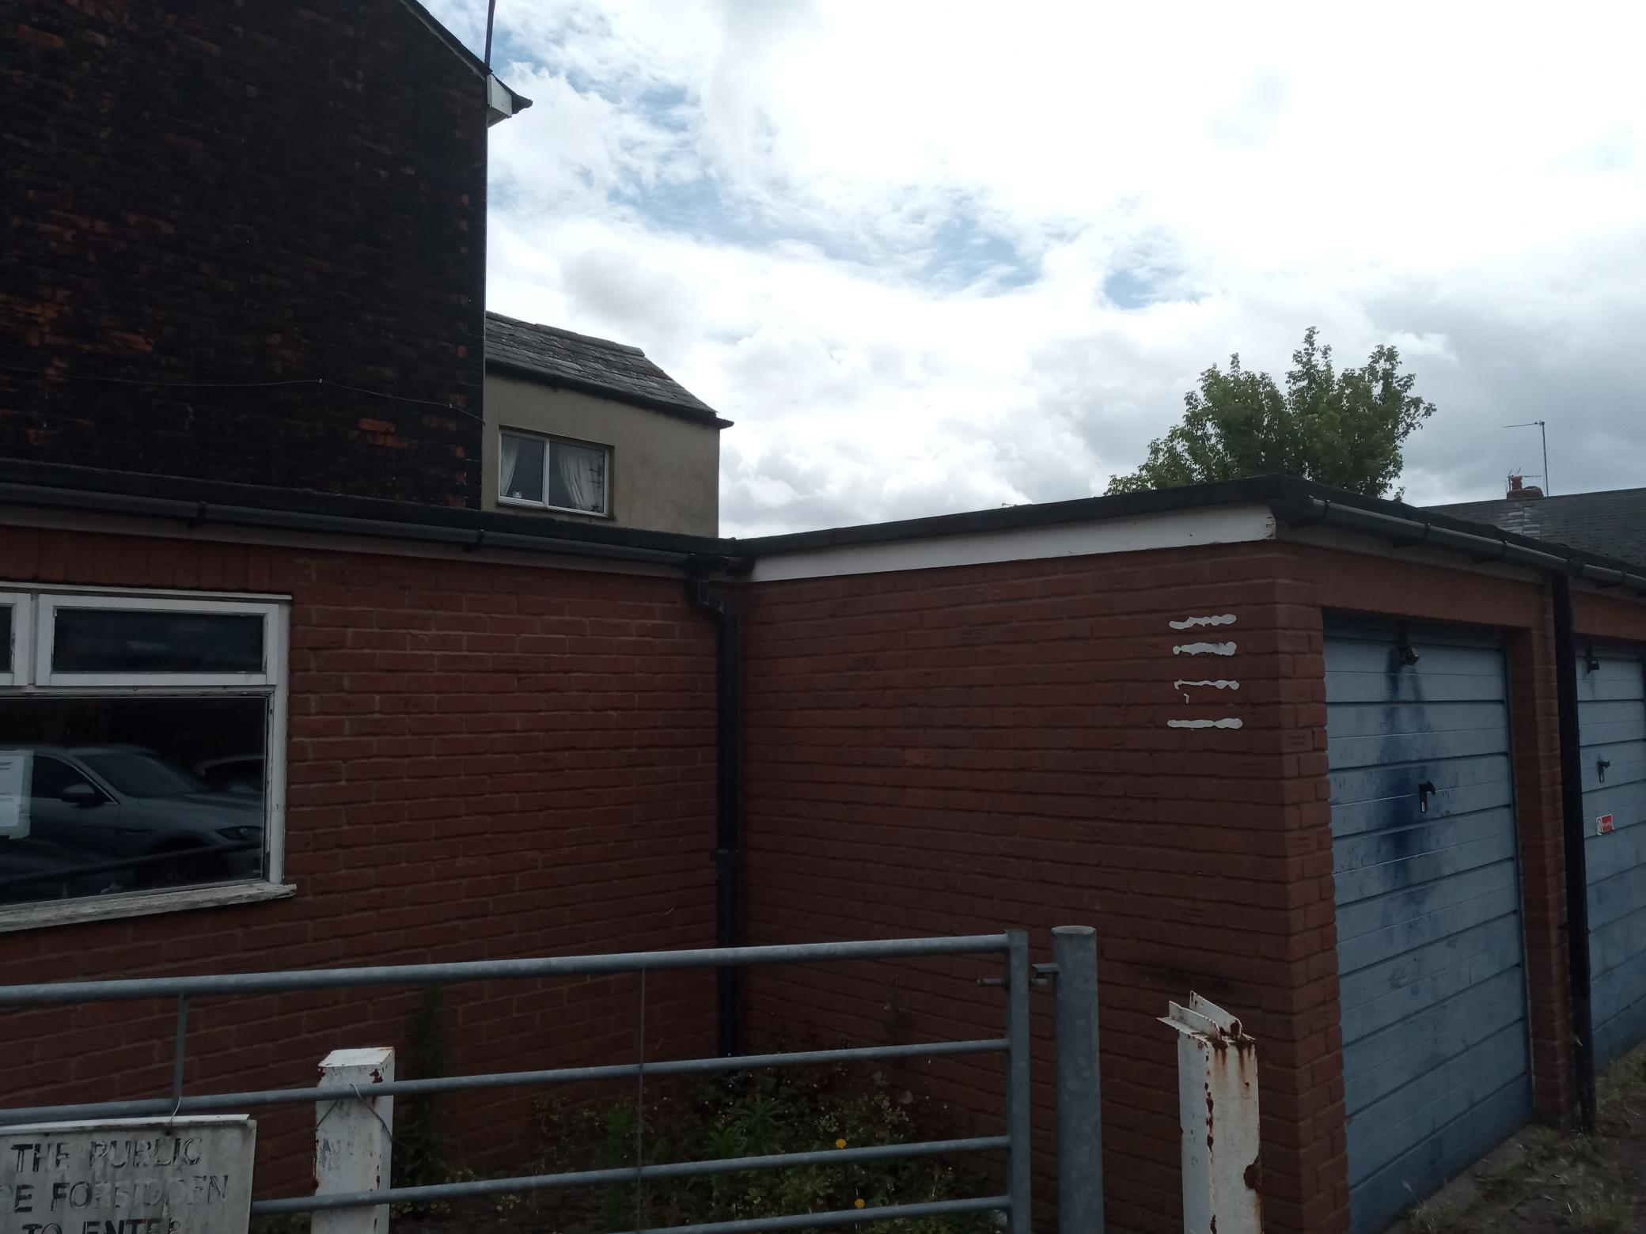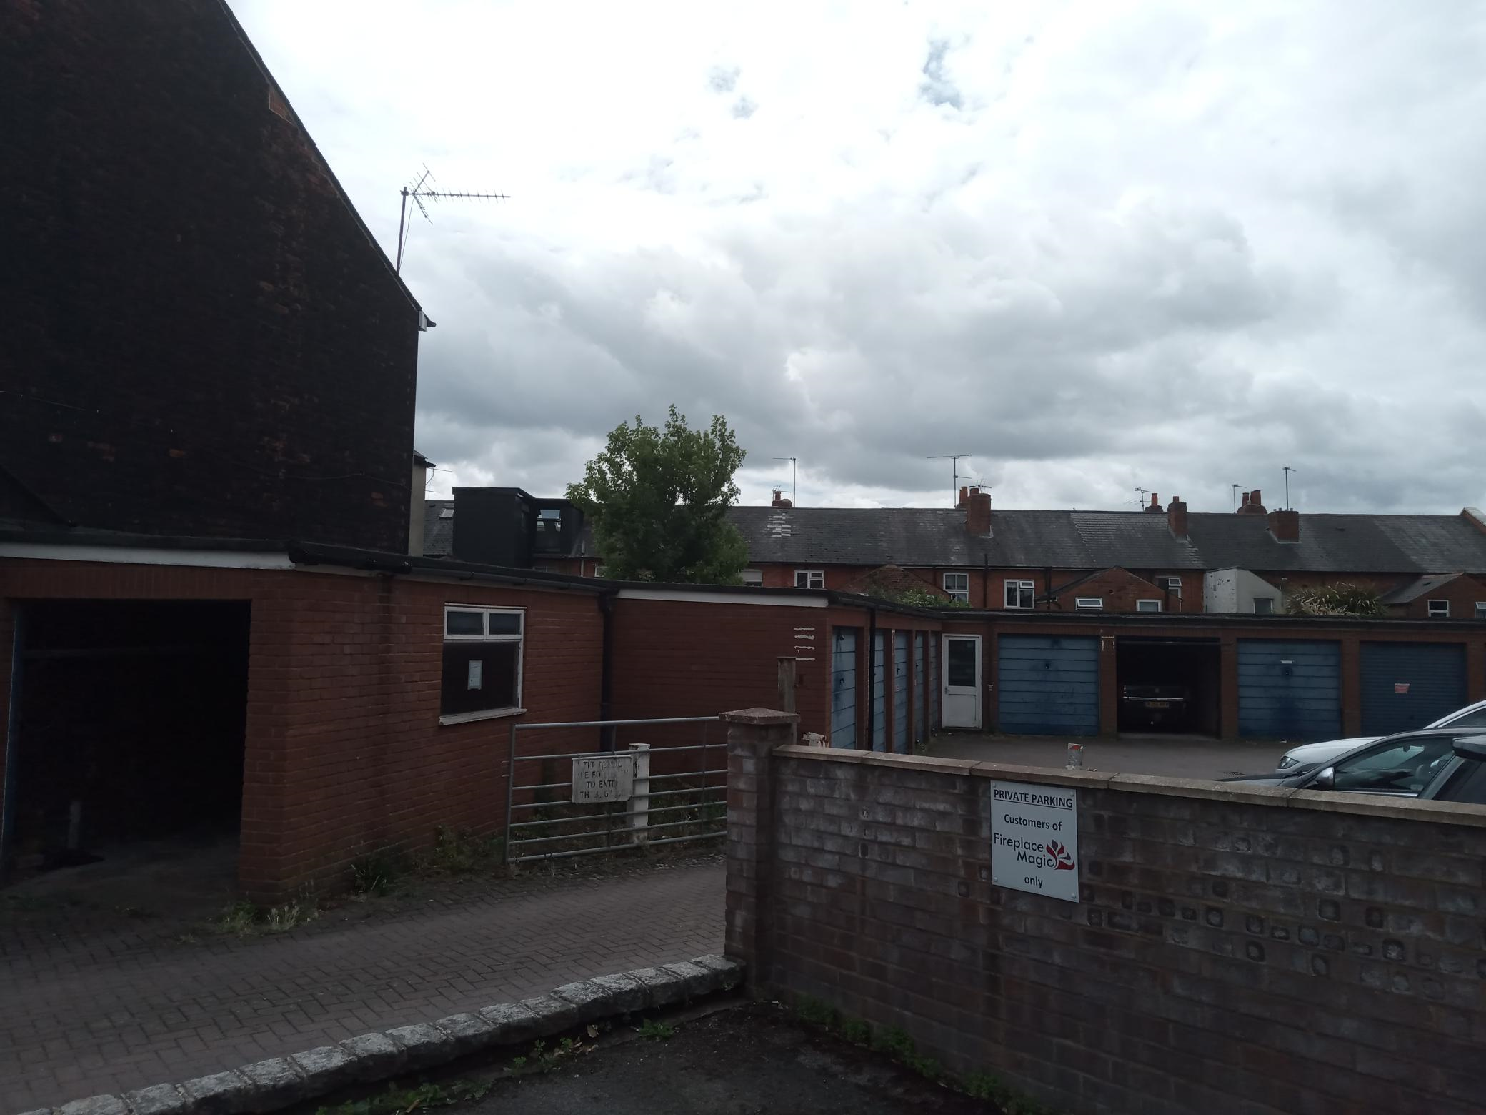
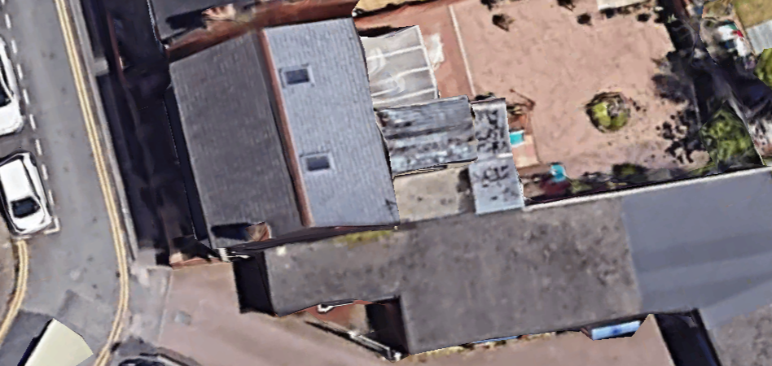

2. PROPOSAL AND SUPPORTING INFORMATION
The proposal presents an upward first floor side and rear extension, on part of the footprint of the existing garages attached to the side of the dwelling on the ground floor level. This creates additional first floor GIA of approximately 25sqm.

Plans considered dated March 2019, received 28/04/2023
Drawing No 01: Existing Plans and Elevations + Location Plan
Drawing No 02: Proposed Plans and Elevations + Block Plan

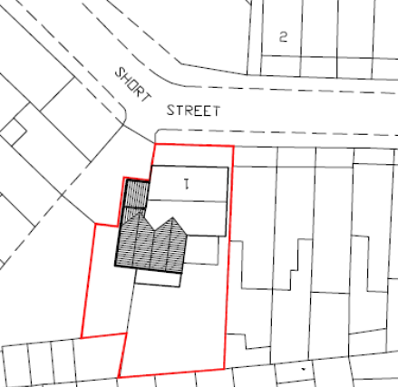

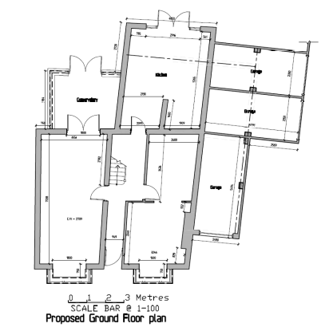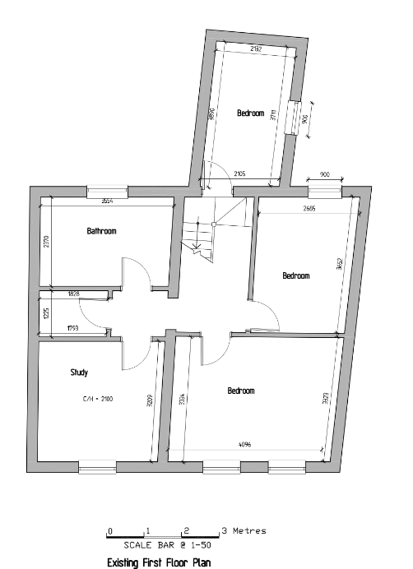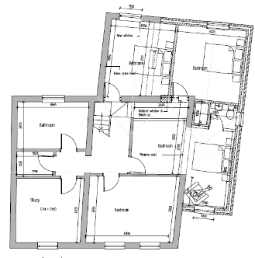
Existing and Proposed Ground Floor Existing First Floor Plan Proposed First Floor Plan

- RELEVANT PLANNING HISTORY
None

4. CONSULTATIONS

The following addresses were consulted by letter.

7 Chesterman Street, Reading, RG1 2PR
1 Chesterman Street, Reading, Berkshire, RG1 2PR
5 Chesterman Street, Reading, RG1 2PR
59 Sherman Road, Reading, RG1 2PP
57 Sherman Road, Reading, Berks, RG1 2PP
55 Sherman Road, Reading, RG1 2PP
61 Sherman Road, Reading, RG1 2PP
18 Short Street, Reading, RG1 2PS
53 Sherman Road, Reading, RG1 2PP
63 Sherman Road, Reading, RG1 2PP

No letters of representation have been received.

Ecology Comments.
The application site comprises a large end of terrace house in Caversham where it is proposed to add a first floor side and rear extension.

It is considered very unlikely that the proposals will impact upon bats or other protected species and there are therefore no objections to this application on ecological grounds.

Equality Act 2010:
In determining this application the Council is required to have regard to its obligations under the Equality Act 2010. However, there is no indication or evidence (including from consultation on the application) that the protected groups identified by the Act have or will have different needs, experiences, issues and priorities in relation to this particular planning application. Therefore in terms of the key equalities protected characteristics it is considered there would be no significant adverse impacts as a result of the development.

- LEGAL AND PLANNING POLICY CONTEXT

Section 38(6) of the Planning and Compulsory Purchase Act 2004 requires that proposals be determined in accordance with the development plan unless material considerations indicate otherwise. Material considerations include relevant policies in the National Planning Policy framework (NPPF) - among them the 'presumption in favour of sustainable development'. The following local and national planning policy and guidance is relevant to this application:

National Policy
National Planning Policy Framework
National Planning Practice Guidance

Reading Borough Local Plan (2019)
CC7 (Design and the Public Realm)
CC8 (Safeguarding Amenity)
H9 (House Extensions and Ancillary Accommodation)

SPD
Design Guide to House Extensions SPD 2021

6. APPRAISAL
Character and Appearance

Policy H9 states that an extension to a house will be acceptable where it respects the character of the house in terms of scale, location, materials and design and respects the character and pattern of neighbouring properties and the street as a whole in terms of scale, location, materials and design, and any important existing building line. Policy CC7 also sets out relevant considerations for design.

The proposed upward extensions to the side and the rear would be on the footprints of part of the existing garages. The resulting extension would be stepped back from the front line of the Principal Elevation and the ridgeline over the extension is to be stepped down from the level of the original ridgeline. The side of the extension is bordered by a large expanse of land to the next adjoining property. Materials to be used externally are to match existing materials.

Although the proposed extension would be realtively large in the context of the original dwelling it is considered that the specific siting of the proposal and its context would mena that’s impacts would not be unacceptable in the environment in which the original dwelling sits.

Residential Amenity

Policy H9 states that an extension will be acceptable where it does not result in an overbearing impact on neighbours. Policy H10 seeks to ensure that the amenity of gardens and other outdoor areas are not compromised. Policy CC8 states an extension to a house will be acceptable where it will not cause a significant detrimental impact to the living environment of existing or new residential properties.

As stated above in this report, there are no immediate adjoining properties on the side of the proposed extensions. There are also no side windows proposed, apart from the bathroom window. In terms of the additional first floor rear window this would be at a sufficient back to back distance to the properties at the rear, and would create a similar relationship to the existing first floor window, such that there would be no significant detrimental impact on the properties to the rear.

The proposal does not, therefore, present any aspects that could impinge on the privacy of the neighbouring properties and would not have any significant additional impact imposed by the new walls, as a blank wall of the same span exists as is. There are also no perceived negative impacts on sunlight and daylight available to adjoining buildings.

- CONCLUSION
The proposed development has been assessed as set out above and is considered to be acceptable on that basis, subject to the following conditions.

8. RECOMMENDATION: Grant

Recommended Conditions:
AP1: Approved Plans
TL1: Time Limit Standards
M1: Materials to Match Existing

