

DELEGATED HOUSEHOLDER APPLICATION REPORT

Ward: Coley
App Ref: 230009/HOU
Address: 8 Benyon Court, Reading, RG1 6HR
Proposals: Single storey rear extension
Case Officer: Chukwudi Onwudinanti
Applicant: Matthew Carter
Date received (valid from): 10 January 2023
Target Decision date: 3 May 2023 (EXT)

- SITE DESCRIPTION

The proposal is on an end of terrace two storey dwelling in the Benyon Court Residential Development, Off Bath Road. It is one of five terraces which make up the Benyon Court and has a double detached garage accessed through the rear of the property.

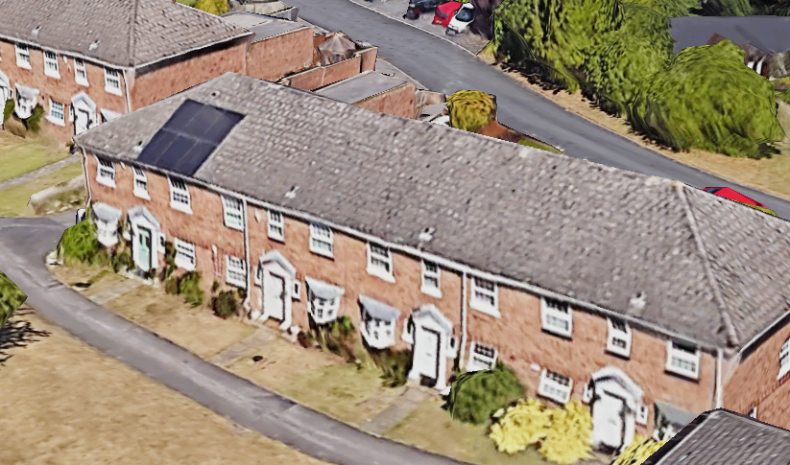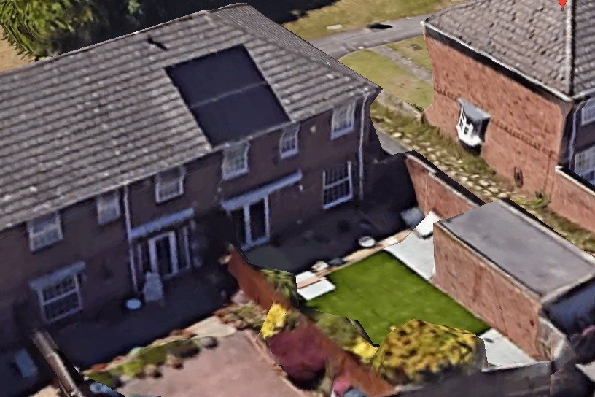

2. PROPOSAL AND SUPPORTING INFORMATION
The proposal is for a single storey rear extension measuring approximately 3.2m to the rear, and 4.8m wide.

Plans considered dated 11/06/2022 received 06/01/2023
Drawing 01: Existing Plans and Elevations
Drawing 02: Proposed Plans and Elevations
Drawing 03: Proposed Block Plan
Drawing 04: Site Location Plan

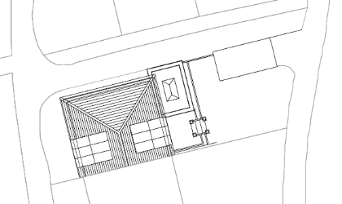
Proposed Block Plan
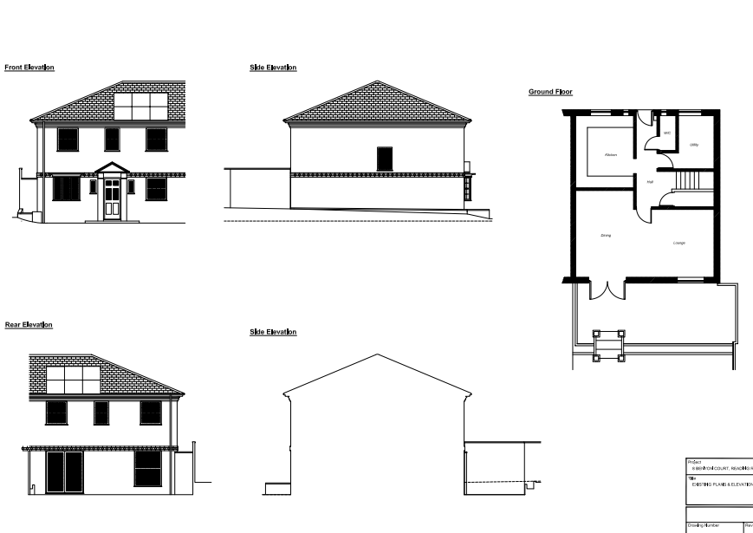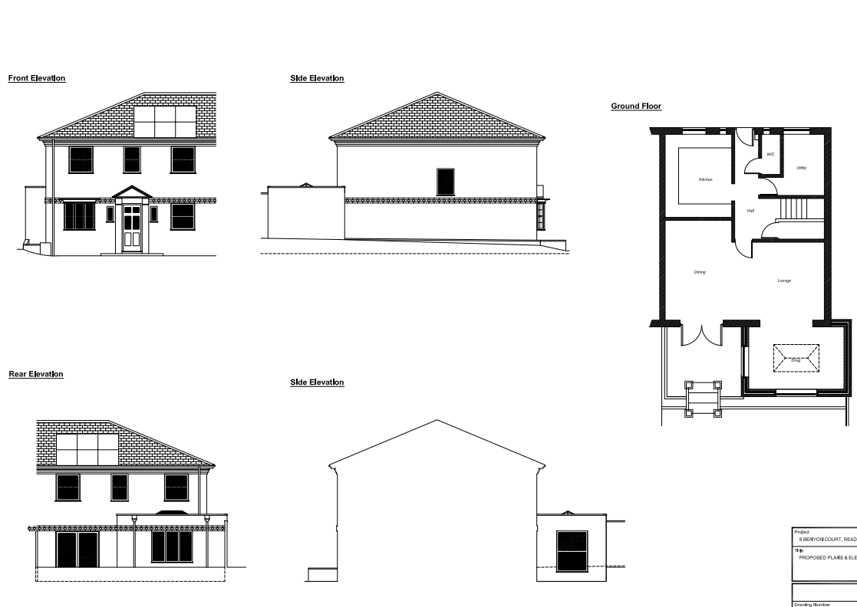
Existing Plans and Elevations Proposed Plans and Elevations

- RELEVANT PLANNING HISTORY
None

4. CONSULTATIONS

The following addresses were consulted by letter.

9 Benyon Court, Reading, RG1 6HR
7 Benyon Court, Reading, RG1 6HR

No letters of representation have been received.

Equality Act 2010:
In determining this application the Council is required to have regard to its obligations under the Equality Act 2010. However, there is no indication or evidence (including from consultation on the application) that the protected groups identified by the Act have or will have different needs, experiences, issues and priorities in relation to this particular planning application. Therefore in terms of the key equalities protected characteristics it is considered there would be no significant adverse impacts as a result of the development.

- LEGAL AND PLANNING POLICY CONTEXT

Section 38(6) of the Planning and Compulsory Purchase Act 2004 requires that proposals be determined in accordance with the development plan unless material considerations indicate otherwise. Material considerations include relevant policies in the National Planning Policy framework (NPPF) - among them the 'presumption in favour of sustainable development'. The following local and national planning policy and guidance is relevant to this application:

National Policy
National Planning Policy Framework
National Planning Practice Guidance

Reading Borough Local Plan (2019)
CC7 (Design and the Public Realm)
CC8 (Safeguarding Amenity)
H9 (House Extensions and Ancillary Accommodation)

SPD
Design Guide to House Extensions 2021

6. APPRAISAL
Character and Appearance

Policy H9 states that an extension to a house will be acceptable where it respects the character of the house in terms of scale, location, materials and design and respects the character and pattern of neighbouring properties and the street as a whole in terms of scale, location, materials and design, and any important existing building line. Policy CC7 also sets out relevant considerations for design.

All aspects of this proposed extension is to the rear of the address. The scale of the extension is moderate, extending just above 3m to the rear and taking up only about 4.8m of the width of the existing dwelling. The roof over the extension will be a flat one and the ground to eave height will not exceed 3m and all new materials are to match existing materials used on the external walls of the property.

The changes presented by this proposal are minimal and are not considered to alter the character of the existing dwelling in significant ways. It is therefore considered that the proposal is respectful of the character of the house in terms of scale, location, materials and design.

Residential Amenity

Policy H9 states that an extension will be acceptable where it does not result in an overbearing impact on neighbours. Policy H10 seeks to ensure that the amenity of gardens and other outdoor areas are not compromised. Policy CC8 states an extension to a house will be acceptable where it will not cause a significant detrimental impact to the living environment of existing or new residential properties.

The extension to the existing dwelling is on the side of the property that adjoins a public pathway and is limited to under 3m in height, with a flat roof over. There are no side windows presented that would present any significant harmful impact on the neighbours on No 9. No habitable rooms of any adjoining property would be in close proximity with the new development, such that any lines of access to daylight and sunlight would be compromised.

The LPA therefore considers that there would not be any privacy, overlooking, overbearing and loss of sunlight/daylight issues as a result of the changes proposed in this proposal.

- CONCLUSION
The proposed development has been assessed as set out above and is considered to be acceptable on that basis, subject to the following conditions.

8. RECOMMENDATION

Recommended Conditions:
AP1: Approved Plans
TL1: Time Limit Standards
M1: Materials to Match Existing

