DELEGATED HOUSEHOLDER APPLICATION REPORT

Ward: Caversham
App Ref: 220708/HOU
Address: 41 Ardler Road, Caversham, Reading, RG4 5AE
Proposals: Double storey rear extension, loft conversion
Case Officer: Chukwudi Onwudinanti
Applicant: Mr Richard Roberson
Date received (valid from): 15 May 2022
Target Decision date: 10 July 2022

1. INTRODUCTION
The proposal site is a set of semi- detached two storey dwellings on the western side of Ardler Road, among similar styled as well as varied styled buildings on both sides of the road, in a predominantly residential neighbourhood. The site benefits from roads running in front and to the back of the plot off Hardy Close. The site is not in an Article 4 Direction or Conservation Area.
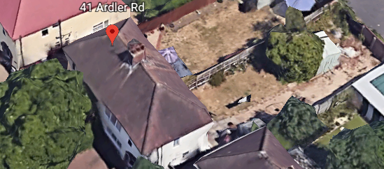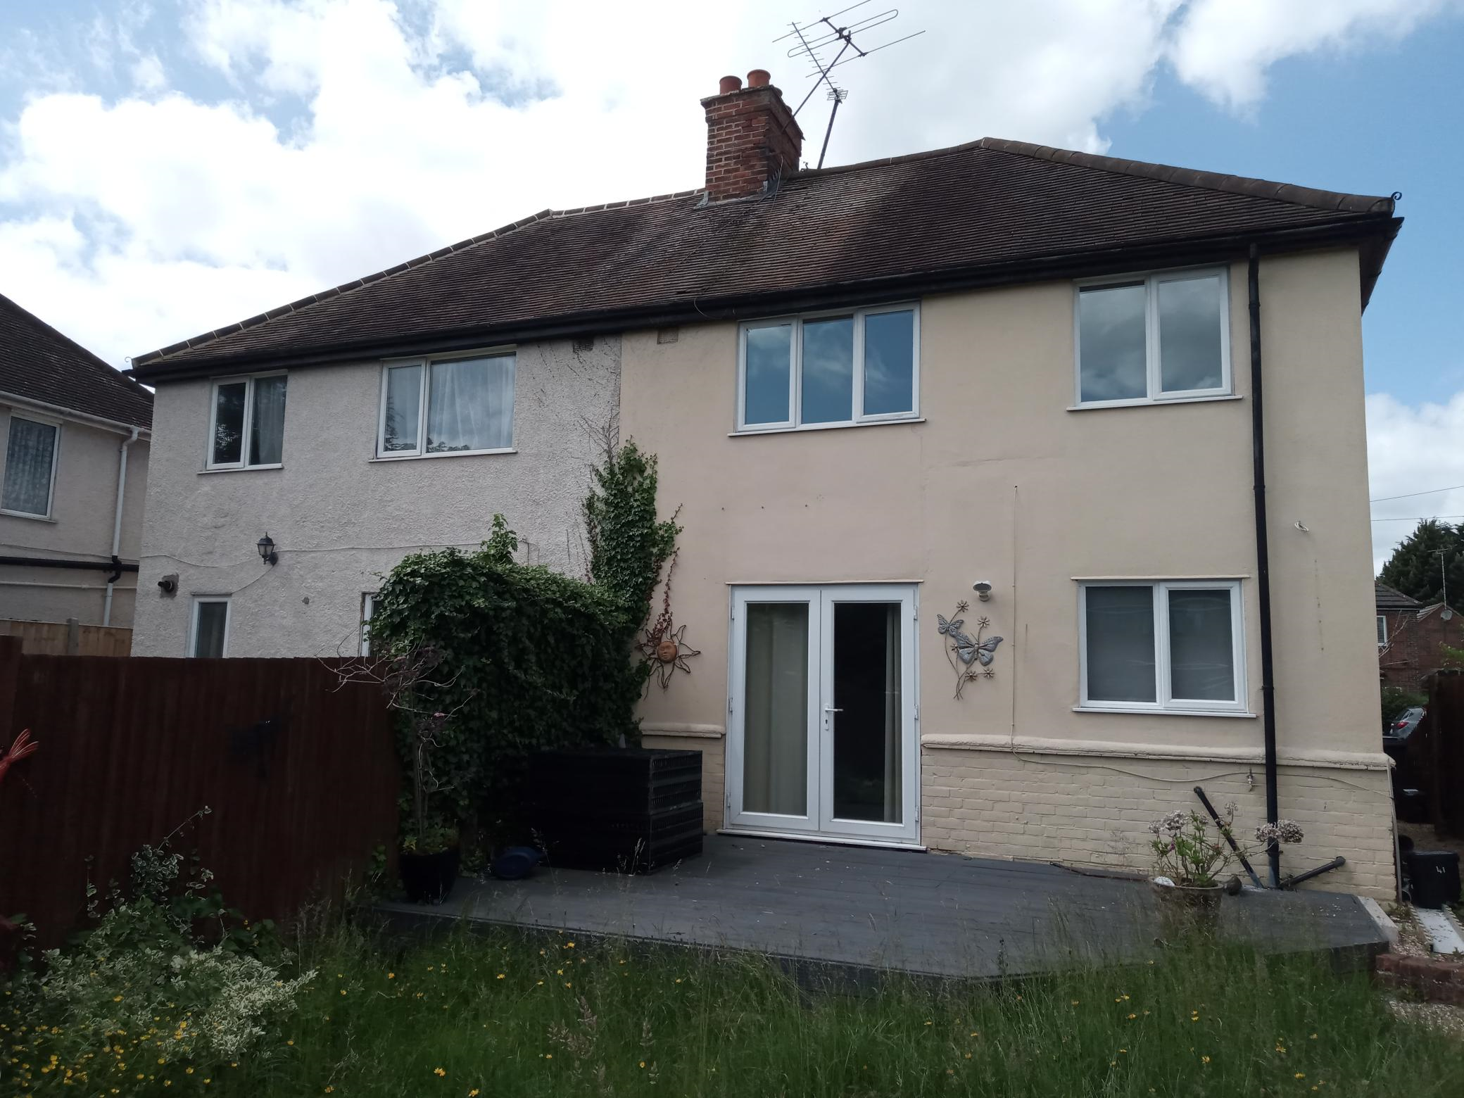

2. PROPOSAL AND SUPPORTING INFORMATION
The application red line includes the proposal for double storey rear extensions for both Nos 39 and 41 Ardler Road measuring approximately 4.8m deep on the ground floor and 3m on the first floor, and the two rear extensions combined, would run the width of the original building. The single storey elements of the rear extensions have different roofs, with no. 41 as a flat roof and no. 39 with a mono-pitch. The proposal also includes a loft conversion for no. 41, with velux roof lights.

Plans considered submitted 16th May 2022
Location Plan
Existing Site Plan
Existing Ground Floor Plan
Existing First Floor Plan
Elevations Existing
Proposed Block Plan
Site Plan Proposed.2
Ground Floor Proposed Plan
First Floor Proposed Plan
Roof Layout
Elevations as Proposed.2
Drawing No: Phase Plan 1 Received 7th September 2022

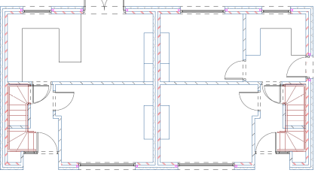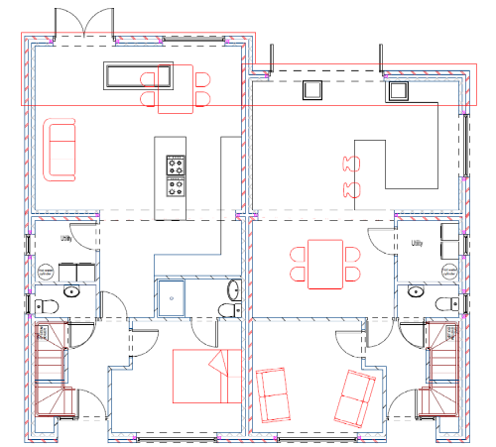
Existing Ground Floor Plan Proposed Ground Floor Plan

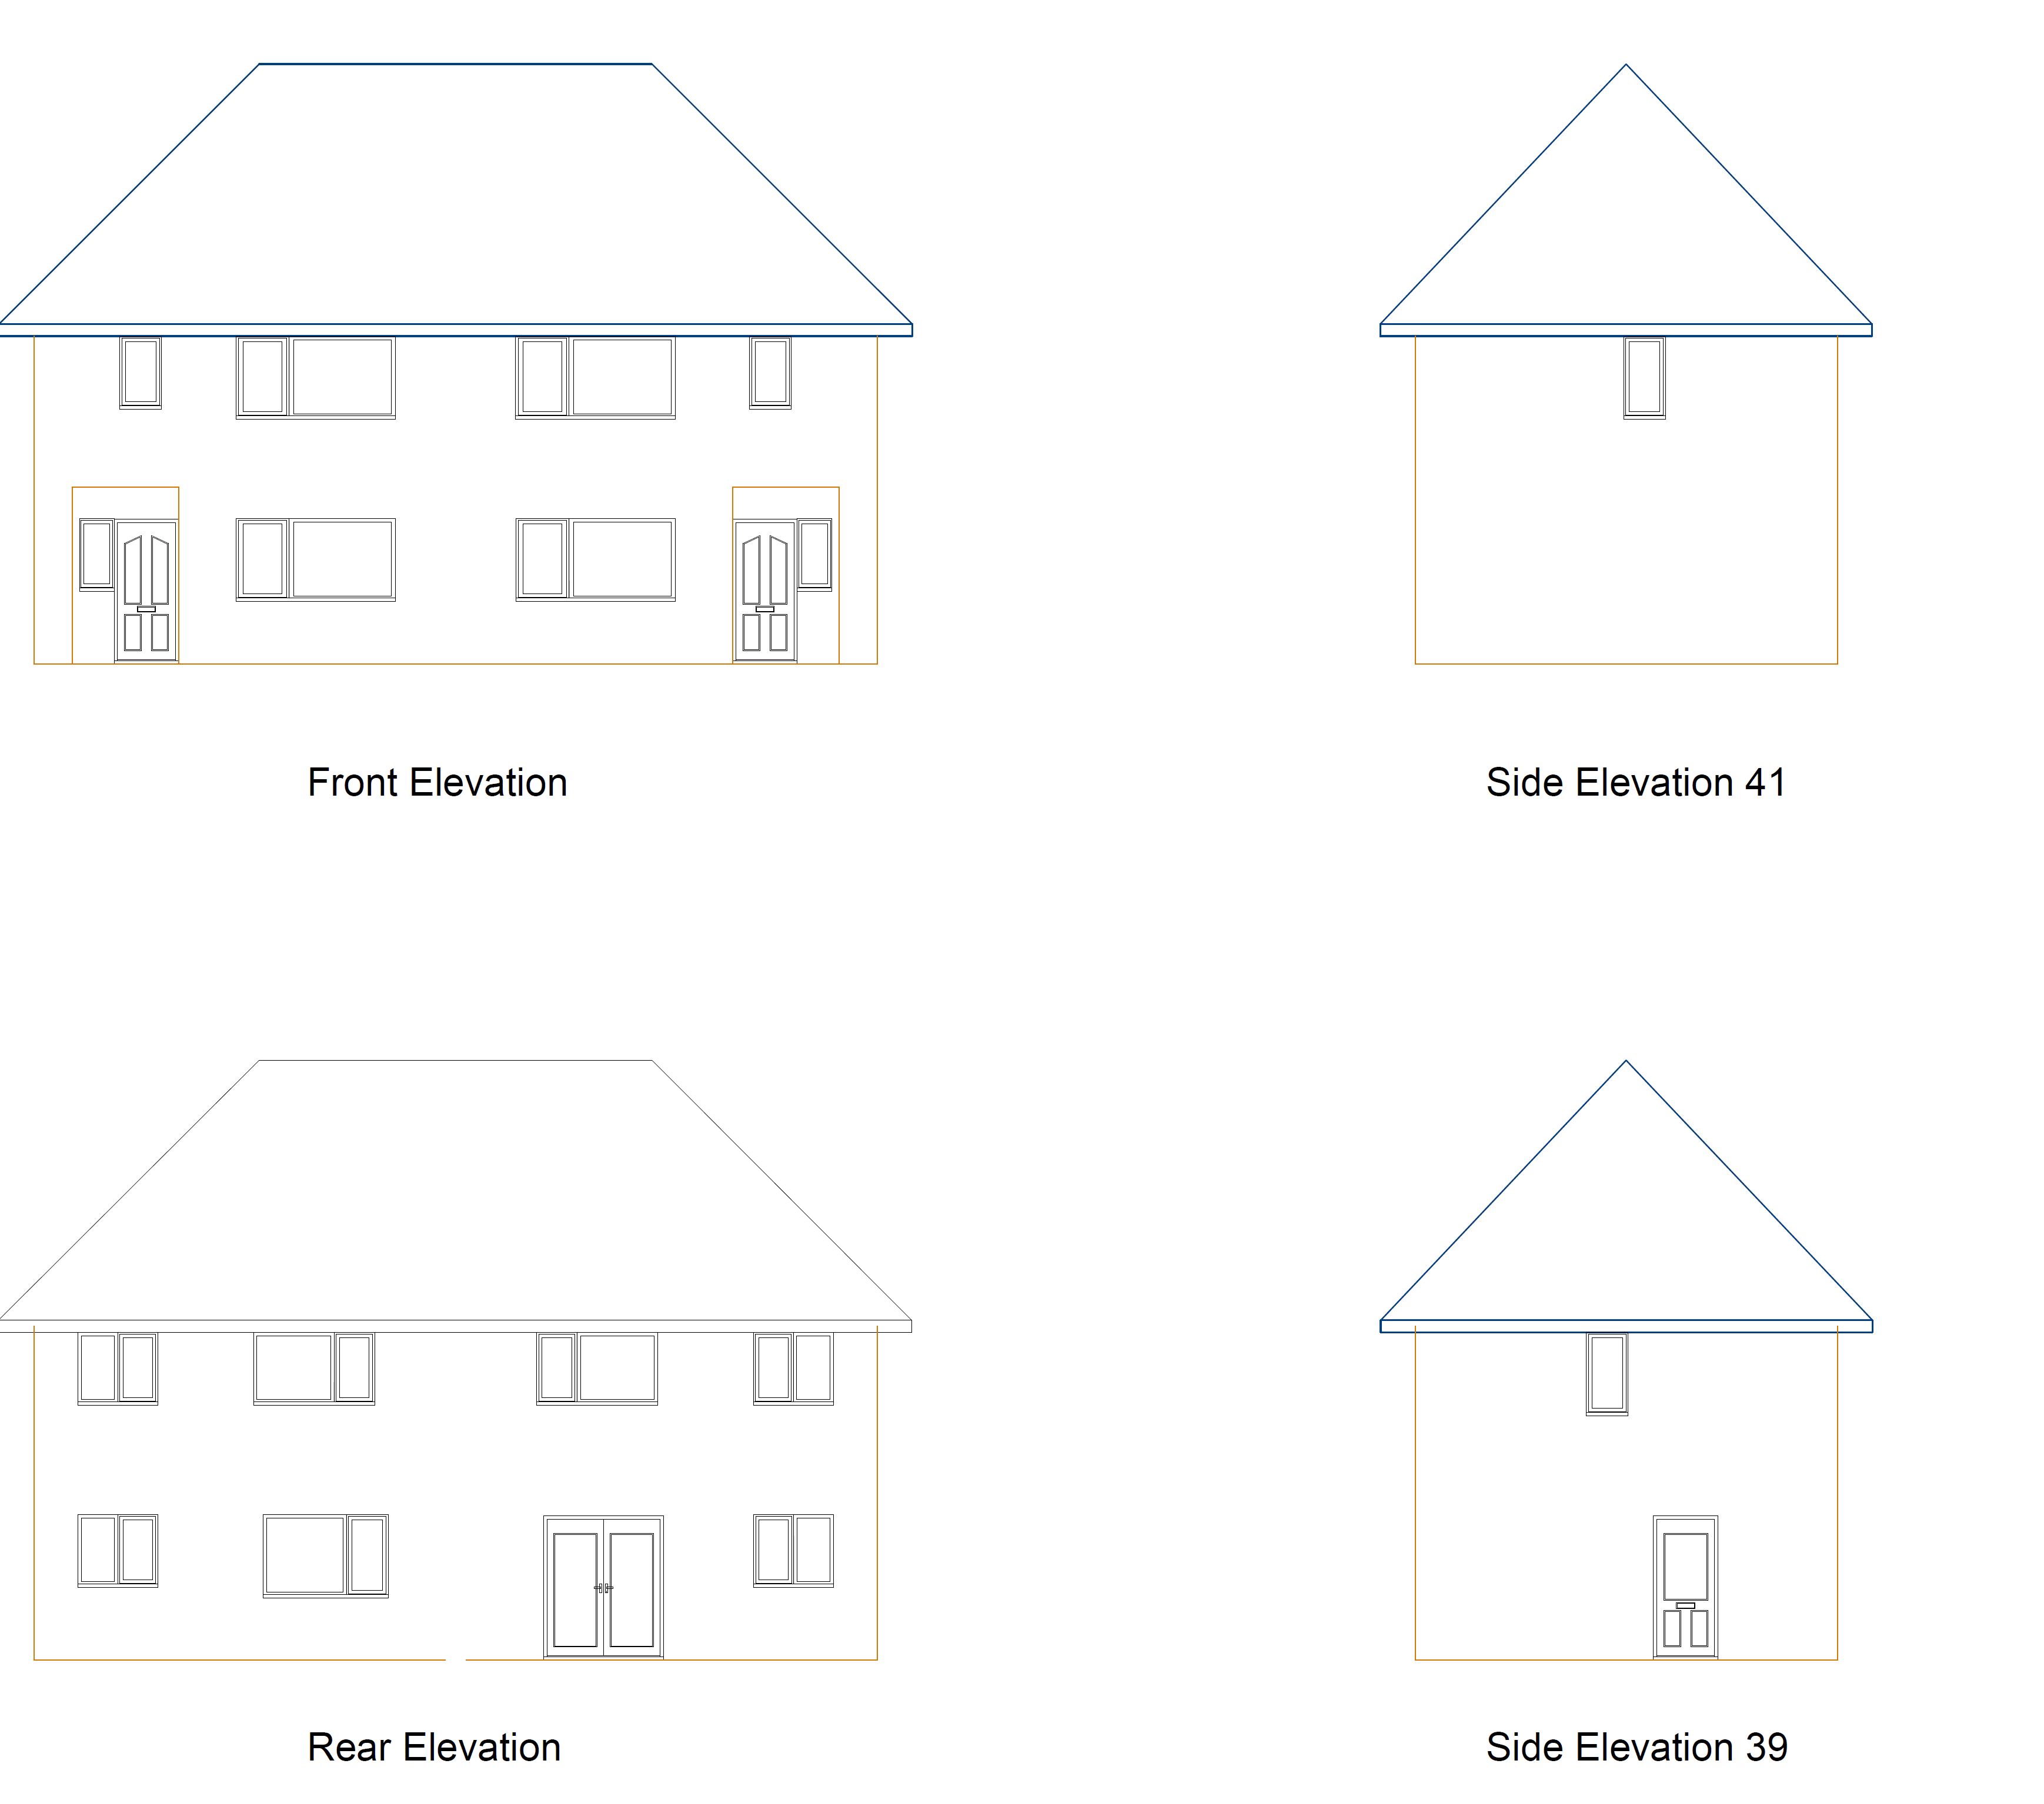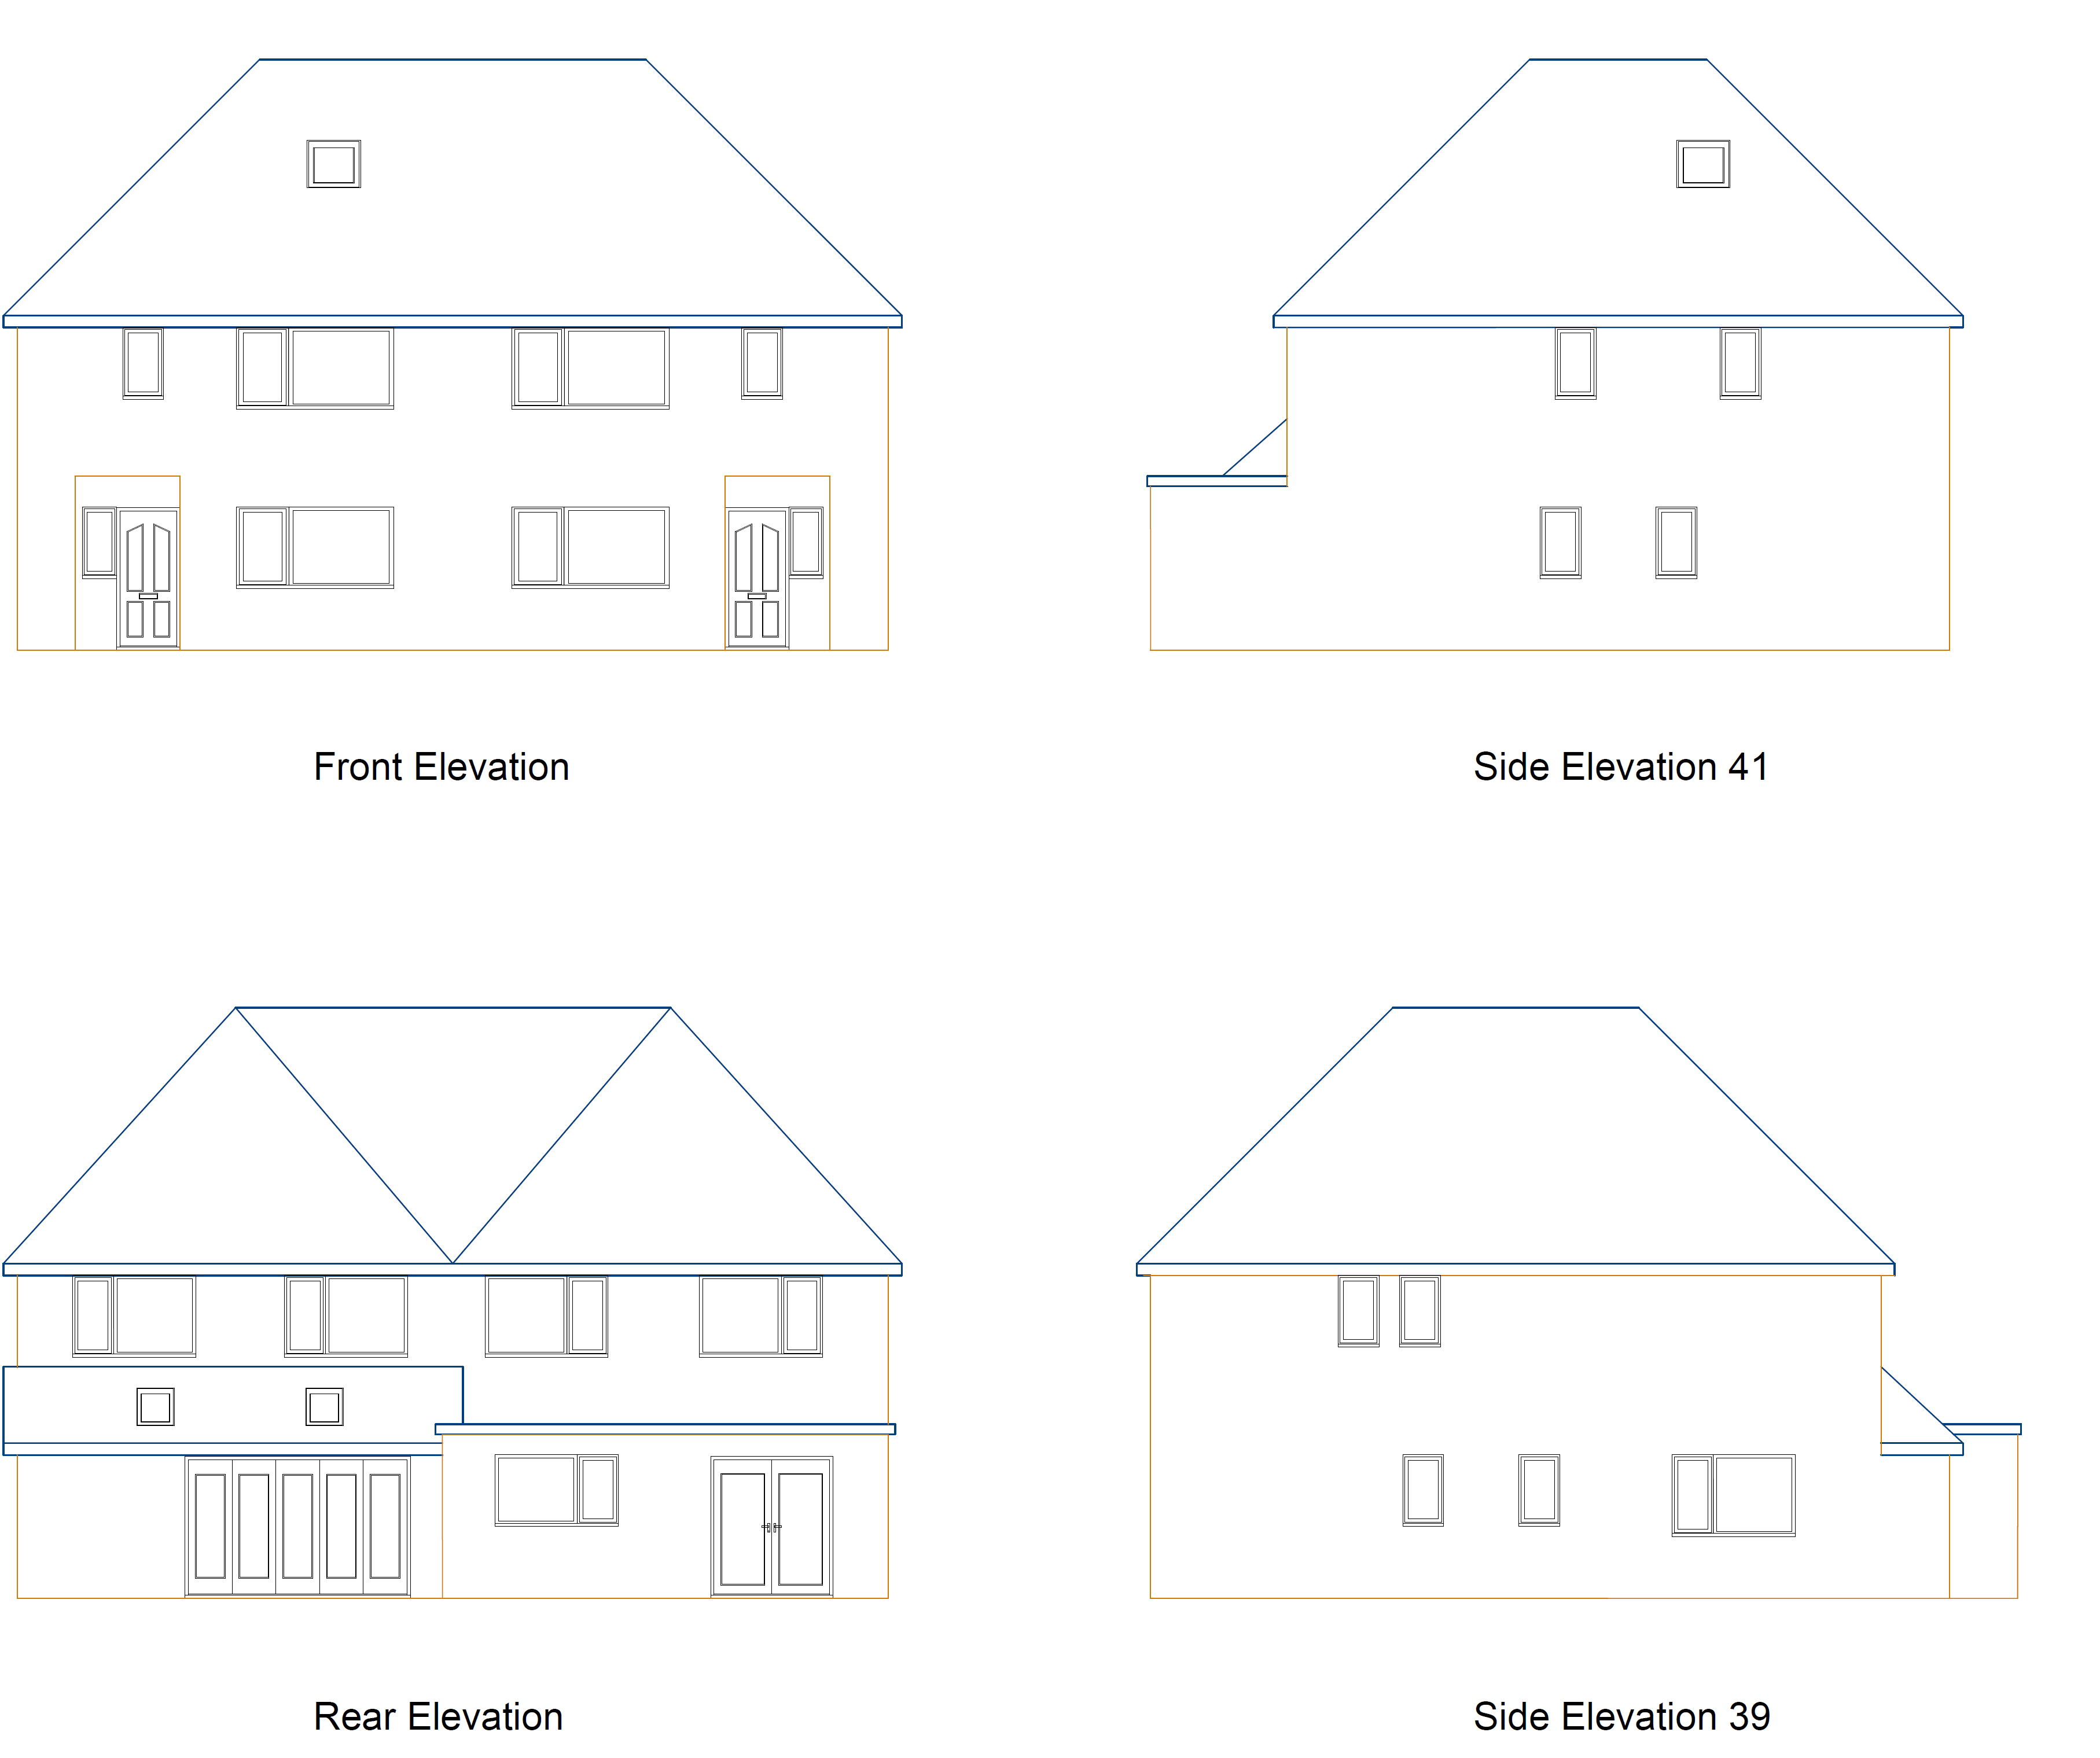
Existing Elevations Proposed Elevations

- RELEVANT PLANNING HISTORY

220349/HOU - Double storey rear extension, loft conversion and garage - withdrawn 8/4/22

4. CONSULTATIONS

4.1 The following addresses were consulted by letter.

39 Ardler Road, Caversham, Reading, Berkshire, RG4 5AE
43 Ardler Road, Caversham, Reading, RG4 0AE
37 Ardler Road, Caversham, Reading, RG4 5AE

4.2 Letters of representation have been received as follows:

Comments from 37 Ardler Road:

Number 39 has massive windows on the ground floor and first floor side elevation. These need to be obscured for privacy and fire protected for safety. Number 41 also has side windows, these needs to be obscured for privacy and fire protected for safety.

Equality Act 2010:
In determining this application the Council is required to have regard to its obligations under the Equality Act 2010. However, there is no indication or evidence (including from consultation on the application) that the protected groups identified by the Act have or will have different needs, experiences, issues and priorities in relation to this particular planning application. Therefore in terms of the key equalities protected characteristics it is considered there would be no significant adverse impacts as a result of the development.

- LEGAL AND PLANNING POLICY CONTEXT

Section 38(6) of the Planning and Compulsory Purchase Act 2004 requires that proposals be determined in accordance with the development plan unless material considerations indicate otherwise. Material considerations include relevant policies in the National Planning Policy framework (NPPF) - among them the 'presumption in favour of sustainable development'. The following local and national planning policy and guidance is relevant to this application:

National Policy
National Planning Policy Framework
National Planning Practice Guidance

Reading Borough Local Plan (2019)
CC7 (Design and the Public Realm)
CC8 (Safeguarding Amenity)
H9 (House Extensions and Ancillary Accommodation)

SPD
- Design Guide to House Extensions (2021)

6. APPRAISAL

H9 states: An extension to a house will be acceptable where it:

- Respects the character of the house in terms of scale, location, materials and design;

To assess this, the following has been considered – would the proposal:
- detract from the appearance of the original building through the use of ill-matching materials and by not fitting in with the design, scale and proportions of the original building; NO, while the scale of this proposal is significant, it does not detract from the appearance of the original building as all aspects of the extension are to the rear and not visible from the street scene.
- reduce the amount of usable amenity space for the property to an unacceptable degree; NO, the extension to the rear extends well into the back garden, however, the increased footprint of the building to the rear is not considered to be such that the amount of usable amenity is no longer acceptable.
- require the loss of trees in the garden or put significant trees at risk; NO, there are no trees in the immediate proximity of any aspect of the development.

- Respects the character and pattern of neighbouring properties and the street as a whole in terms of scale, location, materials and design, and any important existing building line; Respects neighbour’s amenities and does not present a large blank façade to public areas.

To assess this, the following has been considered – would the proposal:
- significantly reduce the amount of daylight and sunlight enjoyed by neighbouring properties;

NO, the first floor aspects of this proposal has been stepped back to ensure that they comply with the 45 degree rule for sunlight and daylight impact assessment. While the side windows of the adjoining buildings on both sides will be impacted to some degree by the new development, these impacts are not considered to be significantly more than the impact of the existing dwelling.

The application has been assessed based on the extensions taking place in tandem. There would be detrimental effects on the residential amenity of the occupants of one or other of the dwellings if only one of the extensions were built. It is considered appropriate, therefore, to apply a condition requiring the completion of the whole development. This condition, having been agreed with the applicants, shall be that ALL external walls of this proposal as approved will be completed before roofing of ANY part is undertaken. The works will therefore be phased in 2 parts:

Phase 1: All External Walls
Phase 2: Roofing and other parts

These provisions will be secured via Grampian Conditions attached to the Decision Notice.

- invade the privacy of neighbouring properties through overlooking from windows or balconies;

NO, while there are windows to the sides of this proposal, these windows are bathroom windows and conditions will be attached to the decision requiring these to be obscure glazed and for no further windows or openings to be allowed unless subsequently agreed by the LPA.

- detract from the character of neighbouring properties through siting, excessive bulk, ill-matching materials or inconsistent design;

NO, as stated above, the extensions are to the rear and do not detract from the character of the neighbourhood properties as they are not visible from the street.

- detract from the appearance of the street or area by using ill-matched materials, glazing and detailing;

NO, the extensions are not visible from the street.

CC8: Safeguarding Amenity states an extension to a house will be acceptable where it will not cause a significant detrimental impact to the living environment of existing or new residential properties.

To assess this, the following has been considered – would the proposal cause a significant detrimental impact to the living environment of existing or new residential properties in terms of:

- Privacy and overlooking; No, see above.
- Access to sunlight and daylight; No, see above.
- Visual dominance and overbearing effects of a development; No, see above.
- Noise and disturbance; No

- CONCLUSION
The proposed development has been assessed and the proposed works are considered to be in accordance with the above relevant policies and planning permission can be granted.

- RECOMMENDATION
Grant

