COMMITTEE REPORT

BY THE DIRECTOR OF ECONOMIC GROWTH & NEIGHBOURHOOD SERVICES
READING BOROUGH COUNCIL
PLANNING APPLICATIONS COMMITTEE: 13th January 2021

Ward: Battle
App No: 201391/FUL
Address: Land At, 362 Oxford Road, Reading, RG30 1AQ

Proposal: Erection of a mixed-use development comprising of two commercial units on the ground floor (157.5 sqm), 26 residential units (including 30% affordable housing), associated landscaping, car and cycle parking (amended description).

Applicant: Stonegate Homes
13 Week Target Date: 29 Jan 2021

RECOMMENDATION:

Delegate to the Head of Planning, Development and Regulatory Services (HPDRS) to:

- GRANT full planning permission, subject to the satisfactory completion of the Section 106 agreement;

The S106 to include the following heads of terms:

- Secure the agreed level of on-site affordable housing consisting of 2 x 1-bed, 5 x 2-bed, 1 x 3-bed, of which x5 would be for affordable rent and x3 shared ownership.
- £64,700 Open Space contribution to improve and extend facilities within the Thames Parks - payable before first occupation;
- Secure a construction phase Employment Skills and Training Plan or equivalent financial contribution. As calculated in the Council’s Employment Skills and Training SPD (2013) – payable on commencement.

All financial contributions index-linked from the date of permission.

Or;

- Refuse full planning permission if sustainability matters not resolved or the S106 agreement is not completed by 29th January 2021 (unless the Head of Planning, Development and Regulatory Services Officers agree to a later date for completion of the legal agreement)

Conditions:

- TIME LIMIT (STANDARD)
- APPROVED PLANS
- DWELLING MIX (RESTRICTION)
- MATERIALS (TO BE APPROVED)
- SAP ASSESSMENT MAJOR - AS BUILT (TO BE APPROVED)
- DETAILS OF PHOTOVOLTAIC ARRAY(S) (TO BE APPROVED, INCLUDING IMPLEMENTATION)
- SUSTAINABLE DRAINAGE (TO BE IMPLEMENTED)
- LANDSCAPING LARGE SCALE (TO BE APPROVED)
- HABITAT ENHANCEMENT SCHEME (TO BE APPROVED)
- SECURED BY DESIGN (TO BE APPROVED)
- NOISE MITIGATION SCHEME (AS SPECIFIED)
- HOURS OF DELIVERIES/WASTE COLLECTION
- HOURS OF OPENING/OPERATION
- MECHANICAL PLANT (NOISE ASSESSMENT REQUIRED)
- CONTAMINATED LAND ASSESSMENT (TO BE SUBMITTED)
- REMEDIATION SCHEME (TO BE SUBMITTED)
- REMEDIATION SCHEME (IMPLEMENT AND VERIFICATION)
- UNIDENTIFIED CONTAMINATION
- HOURS OF CONSTRUCTION/DEMOLITION
- CONSTRUCTION METHOD STATEMENT (TO BE SUBMITTED)
- NO BONFIRES
- REFUSE AND RECYCLING (AS SPECIFIED)
- VEHICLE PARKING (AS SPECIFIED)
- VEHICULAR ACCESS (DETAILS TO BE APPROVED)
- CYCLE PARKING (TO BE APPROVED)
- PARKING PERMITS 1
- PARKING PERMITS 2
- DELIVERY AND SERVICING MULTI-UNIT (TO BE APPROVED)
- EV CHARGING POINTS
- ADAPTABLE UNITS
- EXTERNAL LIGHTING (TO BE APPROVED, IF ANY IS PROPOSED)
- ARBORICULTURAL METHOD STATEMENT (TO BE SUBMITTED)
- TREE PROTECTION MEASURES (TO BE SUBMITTED)
- PROVISION/RETENTION OF LIFTS

Informatives

- Positive and Proactive Working - approval
- Pre-commencement conditions
- Highways
- S106
- Terms
- Building Control
- Complaints about construction
- Encroachment
- Contamination
- Noise between residential properties – sound insulation of any building
- Community Infrastructure Levy (CIL)
- Parking Permits
- Ongoing information conditions
- Access construction
- Canopies and structures overhanging the highway

1. INTRODUCTION
1.1 The site for which this application relates is a broadly rectangular vacant piece of land of 0.3 hectares to the west of Reading town centre. The site adjoins the parade of shops and short stay car park to the south-west, the Tesco Extra superstore to the north-west, residential buildings to the north and east and the Conservative club (the Curzon Club) to the south which fronts Oxford Road. Whilst currently vacant and surrounded by hoarding, the site is classified as previously developed land. There are some mature trees along the eastern and southern borders of the site.
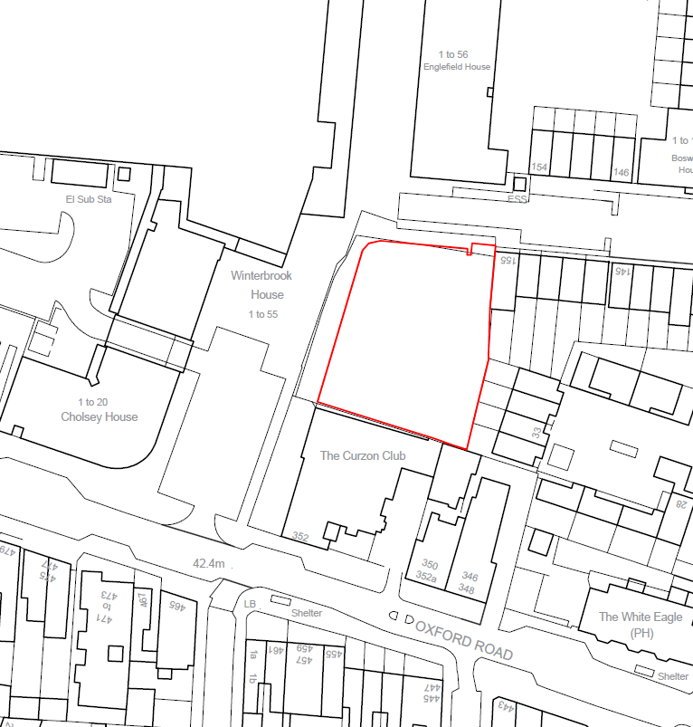
Short stay car park
Tesco
Figure 1 – Extract from site location Plan with land uses
1.2 The site is an allocated housing site within the Local Plan under Policy WR3j (Land at Moulsford Mews). It also adjoins the northern boundary of the Oxford Road West district or local centre. There are no listed buildings on or adjoining the site, it is not located within a Conservation Area, and is not within an area of high flood risk. Vehicular access is gained from the north along Moulsford Mews. The site can also be accessed by pedestrians from the south, via Oxford Road and the short stay car park.
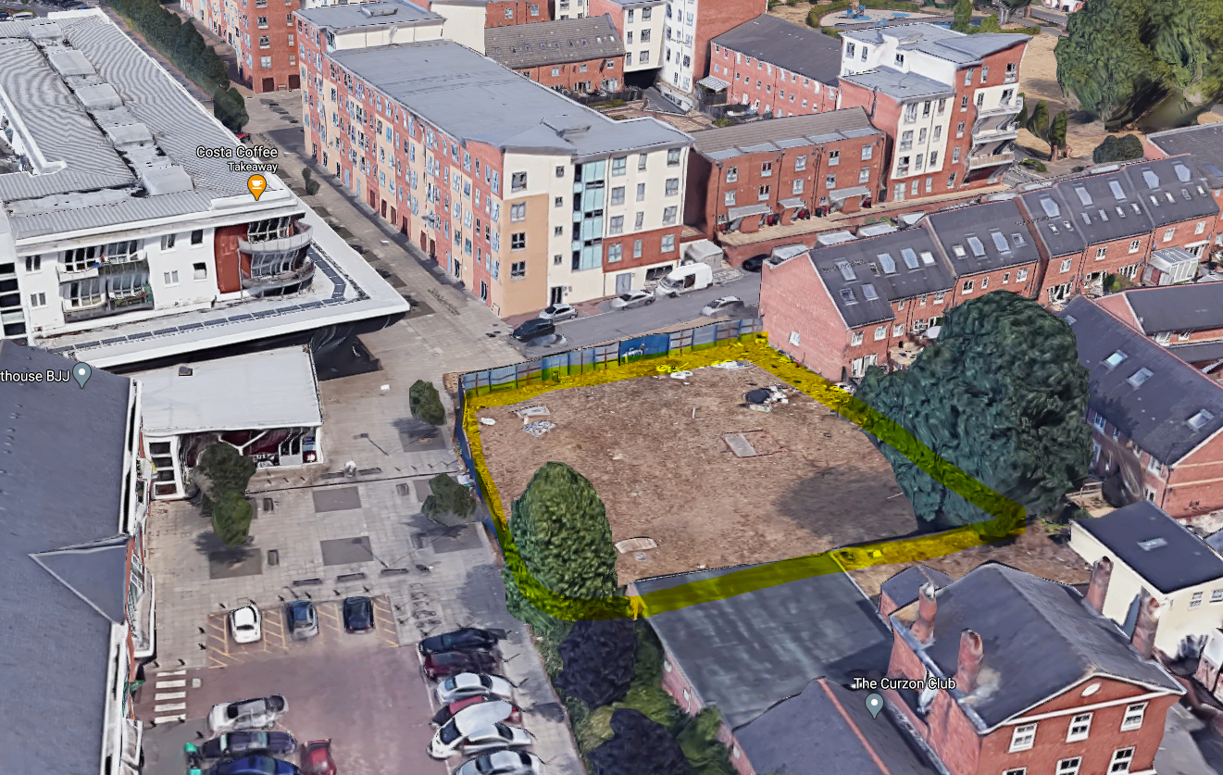Figure 2 – Aerial (Google maps 2020)
1.3 The site is accessible to public transport along Oxford Road, with frequent bus links into Reading town centre, and Reading West Station is approximately 9 minutes’ walk.
1.4 The site formed part of the former Battle Hospital site, which was comprehensively redeveloped. The Battle Hospital Planning Brief (2005) showed a health centre on the site. However, this was not subsequently required by the NHS Trust and the site was subsequently allocated for housing in the Reading Local Plan (2019). The requirement for a health centre therefore fell away with the adoption of the new Local Plan.
1.5 The site is bounded by Englefield House to the north, a 5-storey block of flats, the 3-storey townhouses along Curzon Street to the northeast, 2-storey houses on Battle Place to the east, the Curzon Club to the south and beyond that the Oxford Road, the 3 storey Cholsey House to the West, and 4-storey Tesco store to the northwest, which has residential over (see Fig 2 above).

2. PROPOSAL

2.1 The application seeks permission for the redevelopment of the site to provides a mixed-use development comprising of two commercial units on the ground floor and 26 residential units on upper floors. The residential element would comprise of 5 x 1 bedroom, 13 x 2 bedroom and 8 x 3-bedroom units, of which 8 would be affordable units.

2.2 The two flexible commercial units would total approximately 157.5 sqm and have active frontages onto the public plaza in front of the site and with Curzon Street/Moulsford Mews. Secure cycle parking, 22 car parking spaces, and 4 electric car charging units will be provided.

The development will take the form of 4-6 storey building, with a mixture of integral balconies and private terraces. The scheme would also include four separate living green walls to the eastern and northern elevation, green roofs, and a roof mounted solar PV array.

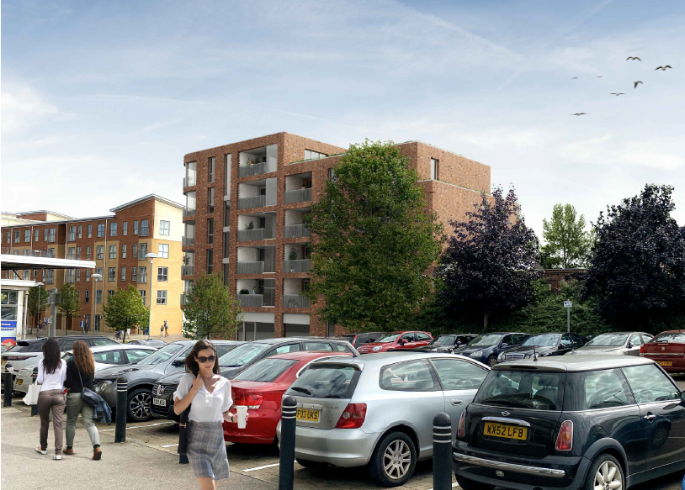
Fig 3 – CGI visual of proposal (view from Oxford Road)

2.3 Submitted Plans and Documentation:

Original proposed plans submitted with application:

LOC P1 Site Location Plan
BLOC P1 Block Plan
050 P1 Existing Site Plan
100 P1 Site Plan
110 P1 Ground Floor Plan
111 P1 First Floor Plan
112 P1 Second Floor Plan
113 P1 Third Floor Plan
114 P1 Fourth Floor Plan
115 P1 Fifth Floor Plan
116 P1 Roof Plan
140 P1 Existing Street Elevations
141 P1 Existing Street Elevations
142 P1 Proposed Street Elevations
143 P1 Proposed Street Elevations
144 P1 Elevations Sheet 1 of 2
145 P1 Elevations Sheet 2 of 2
150 P1 Render View 1
151 P1 Render View 2

2.4 Revised plans/documents received December 2020

LOC P1 Site Location Plan
BLOC P1 Block Plan
100 P3 Site Plan
110 P4 Ground Floor Plan
111 P1 First Floor Plan
112 P1 Second Floor Plan
113 P1 Third Floor Plan
114 P1 Fourth Floor Plan
115 P1 Fifth Floor Plan
116 P1 Roof Plan
142 P2 Proposed Street Elevations
143 P2 Proposed Street Elevations
144 P2 Elevations Sheet 1 of 2
145 P2 Elevations Sheet 2 of 2
150 P2 Render View 1
151 P2 Render View 2
160 P2 Natural Environment Plan

3. PLANNING HISTORY

06/00011/FUL

Erection of 434 no. dwellings and health care/social care/community care facility with associated car parking, open space, landscaping and new access arrangements.

GRANTED 10/11/2006

4. CONSULTATIONS

4.1 Transport

No objection subject to conditions.

4.2 Environmental Protection
No objections see discussion below in Appraisal section.

4.3 RBC Ecology

No objection subject to conditions.

4.4 Natural Environment Team (Landscape)
Object to the removal of the Sycamore tree on site.

4.5 RBC Housing Officer
No objection to affordable housing offer and proposed tenure split.

4.6 RBC Leisure Team

A contribution of £63,700 is sought for improvements to existing open space facilities as a result of the development.

4.7 Crime Prevention Design Advisor

No objection subject to conditions.

4.8 Sustainability/Energy Officer

No comment received.

4.9 Public representations

Letters were sent to various properties in the area and a site notice was displayed at the site.
At the time of writing, 6 letters of representation have been received raising the following issue:
- “How many [parking] spaces will be created for these 26 residential units? It's already very limited and can cause congestion”.

- “Not enough parking spaces have been proposed for the 26 homes that are being built. There is already a parking crisis in the area, with plenty of flats and HMO properties and therefore lots of cars. People who work in the area also park their cars around the Battle Hospital development, which causes a lot of disruption.”

- “There should be more affordable housing, the number proposed is not enough”.

- “I do not support this application as the stretch of road from Battle Square to Moulsford Mews is small and narrow. As such, this block of 26 flats could make this stretch of road very busy and difficult for existing residents to operate”.

- “Frankly the idea that replacing the fairly cute, if a bit derelict, Battle Hospital building with an actual eyesore tower block is just really saddening. I agree with the need for new homes to be built but please pay someone to design architecture people will enjoy for years to come rather than (as with the mock image I saw on getreading.co.uk) will no doubt come to resent as another eyesore tower block. Also how is the current state of Battle Hospital related to crime rates please explain? I was under the impression it was due to underfunded policing, stagnating wages, the coexistence of wealthy with poor people in separate but equal neighbourhoods, and probably now increased unemployment due to covid19.”

- “We are in the process of purchasing 9 Englefield House RG30 1ET. This flat will be directly opposite the new development. This will mean our flat will be directly opposite the balcony on the 2nd floor (plot 1). They will be able to view directly into our flat. The height of the new development will block the light coming into our flat. We see from the Sunlight report we would have a VSC reduction of less than 0.8 (0.6 show in report) which is outside the BRE guidelines.”

The application material also includes a statement of community involvement (SCI) and details of this will be provided in an update report.

5. RELEVANT PLANNING POLICY AND GUIDANCE

5.1 Section 38(6) of the Planning and Compulsory Purchase Act 2004 requires that proposals be determined in accordance with the development plan unless material considerations indicate otherwise. Material considerations include relevant policies in the National Planning Policy Framework (NPPF) which also states at Paragraph 11 “Plans and decisions should apply a presumption in favour of sustainable development”.

5.2 The following relevant planning policy and guidance is applicable to the assessment of this application.

5.3 National Planning Policy Framework (NPPF) (Feb 2019)

Section 2 - Achieving sustainable development
Section 4 - Decision-making
Section 5 - Delivering a sufficient supply of homes
Section 7 - Ensuring the vitality of town centres
Section 8 - Promoting healthy and safe communities
Section 9 - Promoting sustainable transport
Section 11 - Making effective use of land
Section 12 - Achieving well-designed places
Section 14 - Meeting the challenge of climate change, flooding and coastal change
Section 15 - Conserving and enhancing the natural environment

5.4 Reading Borough Local Plan 2019

CC1: PRESUMPTION IN FAVOUR OF SUSTAINABLE DEVELOPMENT
CC2: SUSTAINABLE DESIGN AND CONSTRUCTION
CC3: ADAPTATION TO CLIMATE CHANGE
CC5: WASTE MINIMISATION AND STORAGE
CC6: ACCESSIBILITY AND THE INTENSITY OF DEVELOPMENT
CC7: DESIGN AND THE PUBLIC REALM
CC8: SAFEGUARDING AMENITY
CC9: SECURING INFRASTRUCTURE

EN1: PROTECTION AND ENHANCEMENT OF THE HISTORIC ENVIRONMENT
EN10: ACCESS TO OPEN SPACE
EN12: BIODIVERSITY AND THE GREEN NETWORK
EN14: TREES, HEDGES AND WOODLAND
EN15: AIR QUALITY
EN16: POLLUTION AND WATER RESOURCES
EN17: NOISE GENERATING EQUIPMENT
EN18: FLOODING AND DRAINAGE

EM3: LOSS OF EMPLOYMENT LAND

H1: PROVISION OF HOUSING
H2: DENSITY AND MIX
H3: AFFORDABLE HOUSING
H5: STANDARDS FOR NEW HOUSING
H6: ACCOMMODATION FOR VULNERABLE PEOPLE
H10: PRIVATE AND COMMUNAL OUTDOOR SPACE

TR1: ACHIEVING THE TRANSPORT STRATEGY
TR3: ACCESS, TRAFFIC AND HIGHWAY-RELATED MATTERS
TR4: CYCLE ROUTES AND FACILITIES
TR5: CAR AND CYCLE PARKING AND ELECTRIC VEHICLE CHARGING

WR3j LAND AT MOULSFORD MEWS
5.5. Supplementary Planning Documents

Sustainable Design and Construction (2019)
Planning Obligations under Section 106 SPD (2015)
Employment, Skills and Training SPD (2013)
Affordable Housing SPD (2013)
Revised Parking Standards and Design (2011)

5.6 Other Reading Borough Council Corporate documents

Reading Tree Strategy (2010)
Reading Open Space Strategy Update Note (2018)
Reading Open Space Strategy (2007)
Waste Management Guidelines for Property Developers, Reading Borough Council

5.7 Other material guidance and legislation

National Planning Practice Guidance (2020)
The Community Infrastructure Levy (CIL) Regulations (Amended 2015)
Berkshire (including South Bucks) Strategic Housing Market Assessment - Berkshire Authorities and Thames Valley Berkshire Local Enterprise Partnership, Final Report, February 2016, prepared by GL Hearn Ltd
Site Layout Planning for Daylight and Sunlight: a guide to good practice (BR 209), P. Littlefair, 2011

6. APPRAISAL

The main matters to be considered are:

6.1 Principle of development
6.2 Character and design
6.3 Amenity
6.4 Natural environment
6.5 Health and wellbeing
6.6 Sustainability
6.7 Transport
6.8 Environmental Protection
6.9 S106/Community Infrastructure Levy
6.10 Other matters

6.1 Principle of development

6.1.1 Planning law requires that applications for planning permission must have regard to Section 38(6) of the Planning and Compulsory Purchase Act 2004, which requires that proposals be determined in accordance with the Development Plan unless material considerations indicate otherwise. In this case the development plan for the area is the Reading Borough Local Plan (2019). At a national level, the National Planning Policy Framework (NPPF) constitutes guidance which the Local Planning Authority (LPA) must have regard to. The NPPF does not change the statutory status of the development plan as the starting point for decision making but constitutes a material consideration in any subsequent determination.

6.1.2 The NPPF sets out a presumption in favour of sustainable development running through both plan-making and decision-taking. The three dimensions to achieving sustainable development are defined in the NPPF as: economic, social and environmental. Paragraph 11 of the Framework indicates that, for decision taking, where Local Plan policies are up to date: development proposals that accord with the Development Plan should be approved without delay. Both the adopted Local Plan and the NPPF require a positive approach to decision-taking to foster the delivery of sustainable development. These three dimensions of sustainable development are also central to the Council’s Local Plan core policy CC1. This repeats the aims of the NPPF in approving development proposals that accord with the Development Plan. How this proposal meets the three dimensions to achieving sustainable development will be concluded at the end of this report weighed against the level of Local Plan compliance.

Land use principles

6.1.3 The principle of residential development is established under Local Plan housing allocation Policy WR3j (Land at Moulsford Mews), which allocates the site for residential development.

WR3j LAND AT MOULSFORD MEWS Development for residential. Development should:
• Address air quality impacts on residential use; and
• Address any contamination on site.
Site size: 0.16 ha 10-16 dwellings

Any development on this allocated site should address air quality impacts on any residential use and address any contamination on site. Both matters concerning air quality and contamination will be dealt with later in this report.

6.1.4 In terms of the proposed flexible commercial space at ground floor level, Local Plan Policy RL1 relates to the network and hierarchy of district and local centres. This policy highlights the need for new development to maintain and enhance the vitality and viability of these centres. Although the site is not allocated for any retail, and it is not within a district or local centre, as mentioned, the site adjoins the boundary of the Oxford Road West District Centre. Local Plan Policy RL3 (c) states that: “Within and adjacent to district, major local and local centres, all new development should provide some ‘centre uses’ at the ground floor, unless it can be clearly demonstrated that this would not be possible or appropriate.”

6.1.5 This has added importance considering the rapidly evolving economic and social consequences of the Covid19 pandemic. The need to allow flexible and attractive commercial space at ground floor within such developments that front public space with such local centres is essential in ensure complimentary uses like cafés, restaurants and services can provide for the needs of residents alongside large scale retail (Tesco). Therefore, due to the site’s location adjacent to the Oxford Road West District Centre, the provision of two commercial units at the ground floor level is welcomed and accords with Policy RL3. This is also considered to have wider urban design merits which will be discussed later in this report.

Housing mix and density

6.1.6 The NPPF seeks to ‘boost significantly the supply of housing’ and deliver a wide range of homes, of different types and tenures. Achieving an efficient use of the land within the context of any central and sustainably located site is a key priority both at a national and local level. The NPPF states that LPAs should actively “encourage the effective use of land by reusing land that has been previously developed (brownfield land), provided that it is not of high environmental value”. In general terms, officers support those urban design principles which encourage an ambitious approach to density on such sites.

6.1.7 Policy CC6 ‘Accessibility and the intensity of development’ makes the important link between the scale and density of development and its inherent level of accessibility by walking, cycling and public transport to a range of services and facilities, with opportunities for increased density taking place in the most accessible locations. This does not override other planning considerations, but is an important element of meeting the borough's development needs in the most sustainable way. Policy H2 which specifically considers density and mix, requires that the appropriate density of residential development is informed by the character and mix of uses of the area in which it is located and its current and future level of accessibility.

6.1.8 Within the Local Plan, indicative densities for different areas are set out in Local Plan extract Figure 4.5. This indicates such a site located within the and urban district centre would have an indicative density of between 60-120 dwellings per hectare. The supporting text goes on to acknowledge that the criteria discussed above may indicate that different densities are appropriate, despite the indicative density range indicating otherwise.

6.1.9 A density of 162.5 dwellings per hectare is calculated across the site. Whilst this is higher than envisaged in the allocation, this is similar to the adjoining flats at Englefield House opposite Tesco and consistent with the Local Plan’s aim to ensure density positively assists in meeting identified needs in highly sustainable locations. Given the proposed format of development (a dual core L-shaped block fronting existing commercial and higher density residential), the resultant quantum of development and density does not cause any conflict with policy or depart significantly from the density of other existing or recently approved developments on the former Battle Hospital site. However, notwithstanding the conclusion that such density may be appropriate in this location, this does not negate the need for careful attention to be paid to design, character of the surrounding area, and wider planning merits which will be covered below.

6.1.10 Policy H2 also identifies that wherever possible, residential development should contribute towards meeting the needs for the mix of housing in the Borough, and in particular for family homes of three or more bedrooms. As detailed below, the proposal would provide a mix of units, including a high proportion of three-bedroom units.

Units size | Number of units
1 bed, 2 person | 5
2 bed, 3 person | 5
2 bed, 4 person | 8
3 bed, 5 person | 8
Total | 26
Figure 4 – Proposed unit mix

6.1.11 When considered against the requirements of the Local Plan, the following proportions are calculated:

Units size | Proportion
1 bed units (5 units) | 19.3%
2 bed units (13 units) | 50%
3 bed units (8 units) | 30.7%
Figure 5 – Proposed unit mix proportions

6.1.12 The proposal therefore provides a higher proportion of larger units (3-bedroom) than smaller units (1-bedroom). Furthermore, the provision of 2-bedroom units is composed of two sizes, 3 or 4-person occupancy. Based on the characteristics of the site and the appropriateness for range of units in such an arrangement, the overall mix is supported and complies with the objectives of Policy H2.

Affordable housing

6.1.13 Affordable Housing is a key identified priority within the borough. Policy H3 of the Local Plan (Affordable Housing) seeks to ensure that development proposals of more than 10 dwellings should provide the equivalent of 30% on-site provision of affordable housing.

6.1.14 The Council’s currently adopted Affordable Housing SPD (2013) requires that new development should include a range and mix of tenures of affordable housing (as appropriate depending on site size) to reflect local needs. This is reflected in the emerging and updated Affordable Housing SPD (draft) (2020) which identifies a tenure mix 38% Shared ownership and 62% rented, with rented allowed to be Affordable Rent but capped at 70% of Market rent including service charges is required to meet the borough’s most pressing needs.

6.1.15 The proposed development would provide 8 affordable housing units, the mix of which is set out in Figure 6 below. Two of the affordable units would achieve M4(3) standards as required by policy.

Units size | Number of units
1 bed, 2 person | 2
2 bed, 3 person | 2
2 bed, 4 person | 3
3 bed, 5 person | 1
Total | 8
Figure 6 - Affordable unit mix

6.1.16 In order to meet the Council’s desired affordable housing tenure, five of the units would need to be for affordable rent, with the remaining three shared ownership. Through negotiation with the Applicant, Officers have secured agreement that this desired mix of affordable housing will be provided on site.

6.1.17 A policy compliance quantum and tenure split of affordable housing therefore constitutes a significant and tangible public benefit of the proposal and provides a welcome contribution to local affordable housing needs in the borough. This would be secured via S106 agreement and be considered as part of the overall planning balance for the scheme in a later section of this report.

6.2 Character and design

6.2.1 Section 12 of the NPPF ‘Achieving well-designed places’, reinforces the importance of good design in achieving sustainable development, by ensuring the creation of inclusive and high-quality places. Paragraph 127 of the NPPF includes the need for new design to function well and add to the quality of the surrounding area, establish a strong sense of place, and respond to local character and history, including the surrounding built environment and landscape setting, while not preventing or discouraging appropriate innovation or change.

6.2.2 The Government’s National Design Guide 2019 (NDG) is clear that well-designed places contribute to local distinctiveness. This may include introducing built form and appearance that adds new character and difference to places. Policy CC7 ‘Design and the Public Realm’ sets out local requirements to design and requires that all developments must be of high design quality that maintains and enhances the character and appearance of the area in which it is located.

6.2.3 Any proposal will be considered carefully against these local and national policy objectives, including heights, building lines, and plot coverage. These points will be considered under the following sub-headings.

Layout

6.2.4 The proposed development is considered to build on and respect the existing layout of surrounding development, providing continuity and enclosure through appropriate relationships between the building and spaces in front of it. The proposed footprint and frontages continue to align with the historic approval for the health centre on site and those created by adjoining buildings along Curzon Street. The inclusion of chamfered glazed commercial frontages at ground floor provides welcome activity to the public ream at the end of Moulsford mews and adjacent to the existing short stay car park. Currently, parts of Moulsford Mews are not well surveyed and existing hording around the site provides for an unpleasant pedestrian and resident experience. As such, the extent and position of the building line along both the northern and western frontages is welcomed.

6.2.5 To the rear, the building set back from the eastern boundary and neighbouring rear gardens. The eastern and southern parts of the ground floor layout comprise of a residential parking area. The southern part of the building steps away from the Curzon Club boundary. Given the extensive flat roof element of the Curzon Club and established frontage to the short stay car park, the proposal is not considered to prevent any reasonable future development aspirations or of that site. Therefore, in this respect the proposal is considered to respond positively to its local context and reinforce the existing street structure which exists at this part of West Reading.

Scale

6.2.6 The application site occupies a corner position, adjoining varying scales of built form. These consist of the large plain four storey rectangular building of Winterbrook House which accommodates both Tesco and flats above (1), five storey Englefield House on Moulsford Mews (2), the three storey modern terrace of Curzon Street (3), the pitched roof mixed use parade of Cholsey House (4), and finally the rear of the three storey Curzon Club on Oxford Road (5) (See Figure 7 below)

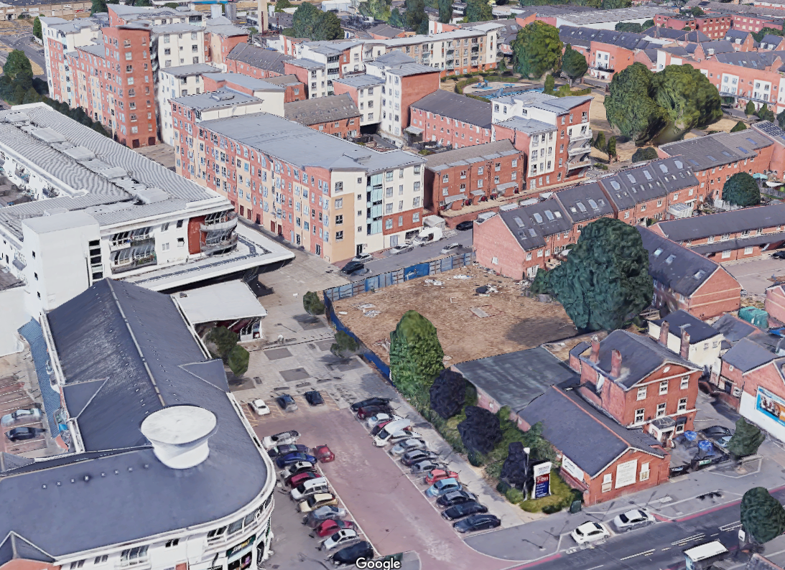
3
4
5
2
1
Figure 7 – Surrounding development scale

6.2.7 The proposal would see a 4-storey element to the north west closest to the three storey town houses along Curzon Street. The building steps up to a 6-storey block at the north west corner of the site. The 4-storey element is considered to maintain a respective scale to those dwellings along Curzon Street, visually reducing the mass as seen from the street and approach (See figure 8 below).

6.2.8 A 5-storey element would face south, addressing the Curzon Club and distant views form Oxford Road. The massing of the proposed building is concentrated in the north west corner of the site, adjacent to the existing block of flats along Moulsford Mews and the adjacent Tesco store.

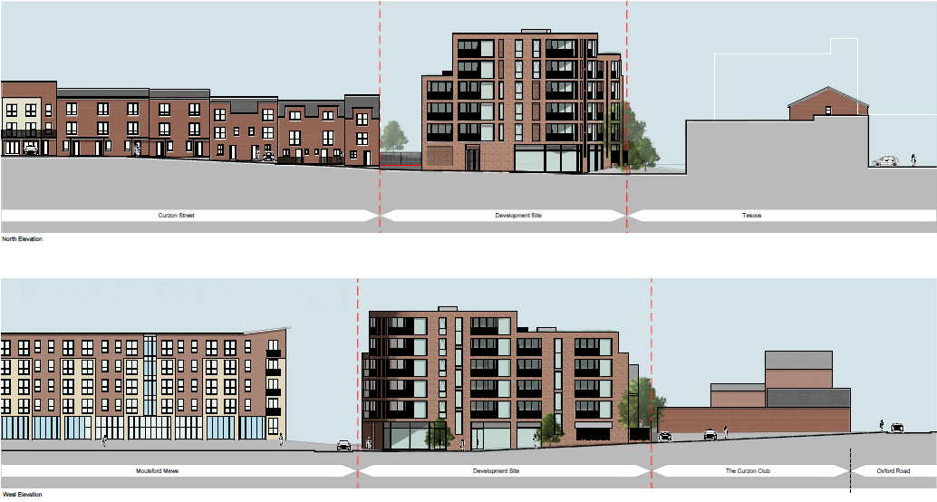
Figure 8 – Proposed street scenes

6.2.9 The location of the taller element to the northwester corner is considered to fulfil a number of key urban design principles. The proposal is properly able to address the corner, as no blank elevation is presented to the public realm.
This ensures the building turns the corner successfully. The highest part of the proposal addresses the corner, is augmented with generous amount of glazing and verticality. This creates a central focus to the development with the tallest elements addressing the adjacent similarly scaled block of flats opposite (see Fig 8 above). This allows the building to perform a positive role on the corner, marking a visual termination along Moulsford Mews at ground level but also helps improve the continuity of the frontage (See Fig 9 below)
The stepping down of levels to the Curzon Club also has benefits aside from visual transition, it allows south facing sedum roofs at fourth and fifth floor level.

6.2.10 In summary, the site occupies a prominent corner plot where the relationship of any new building is largely determined by its position fronting onto a public plaza and busy supermarket forecourt. When considering the general scale and proportions of this proposal, the building will be primarily read from Moulsford Mews and or the short stay car park to the west when travelling north from the Oxford Road. In responding to this context, the scale of the development is considered acceptable in context.

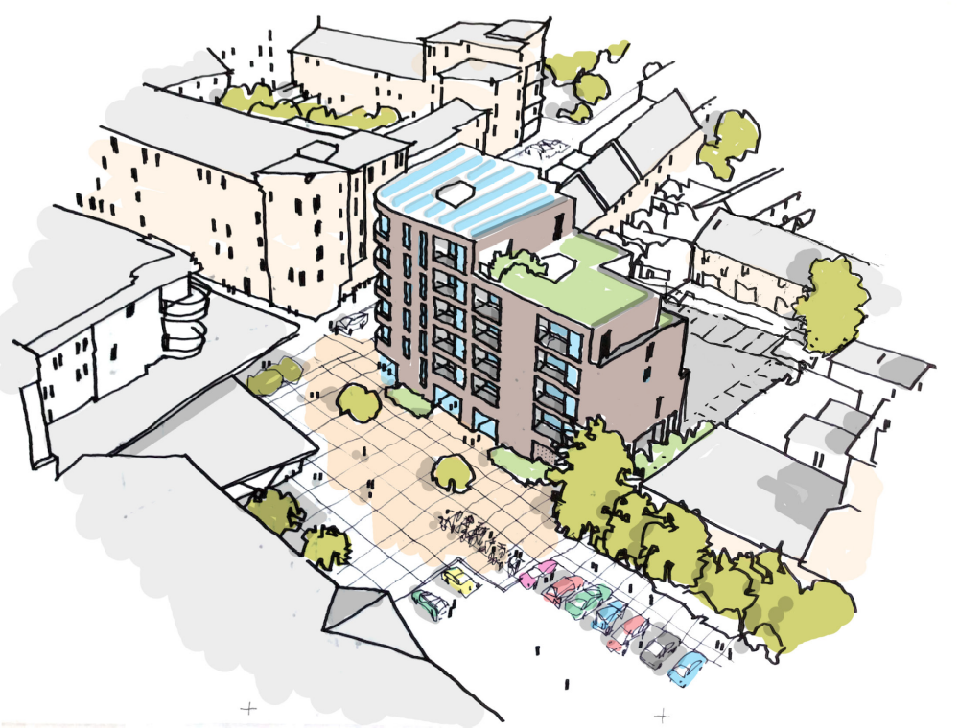
Figure 9 – Artist impression looking northeast.

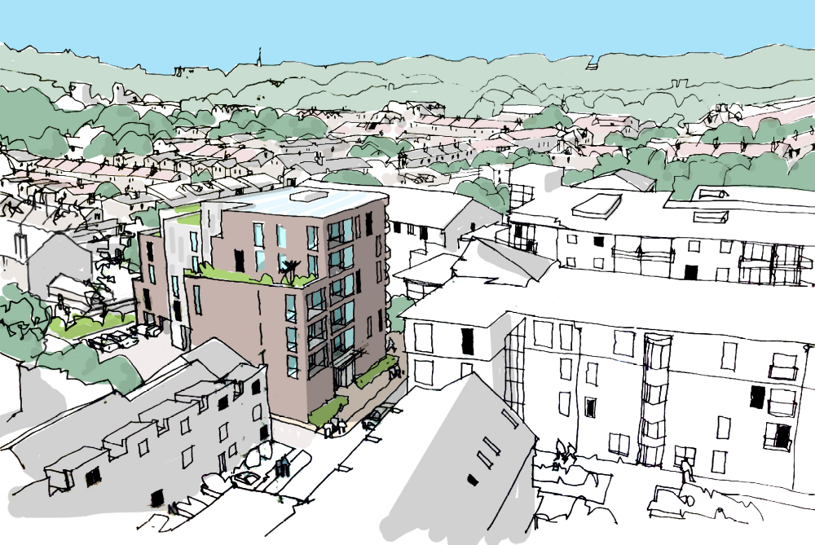
Figure 10 – Artist impression looking southwest.

6.2.11 With regard to the human scale of the proposal, the ground floor entrances to the commercial units are considered well-articulated, successfully defining the building at street level and provide this corner plot with much-needed definition, surveillance and activity at street level. This creates a degree of local character and distinctiveness, which it could be argued is not successfully provided by current development in the vicinity (See Fig 11 below).

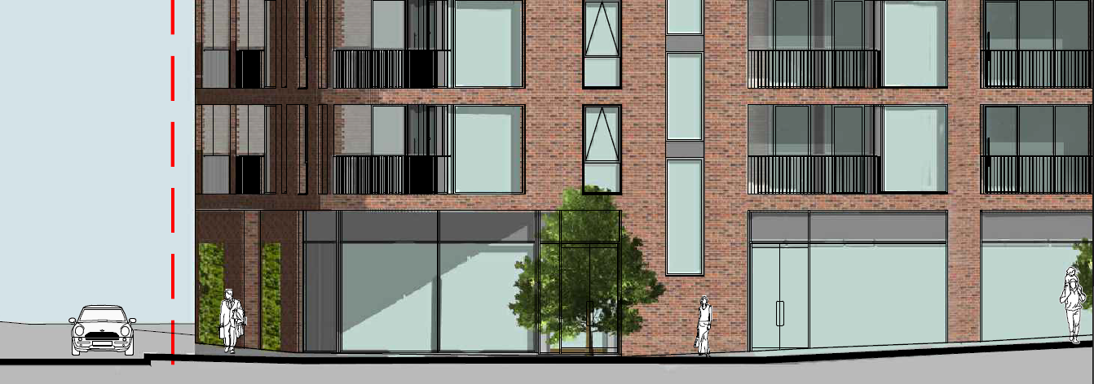
Figure 11 – Ground floor entrances to the commercial units.

6.2.12 In conclusion, it is felt that a development of this scale sits comfortably on the site and make the most of the opportunities presented by the disparate scale and uses of surrounding buildings.

Design

6.2.13 Turning to the detailed design of the building, the local area benefits from a contrast between more traditional/historic (Oxford Road) and modern styles found within the former Battle Hospital site.

6.2.14 The proposal has deeply recessed balconies, which are considered to add depth to the façade whilst enabling the building to front the public realm. The stacking of windows and balconies add welcome rhythm and a verticality to the façade. The same applies to the rhythm of the stairwell windows. As described above, the ground floor commercial units feature large areas of glazing, adding interest to the edge of the public realm and create a visual focus at the end of Curzon street and Moulsford Mews.

6.2.15 The appearance of the development and the proposed materials reflect the style and materials traditionally used within the local area but employ a much more contemporary and robust style when compared to much of the rendered blocks of flats within the former Battle Hospital site. A single colour of brick forms the primary material, punctuated by the balconies, creating relief in the facade and interest. Areas of perforated brick work and recessed panels of textured brick work add interest across the building. Brick piers and anthracite framed glazing are used to help define the ground floor and mark the entrances to the commercial units, is considered to create a visually interesting street level public realm.

6.2.16 The rear elevations are clad in white and grey cladding panels, helping reduce the mass of the rear elevation by breaking up any extensive areas of brick work. Balcony reveals are clad in white glazed brick work to reflect the local vernacular architecture where glazed bricks are used for banding on Victorian/Edwardian terraces. The glazed bricks would contrast against the red brick whilst reflecting light further into the plan of the building.

6.2.17 Further to the above, officers actively pursued the need to enhance the public realm around the building as much as possible, providing more opportunity for both human interaction and additional soft landscaping. This led to the introduction of two living green walls to the two principal ground floor elevations. These frame the commercial entrances and providing welcome relief to what is recognised is a rather urban environment. These features combined are not only considered to enliven and enhance what is currently a harsh and poorly-surveyed part of Oxford Road, but in conjunction with the proposed flexible commercial use, will encourage greater public interaction and reinforce the site’s prominent corner plot position. In this respect the development is considered to perform a positive role, an welcome intervention into an area where public realm improvements and a safe welcoming environment is a priority and further provide a framing of the pedestrian walkway and short-stay car park.

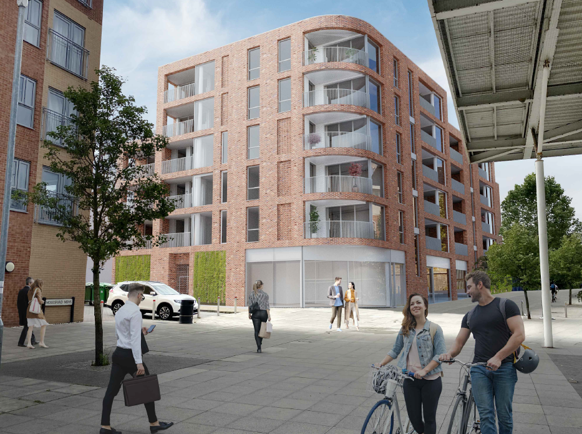
Figure 12 – CGI looking southeast

6.2.18 The proposal is considered to represent an ambitious design, and through its articulation and materiality, successfully integrates with both the more modern development on the former Battle Hospital site and more traditional ‘red brick’ development along Oxford Road.

6.2.19 In summary, the design of this building is considered to respond positively to the opportunity created by the site’s current lack of activation and seeks to raise design standards by not simply replicating surrounding buildings and spaces, but by creating a more positive sense of place than would not have otherwise existed at present.

6.3 Amenity

Privacy

6.3.1 The site is within a densely built up area with a mixture of large flatted development adjoining more high-density terraces. This is reflective of the site’s location directly adjoining a district parade of shops, the large Tesco Supermarket and the commercial offer contained along Oxford Road. The proposal would introduce primary active frontages at all levels facing onto the public realm (North and west). Windows and some balconies would face the rear towards the rear gardens of those houses along Battle Place and the adjoining terrace on Curzon Street.

6.3.2 Due to the layout and orientation of the application site, the closest rear facing windows would be approximately 19.6m from the rear elevation of the end terrace house on Battle Place. Only an oblique view would be attainable, furthermore due to nature of the rooms served by these windows (bedrooms), this is not considered to give rise to any serous privacy concerns. On the eastern elevation of the scheme, the more direct view attainable from bedrooms are greater than 24m. These distances are in excess of good practice and existing relationships in question.

6.3.3 To the north facing Englefield House, the distances are closer (approximately 14m, but are reflective of prevailing front/front separation distances within the wider Battle Hospital development to the north (See Fig 13 below).

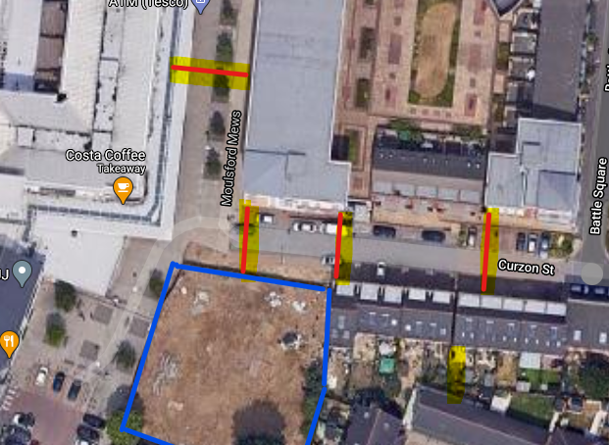
Figure 13 – Relationship to Englefield House.

6.3.4 Third party representations have been received from occupants within Englefield House raising concern over window to window distances. This relationship is considered no different from the existing relationship along Curzon Street, or that to the north between Englefield House and Sourton House.

6.3.5 Nonetheless, it must be recognised that by virtue of occupying a vacant and undeveloped site, any new development in this location is likely to cause a greater perception of change and associated overlooking and loss of privacy towards surrounding buildings. However, no new views (which are not already attainable into adjoining gardens) would be created and the inter-relationship between the site and its surroundings would not be substantially different or more harmful proximity to that which already exists in this urban area, and therefore this scheme is considered acceptable in terms of Policy CC8.

Daylight and sunlight

6.3.6 The applicant has provided a daylight/sunlight assessment with the application. The report shows that the scheme would not have a significant detrimental impact upon adjoining properties in terms of daylight/sunlight. In addition, the proposed development would provide all proposed flats with sufficient daylight/sunlight.

6.3.7 A third party representation was received from a prospective purchaser of 9 Englefield House, and highlighted concern over the relationship between the development and the effects to Vertical Sky Component (VSC) levels in respect of overshadowing.

6.3.8 Following further analysis was undertaken in considering this point. It is understood the room in question, identified as R1 at first floor level, to be a dual aspect space to the corner of the building benefiting from light from four windows across both the south and the west elevations. The BRE guideline on the application of the VSC metric state that if the retained VSC falls below 27% and the proportional retention value falls below 0.8 times its former value, the effects on the room are likely to be noticeable. The prospective purchaser commented that reductions close to or below 27% are a breach of the guidance. This is not a strictly correct interpretation of the assessment, as the reduction factor also needs to be considered. This also does not consider the fact that in urban areas, locations which exceed 27% are not guaranteed and far from expected.

6.3.9 In terms of the reduction factors, the incoming purchaser notes changes exceeding the 0.8 target affecting individual windows. Section 2.2.6 of the BRE guidelines states that, where a room is served by two or more main windows then the mean VSC effects may be considered. Considering the effects across the windows highlighted by the potential future resident mean retained proportional value remains at 0.8 the former figure and therefore complies with the BRE targets.

6.3.10 It is also worth noting that the amount of sky visible at desk height from this room will not be materially affected such that daylight penetration within the space will not significantly alter.

Living conditions of future occupiers

6.3.11 All dwellings have been proposed to meet or exceed the nationally described space standard (as outlined in Policy H5) for the type of dwelling/number of bedrooms. As such, all flats are considered acceptable in this regard.

6.3.12 Policy H10 states that “…. flats may be provided with communal outdoor space, balconies and/or roof gardens”. In this instance, each proposed dwelling has a private balcony/terrace. Proposed balconies spaces have been
orientated towards the north and west to avoid possible overlooking of gardens to the east of the site. Each balcony/terrace is accessed off of the primary living space by either glazed door or a set of Bi-fold doors. The balcony/terraces sufficient size to allow a table and chairs. The recessed balconies feature a bespoke metal balustrade and the internal faces of the balconies are clad in glazed bricks to reflect additional light into each dwelling.

6.3.13 Despite balcony/terraces providing sufficient private amenity space for each flat, future residents would be reliant on public open spaces for informal recreation. The site is well located for access to Battle Square Park (1 min walk away) which contains a LEAP (Local Area Equipped for Play), the Council run Kensington Recreation Ground (5 mins walk away) and Portman Road Park (6 mins walk away) which both contain a wider range of facilities.

6.3.14 As such, officers consider it necessary and appropriate to secure a contribution for improvements to these existing facilities as a result of the development, particularly given the over-emphasis on larger units and the lack of on-site amenity space. Based on the standard formula provided for by the Council’s Open Space Officer, a contribution of £63,700 will be sought and secured via Section 106 Agreement.

Accessibility and lifetime homes

6.3.15 Policy H5(f) requires that on all developments of 20 or more new build dwellings, at least 5% of dwellings will be wheelchair user dwellings in line with M4(3) of the Building Regulations. Any market homes provided to meet this requirement will be ‘wheelchair adaptable’ as defined in Part M, whilst homes where the Council is responsible for allocating or nominating an individual may be ‘wheelchair accessible’.

6.3.16 The development includes this provision and officers are satisfied that the accessibility/adaptability of the units can meet these requirements. To ensure these units are provided and maintained as such, a compliance condition is recommended to state that a policy compliant proportion of wheelchair user dwellings are ready prior to first occupation and are retained as such thereafter.

Crime prevention

6.3.17 A number of suggestions have been received from the Thames Valley Police Crime Prevention Design Advisor relating to security on the site. These elements are considered necessary and reasonable and could be covered by the recommended condition.

6.4 Natural environment

6.4.1 The Local Plan recognises the importance of natural features, the valuable contribution they can make to a place and to people’s quality of life, especially in a developed urban area like Reading. There is a need for development in such locations to take all opportunities realistically available to integrated additional natural features into the overall design. These include natural and designed landscapes, a high public realm, and trees, grass, planting etc. This is a key aspect in demonstrating the Council’s ambition and commitment to tackling climate change and supported through the Council’s Tree Strategy.

6.4.2 The proposed development site is within Area Tree Preservation Order (TPO) 103/03 which protects all trees that were growing on the former Battle Hospital site, when the Order was served (in 2003). It is also located within Battle Ward, which has the lowest tree canopy cover in the borough.

6.4.3 The site is currently vacant, largely cleared and surrounded by hording. The site contains a single Sycamore tree located at the south east corner of the site. Just outside of the southwest boundary is a London Plane tree.

6.4.4 The Sycamore tree is proposed to be removed and replaced with a smaller tree. This tree is covered by the TPO 103/03. The Tree Survey conducted by the applicant’s tree consultant confirms the condition of this tree is good and estimates it has a remaining contribution of 20+ years. This indicates as a starting point that this tree should be retained.

6.4.5 However, it should be noted that in the original 2006 planning permission for West Village (06/00011/FUL), this tree was not proposed to be retained, and this portion of the health centre was covered by the parking area for the health centre. Alternative smaller canopy trees were proposed along the eastern boundary. A similar approach is proposed under this proposal with a replacement (smaller) tree being located to the south-eastern corner of the resident’s car park. This is not considered to constitute a like-for like replacement nor result in any net gain in on site tree planting. Accordingly, the Natural Environment Team expresses concern that the proposal did not include sufficient enhancements to outweigh the removal of this tree. However, as with any consequence of development, this must be considered alongside any wider environmental benefits of the development as a whole in addition to any identified social and economic benefits to be outline later in this report.

6.4.6 The London Plane tree is to be retained and protected via tree protection measures. However, whilst clearly outside the site boundary, it appears the exact position of this tree remains unconfirmed. This being the case, the Council require further confirmation as to the exact tree protection methods that will be undertaken in accordance with the Tree Protection plan. Officers are of the view this can be reasonably secured via conditions.

6.4.7 With regards to the utilisation of available roof space, further discussions have taken place between the applicant and officers from pre-application stage and through the application process. A revised Natural Environment Plan was submitted in December 2020 which substitutes the originally-proposed sedum roofs with wildflower green roofs to all flat roof elements (See Fig X below). This type of green roof is compatible with the proposed rooftop Solar PV panels which will be discussed later in this report.

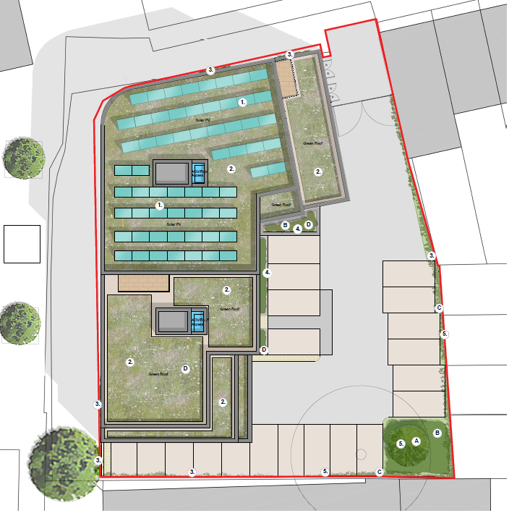
Figure 14 – Identification of green roofs and soft landscaping.

6.4.8 In addition, as part of these revised plans your officers were also able to secure four separate areas of ‘green wall’ facing the public realm. These livings walls would frame either side of the ground floor commercial units on the northern and western elevation (See Fig 15 and Fig 16 below).

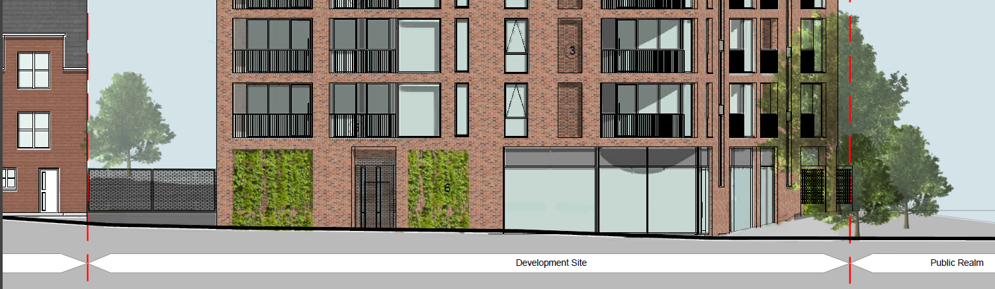
Figure 15 – Northern ground floor elevation and enlarged image of Green Wall location.

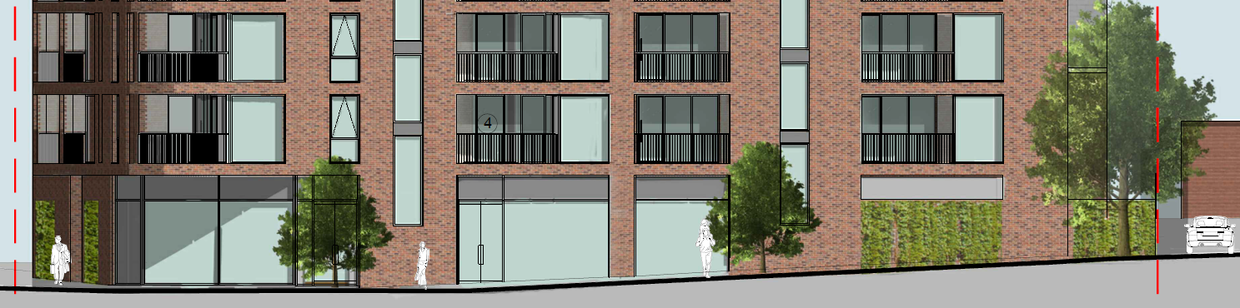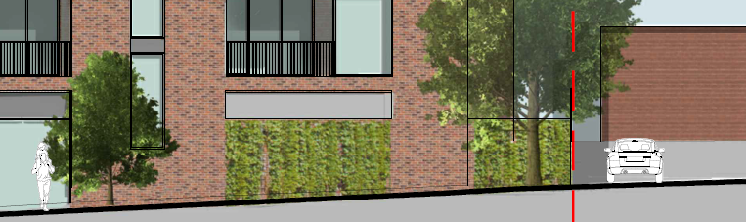
Figure 16 – Western ground floor elevation and enlarged image of Green Wall location.

6.4.9 Where ‘in the ground’ planting is not feasible, it is recognised the benefits both green walls and green roofs can bring. These two features ensure that natural landscaping is incorporated whilst also improving the appearance of the buildings, which is particularly important in an urban area such as this, and also contributes to reducing the hard ‘canyon’ effect which is currently created by the existing hoarding that encloses the site.

6.4.10 Both the green wall and green roofs are considered a potentially very effective means of improving the sustainability credentials of the building, increasing thermal insulation and providing pollution filtration. Given the limited space between the frontage and the pavement, it is considered a positive and creative way of allowing this site to contribute positively and practically with green infrastructure. The green wall in conjunction with the glazed active façade is considered to create a welcoming and enlarged public realm around the building. The details of the green wall, alongside its ongoing maintenance, would be secured via a specific landscaping condition and this is considered appropriate in the circumstance.

6.4.11 The proposal also seeks to maximise soft landscaping through the provision of additional box planters, large shrubs and climbers to the car parking area. The full planting specification, along with ongoing management and maintenance will be secured via condition to be determined post approval. The Council’s Ecologist has raised no objection to the proposal subject to conditions ensuring habitat enhancement measures be secured.

6.4.12 In considering the level of greening that can be realistically secured on a constrained site in a urban district location, officers are of the view that the proposal now provides a meaningful contribution to the adjoining District Centre’s environment, and performs a considerably greater role than the site does at present. The four green walls, green roofs, replacement tree planting and soft landscaping is a positive package that maximises green infrastructure on this site and is considered sufficient to outweigh the loss of the Sycamore tree. This overall contribution is afforded great weight in the overall balance.

6.5 Health and wellbeing

6.5.1 The current Covid19 pandemic has highlighted the critical role our urban environment has on the way we live and work. It also highlights how, as a Local Planning Authority, supporting well planned development can have a huge impact on peoples’ health, wellbeing, safety and overall comfort. In addition to the above discussion on amenity, the Council has an obligation to consider the following health and wellbeing topics in relation to any new development.

6.5.2 Maximising exposure to natural daylight, providing users with an external view and connection to nature are crucial measures in supporting the mental wellbeing of occupants and supported strongly by Policy CC8 ‘Safeguarding amenity’. As described, for an urban location all proposed flats have access to natural light, and outdoor space, with the smallest flats benefitting from multiple windows and external balconies serving living areas. Larger flats a mixture of duel and triple aspect in addition private balconies/terraces. This access to private outside space would assist with recovery from respiratory illnesses and support any unintended or prolonged occupation should the situation require. The development will maximise the use of natural daylight and reducing the need for artificial light by occupants through generous amounts of glazing and the use of glazed brick to balconies.

6.5.3 In recognition of the challenges presented by climate change and with due regard to the Council’s recently declared climate emergency, extreme temperatures can also have an immediate and detrimental effect on health and wellbeing of residents. Effectively controlling and regulating temperature both in warmer months and those colder months is crucial in maintaining a healthy and comfortable environment which is supported by Policy CC3: ‘Adaptation to climate change’. No units are primarily south facing in order to avoid overheating, private balconies provide the opportunity for natural ventilation to habitable rooms and the green roofs provide valuable thermal insulation against extreme temperatures.

6.5.4 Crime and the fear of crime also have a major impact on quality of life and the wellbeing of a building occupants and must be considered carefully on this site. Enabling occupants to feel safe and secure is therefore essential to successful, sustainable communities and is supported by Policy CC7 ‘Design and the public realm’. The proposed development now provides welcome natural surveillance of the adjacent parking areas and pedestrian areas between buildings.

6.5.5 As described in the previous section, green infrastructure and access to green space provides benefits not only to the natural environment, but to the building’s occupants. Introducing design elements like the green walls which supports human interaction with nature can lead to the promotion of a healthy lifestyle through the promotion of exercise, opportunities for relaxation and subsequently reducing stress levels. This development provides all flats with private external amenity space. This offers the opportunity for fresh air, drying of clothes and importantly ventilation of internal spaces. Accordingly, the above health and wellbeing factors are considered key material planning benefits which must be afforded weight in the overall balance.

6.6 Sustainability

6.6.1 Local Plan Policy H5 ‘Standards for New Housing’ seeks that all new-build housing is built to high design standards. In particular, new housing should adhere to national prescribed space standards, water efficiency standards in excess of the Building Regulations, zero carbon homes standards (for major schemes), and provide at least 5% of dwellings as wheelchair user units. Policy CC2 (Sustainable Design and Construction) and Policy CC3 (Adaption to Climate Change) seeks that development proposals incorporate measures which take account of climate change. Policy CC4 (Decentralised Energy) seeks that developments of more than 20 dwellings should consider the inclusion of combined heat and power plant (CHP) or other form of decentralised energy provision.

6.6.2 The applicant has submitted a sustainability and energy report as part of the application which follows the relevant policies and Sustainable Design and Construction SPD guidance applying the recognised energy hierarchy of ‘be lean’, ‘be clean’ and ‘be green’.

6.6.3 The information submitted demonstrates that through the measures outlined in the energy strategy, it is anticipated that a 37.4% improvement below Building Regulations Part L compliant baseline is achievable. In terms of decentralised energy, the inclusion of a decentralised system is not financially viable for a development of this size, however roof mounted Photo Voltaic cells are included and positively support the development in achieving the above energy improvement below Building Regulations.

6.6.4 A sustainable drainage strategy (SuDs) has also been submitted as part of the application. No objection is raised by the Local Flood Authority (RBC Transport), subject to conditions to secure a timetable for its implementation and details of management and maintenance of the scheme and its implementation in accordance with the approved details.

6.6.5 Officers are satisfied that the proposals demonstrate a good standard of sustainability and in particular the requirement adhering to zero carbon homes standards and therefore the development is policy compliant in this regard.

6.7 Transport

6.7.1 As described the site formed part of the 2006 planning application for the redevelopment of the former Battle Hospital site (06/00011/FUL). A Healthcare centre was proposed for the site within the application, but the site was never developed. A total of 16 car parking spaces were proposed for the health centre. The proposed development consists of the construction of two small commercial units on the ground floor. A total of 22 car parking spaces is proposed for the site.

6.7.2 Vehicular access is proposed via Curzon Street and will take the form of a vehicle crossover. A small section of Curzon Street (western end) is currently unadopted. As the granting of planning consent does not confer any rights of access, it should therefore be noted that the red line area does not extend to the adopted section of Curzon Street. The applicant has confirmed that full access rights are in place (although this is not strictly speaking a planning matter).

6.7.3 The site is located in Zone 2, Primary Core Area, of the Revised Parking Standards and Design SPD. It is close to the A329 Oxford Road, the main transport corridor between central Reading and the west and is well served by public transport, with buses continuing either into or out of the Central Core Area whilst Reading West Railway Station is located circa 700m walk to the east of the site.

6.7.4 In view of this, a methodology has been agreed which uses the existing car ownership data from the local area to forecast the demand and parking requirement for the development. As described, 22 car parking spaces is proposed for the development equating to 0.84 spaces per residential apartment. This takes into account the sustainability of site, proximity of public transport services and the presence of a car club. These factors contribute towards lower levels of car ownership within the area.

6.7.5 The development will provide a total of 4 electric vehicle charging spaces which is above the required provision as outlined in Policy TR5. This will be secured by condition. In addition there is a ‘Co-Wheels’ car club on Oxford Road in the vicinity of the site. This is publicly accessible so anyone who lives on the site can register to become a member and then book the car.

6.7.6 No parking is proposed for the two small commercial units. It is agreed that these commercial units make use of the existing short stay car park to the west of the site and the short stay on street parking bays along Oxford Road, which customers and deliveries for existing commercial units already make use of. The commercial units provide the opportunity for linked trips between the existing and proposed commercial uses within the area.

6.7.7 A secure store is proposed on site which can accommodate 32 long stay cycle parking spaces in tiered racking. However, it would be a preference to see the residential and commercial cycle parking separated to improve security. This can be specified and covered by condition.

6.7.8 The refuse stores are located adjacent to the main vehicular entrance on the northern boundary of the site to allow servicing to occur from Curzon Street. The bin store has been enlarged on the amended plans to accommodate the required number of bins.

6.7.9 Swept path drawings have been provided demonstrating that delivery vehicles and refuse vehicles can gain access to the site. Given that there is no turning head on Curzon Street, it is assumed that refuse vehicles currently reverse the length of Curzon Street to service the existing residential properties. However, the proposed site access provides the opportunity for refuse vehicles and larger delivery vehicles to use the site access as a turning area. Swept path analysis drawings have been produced to demonstrate that a refuse vehicle is able to turn at the eastern end of Curzon Street utilising the site access.

6.7.10 As described, the commercial uses will complement the existing commercial uses in the area. Potential uses could include non-food retail, hairdressers, beauticians, a small café or a takeaway use. These types of uses will only generate a very small number of servicing and delivery vehicle movements, with the majority of deliveries undertaken by smaller transit van type vehicles. Swept path analysis drawings have been produced to demonstrate that a 7.5 tonne delivery vehicle is able to enter the site and undertake a three point turn within the parking area. This is acceptable given the size of the commercial units, however, a Delivery and Servicing Plan is required prior to first occupation of the units to ensure deliveries are appropriately managed once the end users are known.

6.7.11 In light of the above no transport or access objections to this application area raised subject to those recommended conditions.

6.8 Environmental Protection

Air quality

6.8.1 The site is located close to the Oxford Road, and within an AQMA. As such, the impact of air pollution on new occupants is of particular concern. In support of the application, an Air Quality Assessment was submitted.

6.8.2 During construction, adopting appropriate mitigation measures is considered able to adequately prevent any significant air quality effects on the surrounding area. The proposed development is not expected to introduce new receptors into an area of existing poor air quality, nor is it anticipated to significantly impact local air quality. The development would include four electric vehicle charging bays, sharing two charging stations, 32 cycle storage spaces, two green wall elevations, sedan roofs and replacement tree planting on a site.

6.8.3 the Council’s Environmental Protection officers have reviewed the Air Quality Assessment and recommend conditions securing implementation in line with these reports would be acceptable and ensure appropriate noise/air quality for the proposed development. Construction hours, control of noise and dust during construction will also be conditioned.

6.8.4 As such, the proposed development is considered to positively contribute to improve air quality and comply with all relevant local and national air quality policy subject to relevant conditions.

6.9 S106/Community Infrastructure Levy

6.9.1 The proposals would be liable for CIL and the approximate liability is projected to be £198,398. This may be subject to change, as the applicant could apply for relief on the on-site affordable housing units and or deferral of payment as permitted under new legislation enacted because of Covid19.

6.9.2 A construction phase Employment Skills and Training Plan would also be secured via the Section 106 legal agreement as per the Council’s Employment Skills and Training SPD. This could be in the form of a site-specific plan or equivalent a financial contribution. As such, the S106 will secure this in a flexible manner covering both options.

6.9.3 With regard to a planning obligation, a Section 106 Agreement would be required to secure the following heads of terms as described in this report:

  - Secure the agreed level of onsite affordable housing (Detail mix);
  - £63,700 Open Space contribution to improve and extend facilities within the nearby parks;
  - Secure a construction phases Employment Skills and Training Plan or equivalent financial contribution. As calculated in the Council’s Employment Skills and Training SPD (2013).

6.9.4 Policies CC9 (Securing Infrastructure) and DM3 (Infrastructure Planning) allow for necessary contributions to be secured to ensure that the impacts of a scheme are properly mitigated. It is considered that each of the obligations referred to above would comply with the NPPF and Community Infrastructure Levy (CIL) in that it would be: i) necessary to make the development acceptable in planning terms, ii) directly related to the development and iii) fairly and reasonably related in scale and kind to the development.

6.10 Other matters

Equalities Impact

6.10.1 In determining this application the Council is required to have regard to its obligations under the Equality Act 2010. There is no indication or evidence (including from consultation on the application) that the protected groups as identified in the Act have or will have different needs, experiences, issues and priorities in relation to the particular planning application. Therefore, in terms of the key equalities protected characteristics it is considered there would be no significant adverse impacts as a result of the development.

Representations

6.10.2 All relevant matters raised are covered within the Appraisal section above.

7. CONCLUSION

7.1 The proposal would see a mixed use residential led scheme on vacant land allocated for housing within the local plan. The principle of development is therefore considered acceptable. Whilst not significant, an uplift in site indicative capacity further contributes towards the borough’s annual housing targets. The overall dwelling mix proposed by the development is acceptable in accordance with the requirements of the local plan.

7.2 Concern has been raised by nearby residents as to the affect the development would have upon existing parking, natural light and privacy. Furthermore, the loss of the single sycamore tree is resisted by the Natural Environment Team. As such it is necessary to consider under the three dimensions of sustainable development the benefits of the proposal in their entirety.

7.3 Economically, during the construction phase the proposed development would clearly contribute to and encourage associated economic activity by directly sustaining jobs in the borough. This would be supported further by a construction phase Employment Skills and Training Plan which can be secured via the Section 106 legal agreement.

7.4 The proposal would create flexible and commercially attractive space directly adjoining a District Centre which would support continued employment opportunities, complimenting surrounding residential and non-residential uses. Through development of vacant and under-utilised brownfield land, the site would make an important and positive contribution to the economic recovery of the borough throughout and following the Covid19 pandemic.

7.5 In the longer term, future occupants of 26 new flats will contribute to the viability and vitality of businesses in the district centre at a time where the economic health of many neighbourhoods is a key Council priority. Other related economic benefits include CIL contributions, the matters set out in the S106 Heads of Terms, as well as business rates and Council Tax receipts to the Council. The development would therefore clearly perform a positive economic role.

7.6 In terms of the social role, the proposal will undoubtedly fulfil one of the NPPF’s core aims to ‘boost significantly the supply of housing’ and deliver a wide range of homes of different types and tenures. The proposal would contribute to meeting the Borough’s identified housing need through an uplift in the site allocation, and of a mix and density appropriate to its sustainable location.

7.7 The proposal also makes positive policy complaint contribution towards affordable housing in the borough (30%). Ensuring a supply of good quality, secure and affordable housing to meet identified local housing needs is a key priority for Reading Borough Council as highlighted in the Council’s Homelessness Strategy 2016-2021, Local Plan, and corporate objectives. This development would therefore make a welcome contribution to improving access to local affordable housing to meet local needs and would constitute a significant and tangible public benefit.

7.8 In design terms, the site is currently a notable and unwelcome gap next to this District Centre. The proposed development of this brownfield site with what is considered a high-quality modern design is considered to positively improve the character and appearance of the immediate area, by providing much needed visual uplift to what is a busy pedestrian thoroughfare from the Oxford Road. This will allow better natural surveillance and activity along what is currently an inactive frontage.

7.9 Finally, in terms of health and wellbeing, the current Covid19 requires Local Planning Authorities to actively ensure new development maintain peoples’ health, wellbeing, safety and overall comfort. As described, the development is considered to create a good quality level of residential accommodation that would not prejudice or prevent future occupiers from enjoying a good quality of life, hinder any recovery from respiratory illnesses, or make any unintended or prolonged occupation by residents difficult should the situation require. Accordingly, the above health and wellbeing factors are considered key material social benefits.

7.10 Finally, with regard to the natural environment and the role this development will play in meeting the challenge of climate change, it is recognised that new mixed-use development would inherently meet an enhanced level of sustainability than existing through compliance with the Council’s enhanced energy efficiency and sustainability standards. By utilizing allocated previously developed land, the proposal will meet the Council’s spatial strategy for the location of new development by reusing land of low environmental value.

7.11 The introduction of on-site planting, a two green wall and green roofs would provide visual and environmental benefits to the site and immediate area, thereby allowing the site to confidently perform a far greater environmental role then it does currently as vacant land. This coupled with a significant PV array to the roof space constitutes material environmental benefits which outweigh the replacement of the existing sycamore tree.

Summary

7.12 As described above, the proposed development provides notable and tangible benefits, fulfilling many aspects which contribute to achieving the three dimensions of sustainable development. These three overarching objectives, which are interdependent and need to be pursued in mutually supportive ways (so that opportunities can be taken to secure net gains across each of the different objectives).

7.13 Having regard to all mattes raised, it is concluded that those limited adverse impacts caused by this development would be significantly and demonstrably outweighed by those identified benefits when assessed against the relevant policies in the Framework as a whole. Therefore, when applying an overall critical planning balance of all material considerations presented, the application is recommended for approval, subject to the recommended conditions and completion of a S106 Legal Agreement.

Case Officer: Brian Conlon

8. Plans and photos

Site Plan

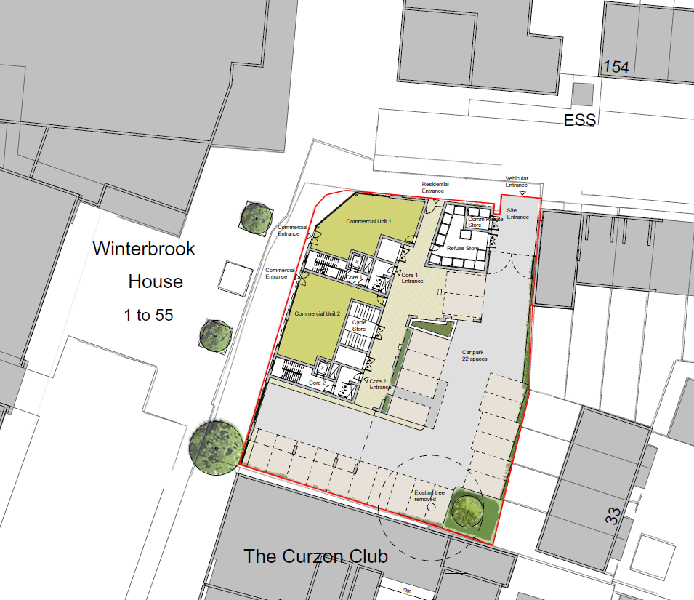

Typical floor plan (third, fourth and fifth)

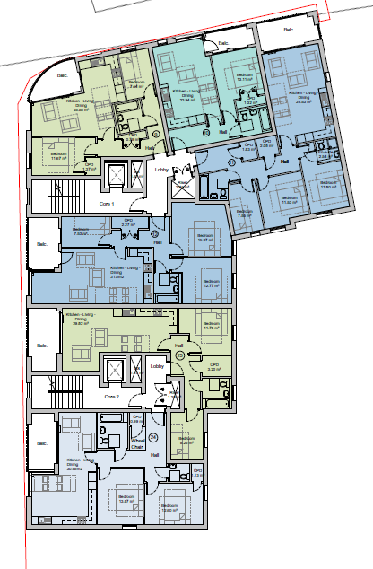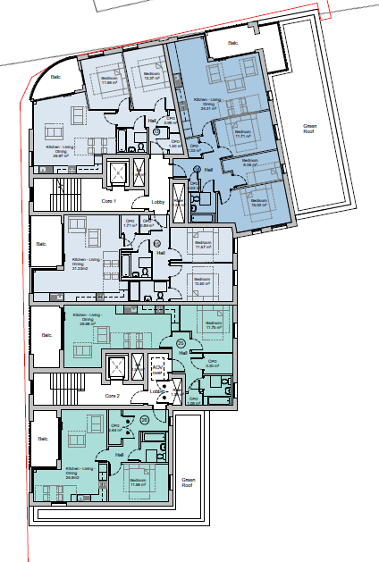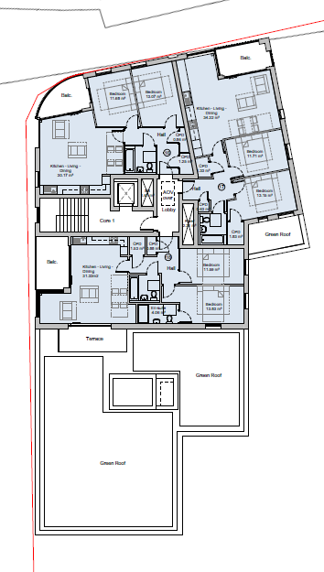

North and east elevation

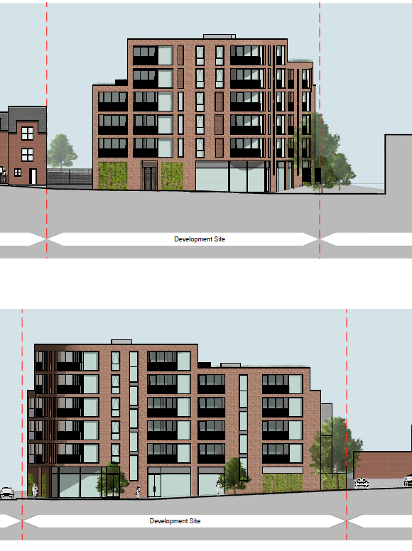

South and west elevation

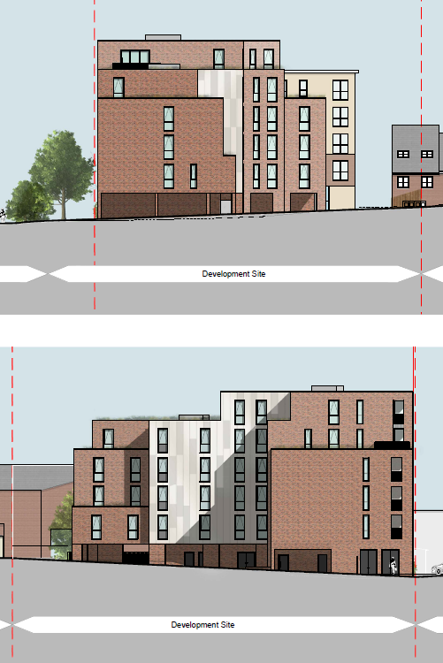

Natural Environment Plan

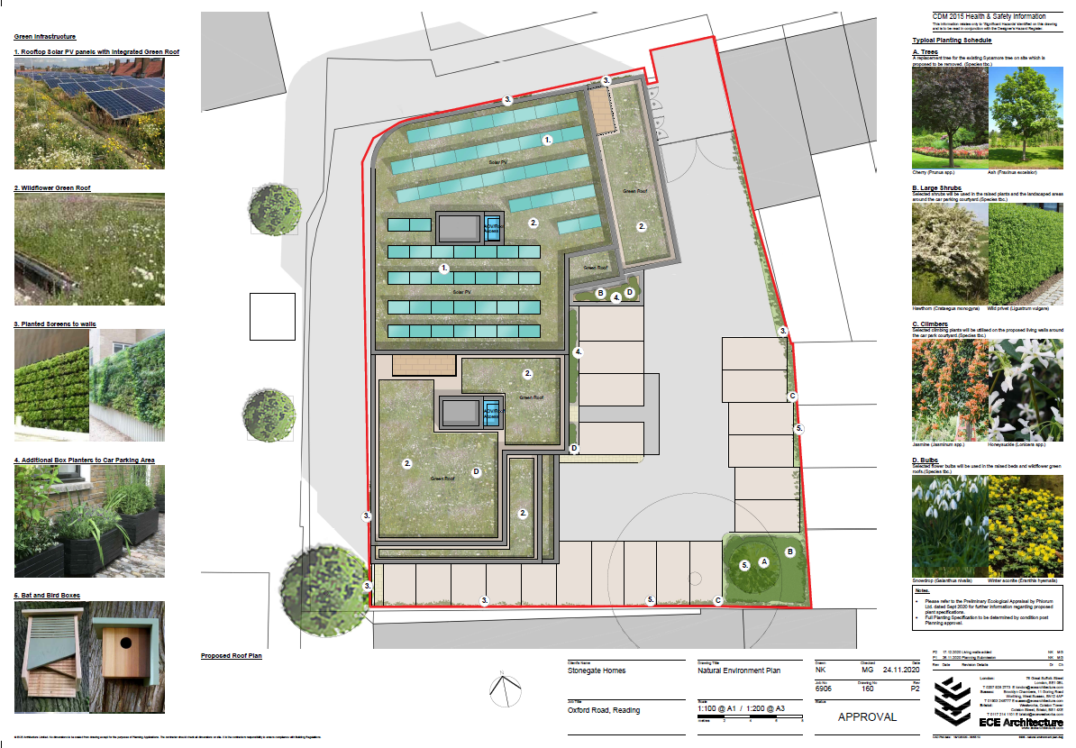

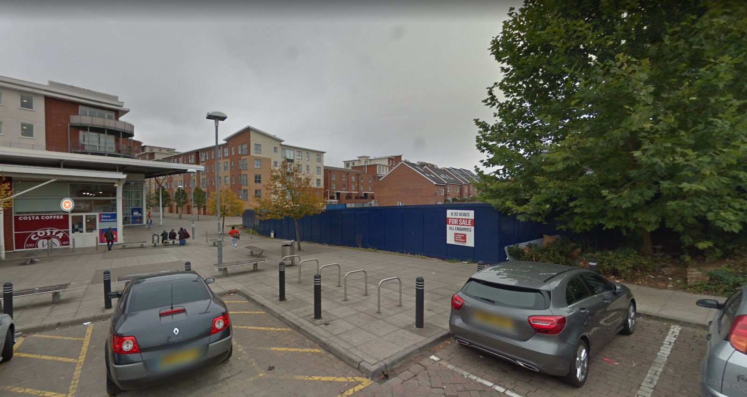
Looking north east from Oxford Road

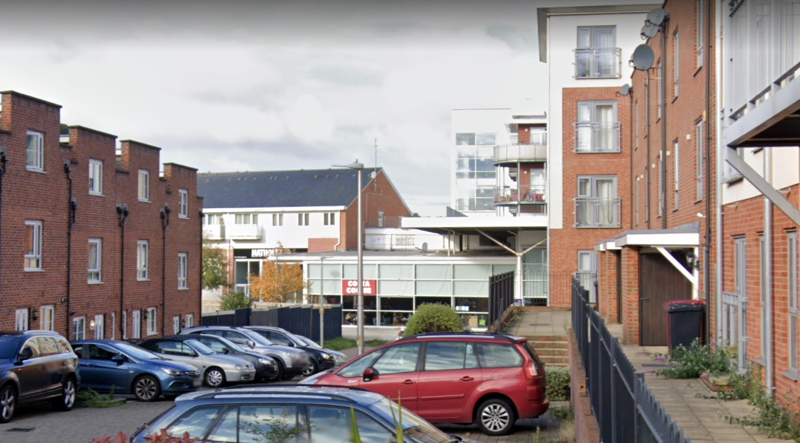
Looking west along Curzon Street

CGIS

