DELEGATED APPLICATION REPORT
Application No: 212006/FUL
Address: Land South of Flagstaff Road, Green Park Village
Proposal: Full planning permission for the construction of a Temporary Car Park, including vehicular access from Longwater Avenue and pedestrian/cycle access on to Flagstaff Road as well as all other associated works
Agreed Target Date: 11/02/22
Case Officer: Alison Amoah

- Site Description and background

The site lies to the south of Flagstaff Road and west of Longwater Avenue, located to the south of residential development at Huntley Place and South Lake Apartments which are part of the wider Green Park Village development (a sustainable new community being developed in a series of phases). Previously unmanaged unused land, which is adjacent to Footpath 11, cycle route and the Foudry Brook.

In accordance with the Environment Agency’s Online Flood Mapping service, the Site lies adjacent to Flood Zones 3 (covering the Foudry Brook) and is located within both Flood Zones 2 and 1. The site is an area of archaeological potential.

- Proposal

In September 2021, planning permission was granted for the construction of a temporary car park to accommodate 150 parking spaces under ref: 210294. This car park replaced the existing contractor car park on the Phase 6 site, to facilitate the development of the Phase 6 residential blocks.

The submission states that the approved level of car parking provision under ref 210294 is now insufficient to meet the needs of the construction team and therefore, the applicant now seeks permission for an extended temporary car park with 300 parking spaces in total. The applicant is now proposing to relocate the second contractor’s car park from 200 Longwater Avenue to the new contractors’ car park. It is expected that the temporary car park would need to remain in place for up to 3 years.

The construction of the temporary car park would comprise Geotextile laid on the existing field, as shown in the plans.

Limited (temporary) lighting would be provided for use during the start and end of normal working hours when needed (for example 6-8am and 4-6pm during the winter months). An access gate is proposed and would be managed and controlled by a ‘Gateperson’ on behalf of St Edward Homes.

- Internal Consultations

Transport – No objections
Comments referred to the summary of the proposals as shown in Table 1.

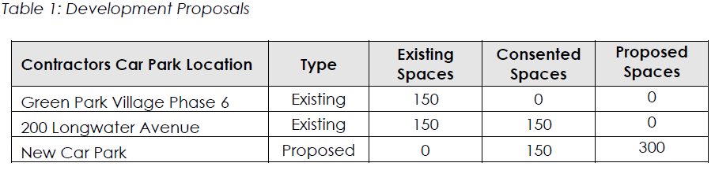

The table above shows that the number of spaces to be provided are equivalent to that already provided within the existing contractors’ car park serving Green Park Village and the second contractors car park from 200 Longwater Avenue. Therefore, the proposals will not give rise to any additional highway traffic impacts on the wider highway network as these vehicles are already travelling to and from Green Park Village.

The car park will be constructed from an impermeable material.

The plans illustrate that car park will be accessed from a temporary priority T-junction off Longwater Avenue, which will be upgraded and constructed with Type 1 material to accommodate vehicular movements to the car park and reinstated upon termination of use. The car park will be constructed from an impermeable material.

It is noted that there are consented vehicle trips that are not currently using Longwater Avenue as the Green Park Village development is still under construction. Therefore, there is capacity within the existing junctions which is not being used until the phased development is occupied.

A Public Right of Way, Footpath 11 and cycle way is present along the northern boundary of the site separated by a water ditch (the Foudry Brook). Pedestrian access from the temporary car park to the Green Park Village development site will be via existing footpaths along the existing highway network and cross the Public Footpath 11.

There are no transport objection to this application providing the access and parking layout is provided in accordance with drawing no. 11056/1001 Rev C5

Suggested conditions

DC1 VEHICLE PARKING (AS SPECIFIED)

DC3 VEHICULAR ACCESS (AS SPECIFIED)

Natural Environment – No objections subject to conditions
The proposal is to the extend the temporary car park, approved under 210294/FUL – comparison of approved (top) and proposed (bottom) is below for reference:

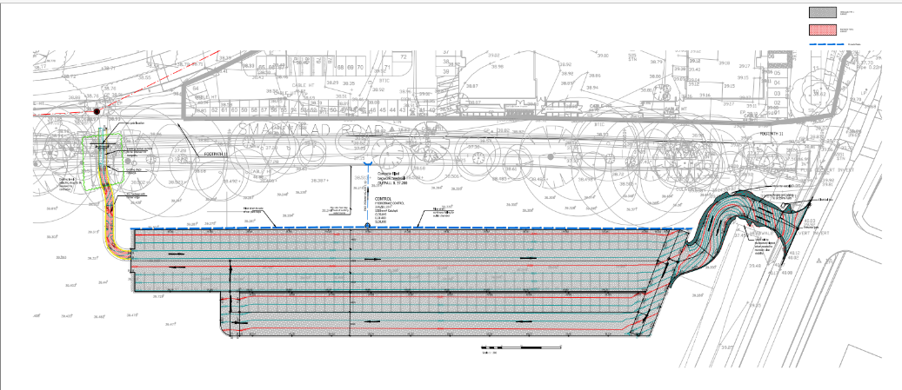
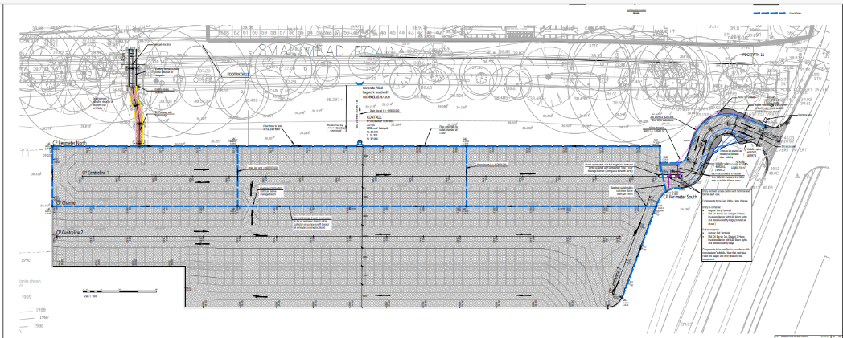

The proposals are supported by Arb Impact Assessment Rev A dated 10.08.21 – this is the same document as submitted under the previous application, the tree survey is more than 12 months old )trees should be checked against the storms/ high winds we’ve had in the last year), it refers to the wrong site plan and hasn’t been updated to reflect the current proposal. Importantly, a Tree Protection Plan is not included, as it was the last application.

Planning Officer Note: The applicant responded with a revised AIA and Tree Protection Plan as required. Natural Environment confirmed:
I have no objections subject to the following conditions:
- As shown on Tree Retention, Removal & Protection Plan Rev A, dated 08/12/2021
- ARBORICULTURAL METHOD STATEMENT (AS SPECIFIED)
- TEMPORARY USE (REINSTATEMENT) (officer note – is covered in the temporary use condition).
- I25 Ongoing information conditions

Ecology – No objections to original scheme, no comment received to amended scheme
The application site comprises an area of open land where is proposed to site a temporary car park. Planning application 210294 was approved in September 2021 for the provision of 150 car parking spaces, however, this is now considered insufficient to meet the needs of the construction team and the current application is for 300 vehicle spaces.

The Ecological Technical Note submitted with this application (CSA August 2021, Revision B concludes that the risk of the proposals adversely affecting protected species is minimal as long as the recommendations in the report are adhered to (see condition 1))

However, we also queried running water off from the car park into a ditch -

As the application is for twice the number of vehicles, the risk of pollution is significantly higher, yet the documents submitted do not address the pollution. Again, could the applicant advise on how any pollution will be contained before it enters into the ditch?

The applicant replied:
The design of the temporary car park includes an MOT Type 1 stone finish with a permeable MOT Type 3 voided stone underneath. Water that does not penetrate the Type 1 will flow across the car park and be intercepted by a network of filter trenches / land drains at the low points. The runoff will be filtered through the stone material in the sub-base and drainage trenches in line with SuDS Manual (CIRIA C753).

Flows will eventually collect at the outfall manhole midway along the north perimeter and the inclusion of a Hydrobrake helps to control the flow rate (equivalent to the Greenfield Qbar flow rate) and eventual discharge to the ditch watercourse at the northern boundary.

Any oil spills etc will be controlled above ground by spill kits locally and disposed of as Control of Substances Hazardous to Health (COSHH) with site waste.

Finally, we have consulted our drainage engineer who confirmed the ditch is not classed as a main river by the EA, so an environmental permit is not required (for flood risk activities, formerly Flood Defence Consent).

The ecologist confirmed: This sounds reasonable and there are no objections to this application on ecology grounds.

Archaeology – No objections
When the possible archaeological implications of the earlier application (210294) were discussed, my colleague originally recommended an archaeological condition, as the site is one of relatively high archaeological potential. The applicant’s agent responded that the ground impacts of the work were only very limited, to just a catch pit and a hydro break. With just these limited impacts, my colleague agreed that no mitigation would therefore be required.

In studying the plans for this new application for a larger car park there appear to be a number of differences from the previous application, including larger drainage runs, and regular inspection chambers. My understanding from the levels marked on the plan is that these do appear to be sunk into the ground, rather than running above existing ground level, as I believe was planned with the earlier application. If these drainage channels and inspection chambers are indeed sunk below ground level there may be an archaeological implication. Please would you ask the applicant’s agent to clarify the total below ground impacts (footprint areas and depths), including the drainage channels, hydrobreak, outfall, and anything else which may have a ground impact, so that I can assess whether there is a need for a condition?

The applicant confirmed:
The enlarged car park drainage design follows the same principles as the previously approved 150 design. This includes building up from the existing ground level with an MOT Type 1 stone finish and a permeable MOT Type 3 voided stone underneath. Water that does not penetrate the Type 1 will flow across the car park and be intercepted by a network of filter trenches / land drains at the low points.

As the Archaeologist has identified, the 300 space design does include a new central drain and inspection chambers due to the increased size of the car park. It is where the drain crosses north to south through the centre of the site to the northern boundary that the drain will be laid circa 100mm below existing ground levels. Plans were provided to demonstrate this.

The design of the car park is based on “building up” material with localised areas of intrusion to a depth of only circa 100mm. We consider there is negligible risk to the site.

Archaeology confirmed no objections.

Environment Agency – Did not wish to comment

- External Consultees

A planning application site notice and a Public Right of Way Site notice was displayed.
No representations have been received for either public consultation period.

- Plans/Documents Considered
- Temporary Contractor’s Car Park (Drawing No. 11056/1001 Rev C5
- Drainage Details – 11056 1701 C3
- Ecological Technical Note Rev B prepared by CSA Environmental dated August 2021
- Revised Arboricultural Impact Assessment prepared by Barton Hyett Associates
- Tree Retention, Removal & Protection Plan (Drawing No. BHA_1063_02 Rev A)
- Proposed Location Plan (Drawing No. G259-BAL-SW-00-DR-A-10-0113
Rev. F)

- Relevant Planning History

See above for previous temporary car park proposal. Numerous applications have been submitted relating to the Green Park Village scheme.

It was confirmed when dealing with the original scheme that Footpath 11 would remain open for public use.

- Equality Act 2010

In determining this application, the Council is required to have regard to its obligations under the Equality Act 2010. However, there is no indication or evidence (including from consultation on the application) that the protected groups identified by the Act have or will have different needs, experiences, issues and priorities in relation to this particular planning application. Therefore, in terms of the key equalities protected characteristics it is considered there would be no significant adverse impacts as a result of the development.

- Relevant Planning Policy and Guidance

Section 38(6) of the Planning and Compulsory Purchase Act 2004 requires that proposals be determined in accordance with the development plan unless material considerations indicate otherwise. The Development Plan for Reading relevant to the application site comprises the Reading Borough Local Plan (2019).

The ‘National Planning Policy framework’ (‘’NPPF’’) 2021 states clearly that its content is to be a material consideration in the determination of applications. The ‘NPPF’ states that due weight should be given to the adopted policies of the Local Development Framework (LDF) (Reading Borough Local Plan, 2019) according to their degree of consistency with the ‘NPPF’ (the closer the policies in the plan to the policies in the ‘NPPF’, the greater the weight that may be given).

- Relevant Policies

The application has been assessed against the following policies:

National
National Planning Policy Framework 2021;
National Planning Policy Guidance 2014 onwards;

Reading Borough Council Local Plan

CC1 Presumption in Favour of Sustainable Development
CC8 Safeguarding Amenity
TR1 Achieving the Transport Strategy
TR3 Traffic, Access and Highway-Related Matters
EN2 Areas of Archaeological Significance
EN12 Biodiversity and the Green Network
EN14 Trees, Hedges and Woodland
EN18 Flooding and Drainage

- Appraisal

The main issues are considered to be:
- Principle of development
- Impact on neighbouring amenity
- Transport Matters
- The Natural Environment
- Archaeology
- Flooding and Drainage

Principle of development
The application site is has already been approved for use as a temporary contractor car parking site on a temporary basis.

There is a clear need for it to be in this location in order to progress development within Green Park Village.

Impact on neighbouring amenity
To the south lies residential properties however these are located 40m away and are buffered by the existing tree line and footpath. Limited lighting will be provided for use during the start and end of normal working hours when needed (e.g. 6 -8am and 4-6pm during the winter months). However, given the separation distance, it is not considered that such lighting would cause adverse effect to neighbouring properties in accordance with Policy CC8 of the Reading Borough Local Plan (2019), especially given the temporary nature of the proposal.

Transport
See comments above. The proposals will not give rise to any additional highway traffic impacts in the context of the existing contractors car park situated with Green Park Village.

There is no transport objection to this application providing the access and parking layout is provided in accordance with the submitted drawing and compliance with conditions to ensure vehicle parking and access is as specified to be in line with Policies TR1 and TR3 of the Reading Borough Local Plan (2019).

The Natural Environment

Trees
In relation to trees, it is confirmed that given the temporary nature of the car park, no additional landscaping is to be provided; however, existing trees to the north of the site will be retained and largely unaffected by the proposals (save for some minor trimming of overhanging tree branches). The Tree related documents will be secured via condition in line with Policy EN14 of the Reading Borough Local Plan (2019).

Ecology
The Ecological Technical Note submitted with this application has been undertaken to an appropriate standard and concludes that the risk of the proposals adversely affecting protected species is minimal as long as the recommendations in the report are adhered to. Concerns raised have been responded to and there are no objections the proposal is considered acceptable in relation to Policy EN12 of the Reading Borough Local Plan (2019).

Archaeology
The site is within an area of archaeological potential, with significant evidence across a range of archaeological periods recorded following various investigations in the area. However, the proposal involves only a small amount of ground work relating to proposed drainage.

It has been confirmed that these further works represent a very minor ground intrusion and low archaeological risk (not that would be picked up as requiring mitigation on its own). As such, the Archaeologist confirmed no mitigation measures would be required by way of a planning condition and the proposal acceptable in relation to Policy EN2 of the Reading Borough Local Plan (2019).

Flooding and Drainage
The proposed car park is set back 10 metres from the adjacent water ditch banks. A French drain will be installed along the perimeter of the car park to filter surface water.

Whilst the car park will be constructed from an impermeable material, surface water will be collected and controlled before discharging into the culvert and so is considered to help prevent flooding on site in accordance with Policy EN18 of the Reading Borough Local Plan (2019). Ordinary watercourse consent has been granted for the draining of water into the Foudry Brook.

- Conclusion

Having regard to the material considerations and all matters raised, the Local Planning Authority considers that the balance of considerations therefore weigh in favour of granting consent subject to conditions.

Recommendation
GRANT

- Conditions:

1. The use of the land as a car park hereby approved shall cease on or before 11th February 2025 (i.e. at the end of 3 years from the date of permission), whichever shall first occur, the use hereby permitted shall cease (and all materials and equipment brought on to the premises in connection with the use shall be removed) and the site shall be restored to its former condition.
REASON: The proposal has only been assessed as a temporary proposal and a permanent retention of such use will need to be re-assessed under local planning policy.

2. Approved plans

3. Vehicle parking as specified

4. Vehicle access as specified

5. Tree Protection Measures as specified
6. Ecological protection as specified

