DELEGATED HOUSEHOLDER APPLICATION REPORT

Ward: Katesgrove
App Ref: 220712/LBC
Address: 21 Christchurch Road, Reading, RG2 7AA
Proposals: Listed Building Consent for a Blue plaque to front wall of the building, about 2 metres above the ground and about 0.5 metres to the left of the door.
Case Officer: Chukwudi Onwudinanti
Applicant: Ms Elizabeth Adelman
Date received (valid from): 16 May 2022
Target Decision date: 11 July 2022

- INTRODUCTION
The address is a listed building in the Christchurch conservation area, situated on the northern side of Christchurch Road with the front of the building facing Glebe road.

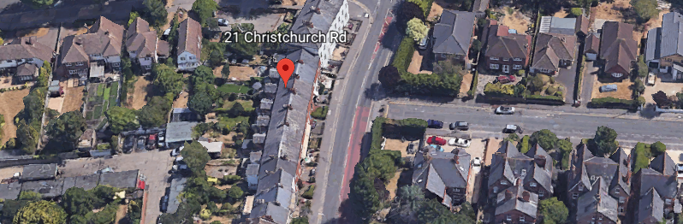

2. PROPOSAL AND SUPPORTING INFORMATION

This is an application for Listed Building Consent for a Blue plaque to be installed on the front wall of the 21 Christchurch Road, a listed building in the Chrsitchurch Conservation Area. The plaque will be placed about 2 metres above the ground and about 0.5 metres to the left of the door.

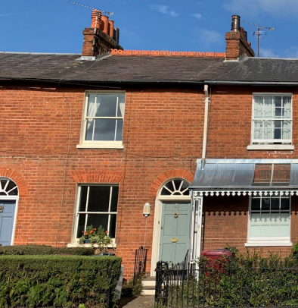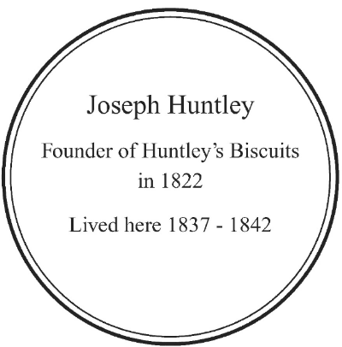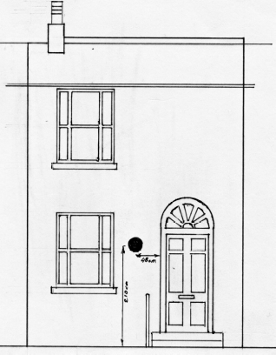

Plans considered (Received 16th May 2022)
Location Plan
Front Elevation

- RELEVANT PLANNING HISTORY

None

4. CONSULTATIONS

4.1 The following addresses were consulted by letter.

34 College Road, Reading, Berkshire, RG6 1QB
23 Christchurch Road, Reading, Berks
70 Whitley Wood Lane, Reading, Berks
3 Glebe Road, Reading
17 Epsom Court, Reading, RG1 6LW
Museum Of English Rural Life, 6 Redlands Road, Reading, RG1 5EX
111 Kendrick Road, Reading, RG1 5EB
53 Northumberland Avenue, Reading, RG2 7PS
116 Kendrick Road, Reading, RG1 5DP
112 Kendrick Road, Reading, RG1 5DP

4.2 Numerous letters of representation have been received. All were all in support of the application.
The CAAC have also made comments in support of the application as follows:

SUPPORT FOR LISTED BUILDING CONSENT 220712 – 21 CHRISTCHURCH ROAD

Reading Conservation Area Advisory Committee (CAAC) support the application for listed building consent to erect a blue plaque to Joseph Huntley who lived at 21 Christchurch Road, then 9 Whitley Crescent, from 1837-1842.

CAAC members and friends provided practical and research assistance for this application.

We will be very pleased to see this addition to Reading’s very select collection of blue plaques in this, the bi-centenary of the foundation of Huntley’s biscuits which later grew into Huntley & Palmers.

Equality Act 2010:
In determining this application the Council is required to have regard to its obligations under the Equality Act 2010. However, there is no indication or evidence (including from consultation on the application) that the protected groups identified by the Act have or will have different needs, experiences, issues and priorities in relation to this particular planning application. Therefore in terms of the key equalities protected characteristics it is considered there would be no significant adverse impacts as a result of the development.

- LEGAL AND PLANNING POLICY CONTEXT

Section 38(6) of the Planning and Compulsory Purchase Act 2004 requires that proposals be determined in accordance with the development plan unless material considerations indicate otherwise. Material considerations include relevant policies in the National Planning Policy framework (NPPF) - among them the 'presumption in favour of sustainable development'. The following local and national planning policy and guidance is relevant to this application:

National Policy
National Planning Policy Framework
National Planning Practice Guidance

Reading Borough Local Plan (2019)
CC7 (Design and the Public Realm)
CC8 (Safeguarding Amenity)
EN1 (Protection and Enhancement of the Historic Environment)
EN3: (Enhancement of Conservation Areas)
EN4: (Locally Important Heritage Assets)

SPD
- Design Guide to House Extensions(2021)

6. APPRAISAL

EN1 (Protection and Enhancement of the Historic Environment)
Historic features, areas of historic importance and other elements of the historic environment, including their settings will be protected and where possible enhanced.
This will include:
- Listed Buildings;
- Conservation Areas;
- Scheduled Monuments;
- Historic parks and gardens; and
- Other features with local or national significance, such as sites and features of archaeological importance, and assets on the Local List.
All proposals will be expected to protect and where possible enhance the significance of heritage assets and their settings, the historic character and local distinctiveness of the area in which they are located. Proposals should seek to avoid harm in the first instance.
In line with EN1 above, and supported by the CAAC, it is deemed that this proposal protects and enhances the significance of 21 Chrsitchurch Road as the plaque will be a constant reminder of the significance of the building as well as its history.

EN3: (Enhancement of Conservation Areas
The special interest, character and architecture of Conservation Areas will be conserved and enhanced. Development proposals within Conservation Areas must make a positive contribution to local character and distinctiveness. Positive consideration will be given to proposals which take opportunities to enhance the character of conservation areas.
The proposal will make a massive positive contribution to the character and distinctiveness of the local area.
EN4: (Locally Important Heritage Assets)
Development proposals that affect locally important heritage assets will demonstrate that development conserves architectural, archaeological or historical significance which may include the appearance, character and setting of the asset.
The plaque to be installed through this proposal will be an addition to the front of the listed building, however this will enhance the character of the asset.

CC8: Safeguarding Amenity states an extension to a house will be acceptable where it will not cause a significant detrimental impact to the living environment of existing or new residential properties.

To assess this, the following has been considered – would the proposal cause a significant detrimental impact to the living environment of existing or new residential properties in terms of:

- Privacy and overlooking; N/A
- Access to sunlight and daylight; N/A
- Visual dominance and overbearing effects of a development; Complies
- Noise and disturbance; N/A
- Artificial lighting; N/A
- Vibration; N/A
- Dust and fumes; N/A
- Smell; N/A
- Crime and safety. N/A

- CONCLUSION
The proposed development has been assessed and the proposed works are considered to be in accordance with the above relevant policies and planning permission can be granted.

- RECOMMENDATION
Grant

