DELEGATED HOUSEHOLDER APPLICATION REPORT

Ward: Park
App Ref: 220826/HOU
Address: 29 School Terrace, Reading, RG1 3LS
Proposals: Solid Wall external insulation to rear extension to house. Installation of roof window, Velux window or equivalent over kitchen rear extension. Internal works.
Case Officer: Chukwudi Onwudinanti
Applicant: David Rowley
Date received (valid from): 27 June 2022
Target Decision date: 21 October 2022 (EXT)

1. SITE DESCRIPTION
The site is an end of terrace Victorian dwelling on the eastern side of School Terrace. On the opposite side of the road is the Newtown Primary school and a few other detached buildings of about the same style and age.

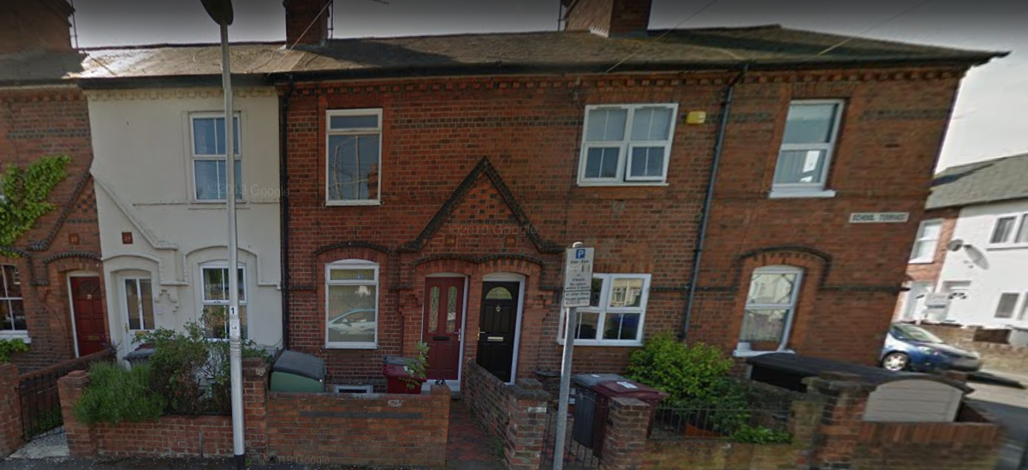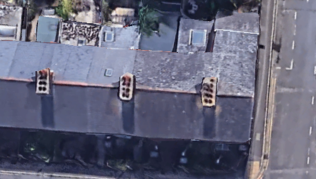

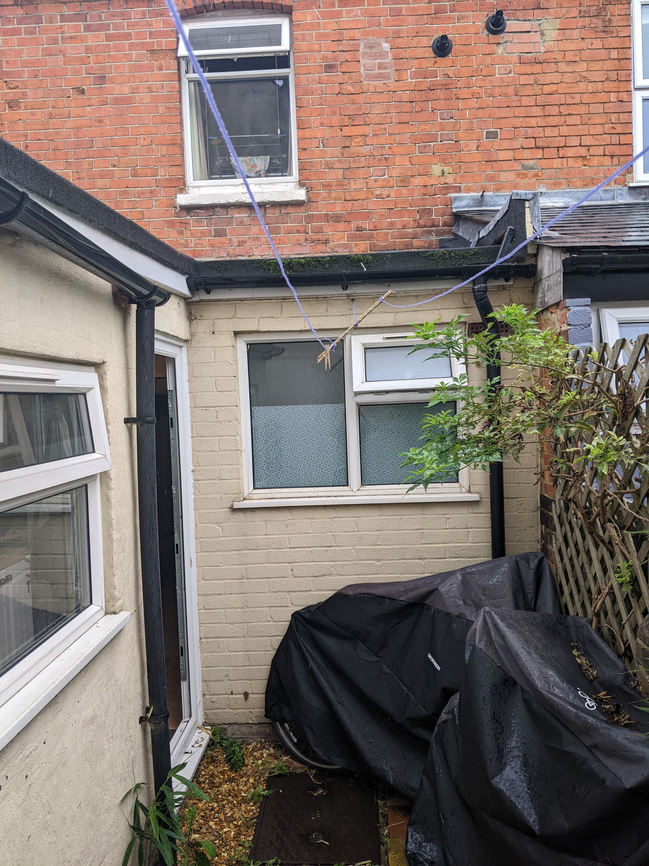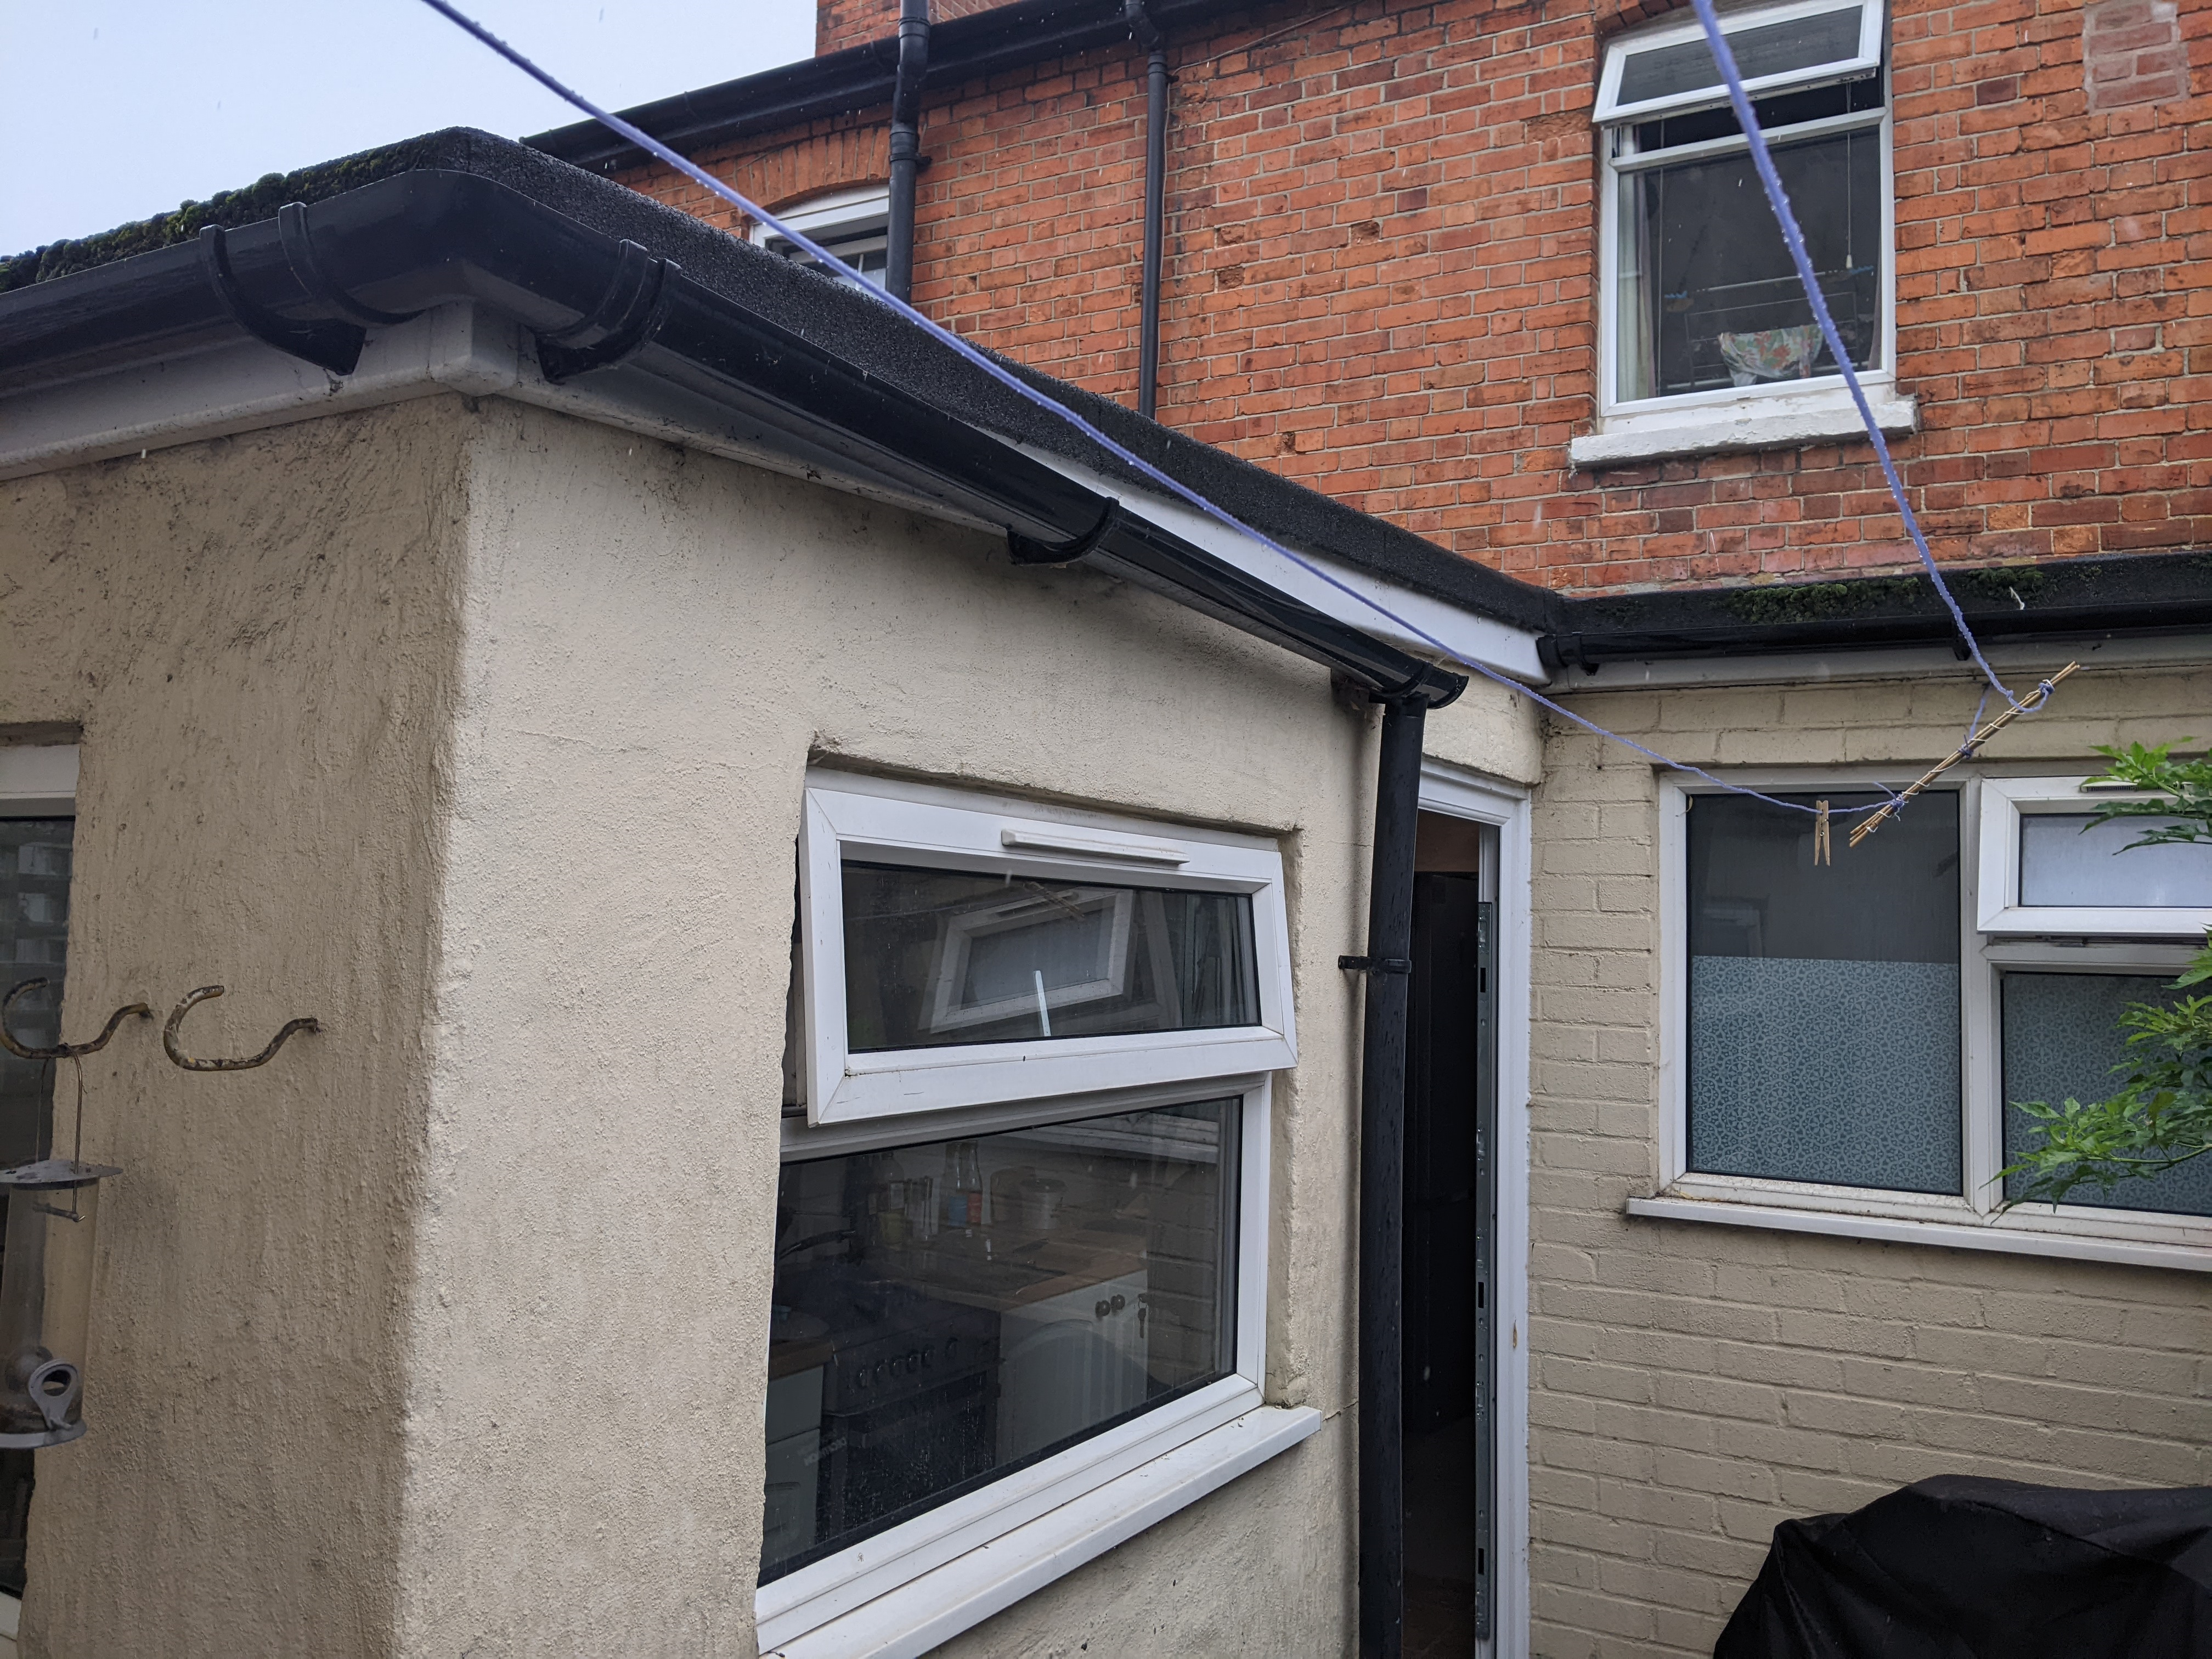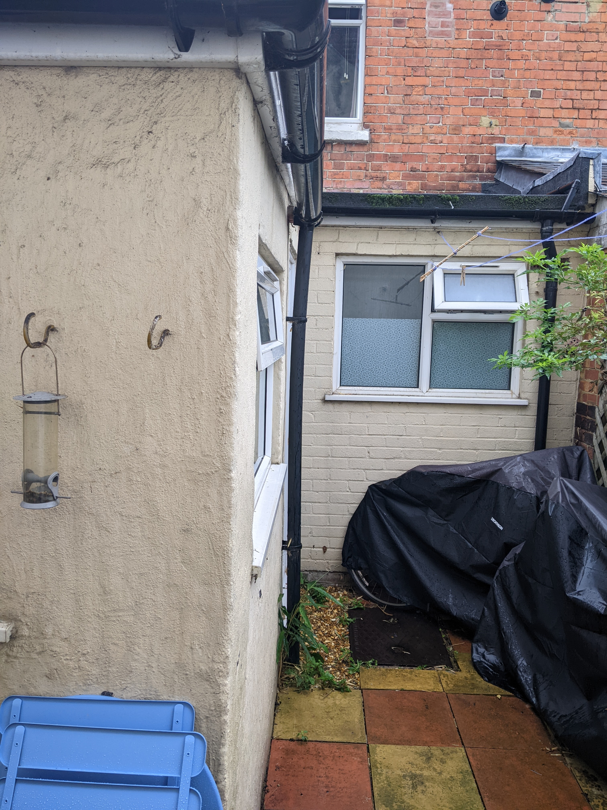

2. PROPOSAL AND SUPPORTING INFORMATION
The proposal is for the insulation of the external walls of the existing extension, installation of a roof window and internal works.

Plans considered (received 28th June 2022)
Location Plan
Existing Elevation
Proposed Elevation
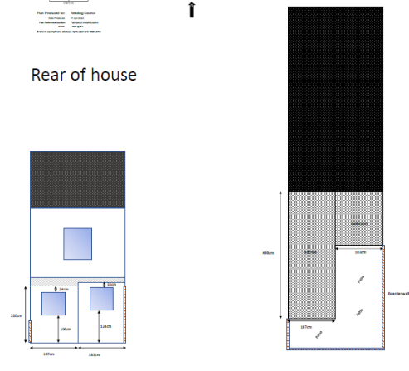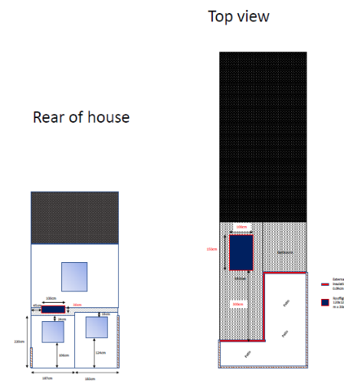
Existing Proposed (with Insulation)

- RELEVANT PLANNING HISTORY

None

4. CONSULTATIONS

The following addresses were consulted by letter.

154 Cumberland Road, Reading, RG1 3JY
30 School Terrace, Reading, RG1 3LS
28 School Terrace, Reading, RG1 3LS

No letters of representation have been.

Equality Act 2010:
In determining this application the Council is required to have regard to its obligations under the Equality Act 2010. However, there is no indication or evidence (including from consultation on the application) that the protected groups identified by the Act have or will have different needs, experiences, issues and priorities in relation to this particular planning application. Therefore in terms of the key equalities protected characteristics it is considered there would be no significant adverse impacts as a result of the development.

- LEGAL AND PLANNING POLICY CONTEXT

Section 38(6) of the Planning and Compulsory Purchase Act 2004 requires that proposals be determined in accordance with the development plan unless material considerations indicate otherwise. Material considerations include relevant policies in the National Planning Policy framework (NPPF) - among them the 'presumption in favour of sustainable development'. The following local and national planning policy and guidance is relevant to this application:

National Policy
National Planning Policy Framework
National Planning Practice Guidance

Reading Borough Local Plan (2019)
CC7 (Design and the Public Realm)
CC8 (Safeguarding Amenity)
H9 (House Extensions and Ancillary Accommodation)

SPD
Design Guide to House Extensions (2021)

6. APPRAISAL
Character and Appearance

Policy H9 states that an extension to a house will be acceptable where it respects the character of the house in terms of scale, location, materials and design and respects the character and pattern of neighbouring properties and the street as a whole in terms of scale, location, materials and design, and any important existing building line. Policy CC7 also sets out relevant considerations for design.

The proposal presents no external alterations to the existing dwelling that are visible on the street scene, therefore it is considered that the development will not have any impact on the character of the street.

The proposed scheme is of a minor nature including some external wall insulation and a rooflight, neither of which would have a detrimental impact on the character of the dwelling. The scheme therefore, accords with Policy CC7 and H9.

Residential Amenity

Policy H9 states that an extension will be acceptable where it does not result in an overbearing impact on neighbours. Policy H10 seeks to ensure that the amenity of gardens and other outdoor areas are not compromised. Policy CC8 states an extension to a house will be acceptable where it will not cause a significant detrimental impact to the living environment of existing or new residential properties.

It would be possible to have some oblique views towards the rear first floor window of the neighbouring property through the proposed roof light, and some views into the rooflight from the upper window, but it is not considered that these would cause such a significant loss of privacy to warrant refusal on this basis.

- CONCLUSION
The proposed development has been assessed as set out above and is considered to be acceptable on that basis, subject to the following conditions.

AP1: Approved Drawings
M1: Materials to Match Existing
TL1: Time Limits

8. RECOMMENDATION: Grant

