DELEGATED HOUSEHOLDER APPLICATION REPORT

Ward: Caversham
App Ref: 220685/HOU
Address: 83 Henley Road, Reading, RG4 6DS
Proposals: Proposed single storey flat roof rear extension with parapet wall. Rear extension to have roof lantern and bifold doors.
Case Officer: Chukwudi Onwudinanti
Applicant: Miss Claire Cole
Date received (valid from): 11 May 2022
Target Decision date: 12 August 2022

1. INTRODUCTION
The proposal site is a semi-detached two storey dwelling on the southern side of Henley road. It is in a predominantly residential neighbourhood surrounded by buildings of similar as well as varied styles and sizes.
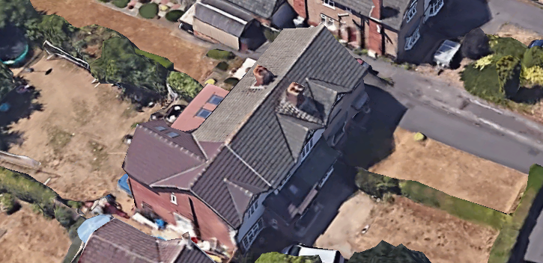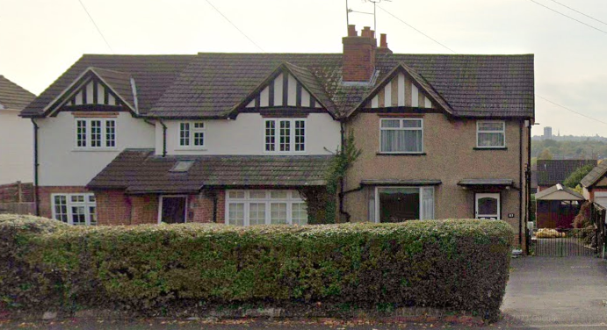

2. PROPOSAL AND SUPPORTING INFORMATION

Proposal is for a single storey flat roof rear extension with parapet wall and a rear extension with roof lantern and bifold doors. All external walls of the proposed extension are to be finished with cedar cladding.

Plans considered received 11th May 2022
Drawing No COLE-0222-01: Proposed Ground Floor Plan
Drawing No COLE-0222-02: Proposed Elevations
Drawing No COLE-0222-03: Existing Plan and Elevations
Drawing No COLE-0222-04: Section A-A
Drawing No COLE-0222-05: Location Plan
Drawing No COLE-0222-06: Block Plan

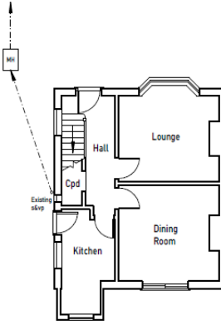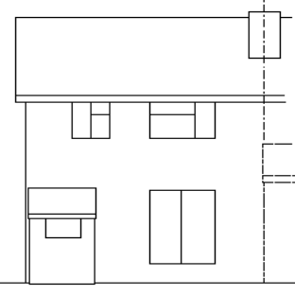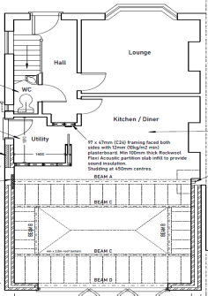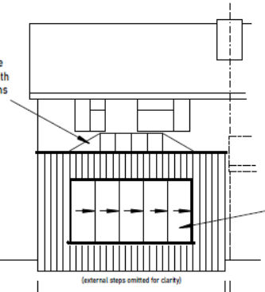

- RELEVANT PLANNING HISTORY

Application Ref: 220611
Description : Flat Roofed Rear extension measuring 4.5m in depth, with a maximum height of 3.8m. Notification of the construction of an extension under class A Part 1 of Schedule 2 of the Town and Country Planning (General Permitted Development) (England) Order 2015.
Decision : Withdrawn

4. CONSULTATIONS

4.1 The following addresses were consulted by letter.

10 Queen Annes Gate, Caversham, Reading
81A Henley Road, Caversham, Reading, RG4 6DS
9 Queen Annes Gate, Caversham, Reading, RG4 5DU
83a Henley Road, Caversham, Reading, RG4 6DS

4.2 No letters of representation have been received.

Equality Act 2010:
In determining this application the Council is required to have regard to its obligations under the Equality Act 2010. However, there is no indication or evidence (including from consultation on the application) that the protected groups identified by the Act have or will have different needs, experiences, issues and priorities in relation to this particular planning application. Therefore in terms of the key equalities protected characteristics it is considered there would be no significant adverse impacts as a result of the development.

- LEGAL AND PLANNING POLICY CONTEXT

Section 38(6) of the Planning and Compulsory Purchase Act 2004 requires that proposals be determined in accordance with the development plan unless material considerations indicate otherwise. Material considerations include relevant policies in the National Planning Policy framework (NPPF) - among them the 'presumption in favour of sustainable development'. The following local and national planning policy and guidance is relevant to this application:

National Policy
National Planning Policy Framework
National Planning Practice Guidance

Reading Borough Local Plan (2019)
CC7 (Design and the Public Realm)
CC8 (Safeguarding Amenity)
H9 (House Extensions and Ancillary Accommodation)

SPD
- Design Guide to House Extensions(2021)

6. APPRAISAL

H9 states: An extension to a house will be acceptable where it:

- Respects the character of the house in terms of scale, location, materials and design;

To assess this, the following has been considered – would the proposal:
- detract from the appearance of the original building through the use of ill-matching materials and by not fitting in with the design, scale and proportions of the original building; NO, while the materials to be deployed for this proposal are cedar cladding and not the existing materials on the original dwelling, it is considered not of significant impact as all aspects of the extension are to the rear and within approximately 3.4m height, so will not be visible from the street scene.
- reduce the amount of usable amenity space for the property to an unacceptable degree; NO, the increase of footprint to the original dwelling is not considered to be unacceptable degree as the depth of the rear extension is limited to 4m and the width is still the width of the existing dwelling.
- require the loss of trees in the garden or put significant trees at risk; NO, there are no trees within the extents of the proposed extension.

- Respects the character and pattern of neighbouring properties and the street as a whole in terms of scale, location, materials and design, and any important existing building line; Respects neighbour’s amenities and does not present a large blank façade to public areas.

To assess this, the following has been considered – would the proposal:
- significantly reduce the amount of daylight and sunlight enjoyed by neighbouring properties; NO, the height of the proposed extension is approximately 3.4m and will not impinging on the amount of daylight and sunlight received by neighbours on both sides. While there’s a side window on the neighbour’s property, this window is proposed to be blocked over (in agreement with the neighbour).
- invade the privacy of neighbouring properties through overlooking from windows or balconies; NO, there are no windows to any sides of the proposed development.
- detract from the character of neighbouring properties through siting, excessive bulk, ill-matching materials or inconsistent design; NO, as has been stated above n this report, the materials to be used to finish the external walls of this development will be in Cedar cladding and not matching the existing materials, it is considered as not detracting from the character of neighbouring properties as all the aspect of the development are to the rear and not to be seen form the street scene.
- detract from the appearance of the street or area by using ill-matched materials, glazing and detailing; NO

CC8: Safeguarding Amenity states an extension to a house will be acceptable where it will not cause a significant detrimental impact to the living environment of existing or new residential properties.

To assess this, the following has been considered – would the proposal cause a significant detrimental impact to the living environment of existing or new residential properties in terms of:

- Privacy and overlooking; No
- Access to sunlight and daylight; No
- Visual dominance and overbearing effects of a development; No

- CONCLUSION
The proposed development has been assessed and the proposed works are considered to be in accordance with the above relevant policies and planning permission can be granted.

8. RECOMMENDATION
Grant

