Delegated Application Report Target Date: 11/11/2022

Address: Green Park Village
Application No: 221178/NMA
Proposal: Amendment to condition 1 of reserved matters permission 170096 for Phase 3B2 to increase the height of the Woodland Close Apartment and some minor external changes to materials, balconies and windows
Case Officer: Alison Amoah

Proposal: The proposed changes are as follows:

- Increase the height of the Woodland Close Apartment block by 1.54m from 17.75m to 19.29m
- Replace combustible glass balustrade to railings for all balconies
- Change Equitone cladding to Hardie Plank to match buildings Longwaters 1,2 and 3 within the same phase
- Side Elevation 1 (previously referenced as North Elevation) cladding panels removed form between the windows
- Front Elevation and Side Elevation (formerly South and North Elevations) opening windows reduced in size
- Rear Elevation (formerly East Elevation) adjustment to some fenestration
- Front Elevation (formerly West Elevation) louvred doors added to gas meter storage; front entrance door relocated and wall surrounding gas meter doors changed from brick to cladding.

Originally Approved under 170096 Proposed Under 221178

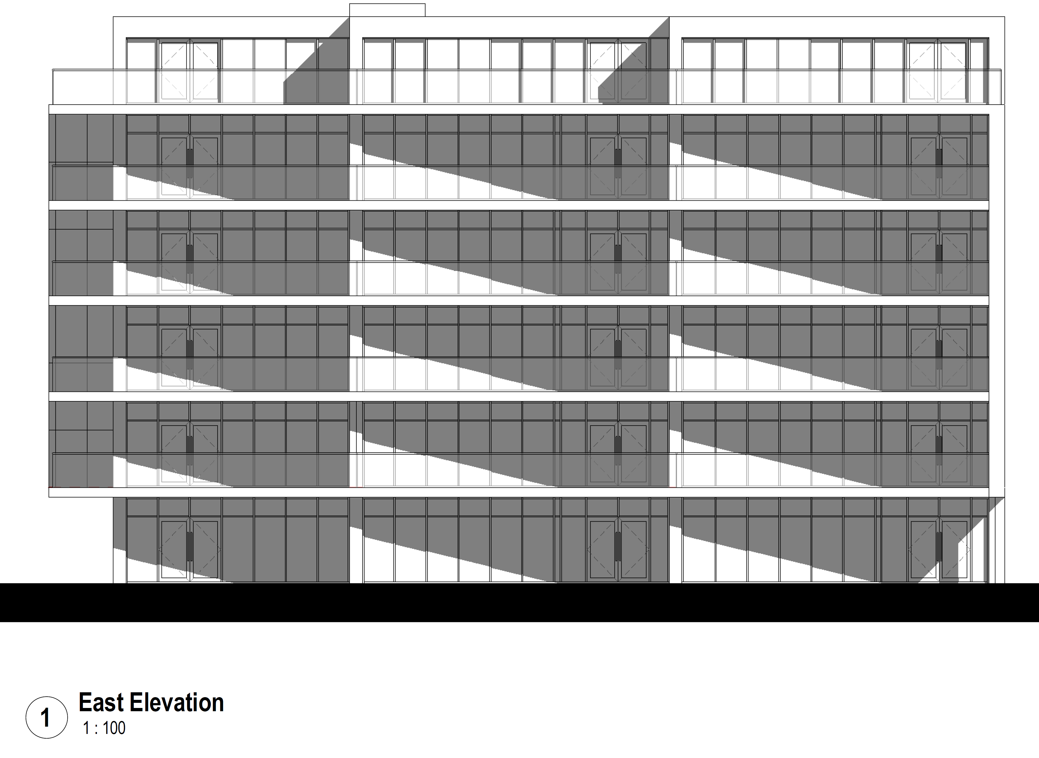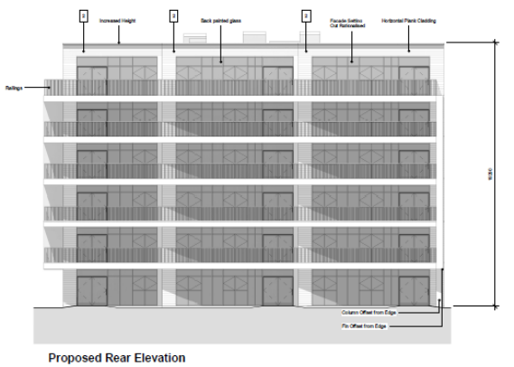
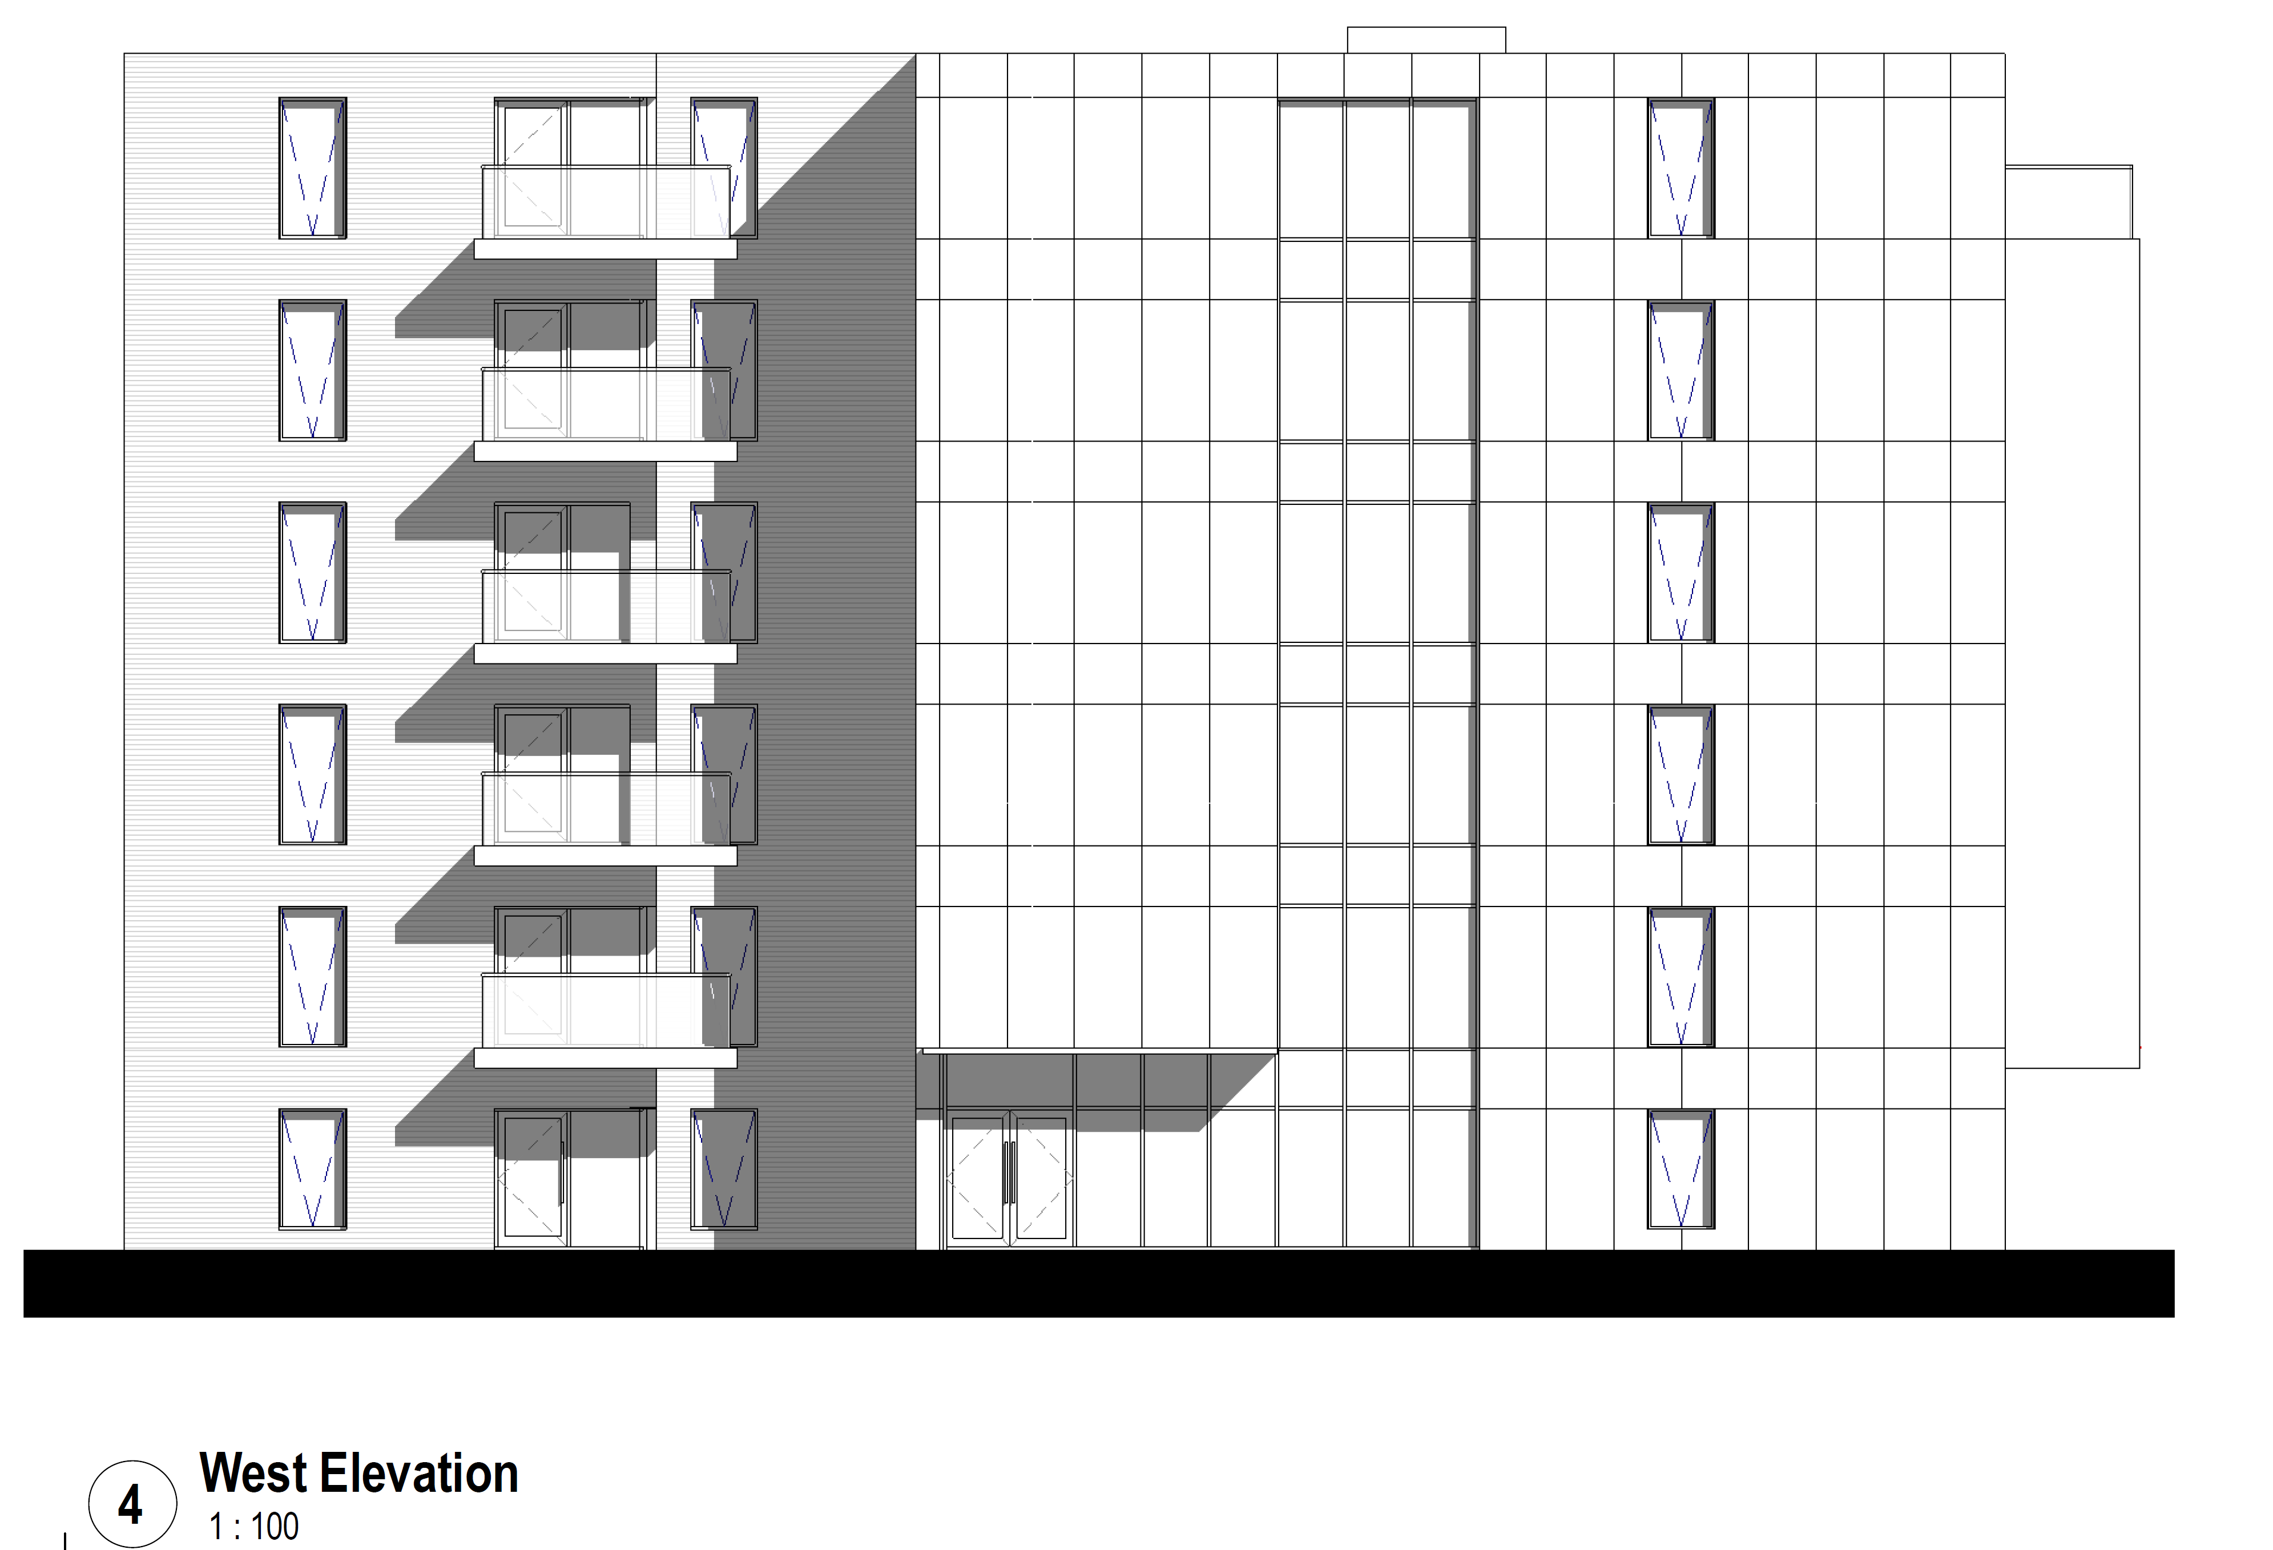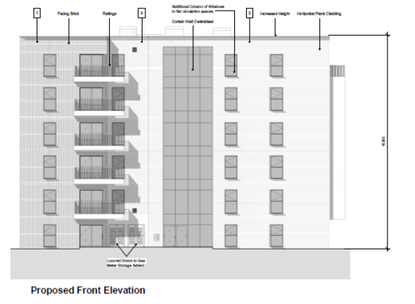

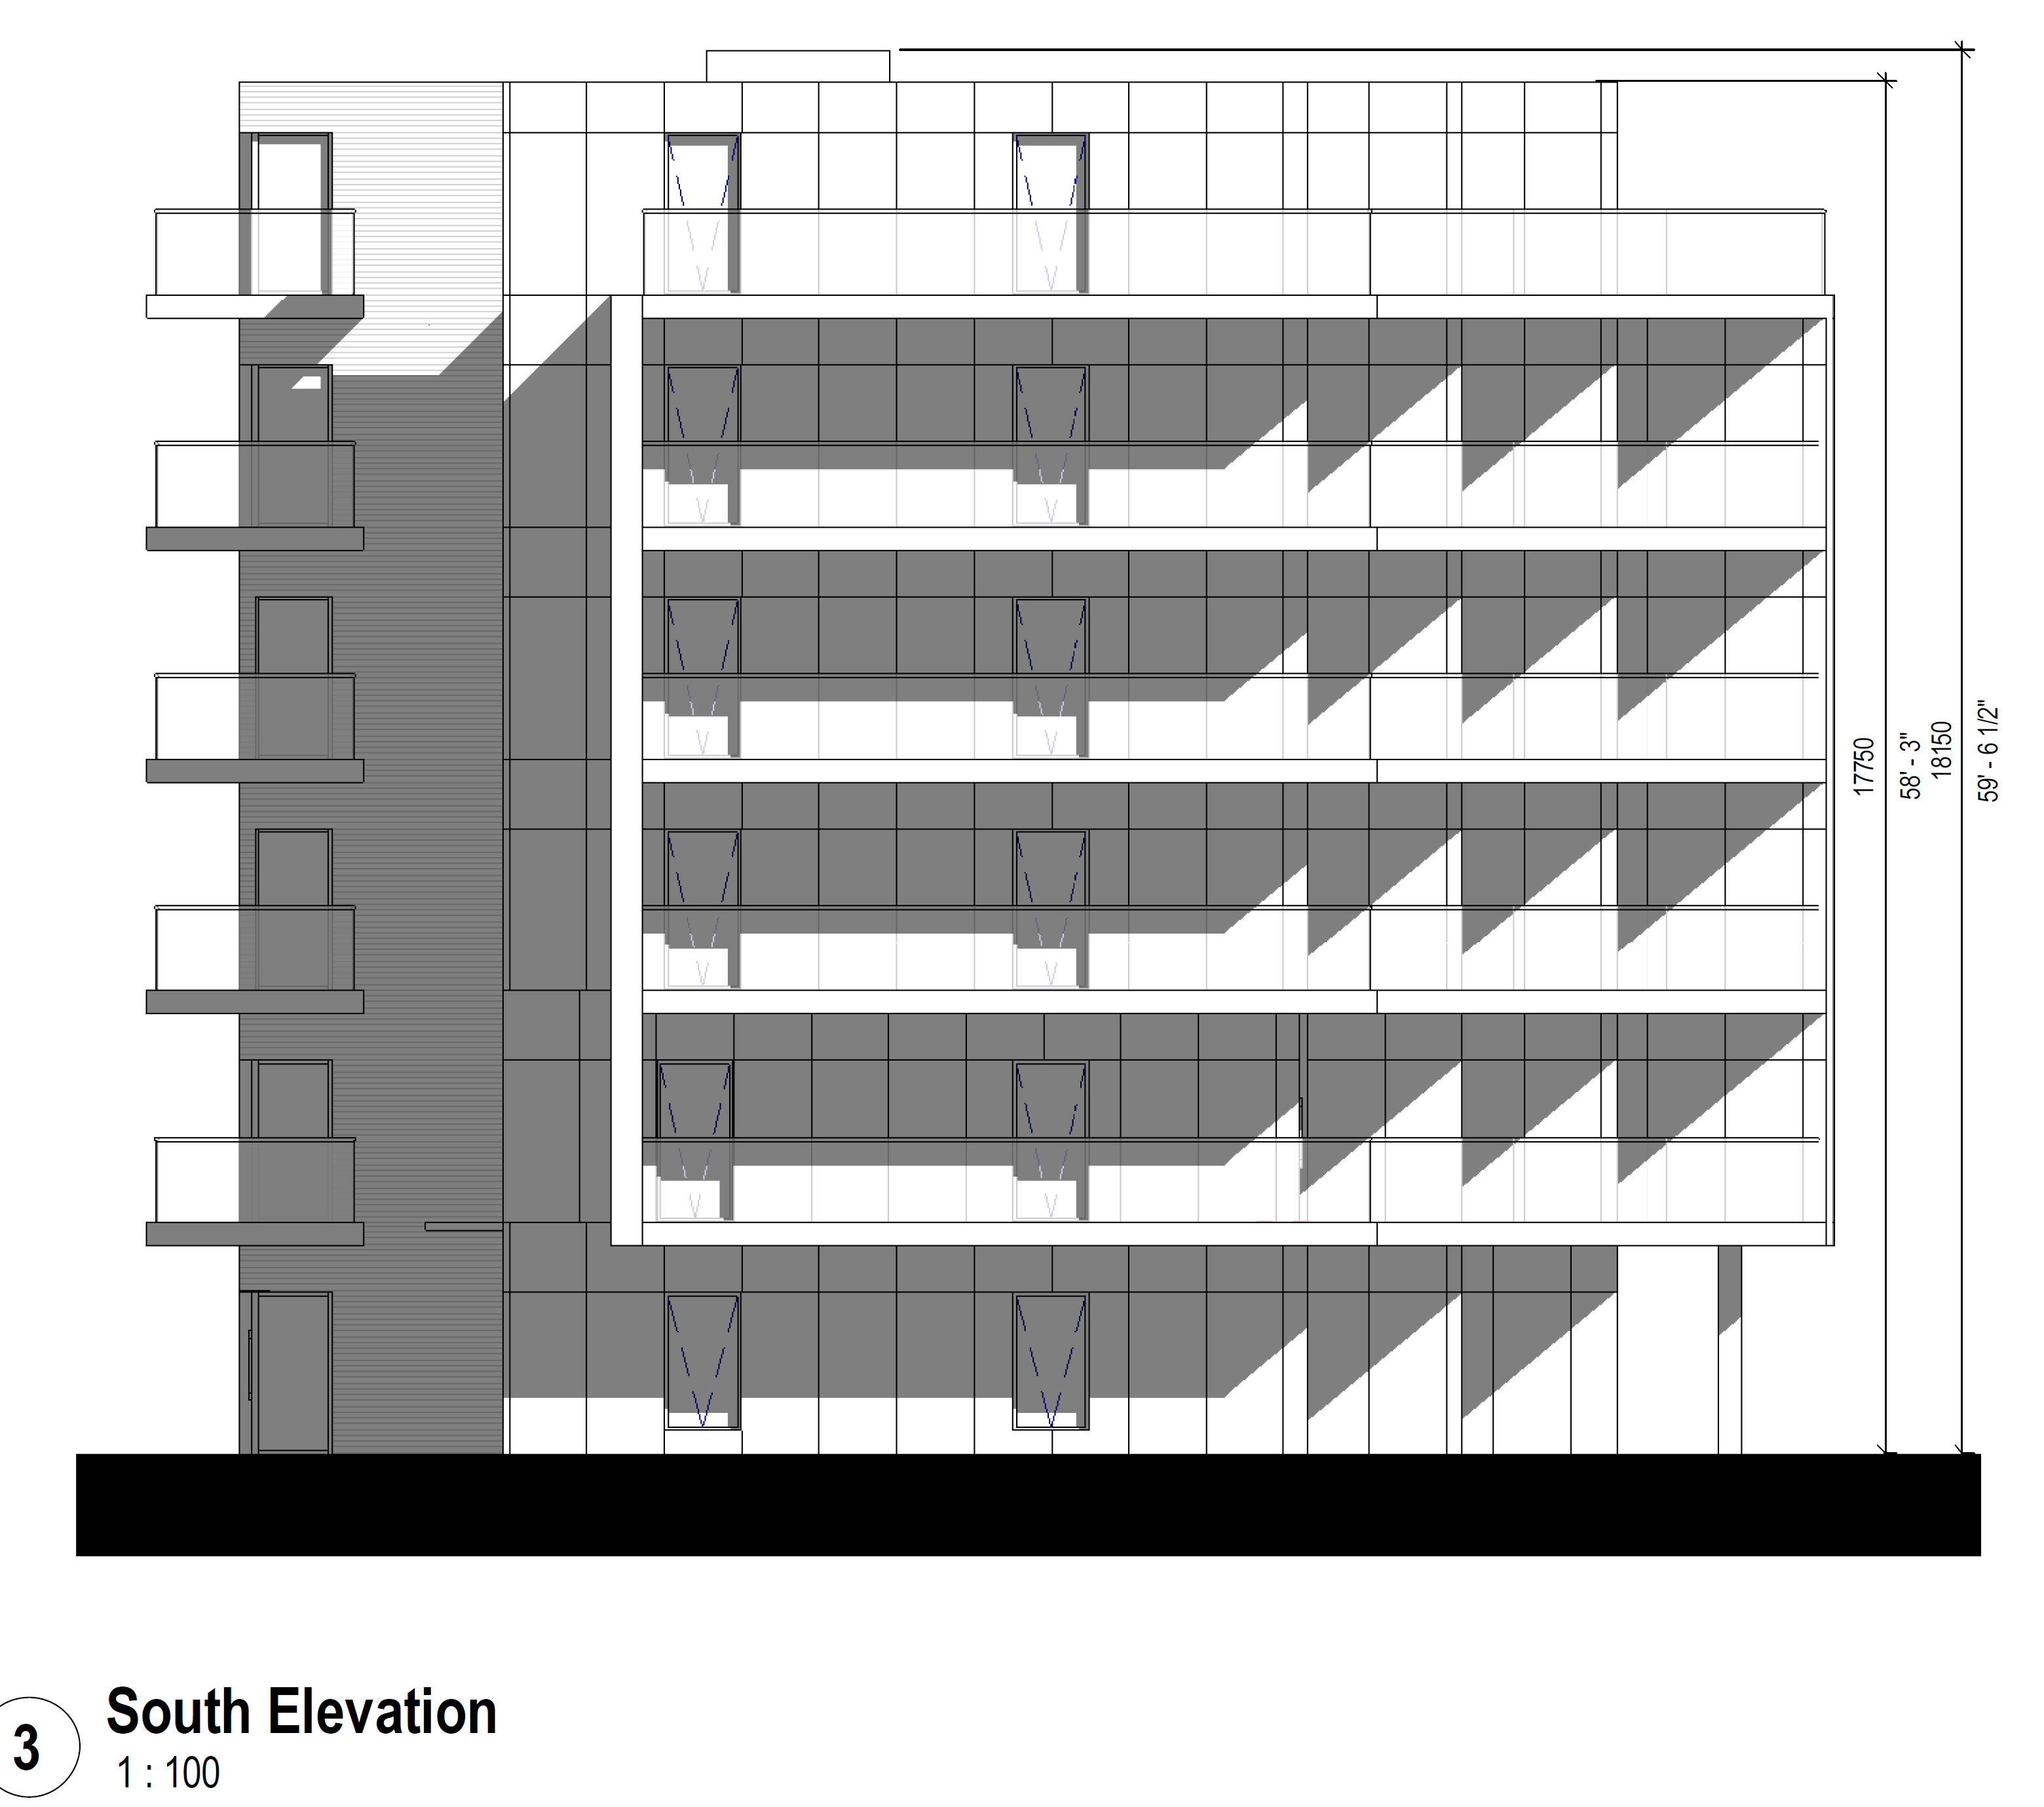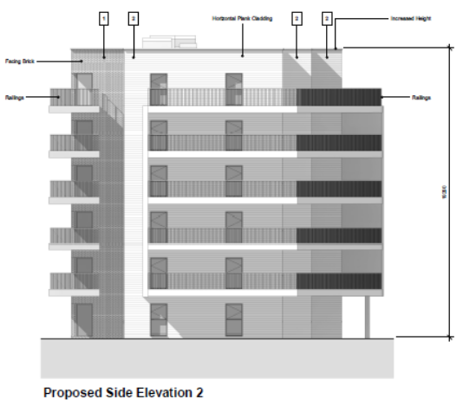

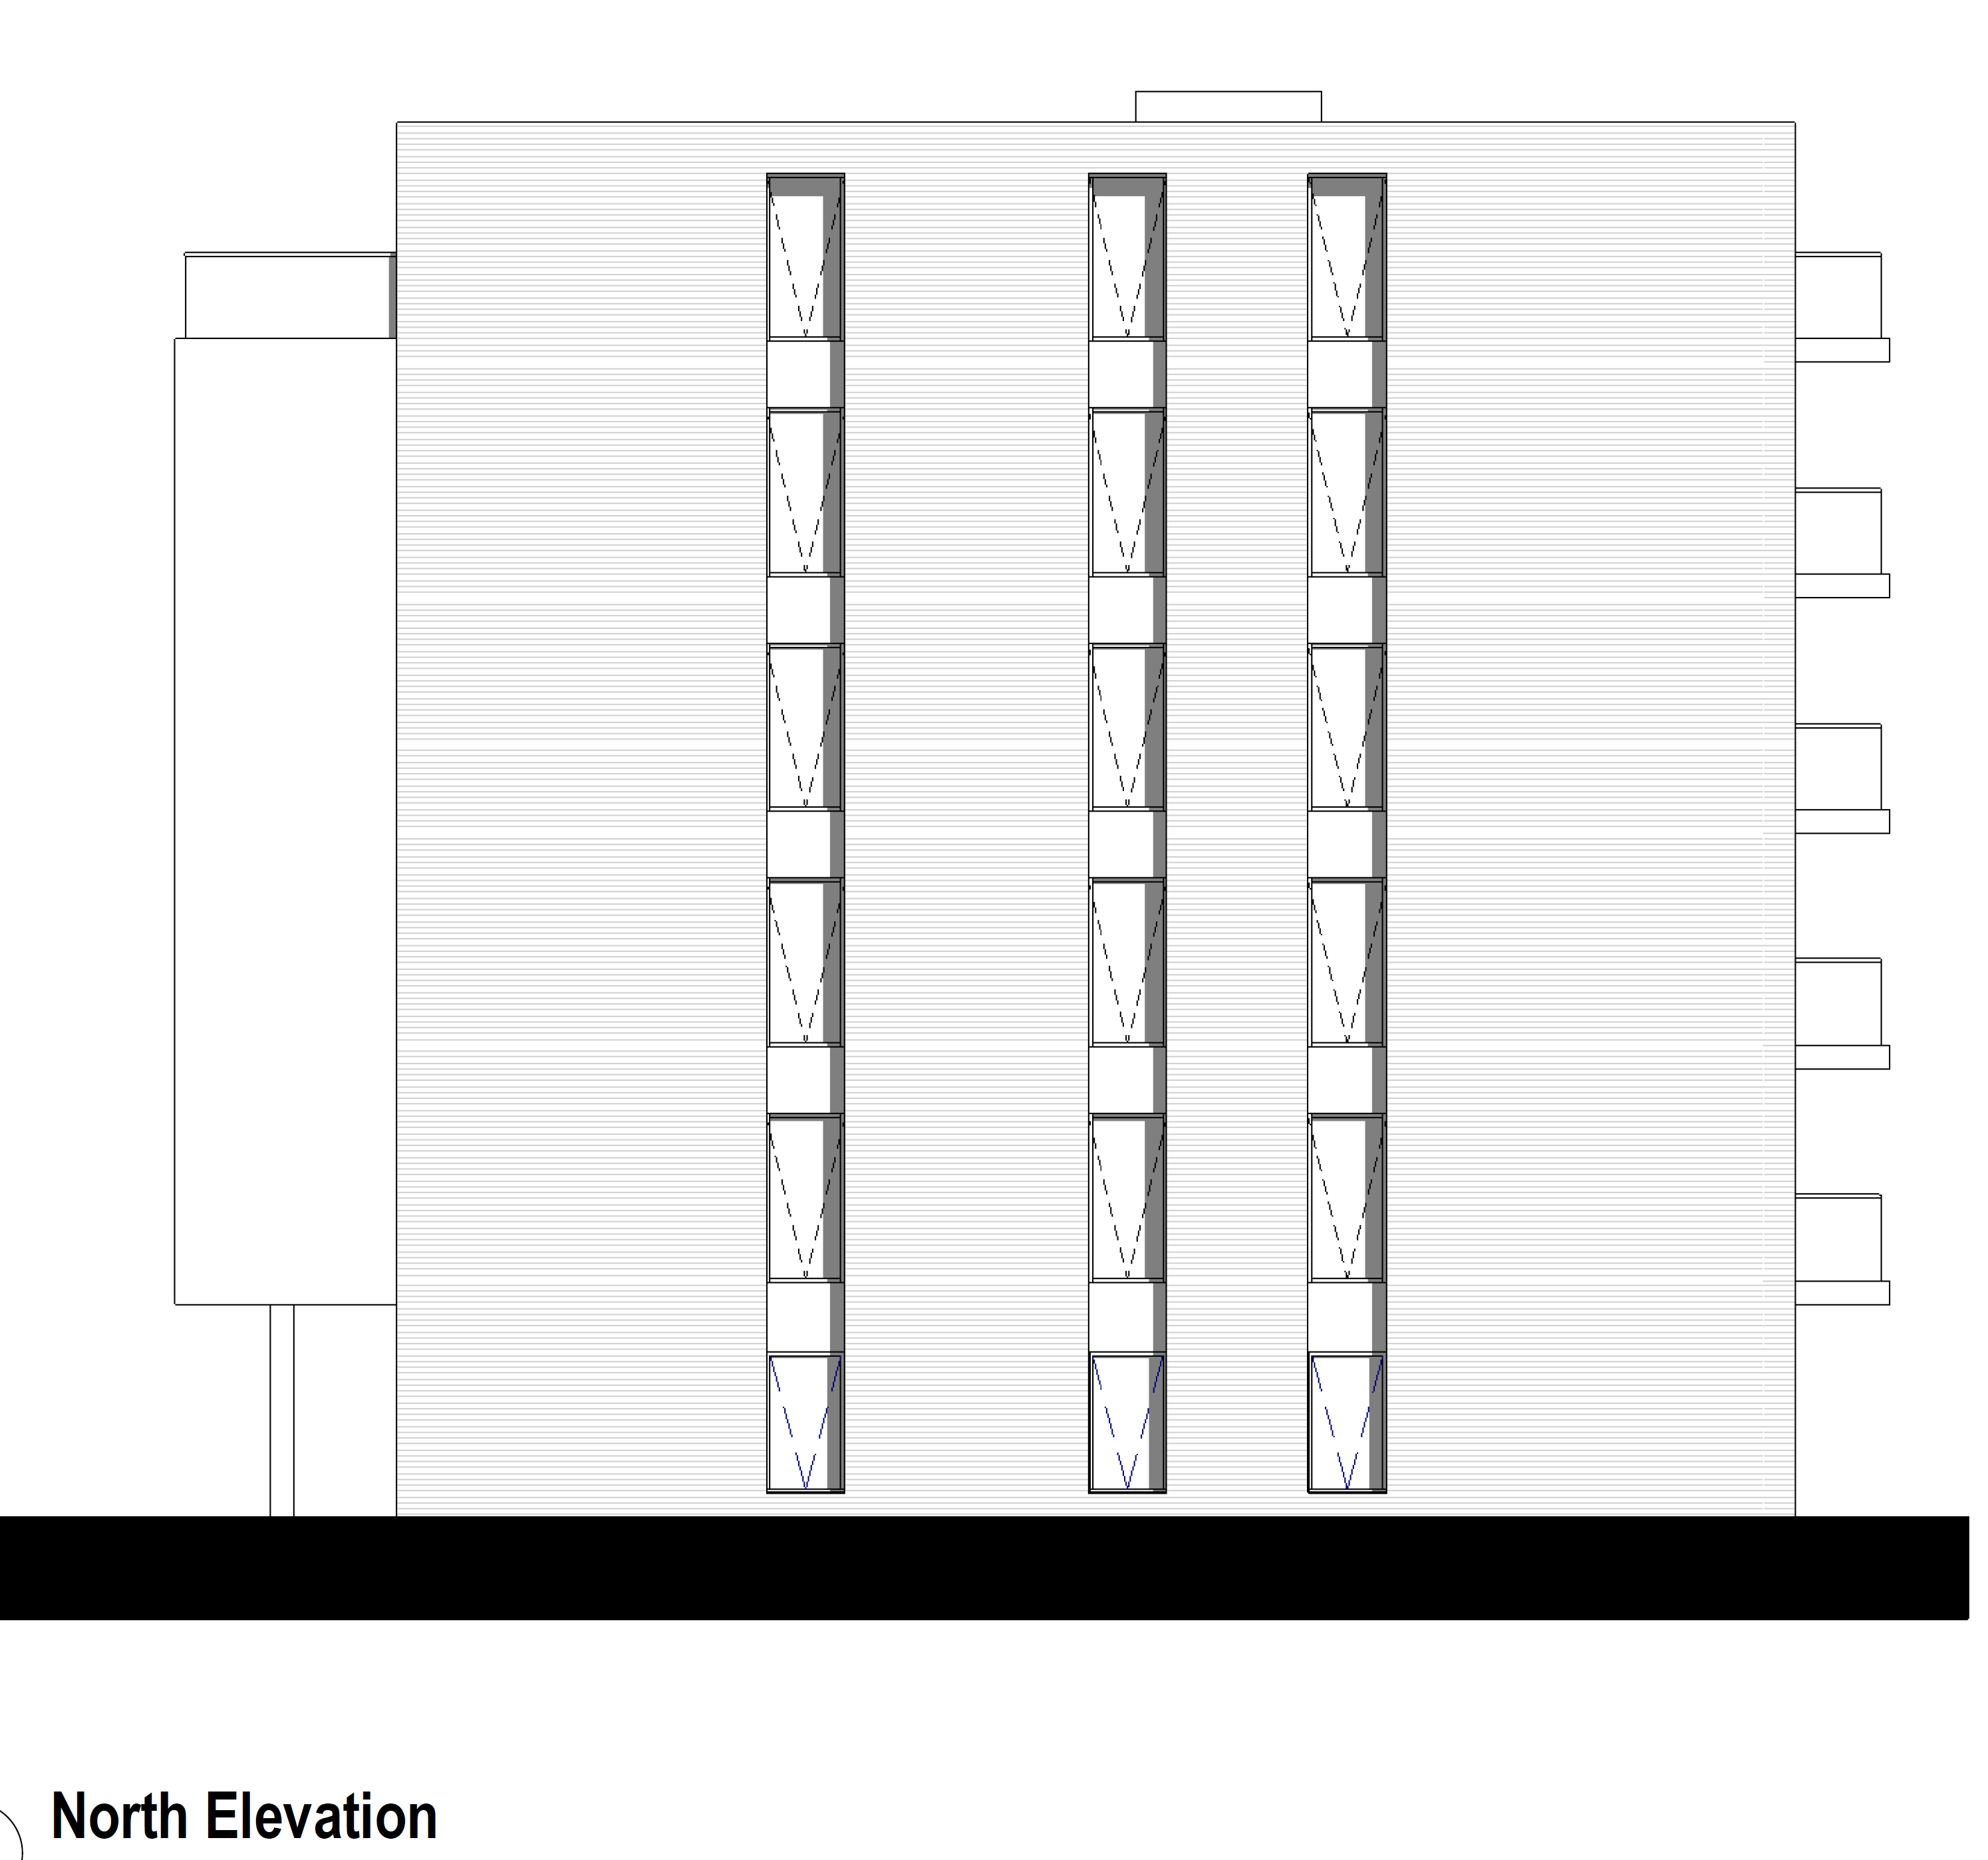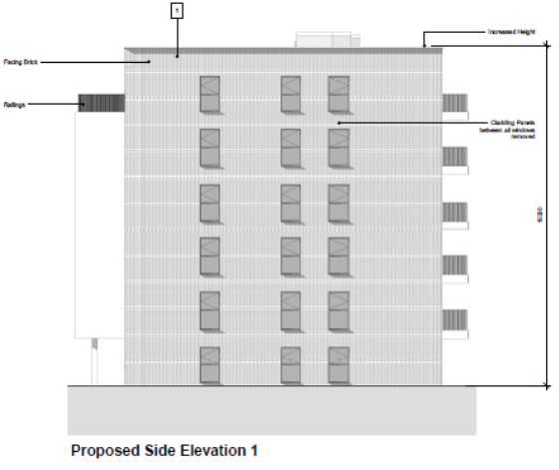

Original Plan approved under 170096/REM | Proposed Amended Plan under 221178/NMA
Woodland Close Apartment Elevations – Drawing no: PL-P3B2-013 Rev P3, received 24th May 2017 | Proposed Elevations [Woodland Apartments] - Drawing no: 22-660-WL-PL-03A, received 30th September 2022

The reason for the proposed changes, as set out by the applicant, is that with respect o the height, the original drawings as approved did not allow for adequate ceiling heights, service zones and roof insulation. The other changes are because of detailed design development.

Objections Received (Summary):
Applications under S96A are not applications for planning permission, so are not covered by the publicity requirements as set out in the DMPO.

Relevant Planning History:
10/01461/OUT (102172) – A planning application for mixed-use development comprising: Phase 1 (submitted in full with no matters reserved and as defined in area on Plan Ref. PL-P1-001) for the construction of housing (Class C3), local retail (Use Classes A1, A2, A3, A4, A5), management suite, village hall, engineering and infrastructure works including reconfiguration of the lake, lakeside access, car parking, pedestrian and cycle routes, services & infrastructure, landscaping and other associated works; and Subsequent phases (submitted in outline with all matters reserved except for details of the main access proposals) for the construction of housing (Class C3), extra care housing with ancillary community uses (Class C2), offices (Class B1), one-form entry primary school Class (Class D1), health surgery (Class D1), Nursery (Class D1), sports pitches, children's play facilities, engineering and infrastructure works including reconfiguration of the lake and vehicular access, lakeside access, car parking, pedestrian and cycle routes, services & infrastructure, landscaping and other associated works – Approved 1/7/11

170096/REM – Application for approval of reserved matters following outline approval for Phase 3B 2 (10/01461/OUT) – Approved 9/6/2017

Appraisal:
It is considered that the proposed changes would have a limited effect on the overall appearance, and although higher than the approved scheme, it is considered that it would not generate any differing effects with respect to residential amenity and overall appearance that would be considered material within the context of the whole development. The apartments are sited with sufficient distance to other dwellings (see Woodland Apartments marked in red on the extract below) such that there would be no resulting negative impact from an increased height of 1.54m.

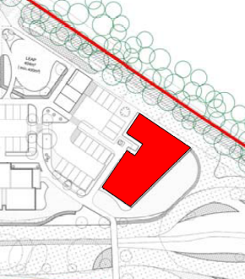

The external changes to the balconies are required for fire regulations and the other external changes include materials consistent with other buildings within the Phase and the changes to windows and doors are very limited. The changes would retain a high-quality design scheme in accordance with Policy CC7.

Conclusion:
The changes as proposed are considered to be acceptable non-material alterations to the approved scheme.

Recommendation:
Approve non-material amendment subject to conditions. Although Section 96(A) of the Act does not allow for the original decision to be re-issued, it does allow the modification of, or imposition of, conditions. In this respect it is considered appropriate to impose an additional condition:

Condition
The plans hereby approved by this Non-Material Amendment (under Section 96A of the Town and Country Planning Act 1990) are as follows:

- Proposed Elevations [Woodland Apartments] - Drawing no: 22-660-WL-PL-03A, received 30th September 2022

Reason: to clarify which plans are approved by this Non-Material Amendment.

INFORMATIVES

1. This notice relates only to the changes to condition 1 of the substantive planning permission (Ref: 170096). It shall be read in the context of the substantive planning permission and is bound by all the conditions and obligations attached to that permission and the original outline permission for Green Park Village 10/01461/OUT (102172). That permission still stands and this notice (and any other notices issued under section 96a for this development) should be read together.

2. In reaching this decision, the local planning authority is satisfied that the changes proposed by this application do not constitute material changes to the approved planning permission.

