

DELEGATED HOUSEHOLDER APPLICATION REPORT

Ward: Redlands
App Ref: 221180/HOU
Address: 95 Northumberland Avenue, Reading, RG2 7PT
Proposals: Proposed ground, first floor side and rear extension.
Case Officer: Chukwudi Onwudinanti
Applicant: Mr Hargun
Date received (valid from): 9 August 2022
Target Decision date: 1st February 2023 (EXT)

1. SITE DESCRIPTION
The property is a two-storey detached property with a single storey side element. The property comes close to the boundary with neighbouring number 93 to the north side but retains 1m gap from the side boundary with the two-storey block of flats at number 97, to the south side. Due to changing ground levels southwards, the property is set on higher ground levels than neighbouring number 97.

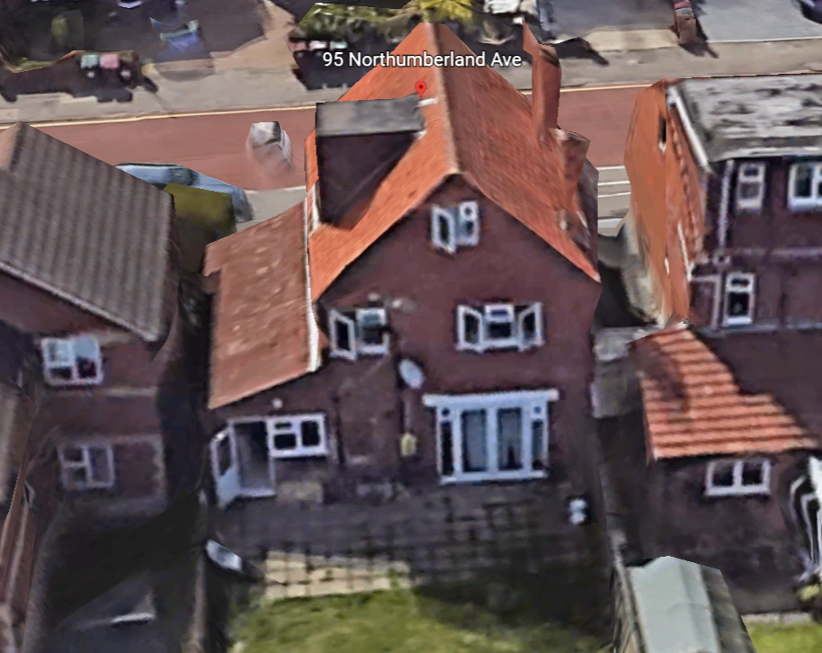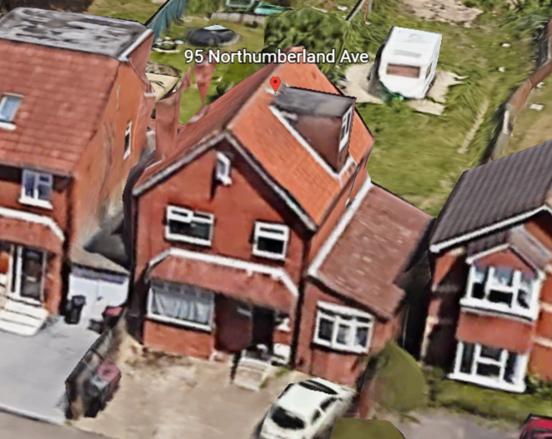

2. PROPOSAL AND SUPPORTING INFORMATION
The application proposes a ground floor rear extension measuring approximately 5.5m at the deepest point and 2.5m at the recessed end, covering most of the width of the existing dwelling. It also proposes a first floor side extension running the whole side of the existing dwelling and increasing to the side by approximately 2.5m.

Plans considered

Drawing No: A-1110 Rev B: Existing & Proposed Side Elevations dated July 2019 and received 1st February 2023
Drawing No: A-1100 Rev B: Existing & Proposed Front and Rear Elevations dated July 2019 and received 1st February 2023
Drawing No: A-1010 Rev A: Existing & Proposed Floor Plans dated July 2019 and received 10th August 2022
Drawing No: A-1000 Rev A: Site Location Plan & Block Plan dated July 2019 and received 10th August 2022
Drawing No: A-1020 Rev A: Existing & Proposed Roof Plans dated July 2019 and received 10th August 2022

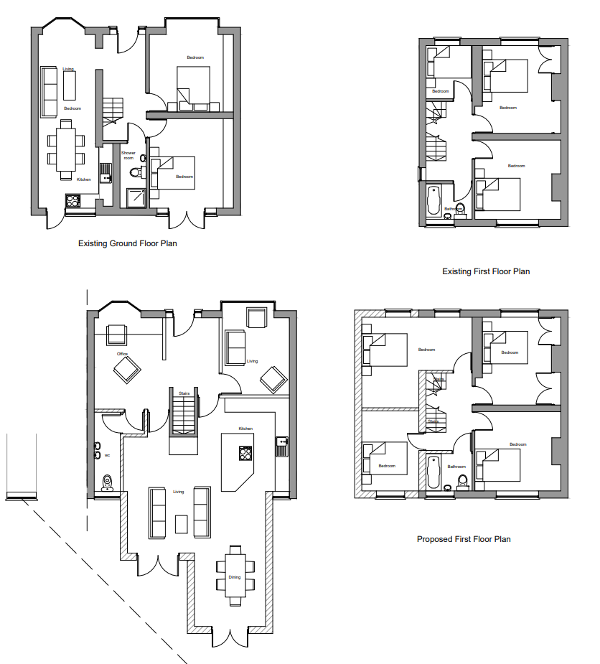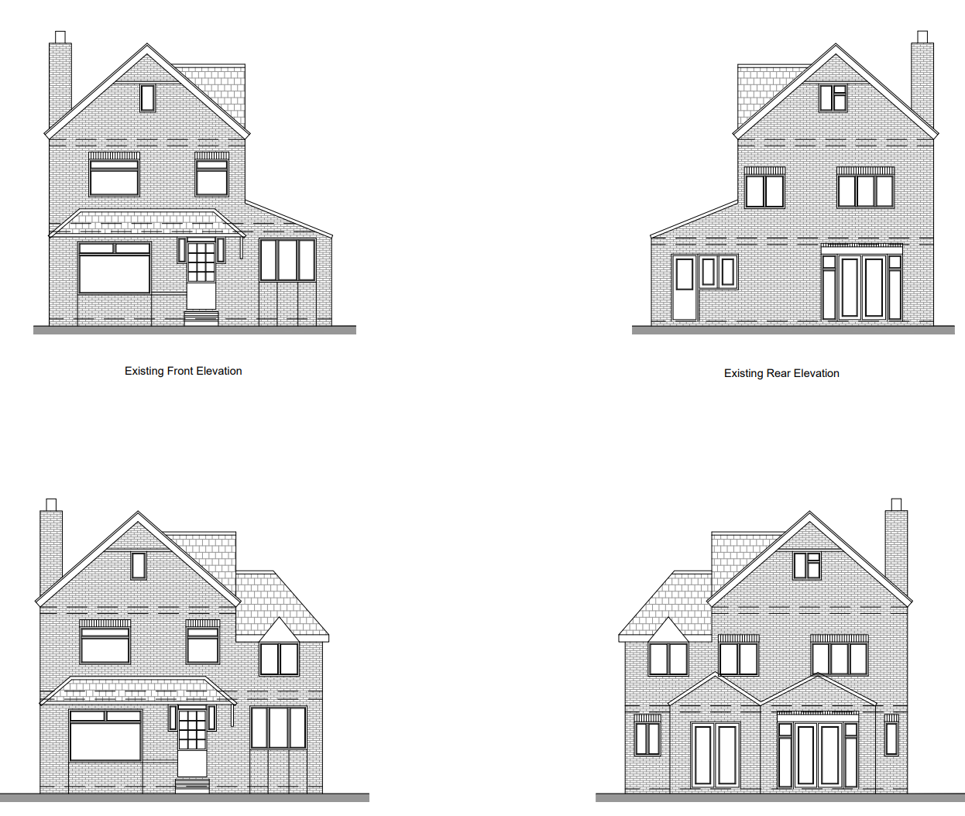

Existing and Proposed Floor Plans Existing and Proposed Elevations

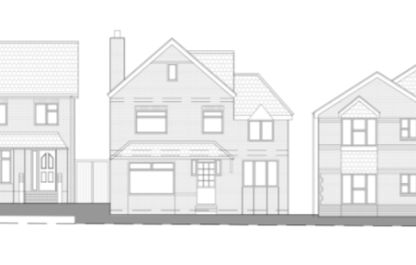
Proposed streetscene

- RELEVANT PLANNING HISTORY

Application Reference: 150460
Description: Rear extension measuring 6.0m in depth, with a maximum height of 2.8m, and 2.6m in height to eaves level. Notification of the construction of an extension under Class A, Part 1 of Schedule 2 of the Town and Country Planning (General Permitted Development) Order 1995 (as amended).
Outcome: Prior Approval Notification: Refusal

4. CONSULTATIONS

The following addresses were consulted by letter.

Flat 2, 97 Northumberland Avenue, Reading, Berkshire, RG2 7PT
Flat 4, 97 Northumberland Avenue, Reading, RG2 7PT
Flat 3, 97 Northumberland Avenue, Reading, RG2 7PT
Flat 1, 97 Northumberland Avenue, Reading, RG2 7PT
93 Northumberland Avenue, Reading, RG2 7PT
11 Morpeth Close, Reading, RG2 7UH
15 Morpeth Close, Reading, RG2 7UH

No letters of representation have been received.

Equality Act 2010:
In determining this application the Council is required to have regard to its obligations under the Equality Act 2010. However, there is no indication or evidence (including from consultation on the application) that the protected groups identified by the Act have or will have different needs, experiences, issues and priorities in relation to this particular planning application. Therefore in terms of the key equalities protected characteristics it is considered there would be no significant adverse impacts as a result of the development.

- LEGAL AND PLANNING POLICY CONTEXT

Section 38(6) of the Planning and Compulsory Purchase Act 2004 requires that proposals be determined in accordance with the development plan unless material considerations indicate otherwise. Material considerations include relevant policies in the National Planning Policy framework (NPPF) - among them the 'presumption in favour of sustainable development'. The following local and national planning policy and guidance is relevant to this application:

National Policy
National Planning Policy Framework
National Planning Practice Guidance

Reading Borough Local Plan (2019)
CC7 (Design and the Public Realm)
CC8 (Safeguarding Amenity)
H9 (House Extensions and Ancillary Accommodation)

SPD
Design Guide to House Extensions 2019

6. APPRAISAL
Character and Appearance

Policy H9 states that an extension to a house will be acceptable where it respects the character of the house in terms of scale, location, materials and design and respects the character and pattern of neighbouring properties and the street as a whole in terms of scale, location, materials and design, and any important existing building line. Policy CC7 also sets out relevant considerations for design.

The first floor side extension presented in this application maintains the footprint of the existing side extension. The ridgeline is stepped down from the existing ridgeline of the dwelling and all materials to be used are to match existing materials. The staggered rear extension is limited to the ground floor, with an overall ground to eaves height of approximately 2.7m. While the deepest part of the extension would be 5.5m, this would not constitute any impediments to the daylight assessable to the adjoining neighbour, so does not impact to a significant level, the amenity of the neighbours or the immediate dwelling.

The ridgeline of the side extension, as noted above has been stepped down from the existing ridgeline and the eaves have also been stepped down to match the levels of the adjoining property. These have made the design subservient to the original dwelling, while maintaining a pleasing level with the adjoining property.

It is therefore considered that the application does not impact to an unacceptable level, the character of the house in terms of its location, scale and materials, when considered under Policy CC7.

Residential Amenity

Policy H9 states that an extension will be acceptable where it does not result in an overbearing impact on neighbours. Policy H10 seeks to ensure that the amenity of gardens and other outdoor areas are not compromised. Policy CC8 states an extension to a house will be acceptable where it will not cause a significant detrimental impact to the living environment of existing or new residential properties.

The side upward extension presents no side windows and there are no existing side windows on the adjoining property. The staggered rear extension is limited to the ground floor. An assessment of the 45 and 60 degree rule shows that there would no impact on the adjoining properties on both sides.

This proposal would therefore not present any privacy, overlooking, overbearing issues, nor would it impact on the daylight assessable to the adjoining property, as stated above in this report.

- CONCLUSION
The proposed development has been assessed as set out above and is considered to be acceptable on that basis, subject to the following conditions.

8. RECOMMENDATION
Application Permitted
Recommended Conditions:
AP1: Approved Plans
TL1: Time Limit Standards
M1: Materials to match existing.

