

DELEGATED HOUSEHOLDER APPLICATION REPORT

Ward: Church
App Ref: 231104/HOU
Address: 227 Northumberland Avenue, Reading, RG2 7PZ
Proposals: Proposed single storey extension and a front porch and demolition of existing chimneys.
Case Officer: Chukwudi Onwudinanti
Applicant: SK Design Consultants
Date received (valid from): 4 August 2023
Target Decision date: 4 December 2023(EXT)

1. SITE DESCRIPTION
The site is a two storey terrace dwelling on the eastern side of Northumberland Avenue. The area is a predominantly residential area with buildings of varying styles and sizes on both sides of the road.
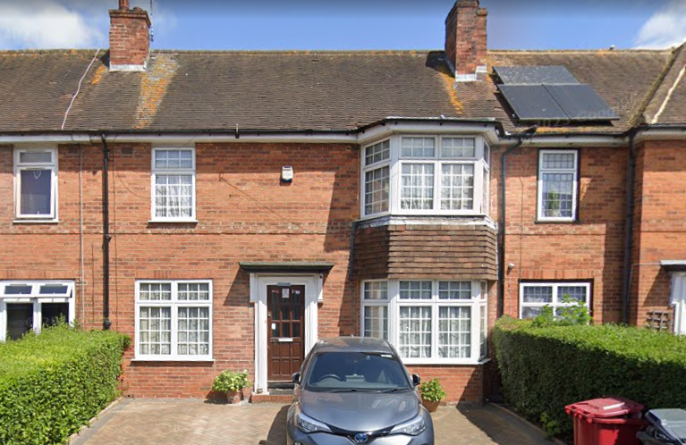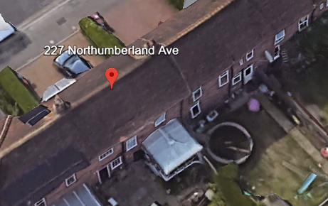

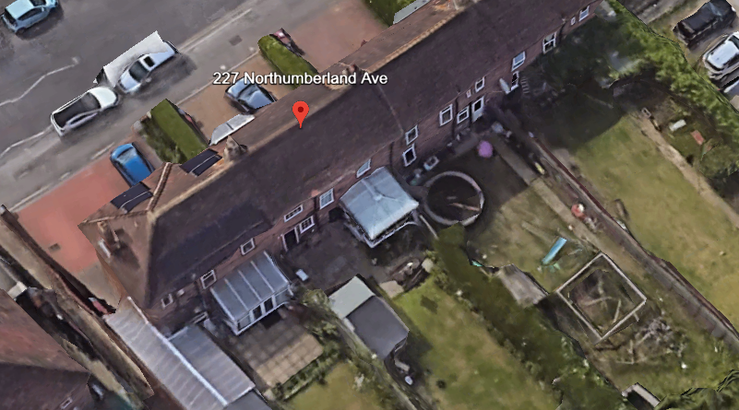
Google Photos

2. PROPOSAL AND SUPPORTING INFORMATION
The proposal is for a single storey rear extension measuring 3.6m wide and 5.3m deep, erection of a new front porch and demolition of existing chimneys. The front porch measures approximately 2.8m wide by 1m deep. The rear extension measures approximately 2.56m ground to eave while the front porch is 2.3m high. Rear extension is covered by a hip roof of 3.86m high ridgeline while the front porch is covered by a mono-pitch roof of maximum height of 3.4m.

Plans considered dated August 2023 received 27/11/2023:
Drawing No P1437 -01: Location and Block Plans
Drawing No P1437 -02 Rev B: Existing and Proposed Plans and Elevations received 04/12/2023
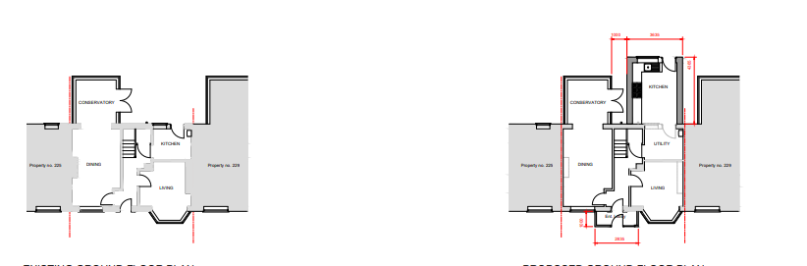
Existing Ground Floor Plan Proposed Ground Floor Plan

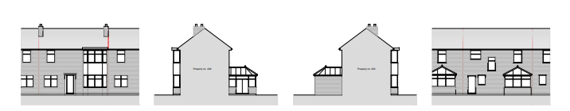
Existing Elevations

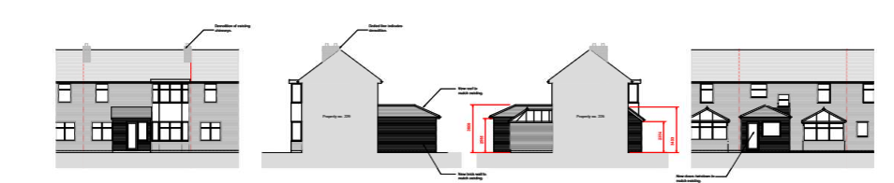
Proposed Elevations

- RELEVANT PLANNING HISTORY

None

4. CONSULTATIONS

The following addresses were consulted by letter.

229 Northumberland Avenue, Reading, RG2 7PZ
225 Northumberland Avenue, Reading, RG2 7PZ

No letters of representation have been received.

Discussions with agent.
The initial submissions had the depth of the rear extension at 5.3m. This was considered unjustifiably excessive by the LPA and the agent was advised accordingly. The agent has subsequently made adjustments to the initial submissions and reduced the depth of the extension to approximately 4.3m.

Equality Act 2010:
In determining this application the Council is required to have regard to its obligations under the Equality Act 2010. However, there is no indication or evidence (including from consultation on the application) that the protected groups identified by the Act have or will have different needs, experiences, issues and priorities in relation to this particular planning application. Therefore in terms of the key equalities protected characteristics it is considered there would be no significant adverse impacts as a result of the development.

- LEGAL AND PLANNING POLICY CONTEXT

Section 38(6) of the Planning and Compulsory Purchase Act 2004 requires that proposals be determined in accordance with the development plan unless material considerations indicate otherwise. Material considerations include relevant policies in the National Planning Policy framework (NPPF) - among them the 'presumption in favour of sustainable development'. The following local and national planning policy and guidance is relevant to this application:

National Policy
National Planning Policy Framework
National Planning Practice Guidance

Reading Borough Local Plan (2019)
CC7 (Design and the Public Realm)
CC8 (Safeguarding Amenity)
H9 (House Extensions and Ancillary Accommodation)

SPD
Design Guide to House Extensions 2021
Revised Parking Standards and Design SPD 2011

6. APPRAISAL
Character and Appearance

Policy H9 states that an extension to a house will be acceptable where it respects the character of the house in terms of scale, location, materials and design and respects the character and pattern of neighbouring properties and the street as a whole in terms of scale, location, materials and design, and any important existing building line. Policy CC7 also sets out relevant considerations for design.

The application proposes a front porch extension projecting 1m forward of the Principal Elevation and approximately 2.9m wide. The height of the porch would be of overall height of 3.4m ground to roof ridge and 2.3m ground to eaves.

On the rear elevation, proposed is a rear extension of 4.3m depth and width of 3.6m, to create a kitchen while converting the existing kitchen into a utility room. The height of the extension to the rear is 2.5m, ground to eave and approximately 3.8, ground to ridgeline.

The introduction of the closed porch on the Principal Elevation is a departure from the prevalent porches on the dwellings on the street, consisting of a flat short projecting slab over the front door. There have been a few alterations to this original design on the street scene. The LPA supports this development of the porch as it seeks to enhance the design of the front porch with minimal impact on the front elevation as a result of the restrained projection and width. The materials are to match existing materials on all aspects of the proposal.

The rear extension aspect has been amended on the advice of the LPA and the resultant projection is considered to be sympathetic to the scale of the original dwelling and the neighbouring dwellings on both sides. The restriction of the extension to the ground floor also ensures that the extension is not visible from the street scene, so does not negatively impact on the character of the neighbourhood, in terms of outlook and the street scene.

Residential Amenity

Policy H9 states that an extension will be acceptable where it does not result in an overbearing impact on neighbours. Policy H10 seeks to ensure that the amenity of gardens and other outdoor areas are not compromised. Policy CC8 states an extension to a house will be acceptable where it will not cause a significant detrimental impact to the living environment of existing or new residential properties.

The projection of the extension to the rear is not to a degree that would cause overbearing effects on the neighbouring property on No 229, as the resultant difference in the lines of the rear extension and the conservatory on No 229 would be less than 1.5m.The hipped roof and limited ground to eave height of 2.5m also mitigates any risk of an overbearing effect on the neighbours at No 229. The extension is separated from No 225 by an existing conservatory on the site.

There are no side windows proposed, therefore there are no real or perceived privacy or overlooking issues on both sides of the site. The particulars of the proposal sited above, regarding the limited extension of the line of the rear elevation beyond the other dwellings on both sides also ensures that any negative impacts on access to daylight and sunlight that could be experienced by the neighbouring dwellings are adequately mitigated.

- CONCLUSION
The proposed development has been assessed as set out above and is considered to be acceptable on that basis, subject to the following conditions.

8. RECOMMENDATION: Grant
Recommended Conditions:
AP1: Approved Plans
TL1: Time Limit Standards
M1: Materials to Match Existing

