

DELEGATED HOUSEHOLDER APPLICATION REPORT
App Ref: 230419/HPA
Address: 12 Rylstone Road, Reading, RG30 1LN
Proposals: Rear extension measuring 6.0m in depth, with a maximum height of 3.0m. Notification of the construction of an extension under class A Part 1 of Schedule 2 of the Town and Country Planning (General Permitted Development) (England) Order 2015.
Case Officer: Chukwudi Onwudinanti
Applicant: Mr Mohan Limbu
Target Decision date: 25 May 2023 (EXT)

INTRODUCTION

The proposal site is a semi-detached dwelling unit on the northern side of Rylstone Road, within a residential area and among a group of four similar styled buildings on one side of the road.
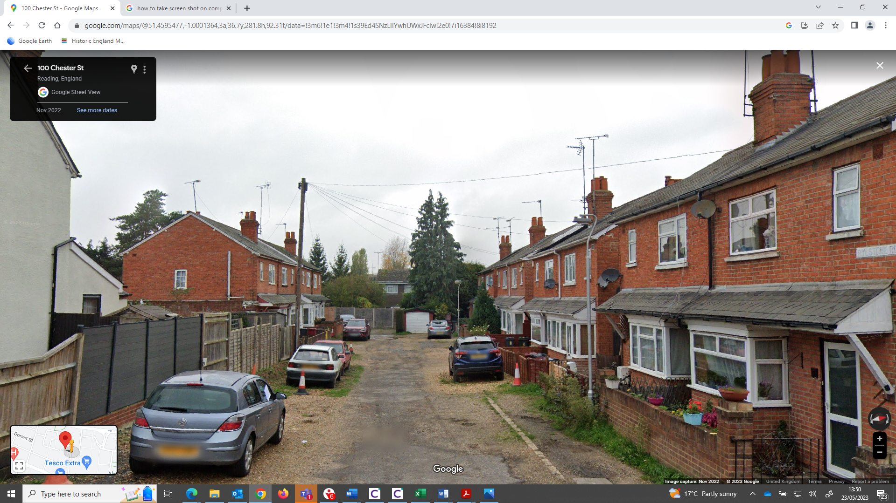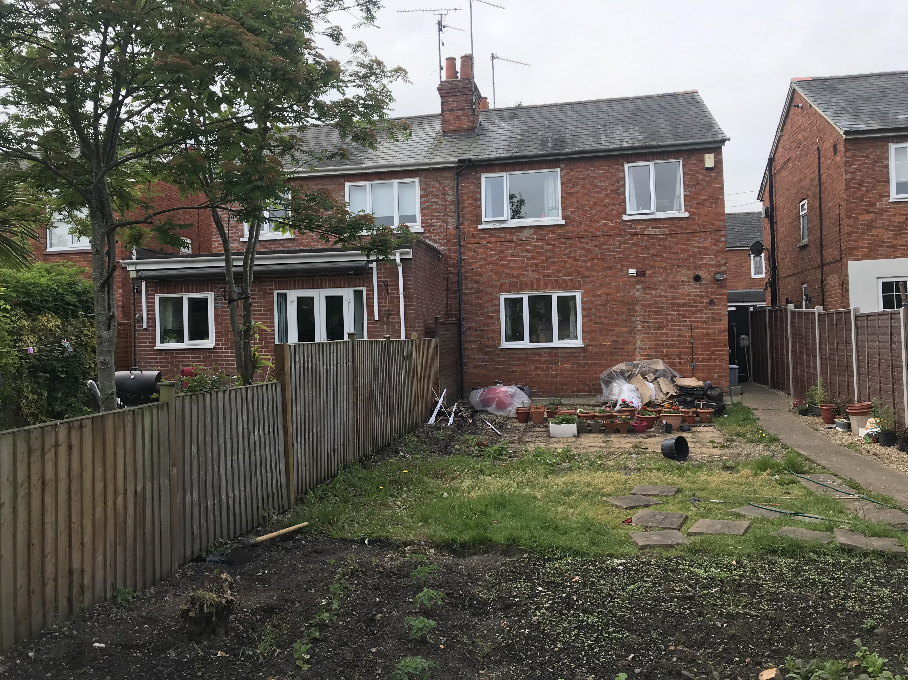

Google Photos Site Photos

PROPOSAL
The applicant has provided information on the proposed rear extension. The extension proposed would:
- Extend beyond the rear wall of the original dwelling by 6m
- Have a maximum height of 3m
- Have an eaves height of 3m

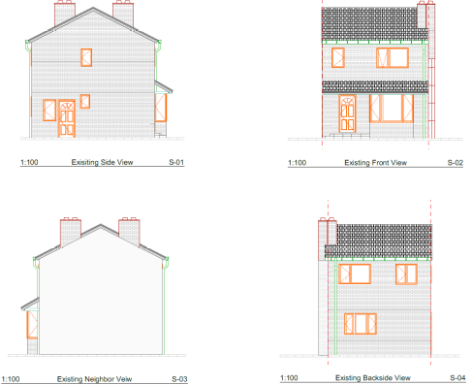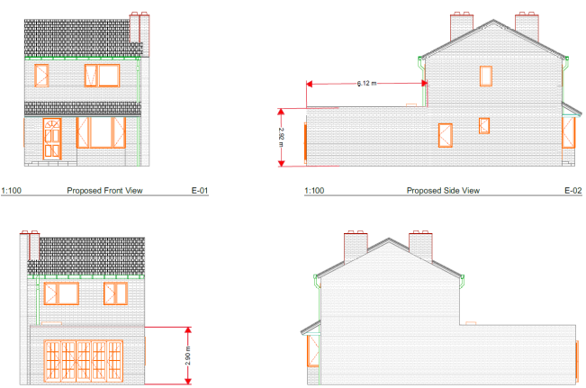

Existing Elevations Proposed Elevations

The proposal can be considered under Paragraph A.1 (g) and (i):

- For a dwellinghouse not on article 2(3) land nor on a site of special scientific interest, the enlarged part of the dwellinghouse would have a single storey and
- Extend beyond the rear wall of the original dwellinghouse by more than 8 metres in the case of a detached dwellinghouse, or 6 metres in the case of any other dwellinghouse – Complies
- Exceed 4 metres in height – Complies ( Height is 3m)

Under Paragraph A.1 (i):
- (i) the enlarged part of the dwellinghouse would be within 2 metres of the boundary of the curtilage of the dwellinghouse, and the height of the eaves of the enlarged part would exceed 3 metres - Complies( Height is 3m)

The application site is not within a Conservation Area nor have PD rights been withdrawn or restricted by way of a direction made under Article 4 or condition attached to an express planning permission.

PLANS SUBMITTED
The applicant submitted the following drawings. Received on 30th March 2023:
A.01.1 Rev P1: Existing Floor and Roof Plans
A.01.2 Rev P1: Existing Elevations
A.01.3 Rev P1: Proposed Floor and Roof Plans
A.01.4 Rev P1: Proposed Elevations
Location Plan
Site Plan
Block Plan

PLANNING HISTORY
None.

NOTIFICATION
In accordance with the relevant provision of the GPDO 2015 Order, as amended, the LPA notified on 11th April 2023 the adjoining owners and occupiers at Nos 14 and 10 Rylstone Road, Reading, as well as No 38 Masson Avenue, Ruislip of the proposed extension providing a period of 21-days for representations to be made. The 21-day consultation period expired on 2nd May 2023.

No letters of representation have been received.

As such, because there have been no objections, the proposed extension is Permitted Development under the 2015 Order, as amended.

Notification is provided that Prior Approval is not required.

The extension must be carried out in accordance with the information provided to the LPA (depth 6m, max height 3m, eaves 3m).

EQUALITIES IMPACT
In determining this application, the Local Planning Authority has had regard to its obligations under the Equality Act 2010. The key equalities protected characteristics include age, disability, gender reassignment, marriage and civil partnership, pregnancy and maternity, race, religion or belief, gender, and sexual orientation.

In terms of the key equalities protected characteristics it is considered there would be no significant adverse impacts as a result of the development.

DECISION
Notification is given that Prior Approval is not required for the extension proposed under proposed under Class A, Part 1, of Schedule 2 to the Town and Country Planning (General Permitted Development) (England) Order 2015, as amended (Prior Approval).

