DELEGATED HOUSEHOLDER APPLICATION REPORT

Ward: Kentwood
App Ref: 220609/HOU
Address: 6 Coniston Drive, Tilehurst, Reading, RG30 6XS
Proposals: Two storey side extension, single storey rear extension connecting to a single storey side and rear. Single storey rear extension, to be same footprint of existing conservatory.
Case Officer: Chukwudi Onwudinanti
Applicant: Mr Chun Hin Tsang
Date received (valid from): 4 May 2022
Target Decision date: 15 September 2022 (EXT)

1. INTRODUCTION
The proposal site is a semi-detached dwelling on the eastern side of Coniston Drive, a cul de sac in a predominantly residential area, among buildings of similar style and size.

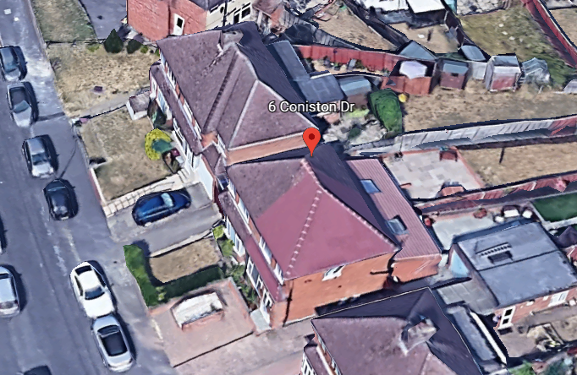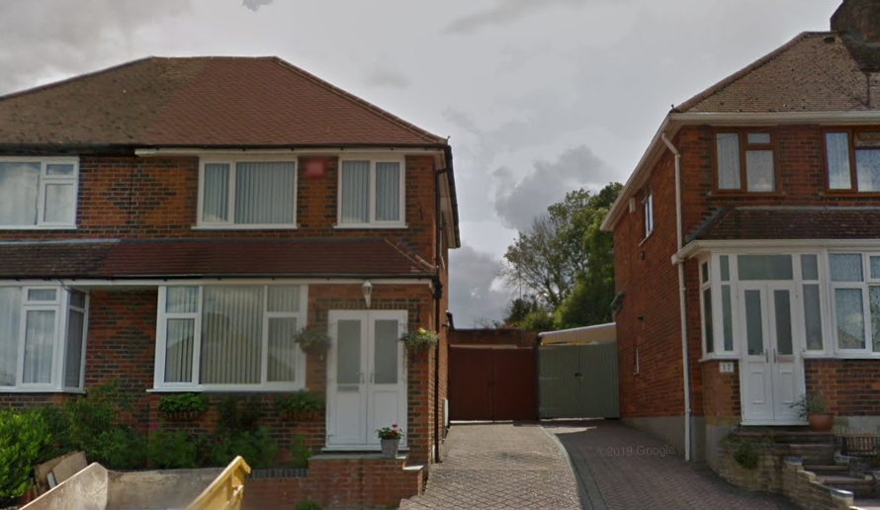

2. PROPOSAL AND SUPPORTING INFORMATION

The proposal is for a two storey side extension and single storey rear extension connecting the side and rear aspects. Single storey rear extension, to be same footprint of existing conservatory.

Plans considered received 26th April 2022
Site Location
Drawing No 1: Existing Plans and Elevations
Drawing No 2: Proposed Plans and Elevations received 2nd August 2022
Proposed Block Plan Rev 1 Received 12th September 2022

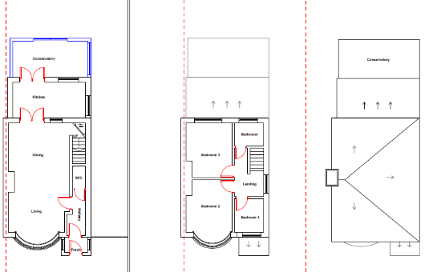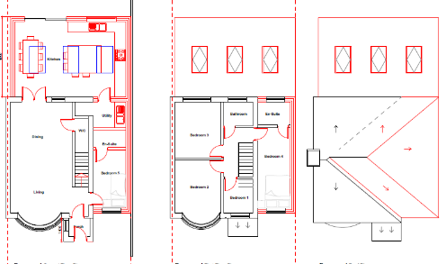

Existing Floor Plans Proposed Floor Plans

- RELEVANT PLANNING HISTORY

None

4. CONSULTATIONS

4.1 The following addresses were consulted by letter.

8 Coniston Drive, Tilehurst, Reading, Berkshire, RG30 6XS
4 Coniston Drive, Tilehurst, Reading, RG30 6XS
25 Rodway Road, Tilehurst, Reading, RG30 6EQ
23 Rodway Road, Tilehurst, Reading, RG30 6EQ

4.2 No letters of representation have been received.

Equality Act 2010:
In determining this application the Council is required to have regard to its obligations under the Equality Act 2010. However, there is no indication or evidence (including from consultation on the application) that the protected groups identified by the Act have or will have different needs, experiences, issues and priorities in relation to this particular planning application. Therefore in terms of the key equalities protected characteristics it is considered there would be no significant adverse impacts as a result of the development.

- LEGAL AND PLANNING POLICY CONTEXT

Section 38(6) of the Planning and Compulsory Purchase Act 2004 requires that proposals be determined in accordance with the development plan unless material considerations indicate otherwise. Material considerations include relevant policies in the National Planning Policy framework (NPPF) - among them the 'presumption in favour of sustainable development'. The following local and national planning policy and guidance is relevant to this application:

National Policy
National Planning Policy Framework
National Planning Practice Guidance

Reading Borough Local Plan (2019)
CC7 (Design and the Public Realm)
CC8 (Safeguarding Amenity)
H9 (House Extensions and Ancillary Accommodation)

SPD
- Design Guide to House Extensions (2021)

6. APPRAISAL

H9 states: An extension to a house will be acceptable where it:

- Respects the character of the house in terms of scale, location, materials and design;

To assess this, the following has been considered – would the proposal:
- detract from the appearance of the original building through the use of ill-matching materials and by not fitting in with the design, scale and proportions of the original building; NO, while the overall footprint of the original dwelling will be increased which will alter the appearance of the original building, the side extension has been stepped back from the front line of the principal façade and the ridge of the roof stepped down on the advice of the PO, in such a way that the extension remains subservient to the original dwelling.
- reduce the amount of usable amenity space for the property to an unacceptable degree; NO, the rear aspect of the extension will only be to the extents of the existing conservatory and the side aspect will not detrimentally affect the amenity space that remains for the usage of the dwelling to an unacceptable degree.
- require the loss of trees in the garden or put significant trees at risk; NO

- Respects the character and pattern of neighbouring properties and the street as a whole in terms of scale, location, materials and design, and any important existing building line; Respects neighbour’s amenities and does not present a large blank façade to public areas.

To assess this, the following has been considered – would the proposal:
- significantly reduce the amount of daylight and sunlight enjoyed by neighbouring properties; NO, It is considered that the side extension which will be double storey will not pose any additional impact to the neighbouring property as the impact, if any, already exists and will not be exacerbated significantly by the extension. There is a side facing window on the adjacent property, on the side of the proposed extension, however there will not be any loss of sunlight to a habitable room as the window is for a stair landing.
- invade the privacy of neighbouring properties through overlooking from windows or balconies; NO, as there are no side facing windows proposed. A condition will be attached to the decision notice to remove permitted development rights for new windows and doors.
- detract from the character of neighbouring properties through siting, excessive bulk, ill-matching materials or inconsistent design; NO
- detract from the appearance of the street or area by using ill-matched materials, glazing and detailing; NO

CC8: Safeguarding Amenity states an extension to a house will be acceptable where it will not cause a significant detrimental impact to the living environment of existing or new residential properties.
To assess this, the following has been considered – would the proposal cause a significant detrimental impact to the living environment of existing or new residential properties in terms of:

- Privacy and overlooking; See above
- Access to sunlight and daylight; See above
- Visual dominance and overbearing effects of a development; See above

- CONCLUSION
The proposed development has been assessed and the proposed works are considered to be in accordance with the above relevant policies and planning permission can be granted.

8. RECOMMENDATION
Grant

