

DELEGATED REPORT – NON-MATERIAL AMENDMENT

Ward: Caversham
App Ref: 221438/NMA
Address: 6 Kidmore Road, Caversham, Reading, RG4 7LU
Proposals: Non material amendment to planning permission 220420 to replace the
pitched roof on the rear dormer with a flat roof and remove the existing chimney on the rear elevation of the house roof (amended)
Case Officer: Chukwudi Onwudinanti
Applicant: Mr Matthew Nicholls
Date received (valid from): 10 February 2023
Target Decision date: 10 March 2023

1. SITE DESCRIPTION
The site is a semi-detached two storey building on the eastern side of Kidmore road, a leafy, predominantly residential area, among buildings of similar styles and sizes.

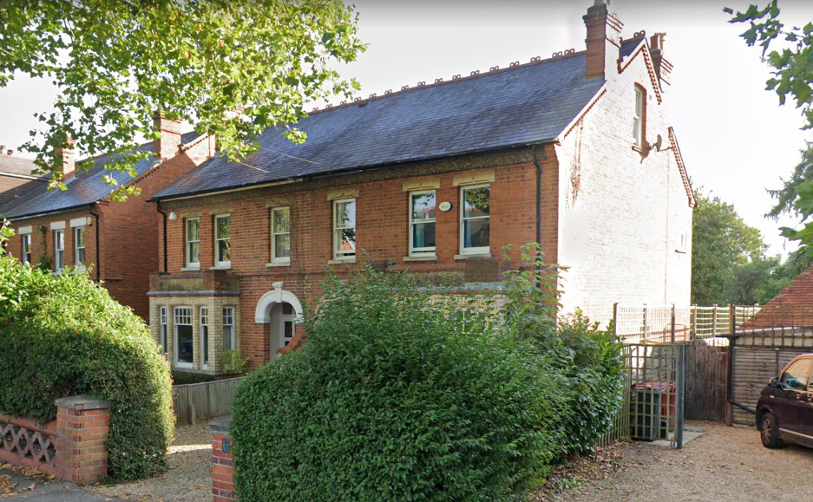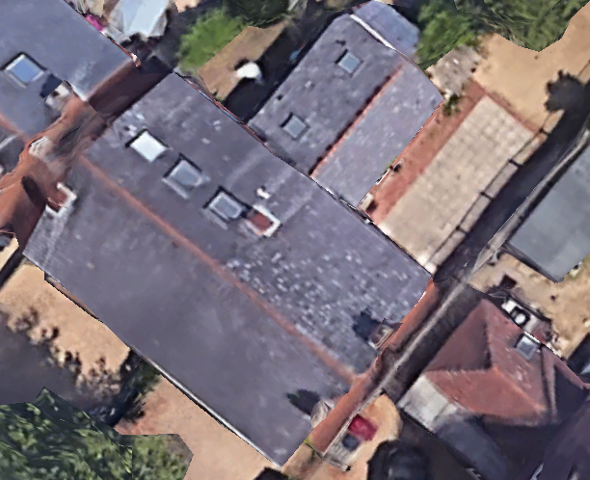

2. PROPOSAL AND SUPPORTING INFORMATION

Non material amendment to replace the pitched roof on the rear dormer with a flat roof to reduce its overall height and to remove the existing chimney on the rear elevation of the house roof - planning approval 220420

Originally Approved under 220420 Proposed under 221438
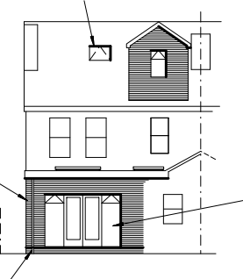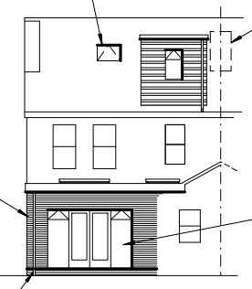

Original Elevation approved under 220420/HOU | Proposed Amended Elevation under 221438/NMA
Drawing no: Nicholls-1121-04: Proposed Elevations, received 23rd March 2022 | Drawing no: Nicholls-1121-04 Rev A: Proposed Elevations received 27th October 2022
Drawing No: NICHOLLS-1121-05: Section A-A, received 23rd March 2022 | Drawing no: Nicholls-1121-05 Rev A: Section AA, received 6th March 2023

Objections Received (Summary):
Applications under S96A are not applications for planning permission, so are not covered by the publicity requirements as set out in the DMPO.

- RELEVANT PLANNING HISTORY
App Ref: 220420/HOU
Proposals: Proposed single storey rear extension and proposed pitched roof dormer on the rear of the house roof
Outcome: Application Permitted
Date of Decision: 31st August 2022

4. Plans Considered:
Drawing no: Nicholls-1121-04 Rev A: Proposed Elevations, received 27th October 2022
Drawing no: Nicholls-1121-05 Rev B: Section AA, received 24th February 2023

5. Appraisal:
The proposed changes, changing the roof on the dormer from pitched to flat roof, and removal of the chimney to the rear would have a very limited effect on the overall appearance, but not one considered to be detrimental to the overall scheme and would have no detrimental effect on residential amenity. The change would in context remain a high-quality design scheme in accordance with Policy CC7.

Conclusion:
The changes as proposed are considered to be acceptable non-material alterations to the previously approved application 220420.

Recommendation:
Approve non-material amendment subject to conditions. Although Section 96(A) of the Act does not allow for the original decision to be re-issued, it does allow the modification of, or imposition of, conditions. In this respect it is considered appropriate to impose an additional condition:

Condition
The plans and statements put forward by the agent hereby approved by this Non-Material Amendment (under Section 96A of the Town and Country Planning Act 1990) are as follows:

Drawing no: Nicholls-1121-04 Rev A: Proposed Elevations, received 27th October 2022
Drawing no: Nicholls-1121-05 Rev B: Section AA, received 24th February 2023

