

DELEGATED APPLICATION REPORT

Ward: Battle
App Ref: 221527/FUL
Address: 381a Oxford Road, Reading, RG30 1HA
Proposals: Proposed single storey rear extension to existing shop to create kitchen and preparation area as part of change of use from Use Class E(a) to E(b)
Case Officer: Chukwudi Onwudinanti
Applicant: Flywingz Ltd
Date received (valid from): 12 October 2022
Target Decision date: 7 March 2023 (EXT)

1. SITE DESCRIPTION
The proposed site is a mid-terrace building on the Southern side of Oxford Road, close to the intersection with Albany Road, flanked on both sides on the terrace by typical commercial units on the ground floor and living quarters above. There are existing substantial extensions to the properties either side at ground and first floor levels. It is within the Oxford Road West District Centre, part of an identified Key Frontage (RL3) and within an Air Quality Management Area (Policy EN15).

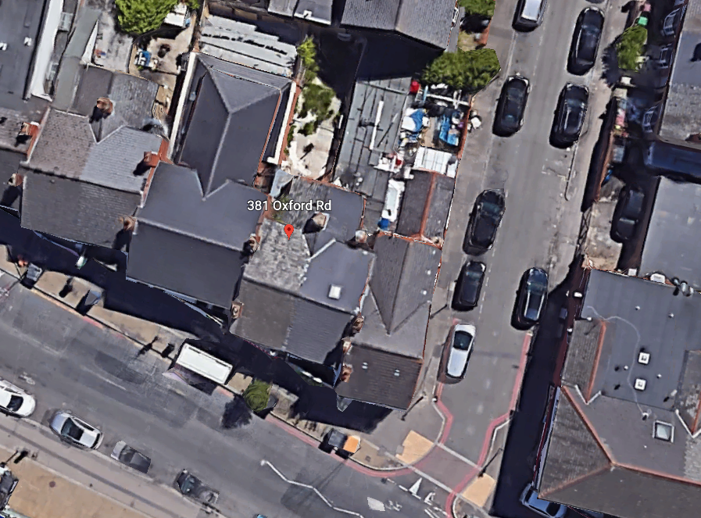
(red line = site boundary; blue line the area of the proposed extension)

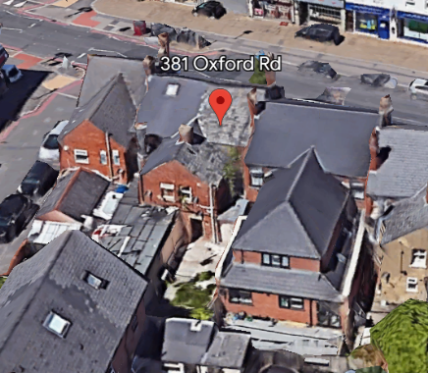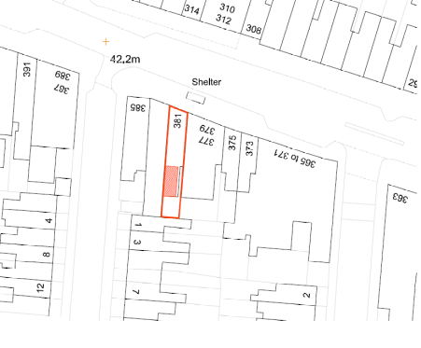

2. PROPOSAL AND SUPPORTING INFORMATION
Proposed flat roofed single storey rear extension to existing shop to create a kitchen within an existing part of the building and a preparation area within the proposed extension, which would measure approximately 6m deep by 3m wide, in association with a proposed ( permitted) change of use from Use Class E(a) - for the display or retail sale of goods, other than hot food, principally to visiting members of the public, to E(b) for the sale of food and drink principally to visiting members of the public where consumption of that food and drink is mostly undertaken on the premises. The proposal also includes introducing a toilet with some limited internal alteration.
Plans considered dated October 2022 received 13th October 2022
Drawing No: OR 381: 001 – Site Block and Location Plans
Drawing No: OR 381: 002 – Existing and Proposed Floor Plans
Drawing No: OR 381: 001 – Existing and Proposed Elevations

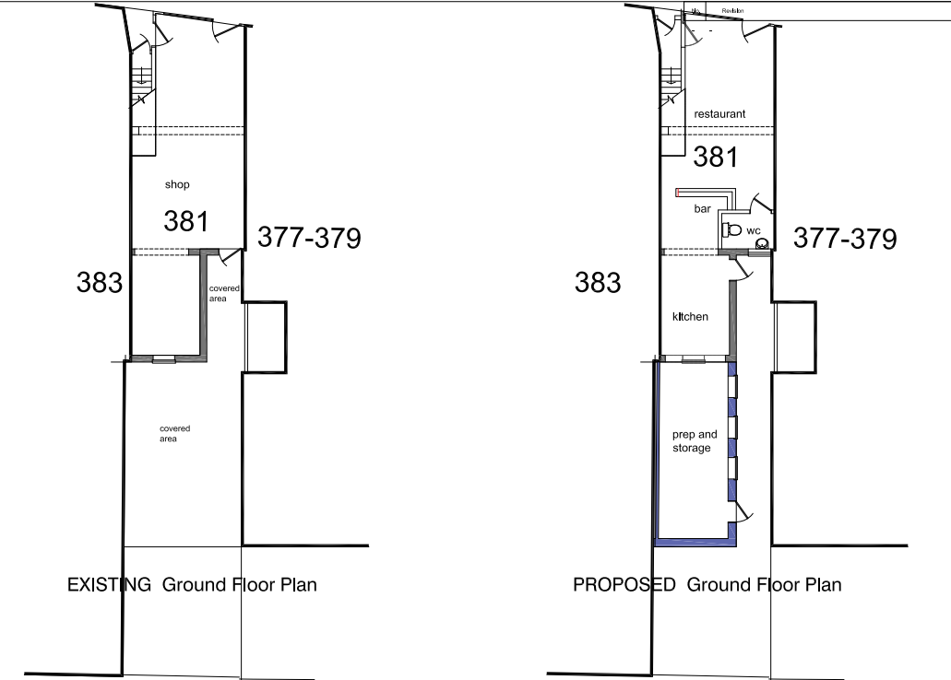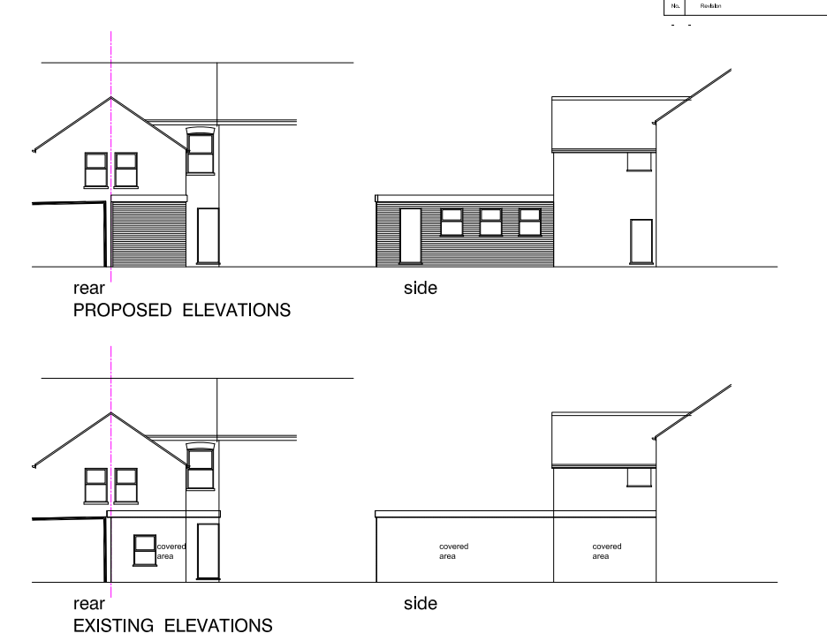
Existing and Proposed Floor Plans Existing and Proposed Elevations

- RELEVANT PLANNING HISTORY

220088/CLP - Certificate of Lawfulness for Proposed loft conversion with a rear dormer and no.2 (two) rooflights to front elevation. (amended) – Confirmed 25/2/2022
4. CONSULTATIONS

The following addresses were consulted by letter.

383 Oxford Road, Reading, RG30 1HA
385 Oxford Road, Reading, RG30 1HA
379 Oxford Road, Reading, RG30 1HA
Flat 2, 379 Oxford Road, Reading, RG30 1HA
Flat 3, 379 Oxford Road, Reading, RG30 1HA
Flat 1, 379 Oxford Road, Reading, RG30 1HA

No letters of representation have been received.

Equality Act 2010:
In determining this application the Council is required to have regard to its obligations under the Equality Act 2010. However, there is no indication or evidence (including from consultation on the application) that the protected groups identified by the Act have or will have different needs, experiences, issues and priorities in relation to this particular planning application. Therefore in terms of the key equalities protected characteristics it is considered there would be no significant adverse impacts as a result of the development.

- LEGAL AND PLANNING POLICY CONTEXT
Section 38(6) of the Planning and Compulsory Purchase Act 2004 requires that proposals be determined in accordance with the development plan unless material considerations indicate otherwise. Material considerations include relevant policies in the National Planning Policy framework (NPPF) - among them the 'presumption in favour of sustainable development'. The following local and national planning policy and guidance is relevant to this application:

National Policy
National Planning Policy Framework
National Planning Practice Guidance

Reading Borough Local Plan (2019)
CC7 (Design and the Public Realm)
CC8 (Safeguarding Amenity)
EN15: Air Quality
RL1: Scale and Location of Retail
RL2: Network and Hierarchy of Centres
RL3: Vitality and Viability of Smaller Centres

6. APPRAISAL

Principle
The proposed extension is in association with the change of use of the existing shop unit at ground floor to a restaurant. As both types of use are within the new E use class this would be a permitted change under The Town and Country Planning (Use Classes) (Amendment) (England) Regulations 2020 (SI 2020/757), which came into effect on 1 September 2020, and the application for consideration therefore relates to external changes only with respect to the single storey rear extension. The use in any case would be wholly acceptable within the Oxford Road West District Centre (Policies RL1, RL2) and within an area designated as a Primary Frontage (RL3). The proposed external works in association with a ‘centre’ use would be acceptable in principle subject to addressing other policy considerations as set out below.

The E use class covers a range of different development types and although it might be desirable to control future changes to this unit to ensure ongoing compliance with the requirements of Policy RL3, it is not considered that any restriction applied through condition would meet all the relevant tests. This is because, it would not be relevant to the development to be permitted, which relates to external changes only, not a change of use.

An informative is recommended to make it clear that a change to a hot food takeaway would require planning permission.

Design and Appearance
Policy CS7 is the overraching design policy, which requires all development “to be of a high design quality that maintains and enhances the character and appearance of the area.”.

The extension proposed in this application is to the rear of the property and limited to a single storey with a maximum height of 2.68m. The materials to be used are to match existing. The combination of the materials to be used, the height of the proposed development and the location, is considered to be respectful of the site and will not adversely impact on the character of the building or the area.

The scheme would therefore comply with Policy CS7.

As stated above, the height of this proposed extension is limited to approximately 2.7m and limited to the rear of the property. There are existing boundary fences to both sides of the property and existing large scale single storey and first floor rear extensions to the adjacent properties. Internal alterations are only limited to installation of a WC. It is therefore considered that there would not be any privacy and overlooking issues, nor any overbearing effects or loss of outlook from neighbouring properties. As a result of the limited height, there also would not be any impact on the sunlight and daylight accessible to the neighbouring properties.

7. CONCLUSION
The proposed development has been assessed as set out above and is considered to be acceptable on that basis, subject to the following conditions.

8. RECOMMENDATION
Recommended Conditions:
AP1: Approved Plans
M1: Materials to Match Existing
TL1: Time Limit Standards

