

DELEGATED HOUSEHOLDER APPLICATION REPORT

Ward: Caversham Heights
App Ref: 230919/HOU
Address: 31 Kidmore Road, Caversham, Reading, RG4 7LR
Proposals: Part two storey, part single storey rear extension with associated internal and fenestration alterations.
Case Officer: Chukwudi Onwudinanti
Applicant: Mr & Mrs Scicluna
Date received (valid from): 3 July 2023
Target Decision date: 2 October 2023

1. SITE DESCRIPTION
The proposal site is a semi-detached two storey dwelling on the western side of Kidmore Road. It is one of residential dwellings in a predominantly residential area characterised by buildings of various styles and sizes
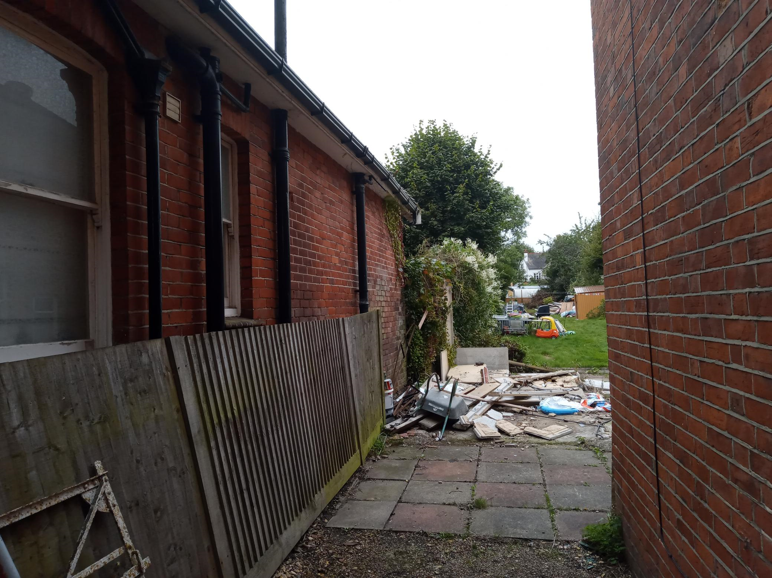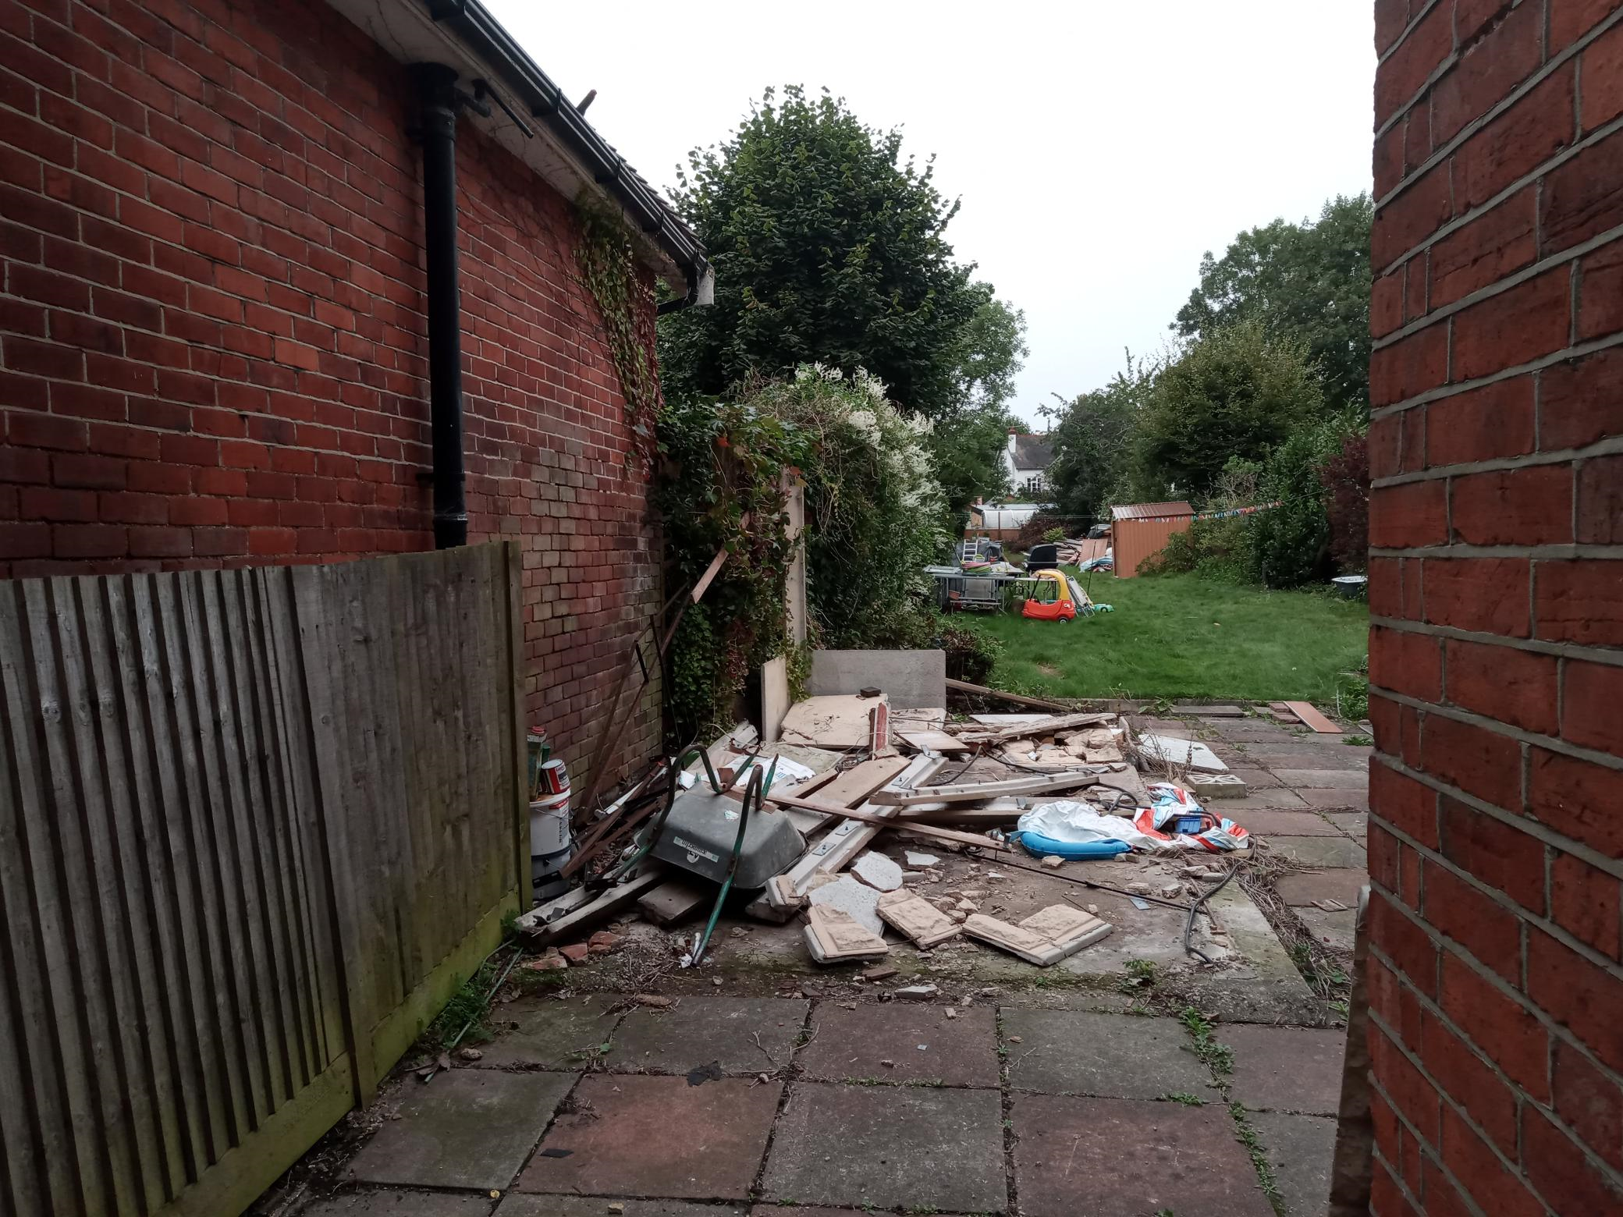

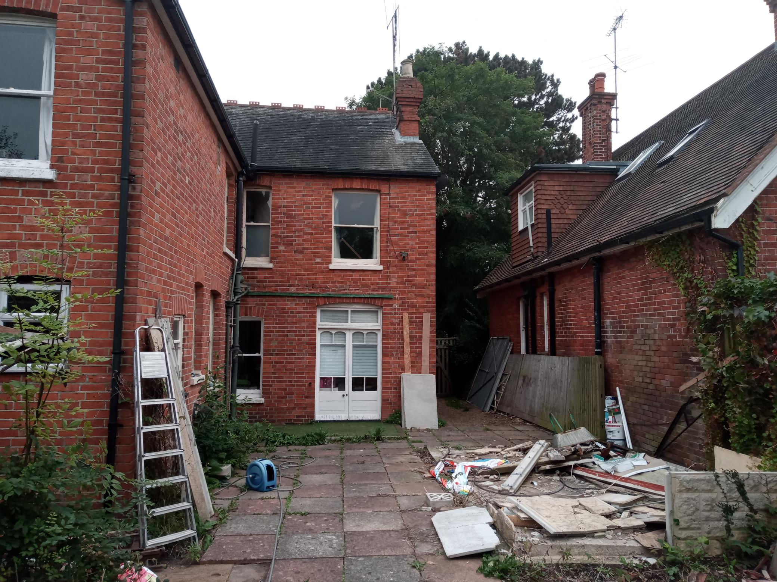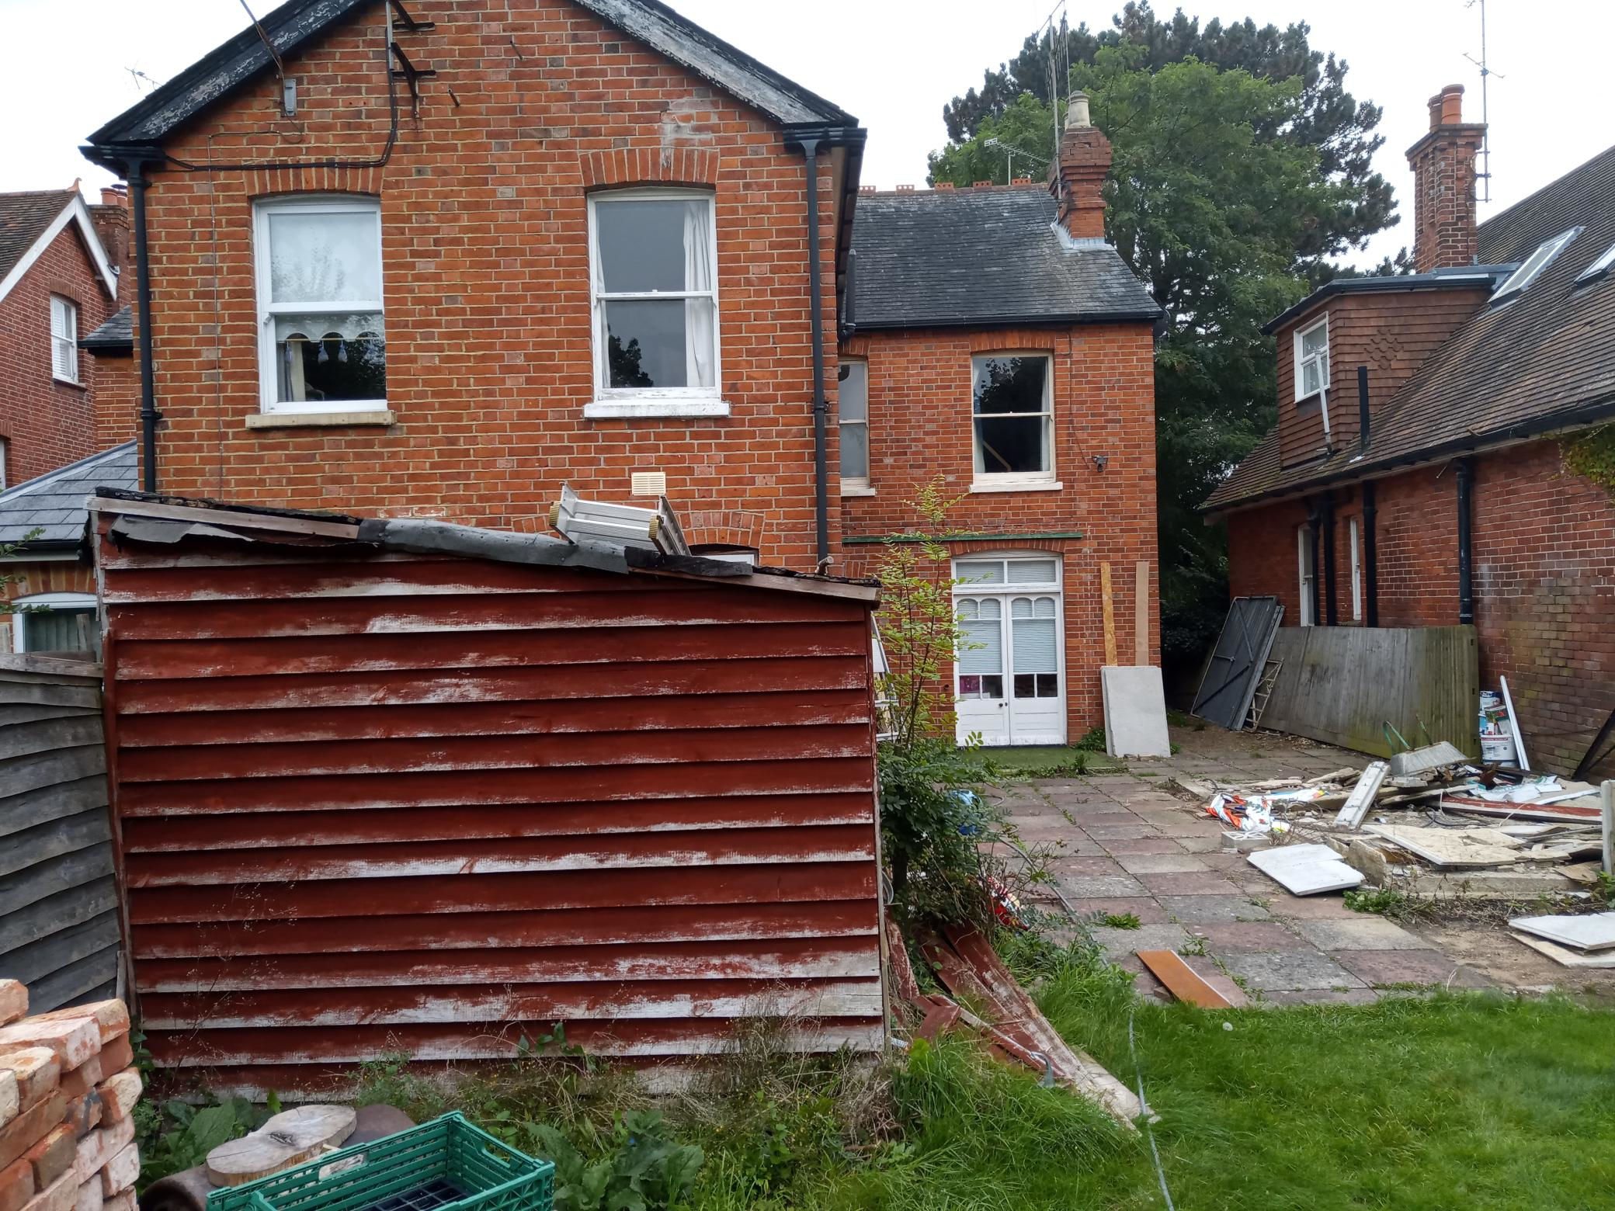

2. PROPOSAL AND SUPPORTING INFORMATION
Part two storey extension measuring approximately 6.7m deep and 4.7m wide, a part single storey rear extension approximately 5m deeper than the first floor aspect and 6.7m wide, with associated internal and fenestration alterations.

Plans considered dated August 2022 received 03/07/2023
Drawing No 24322-06: Proposed Elevations
Drawing No 24322-05: Proposed First & Roof Plan
Drawing No 24322-04: Proposed Ground Floor Plan
Drawing No 24322-03: Existing Elevations
Drawing No 24322-02: Existing First & Roof Plan
Drawing No 24322-01: Existing Ground Floor Plan
Drawing No 24322-07: Block And Location Plans
Nocturnal bat survey report (Indigo Surveys Ltd, Ref: 231089/E1 issued 1 June 2023

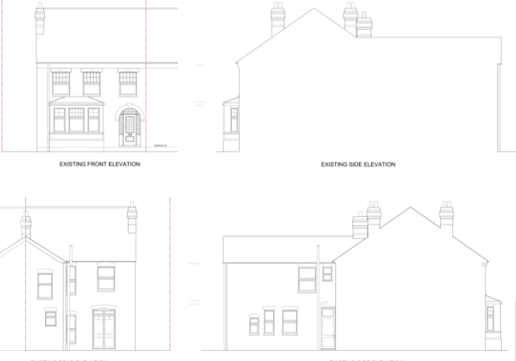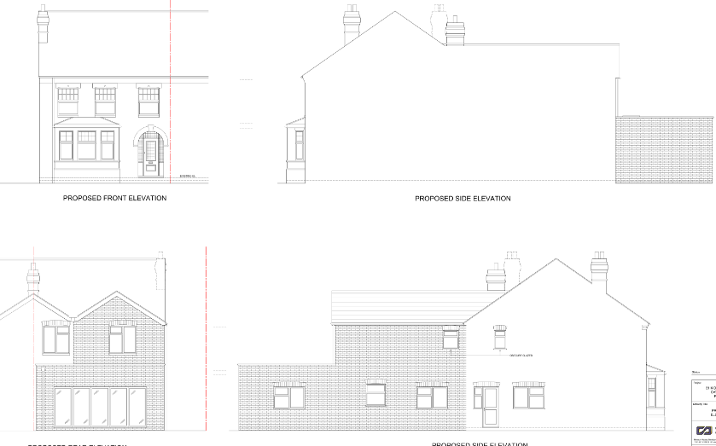
Existing Elevations Proposed Elevations

- RELEVANT PLANNING HISTORY

Application Ref: 231362
Description: Part two storey, part single storey rear extension with associated internal and fenestration alterations.
Outcome: Withdrawn

Application Ref: 230566
Description: Proposed loft conversion and the addition of roof lights.
Outcome: Application Permitted
Decision Date: 10/7/2023

4. CONSULTATIONS

The following addresses were consulted by letter.

36 Albert Road, Caversham Reading
29 Kidmore Road, Caversham, Reading, RG4 7LR
38 Albert Road, Caversham, RG4 7PE
31 Kidmore Road, Caversham, Reading, RG4 7LR

Following letters of representation have been received.

Ecology
Ecology advised that the application be allowed, subject to the following conditions:
Works are to be carried out in full accordance with the bat mitigation measures given in section 4 of the submitted bat survey report [Indigo Surveys Ltd, Ref: 231089/E1 Date of Issue I June 2023] unless otherwise approved in writing by the Council.

Natural Environment – Trees – comments on previous (221362)
No development shall commence on site (including demolition or preparatory works) until an Arboricultural Method Statement and Tree Protection Plan in accordance with the relevant recommendations of appropriate British Standards or other recognised Codes of Good Practice for all existing trees that are not shown as being removed on the approved drawings, both within and adjacent to the site, has been submitted to and been approved in writing by the Local Planning Authority. The development shall not be carried out other than in accordance with the approved Arboricultural Method Statement and Tree Protection Plan.

Equality Act 2010:
In determining this application the Council is required to have regard to its obligations under the Equality Act 2010. However, there is no indication or evidence (including from consultation on the application) that the protected groups identified by the Act have or will have different needs, experiences, issues and priorities in relation to this particular planning application. Therefore in terms of the key equalities protected characteristics it is considered there would be no significant adverse impacts as a result of the development.

- LEGAL AND PLANNING POLICY CONTEXT

Section 38(6) of the Planning and Compulsory Purchase Act 2004 requires that proposals be determined in accordance with the development plan unless material considerations indicate otherwise. Material considerations include relevant policies in the National Planning Policy framework (NPPF) - among them the 'presumption in favour of sustainable development'. The following local and national planning policy and guidance is relevant to this application:

National Policy
National Planning Policy Framework
National Planning Practice Guidance

Reading Borough Local Plan (2019)
CC7 (Design and the Public Realm)
CC8 (Safeguarding Amenity)
H9 (House Extensions and Ancillary Accommodation)

SPD
Design Guide to House Extensions 2021

6. APPRAISAL
Character and Appearance

Policy H9 states that an extension to a house will be acceptable where it respects the character of the house in terms of scale, location, materials and design and respects the character and pattern of neighbouring properties and the street as a whole in terms of scale, location, materials and design, and any important existing building line. Policy CC7 also sets out relevant considerations for design.

The scale of the extensions proposed in this application is relatively large, . However, it is considered the scale of the extensions would be acceptable in the context of the existing scale of the property and other properties on the road..

The two storey rear extension would have a pitched roof and gable ended feature to accord with the existing design and the proposed materials would be to match existing.

There would be no adverse effect on the building line as the proposal is confined to the rear.

It is therefore considered that as large as the extension is, it will be in proportion with the existing dwelling and respect the scale, design and the location of the property.

Residential Amenity

Policy H9 states that an extension will be acceptable where it does not result in an overbearing impact on neighbours. Policy H10 seeks to ensure that the amenity of gardens and other outdoor areas are not compromised. Policy CC8 states an extension to a house will be acceptable where it will not cause a significant detrimental impact to the living environment of existing or new residential properties.

The two storey aspect of the extension would be on the side of the boundary with No 29 Kidmore Road. As demonstrated in the photos above taken on a site visit, there is already an existing impact on the existing windows on No 29 Kidmore Road. The windows on the dormer on No 29 are to a stairway and the windows on the ground floor are obscured and as stated, are already impacted by the two storey wall on No 31. The two storey extension does not exceed the rear line of the existing footprint, but would bring the 2 storey element closer to number 29, but would not impact on the 45% degree line from the nearest habitable window of no. 29.

The ground floor aspect does not impact on the daylight and sunlight access to No 33 as the window on the direct line of the 60 degree assessment is to a utility room. There are no windows on the ground floor of No 29 that could be impacted by this ground floor aspect as there is only a minimal projection of the footprint beyond the rear line of No 29. Side windows proposed are to be obscure glazed, mitigating any privacy and overlooking impacts on No 29.

Natural Environment and Ecology have advised that conditions be attached to ensure that the proposal would have no adverse effects on vegetation or any bats. These conditions are attached in the Decision Notice.

- CONCLUSION
The proposed development has been assessed as set out above and is considered to be acceptable on that basis, subject to the following conditions.

8. RECOMMENDATION: Grant

Recommended Conditions:
Ap1: Approved Plans
TL1: Time Limit Standards
M1: Materials to Match Existing
L7: Aboricultural Method Statement
Bat mitigation measures

