

DELEGATED HOUSEHOLDER APPLICATION REPORT

Ward: Emmer Green
App Ref: 221829/HOU
Address: 75 Kiln Road, Emmer Green, Reading, RG4 8UF
Proposals: Proposed Single Storey Rear Extension and Internal Alterations (As Amended)
Case Officer: Chukwudi Onwudinanti
Applicant: Mrs White
Date received (valid from): 6 December 2022
Target Decision date: 21 April 2023 (EXT)

1. SITE DESCRIPTION
The proposal site is a detached two storey dwelling on the western side of Kiln Road, close to the intersection with Marchwood Avenue. It is one of three buildings of similar style and size, with the other two having had different levels of previous extensions. All buildings on the street are lined up on the one side of the street. The opposite side is not built up.

2. PROPOSAL AND SUPPORTING INFORMATION
The proposal presents a single storey rear extension measuring approximately 5.07m into the rear garden and 3.6m wide, to create an office linked to the existing dwelling and Internal Alterations.

Plans considered dated July 2022
22060.SPP-01: Existing Ground Floor Plan received 7/11/2022
22060.SPP-02: Existing First Floor Plan received 7/11/2022
22060.SPP-03: Existing Elevations received 7/11/2022
22060.SPP-04 Rev A: Proposed Ground Floor Plan received 20/03/2023
22060.SPP-05 Rev A: Proposed First Floor Plan received 20/03/2023
22060.SPP-06 Rev A: Proposed Elevations received 20/03/2023
22060.SPP-07: Location Plan received 7/11/2022
22060.SPP-08 Rev A: Block Plan received 20/03/2023

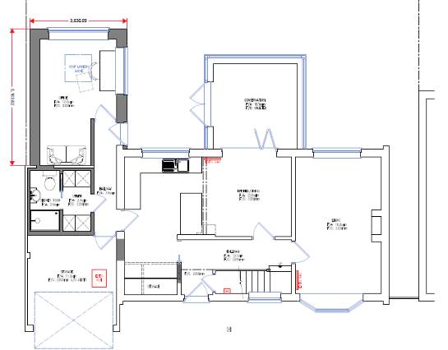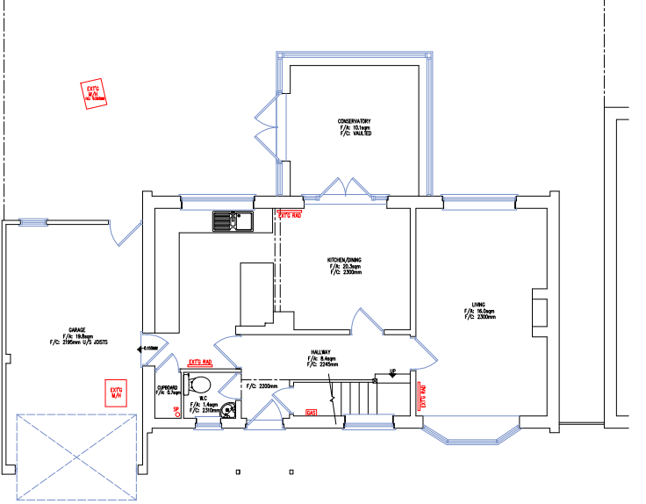
Proposed Ground Floor Plan Existing Ground Floor Plan

- RELEVANT PLANNING HISTORY
None

4. CONSULTATIONS

The following addresses were consulted by letter.

73 Kiln Road, Emmer Green
77 Kiln Road, Emmer Green
4 Marchwood Avenue, Emmer Green

No letters of representation have been received.

Transport Comments.
There are no Transport objections to this application as the proposed works do not change the existing parking arrangements, the single garage is to remain served by the existing dropped cross over. In addition to the garage there is additional parking available on the front drive.

Natural Environment Comments.
The primary concerns are the proposed extensions on the frontage which will inevitably be in the RPA of one, if not both, trees. Given the age of the tree(s), it is more important to avoid impingements into RPAs. No Arboricultural Report (tree survey and AIA) has been provided (as the agent hasn’t acknowledged the tree) as is required, hence the development fails to demonstrate lack of harm to a protected tree of high amenity and historical value. It is therefore not acceptable in this respect.

Equality Act 2010:
In determining this application the Council is required to have regard to its obligations under the Equality Act 2010. However, there is no indication or evidence (including from consultation on the application) that the protected groups identified by the Act have or will have different needs, experiences, issues and priorities in relation to this particular planning application. Therefore in terms of the key equalities protected characteristics it is considered there would be no significant adverse impacts as a result of the development.

- LEGAL AND PLANNING POLICY CONTEXT

Section 38(6) of the Planning and Compulsory Purchase Act 2004 requires that proposals be determined in accordance with the development plan unless material considerations indicate otherwise. Material considerations include relevant policies in the National Planning Policy framework (NPPF) - among them the 'presumption in favour of sustainable development'. The following local and national planning policy and guidance is relevant to this application:

National Policy
National Planning Policy Framework
National Planning Practice Guidance

Reading Borough Local Plan (2019)
CC7 (Design and the Public Realm)
CC8 (Safeguarding Amenity)
H9 (House Extensions and Ancillary Accommodation)
TR5 (Car and Cycle Parking)
EN14 (Trees, Hedges and Woodlands)

SPD
Design Guide to House Extensions 2021
Revised Parking Standards and Design SPD 2011

6. APPRAISAL
Character and Appearance

Policy H9 states that an extension to a house will be acceptable where it respects the character of the house in terms of scale, location, materials and design and respects the character and pattern of neighbouring properties and the street as a whole in terms of scale, location, materials and design, and any important existing building line. Policy CC7 also sets out relevant considerations for design.

The proposal seeks to convert the existing garage into a habitable room while extending approximately 5m to the rear to create an office. This extension is 2.75m high, with a flat roof over. All aspects of the amended application are to the rear and internal, and the materials to be used for all external finishes are to match existing materials. As a result of the amendment, the front building line is maintained.

It is considered that while the extension to the rear is 5.07m, the overall impact to the adjoining property at No73 is limited as a result of the flat roof over the extension and the limited height. Also, as no aspect of the proposed extension is visible from the street, there is no resultant detrimental impact on the character and appearance of the dwelling as well as the street scene.

Residential Amenity

Policy H9 states that an extension will be acceptable where it does not result in an overbearing impact on neighbours. Policy H10 seeks to ensure that the amenity of gardens and other outdoor areas are not compromised. Policy CC8 states an extension to a house will be acceptable where it will not cause a significant detrimental impact to the living environment of existing or new residential properties.

As stated above in this report, the height of the rear extension is limited to 2.75m. There are no side windows proposed and the roof over the extension would be a flat one. There are therefore no significant overbearing effects considered to occur as a result of this proposal and no privacy/overlooking issues.

The extension does not cast any shadows or undermine sunlight and daylight access to any identified habitable room. As the proposal presents an external door, a condition will be attached to the decision for this proposal, to ensure that the newly created space cannot be used independently.

Trees

Policies CC7 and EN14 of the Reading Borough Local Plan 2019

As is reported above, Natural Environment requested extra information regarding a TPO in front of the property. However, this advice has become redundant as the front extension aspect was subsequently removed by the agent/applicant.

- CONCLUSION
The proposed development has been assessed as set out above and is considered to be acceptable on that basis, subject to the following conditions.

8. RECOMMENDATION
Recommended Conditions:
AP1: Approved Plans
PD2: No New Openings
PD6: Ancillary Domestic Use

