

DELEGATED HOUSEHOLDER APPLICATION REPORT

Ward: Caversham Heights
App Ref: 230879/HOU
Address: 50 Shepherds Lane, Caversham, Reading, RG4 7JL
Proposals: Rear and side single storey extensions.
Case Officer: Chukwudi Onwudinanti
Applicant: Mr & Mrs L Ring
Date received (valid from): 27 July 2023
Target Decision date: 6 October 2023

1. SITE DESCRIPTION
The site is a two-storey Tudor style dwellinghouse on the West side of Shepherds Lane, facing the intersection with Woodcote Way. The surrounding area is predominantly residential, comprising dwellings of a similar style and design as well as other residential dwellings of varying styles and design.

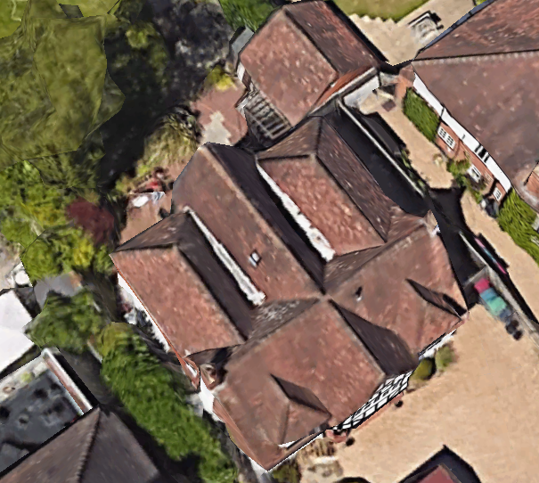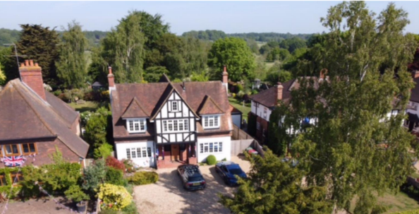

2. PROPOSAL AND SUPPORTING INFORMATION

The proposal presents a ground floor rear extension measuring approximately 2.5m deep and 3.5m wide, to create a “Seating Area” and a side single storey extensions, stepped back from the Principal Elevation front line and measuring 2.5m wide and approximately 8.5m deep, terminating at the existing line of the rear elevation.

Plans considered received 22/06/2023
P-P101_Existing Layout Plans dated Mar 2023
P-P102_ Rev A Proposed Layout Plans dated Mar 2023
P-E201_Existing Elevations dated Mar 2023
P-E202_Rev A Proposed Elevations dated Mar 2023
P-S001_Location Plan dated Mar 2023
P-S002_Existing Site Plan dated Mar 2023
P-S003_Proposed Site Plan dated Jun 2023
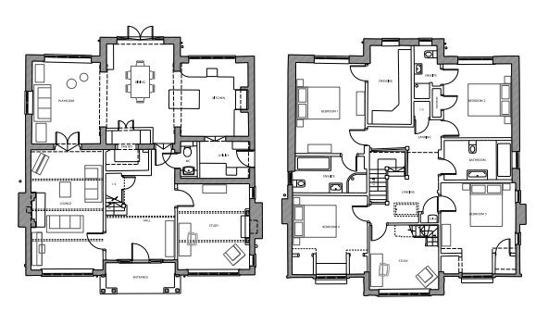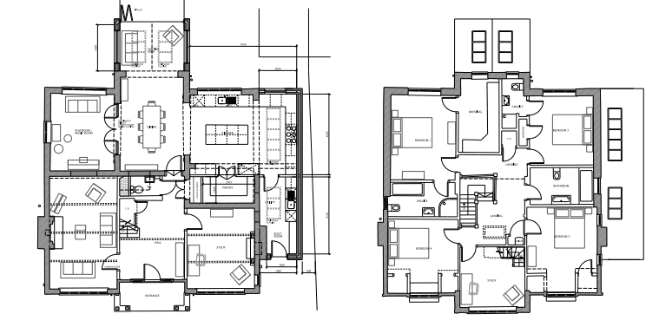
Existing Floor Plans Proposed Floor Plans

- RELEVANT PLANNING HISTORY

Application Ref: 211556
Description: Certificate of Lawfulness for Proposed single storey side extension.
Decision: Application Permitted
Decision Date: 22/10/2021

4. CONSULTATIONS

The following addresses were consulted by letter.

48 Shepherds Lane, Caversham, Reading, RG4 7JL
52 Shepherds Lane, Caversham, Reading, RG4 7JL

No letters of representation have been received.

Equality Act 2010:
In determining this application the Council is required to have regard to its obligations under the Equality Act 2010. However, there is no indication or evidence (including from consultation on the application) that the protected groups identified by the Act have or will have different needs, experiences, issues and priorities in relation to this particular planning application. Therefore in terms of the key equalities protected characteristics it is considered there would be no significant adverse impacts as a result of the development.

- LEGAL AND PLANNING POLICY CONTEXT

Section 38(6) of the Planning and Compulsory Purchase Act 2004 requires that proposals be determined in accordance with the development plan unless material considerations indicate otherwise. Material considerations include relevant policies in the National Planning Policy framework (NPPF) - among them the 'presumption in favour of sustainable development'. The following local and national planning policy and guidance is relevant to this application:

National Policy
National Planning Policy Framework
National Planning Practice Guidance

Reading Borough Local Plan (2019)
CC7 (Design and the Public Realm)
CC8 (Safeguarding Amenity)
H9 (House Extensions and Ancillary Accommodation)

SPD
Design Guide to House Extensions 2021

6. APPRAISAL
Character and Appearance
Policy H9 states that an extension to a house will be acceptable where it respects the character of the house in terms of scale, location, materials and design and respects the character and pattern of neighbouring properties and the street as a whole in terms of scale, location, materials and design, and any important existing building line. Policy CC7 also sets out relevant considerations for design.

The proposal presents extensions to the side and the rear, both on the ground floor level. The rear aspect of the extension is less than 3m deep and extends only 3.5m wide. The side aspect increases the width of the dwelling by approximately 2.5m and extends as deep as the existing footprint while stepped back from the frontline. All materials to be used externally are to match existing materials.

The changes presented in this proposal are considered to be respectful of the character of the existing dwelling in terms of scale, location, materials and design. Also, as the side extension is stepped back from the frontline and has a maximum height of approximately 2.3m, ground to eaves, the extension is considered sufficiently subservient to the existing dwelling.

Residential Amenity
Policy H9 states that an extension will be acceptable where it does not result in an overbearing impact on neighbours. Policy H10 seeks to ensure that the amenity of gardens and other outdoor areas are not compromised. Policy CC8 states an extension to a house will be acceptable where it will not cause a significant detrimental impact to the living environment of existing or new residential properties.

As stated above, the height of the extensions proposed is limited to below 2.5m and there are no side windows proposed. The rear elevation is sufficiently constrained within the width of the existing dwelling, so would have no effect on the neighbouring properties.

The proposal is not deemed to have any overbearing effects and would not present any privacy and overlooking issues.

- CONCLUSION
The proposed development has been assessed as set out above and is considered to be acceptable on that basis, subject to the following conditions

8. RECOMMENDATION: Grant
Recommended Conditions:
AP1: Approved Plans
M1: Materials to Match Existing
TL1: Time Limit Standards

