DELEGATED APPLICATION REPORT

Ward: Whitley
App Ref: 221026/FUL
Address: Wm Morrison Plc, Basingstoke Road, Reading, RG2 0HB
Proposals: Planning application for the erection of a barbers pod within the car park (retrospective)
Case Officer: Chukwudi Onwudinanti
Applicant: .Wm Morrison Supermarkets Ltd
Date received (valid from): 2 August 2022
Target Decision date: 12 October 2022 (EXT)

- SITE DESCRIPTION
The site is bounded by Rose Kiln Lane to the north; the B3031 Basingstoke Road to the east; automotive, foodstore and leisure units to the south; and Gillette Way and Brunel Retail Park to the west. The Morrisons car park is accessed via Rose Kiln Lane and Basingstoke Road with pedestrian links provided via Rose Kiln Lane, Basingstoke Road and Gillette Way. There are bus stops located on Gillette Way and Basingstoke Road further providing accessibility to the site.

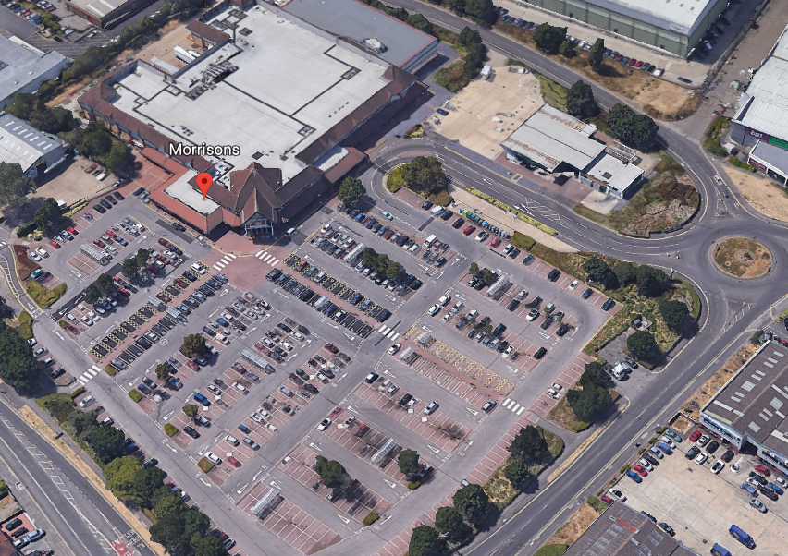



2. PROPOSAL AND SUPPORTING INFORMATION
The planning application is for the erection of a barbers pod within the car park, taking up spaces for three cars (retrospective).

Plans considered received 14th July 2022
Drawing No.359_PL_01Rev A: Location Plan
Drawing No.359_PL_02 Rev A: Proposed Site Plan
Drawing No.100 Rev P01: General Arrangement
Drawing No.140 Rev C02: General Arrangement

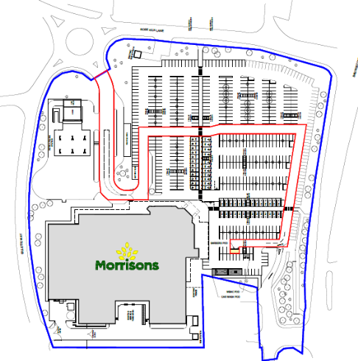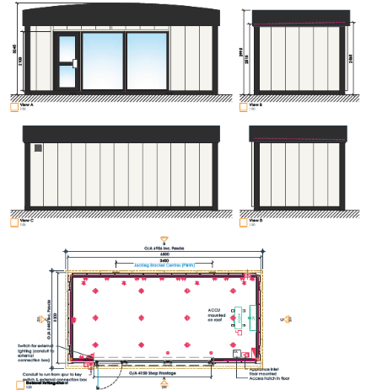
Site Layout Plans and Elevations

- RELEVANT PLANNING HISTORY
None

4. CONSULTATIONS

No letters of representation have been received.

Equality Act 2010:
In determining this application the Council is required to have regard to its obligations under the Equality Act 2010. However, there is no indication or evidence (including from consultation on the application) that the protected groups identified by the Act have or will have different needs, experiences, issues and priorities in relation to this particular planning application. Therefore in terms of the key equalities protected characteristics it is considered there would be no significant adverse impacts as a result of the development.

- LEGAL AND PLANNING POLICY CONTEXT

Section 38(6) of the Planning and Compulsory Purchase Act 2004 requires that proposals be determined in accordance with the development plan unless material considerations indicate otherwise. Material considerations include relevant policies in the National Planning Policy framework (NPPF) - among them the 'presumption in favour of sustainable development'. The following local and national planning policy and guidance is relevant to this application:

Section 16(2) of the Planning (Listed Buildings and Conservation Areas) Act 1990 requires the local planning authority to have special regard to the desirability of preserving a listed building or its setting or any features of special interest which it possesses.

Section 72 (1) of the Planning (Listed Buildings and Conservation Areas) Act 1990 requires the local planning authority in the exercise of its functions to pay special attention to the desirability of preserving or enhancing the character or appearance of a conservation area.

National Policy
National Planning Policy Framework
National Planning Practice Guidance

Reading Borough Local Plan (2019)
CC7 (Design and the Public Realm)
CC8 (Safeguarding Amenity)
TR3 (Access Traffic and Highway-related Matters)
TR5 (Car and Cycle Parking)

6. APPRAISAL
Environmental Protection were consulted on this application and they had no comments.

Transport response:
There are no Transport objections this application as the reduction of car parking spaces will not have a detrimental impact on the existing provision.

The barbers pod is not considered to be out of character with the activities and infrastructure around the immediate environment where it is to be developed. The proposal is for the development to be within a single storey height, so the development does not tower over the rest of the developments around it.

Therefore, taking together the considerations of the PLA and supported by the advice from transport, it is considered that the development of the pod will not impact negatively on the host site.

- CONCLUSION
The proposed development has been assessed as set out above and is considered to be acceptable on that basis, subject to the following conditions.

8. RECOMMENDATION: Grant

