

DELEGATED HOUSEHOLDER APPLICATION REPORT

Ward: Norcot
App Ref: 221596/HOU
Address: 4 Tofrek Terrace, Reading, RG30 2JS
Proposals: Revised proposals for part single and part double storey front and rear extensions to existing dwelling
Case Officer: Chukwudi Onwudinanti
Applicant: Mr S Cani
Date received (valid from): 25 October 2022
Target Decision date: 21 April 2023 (EXT)

1. SITE DESCRIPTION
The application site comprises a two storey mid-terraced dwelling. A short gable projects to the rear. The surrounding area is predominantly residential. The neighbouring properties have been variously extended to the rear. The site topography slopes down gently in a northerly direction.

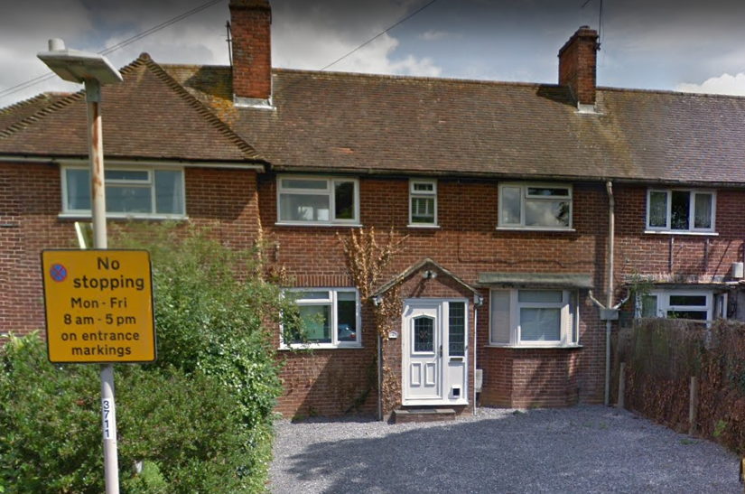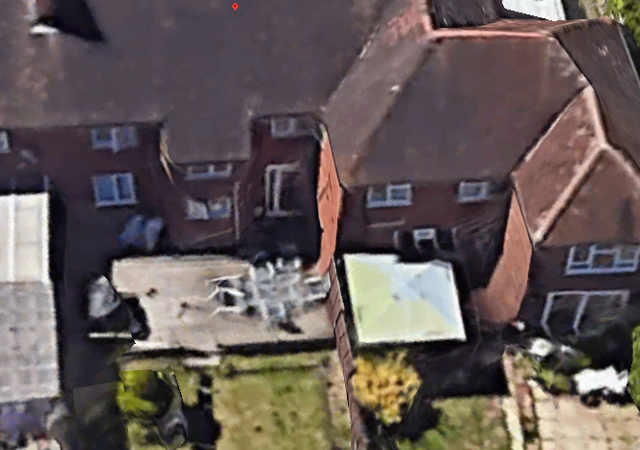

2. PROPOSAL AND SUPPORTING INFORMATION
The proposal is for part single storey extension to the front, increasing the depth of the kitchen by approximately 0.5m to the front. It also includes a rear extension to a depth of 4.3m and width of 7.1m on the ground floor but set back from the boundaries on the first floor level with the depth limited to approximately 2.6m.

Plans considered dated October 2022
TTR04:001 Rev P2: Site & Block Plans received 7 March 2023
TTR04:002 Site Location Plan received 20 March 2023
TTR04:003 Rev P1: Existing and Proposed Ground Floor received 20 March 2023Plans
TTR04:004 Rev P1: Existing and Proposed Elevations received 20 March 2023
TTR04:005: Existing and Proposed First Floor Plans received 20 March 2023

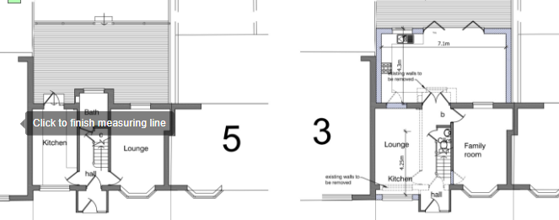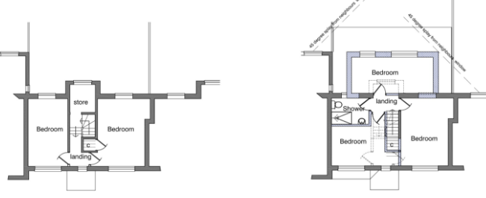
Existing and Proposed Ground Floor Plans Existing and Proposed First Floor Plans

- RELEVANT PLANNING HISTORY
192034
Part one, part two storey rear extension
Application Refused
20/3/2020

200982
Part one, part two storey rear extension
Application Permitted
21/10/2020

201720
Variation of condition 3 (approved plans) of planning permission
200982/HOU, dated 21/10/20 (for a part one, part two storey rear extension), namely to allow an increased depth of 0.5m at the ground floor and 1.5m at the first floor
Application Refused
26/1/2021

4. CONSULTATIONS

The following addresses were consulted by letter.

3 Tofrek Terrace, Reading, Berks
5 Tofrek Terrace, Reading, RG30 2JS
Wilson Primary School, Wilson Road, Reading, RG30 2RW

Letters of representation have been received as follows:
The new front kitchen extension which has been connected to the front porch although the porch was done a few years ago, does this mean that the building line has now moved?

The gap between the properties at the rear does not now show a dimension from the bathroom window.

Depth of the new lounge the original approved drawing showed a depth of 3-5 mtrs the new drawing shows an increase to 4-3 mtrs.

If plans go ahead as is, the view from both my back and front windows will be obscured by a wall.

On the original planning approval conditions and the reason were put in place can these be put in place again

Natural Environment Comments.
The proposals are acceptable in tree terms, however it is appropriate for plans to 1) acknowledge the replacement TPO trees by plotting it and any surrounding soft landscape bed and to 2) show this as physically protected during construction to avoid accidental damage, particularly as it won’t be very big. This can easily be done by adding the tree to the block plan and annotating a ‘construction exclusion zone’ around it with some type of fencing (to be specified on the plan) with a label stating that the protection will be erected prior to commencement and retained until completion. Otherwise, a pre-commencement condition (L7) will be required – given the scale of development and the minimal measures required, it would be best dealt with prior to a decision. Please forward any such plan to me to check.

These comments have been appropriately responded to by the agent/applicant with the submission of the appropriate drawings which are cited in the Decision Notice, in agreement with the Natural Environment Consultees.

Equality Act 2010:
In determining this application the Council is required to have regard to its obligations under the Equality Act 2010. However, there is no indication or evidence (including from consultation on the application) that the protected groups identified by the Act have or will have different needs, experiences, issues and priorities in relation to this particular planning application. Therefore in terms of the key equalities protected characteristics it is considered there would be no significant adverse impacts as a result of the development.

- LEGAL AND PLANNING POLICY CONTEXT

Section 38(6) of the Planning and Compulsory Purchase Act 2004 requires that proposals be determined in accordance with the development plan unless material considerations indicate otherwise. Material considerations include relevant policies in the National Planning Policy framework (NPPF) - among them the 'presumption in favour of sustainable development'. The following local and national planning policy and guidance is relevant to this application:

National Policy
National Planning Policy Framework
National Planning Practice Guidance

Reading Borough Local Plan (2019)
CC7 (Design and the Public Realm)
CC8 (Safeguarding Amenity)
H9 (House Extensions and Ancillary Accommodation)

SPD
Design Guide to House Extensions 2021

6. APPRAISAL
Character and Appearance

Policy H9 states that an extension to a house will be acceptable where it respects the character of the house in terms of scale, location, materials and design and respects the character and pattern of neighbouring properties and the street as a whole in terms of scale, location, materials and design, and any important existing building line. Policy CC7 also sets out relevant considerations for design.

The ground floor extension is an increase of 0.8m on the depth at ground floor of the scheme proposed and approved in a previous application (200982) projecting approximately 1.5m beyond the back line of the adjoining property on No.3. The front extension has been amended on the advice of the LPA to limit it to the existing frontline of both properties on Nos 3 and 4.

The first floor aspect has been amended considerably from the original design, stepping the sides away from the adjoining properties (approximately 1m from No 3) and limited to a depth of 2.6m, so the building line as proposed would not go beyond the existing line of the site and adjoining properties.

The front porch aspect of this extension has been amended to keep the extension limited to the front line of the existing property and the adjoining property in No3.

All Materials are to match existing materials.

Therefore, it is considered that the proposal as amended, respects the character and pattern of neighbouring properties and the street as a whole in terms of scale, location, materials and design.

Residential Amenity

Policy H9 states that an extension will be acceptable where it does not result in an overbearing impact on neighbours. Policy H10 seeks to ensure that the amenity of gardens and other outdoor areas are not compromised. Policy CC8 states an extension to a house will be acceptable where it will not cause a significant detrimental impact to the living environment of existing or new residential properties.

In the previous application (201720: Variation of Condition), permission was sought to increase the depth of the ground floor by 4m and the first floor by approximately 4m, while stepping back the first floor back from the boundaries on both sides with the adjoining properties. This application was refused by the LPA and the subsequent Appeal was dismissed. In the decision to dismiss the appeal, the Inspector stated:

6. In my view, the marginal increase in depth at ground floor level alone would not be such so as to result in an addition which would appear overly large or dominant. The additional depth, however, at first floor level would create a first-floor which would not step-in from the ground floor rear elevation in terms of its depth. The proposed extension would, therefore, appear excessively large and bulky and would not be subservient to the original dwelling.

8. Though I accept that the impact of the first-floor element would be somewhat mitigated by the diminished width this would not be sufficient to ensure that the proposal would be acceptable in design terms.

11. The proposed first-floor element would be set further in from the neighbouring property at No 5 than would be the case under the permitted development. For this reason, though the first-floor, as amended, would have a greater depth I do not consider that this would be such so as to have a markedly more harmful effect on the occupiers of that property than the permitted development.

12. Conversely, however, the increased depth at first-floor level in such close proximity to the neighbouring dwelling at No 3 would cause the proposal to appear as a large, blank, visually dominant addition when viewed from that property. The depth of the proposal at first-floor level, in combination with the existing rear projection at No 3 would harmfully enclose the rear of the property at No 3. The effects of the proposal would be exacerbated by the blank elevation. For these reasons, the proposal would appear as an overbearing and visually intrusive addition which would cause harm to the
living conditions of the occupiers of No 3 Tofrek Terrace.

The original design submitted with this application has been amended to reduce the overall size and the projections beyond the building lines of the existing dwelling and the adjoining properties on both sides. The ground floor is proposed to extend 4.3m (0.8m more than the depth approved in 220982) while the depth of the first floor extension has been limited to approximately 2.6m, maintaining the back line of the adjoining properties.

In the comments on the appeal decision, it is noted that the impact of the increase in depth of the ground floor on the adjoining properties is not such that it was unacceptable. The LPA agree with this summation. However, the comments made by the inspector In terms of the depth of the first floor aspect is considered by the LPA in this instance to have been adequately mitigated by the amendment to this first floor, limiting the depth to 2.6m and within the backline of the adjoining property at No 3. The first floor aspect has also been stepped back from the boundaries on both sides, further mitigating any impacts on the properties at No3 and No5.

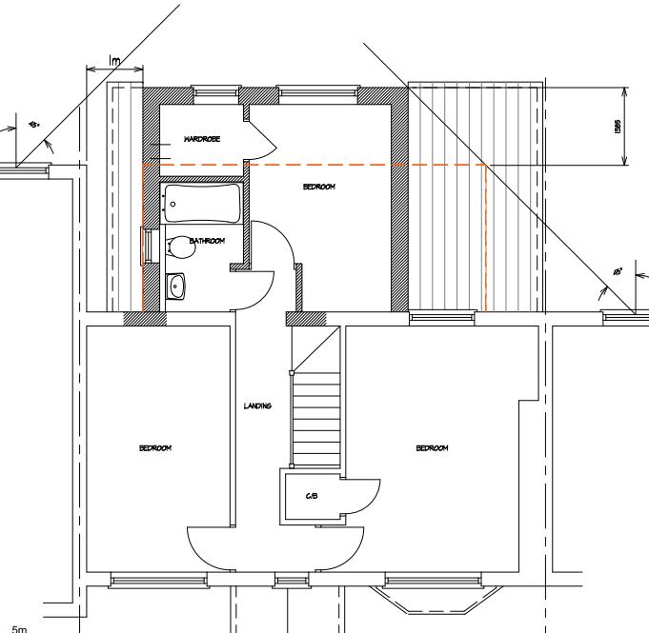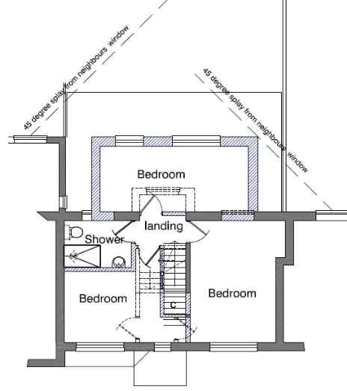

Proposed First Floor Plan (220721) First Floor Plan (Current application)

There are no side windows proposed and 45 degree sunlight assessments have been sent in on the request of the LPA, regarding adjoining properties.

It is therefore considered that there are no aspects of this proposal as amended that present any privacy or overlooking issues, overbearing effects or negative impacts on the sunlight or daylight available to the properties on both sides in such significant ways that would be deemed unacceptable.

- CONCLUSION
The proposed development has been assessed as set out above and is considered to be acceptable on that basis, subject to the following conditions.

8. RECOMMENDATION
Recommended Conditions:
AP1: Approved Plans
TL1: Time Limit Standards
M1: Materials to Match Existing
PD2: No New Openings

